Swiggy: Data Analysis – End-to-End Workflow (Industry Process)
Scenario
You are working as a Data Analyst / Data Management Executive in a startup(Food).
Sales team sends daily/weekly Excel files via email containing sales or customer data.
Your responsibility is to validate, clean, integrate, analyze(Query /Viz), visualize, and share insights with stakeholders (CEO / Director/business leaders ).

1️⃣ Data Receipt from Sales Team
Email Monitoring
- Check sales mailbox every day
- Identify new data files received from:
  - Sales team
  - Marketing team
  - Operations
Downloading Data
- Download Excel files from email
- Save files in a structured folder system
Example:
Data_Analysis/
├── Raw_Data/
│ ├── Sales_2024_01.xlsx
│ ├── Sales_2024_02.xlsx
├── Cleaned_Data/
├── Processed_Data/

2️⃣ Initial Data Validation (Excel)
Before touching the database:
✔ File Validation Checks
- Correct file format (.xlsx)
- Expected columns available
- Data type check (date, number, text)
- No broken or corrupted files

3️⃣ Data Cleaning (Excel)
Cleaning Activities
- Remove unwanted rows (headers repeated, totals)
- Fix spelling issues (Country names, Product names)
- Standardize formats:
  - Date format
  - Text case (UPPER / Proper)

4️⃣ Data Profiling (Understanding Data)
Profiling Tasks
- Number of rows & columns
- Unique values per column
- Min / Max values
- Distribution of data
Helps answer:
- Is data usable?
- Is something missing?
- Any abnormal values?

5️⃣ Data Integration & Mapping
Data Integration
- Combine multiple Excel files into one dataset
- Merge data from:
  - Sales file ( from 4 branch/store )
  - Customer master
  - Product master
Data Mapping
Source Column | Target Column
City | City_Name
Or_Date | Order_Date
Rest_Name | Restaurant_Name
- Ensures consistency before database loading.

6️⃣ Data Quality Checks (Critical Step)
Missing Values (null check )
- Identify empty cells
- Decide:
  - Fill with default value
  - Remove record
  - Keep as NULL
Null Values
- Check mandatory fields:
  - State
  - City
  - Order_Date
  - Restaurant_Name
Duplicate Records
- Blank/Empty string
- Duplicate Detection
- Duplicate Removal
- All issues must be fixed BEFORE loading into database

7️⃣ Data Loading into Database
Database Upload
- Import cleaned Excel data into SQL tables
- Tables like:
  - Order_Name
  - Food_items
  - Sales(4 file)
This is part of the ETL process.

8️⃣ ETL Process (End-to-End)
ETL Explained
- Extract → Excel files from email
- Transform → Cleaning, validation, mapping
- Load → Insert into SQL database
This ensures centralized & trusted data. (single truth? Enterprise data ?)

9️⃣ SQL-Dimensional Modelling(Star Schema)
Dimensional modelling helps organize data in a way that makes analysis simple, consistent, and extremely efficient. Instead of keeping all information mixed in one large table, the Star Schema separates descriptive information into dimensions and keeps all measurable values in a central fact table. This structure reduces data duplication, improves clarity, and makes the entire dataset easier to understand. It also supports faster reporting because queries can access small, focused tables rather than scanning a single bulky dataset. Most analytics and BI tools are designed to work best with star schemas, so this approach ensures smooth dashboard creation, accurate aggregations, and reliable insights. Overall, dimensional modelling provides a clean, scalable, and performance-optimized foundation for any analytical system, regardless of the industry or data source.
To optimize analytics and reporting, build a Star Schema with the following dimension tables:
- dim_date → Year, Month, Quarter, Week
- dim_location → State, City, Location
- dim_restaurant → Restaurant_Name
- dim_category → Cuisine/Category
- dim_dish → Dish_Name
Central fact table:
- fact_swiggy_orders → Price_INR, Rating, Rating_Count, foreign keys to all dimensions
Populate each dimension with distinct data from the cleaned source and load fact table with all keys resolved.

ERD-Diagram: Star Schem 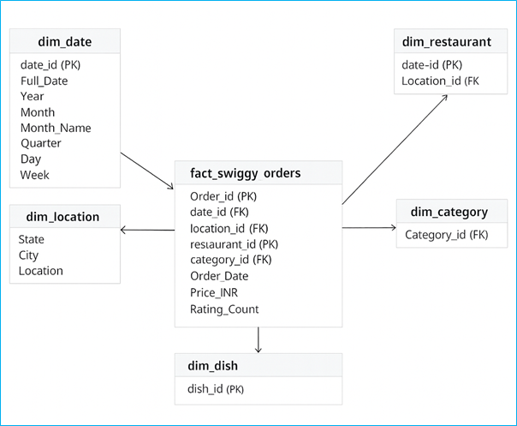
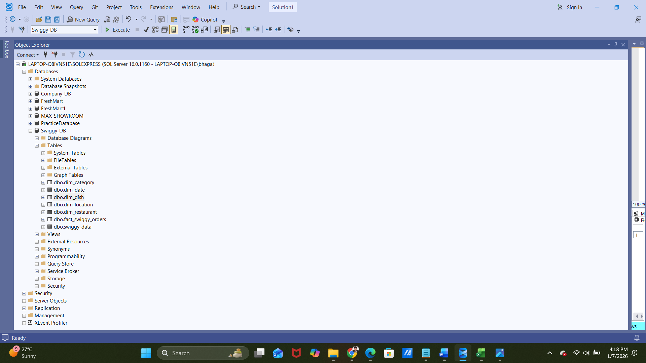

🔟 SQL-Based Data Cleaning & Validation
After loading data:
✔ SQL Validation Checks
- Row count verification
- Foreign key validation
- Null checks
Example:
SELECT COUNT(*) FROM sales WHERE customer_id IS NULL;
✔ Remove Duplicates
DELETE FROM sales
WHERE order_id IN (
SELECT order_id
FROM sales
GROUP BY order_id
HAVING COUNT(*) > 1
);

SQL-Based Data Masking
Sales data contains sensitive customer information such as:
(If it is available do this step, this is very important)
- Email ID
- Customer Name
- Phone (if present)
❗ Not all users should see full customer details
✔ Management needs insights, not personal data
✔ This ensures data privacy & compliance
Eample:-
ALTER TABLE Swiggy_data
ALTER COLUMN Email ADD MASKED WITH (FUNCTION = 'email()');
Example output:
- Original: john.doe@gmail.com
- Masked: jXXXX@XXXX.com
From where business leaders (marketing /Sales/HR/Opr?

1️⃣1️⃣ SQL Data Analysis
KPI Development
- Total Orders
Code:- SELECT
COUNT(*) AS Count_Orders
FROM fact_swiggy_orders;
Output:-
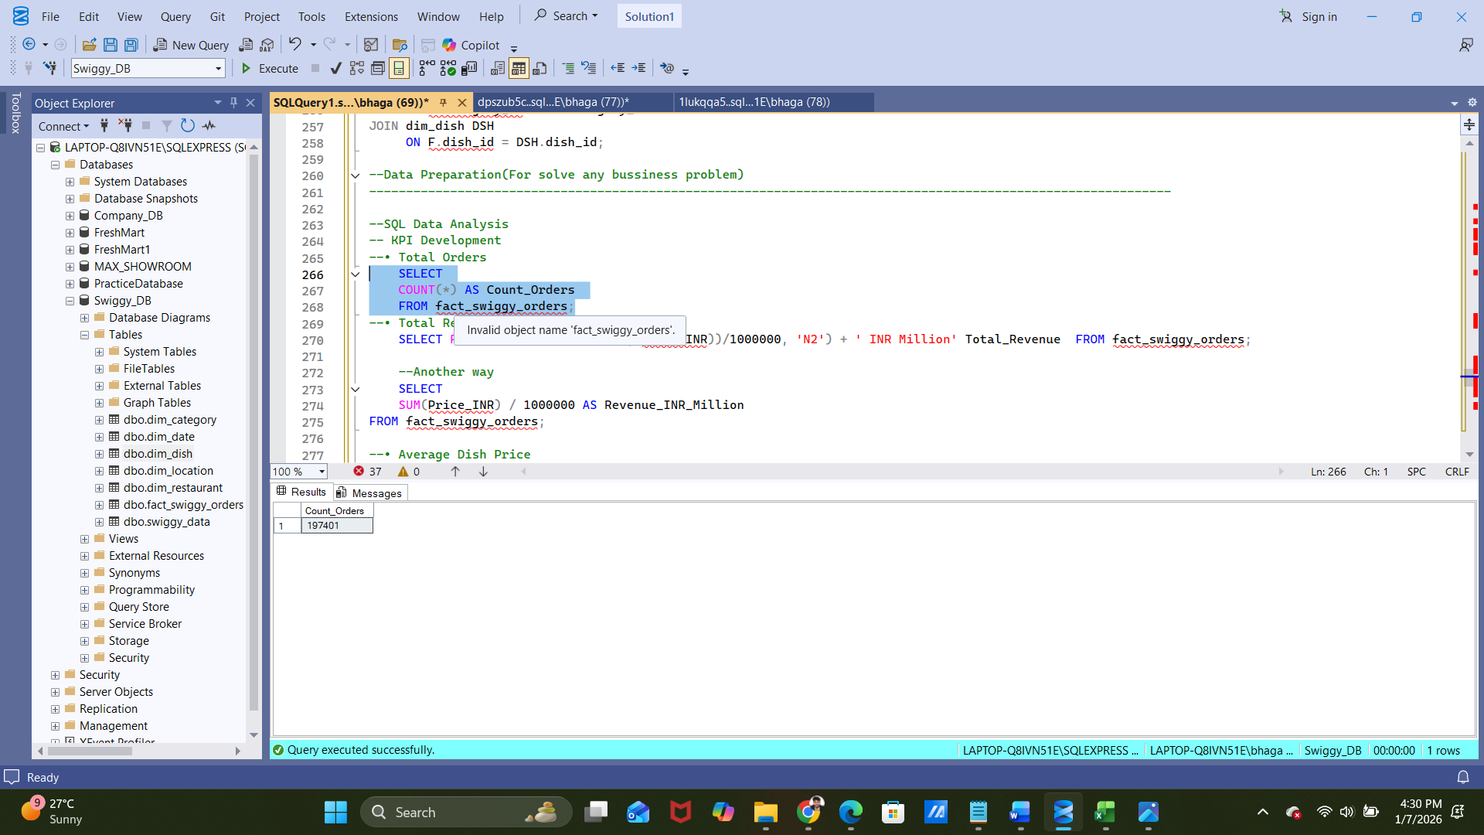
- Total Revenue (INR Million)
Code:- --• Total Revenue (INR Million)
SELECT
FORMAT(SUM(CONVERT(FLOAT, Price_INR))/1000000, 'N2') + ' INR Million'
Total_Revenue
FROM fact_swiggy_orders;
Output:-
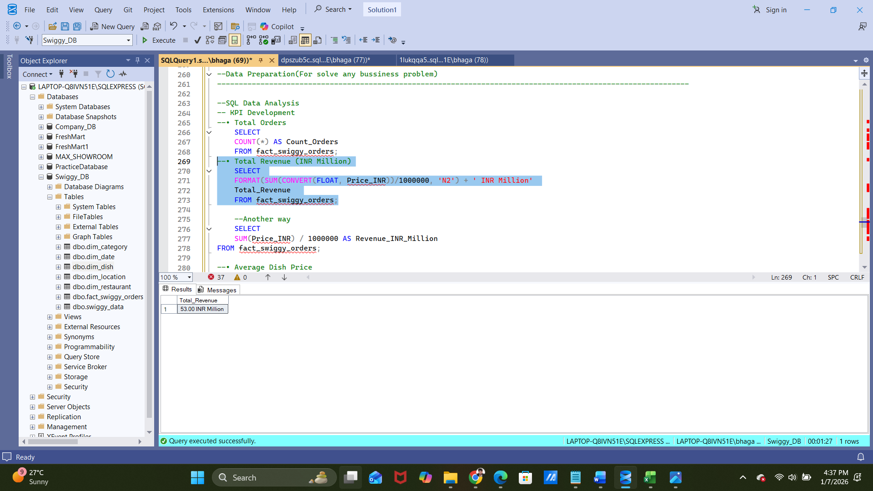
- Average Dish Price
Code:- SELECT FORMAT(AVG(CONVERT(FLOAT, Price_INR)), 'N2') + ' INR'
AS 'Average Dish Price'
FROM fact_swiggy_orders;
Output:-
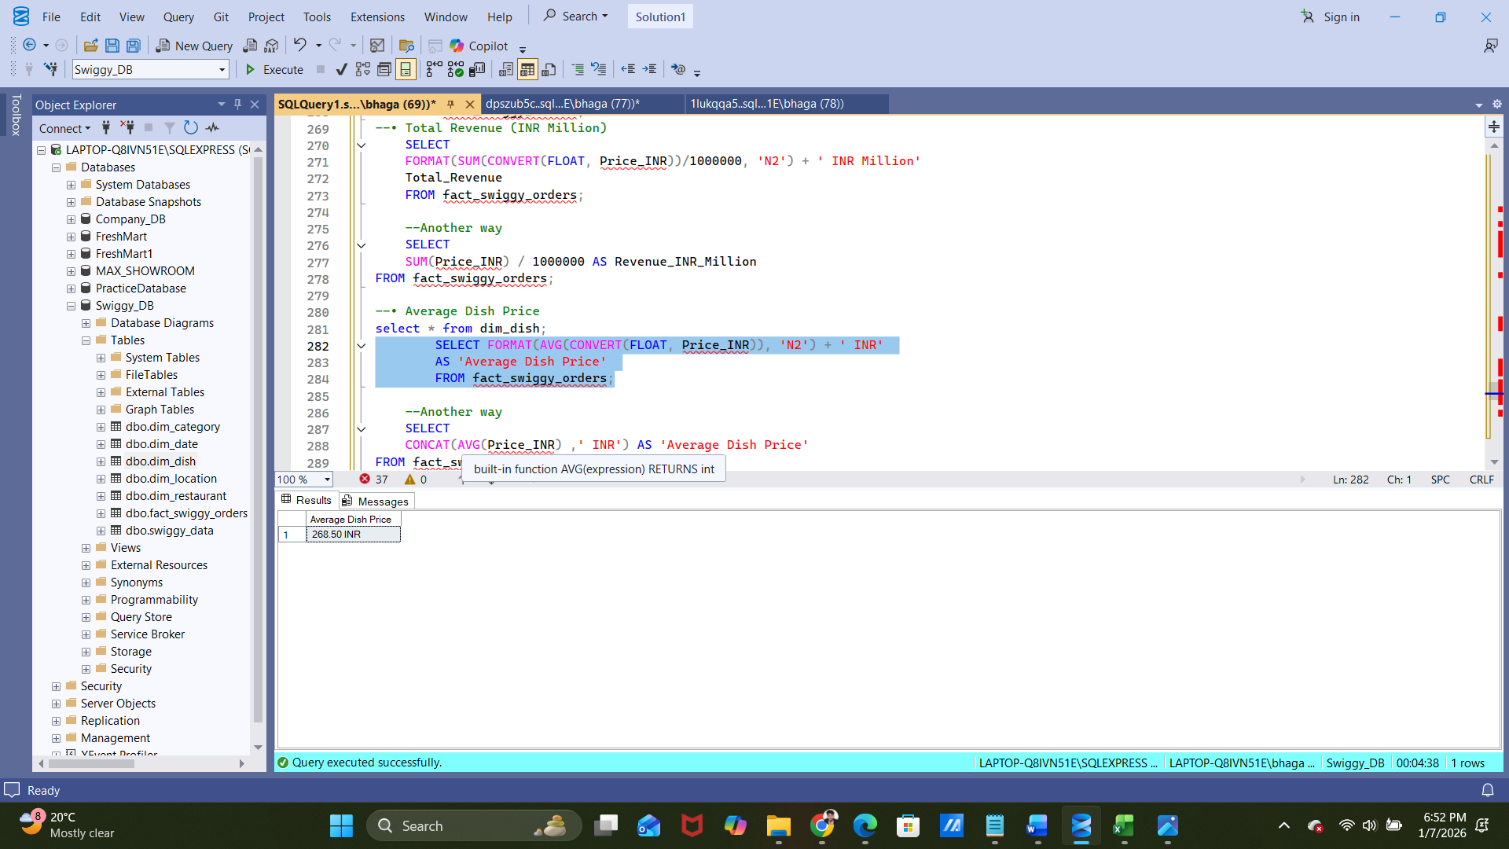
- Average Rating
Example:
SELECT country, SUM(quantity * price) AS revenue
FROM sales s
JOIN customers c ON s.customer_id = c.customer_id
JOIN products p ON s.product_id = p.product_id
GROUP BY country;
Deep-Dive Business Analysis
Date-Based Analysis
- Monthly order trends
Code:-
SELECT
DD.YEAR,
DD.MONTH,
DD.Month_Name,
COUNT(*) AS Count_Orders
FROM fact_swiggy_orders F
JOIN dim_date DD
ON F.date_id = DD.date_id
GROUP BY DD.YEAR,
DD.MONTH,
DD.Month_Name;
Output:-

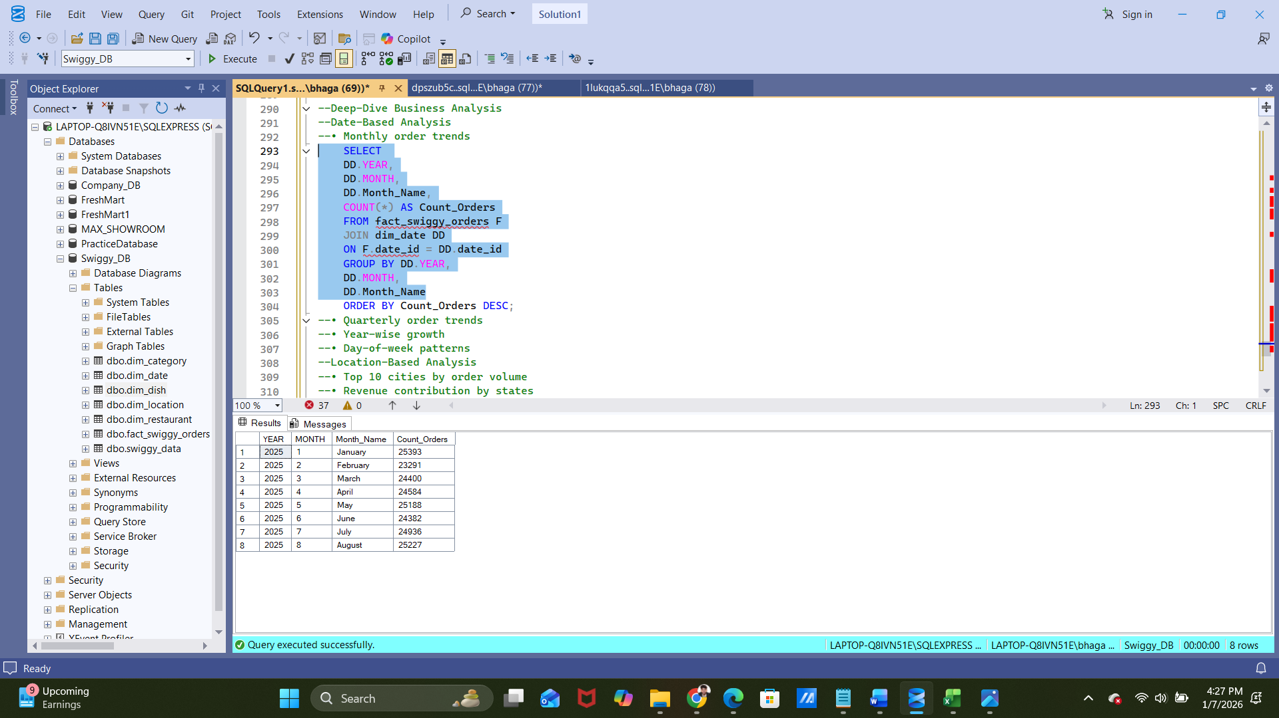
- Quarterly order trends
Code:- SELECT
DD.YEAR,
DD.Quater,
COUNT(*) Quaterly_Orders
FROM fact_swiggy_orders F
JOIN dim_date DD
ON F.date_id = DD.date_id
GROUP BY
DD.YEAR,
DD.Quater;
Output:-
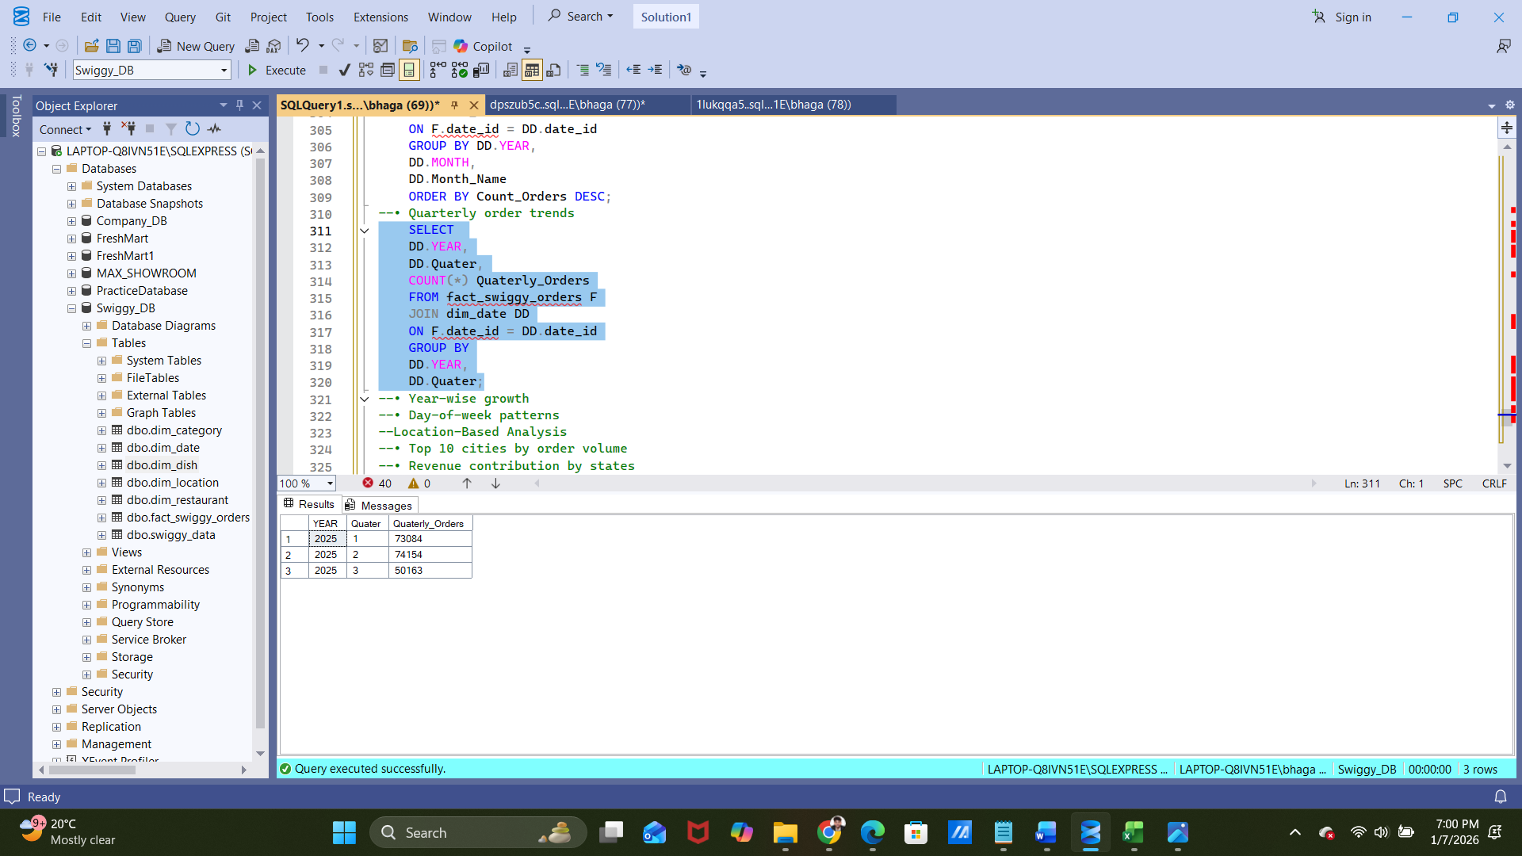
- Year-wise growth
Code:-
SELECT
DD.YEAR,
COUNT(*) AS Count_Orders,
CONCAT(SUM(Price_INR),' INR') AS Total_Sales
FROM fact_swiggy_orders F
JOIN dim_date DD
ON F.date_id = DD.date_id
GROUP BY YEAR;
Output:-
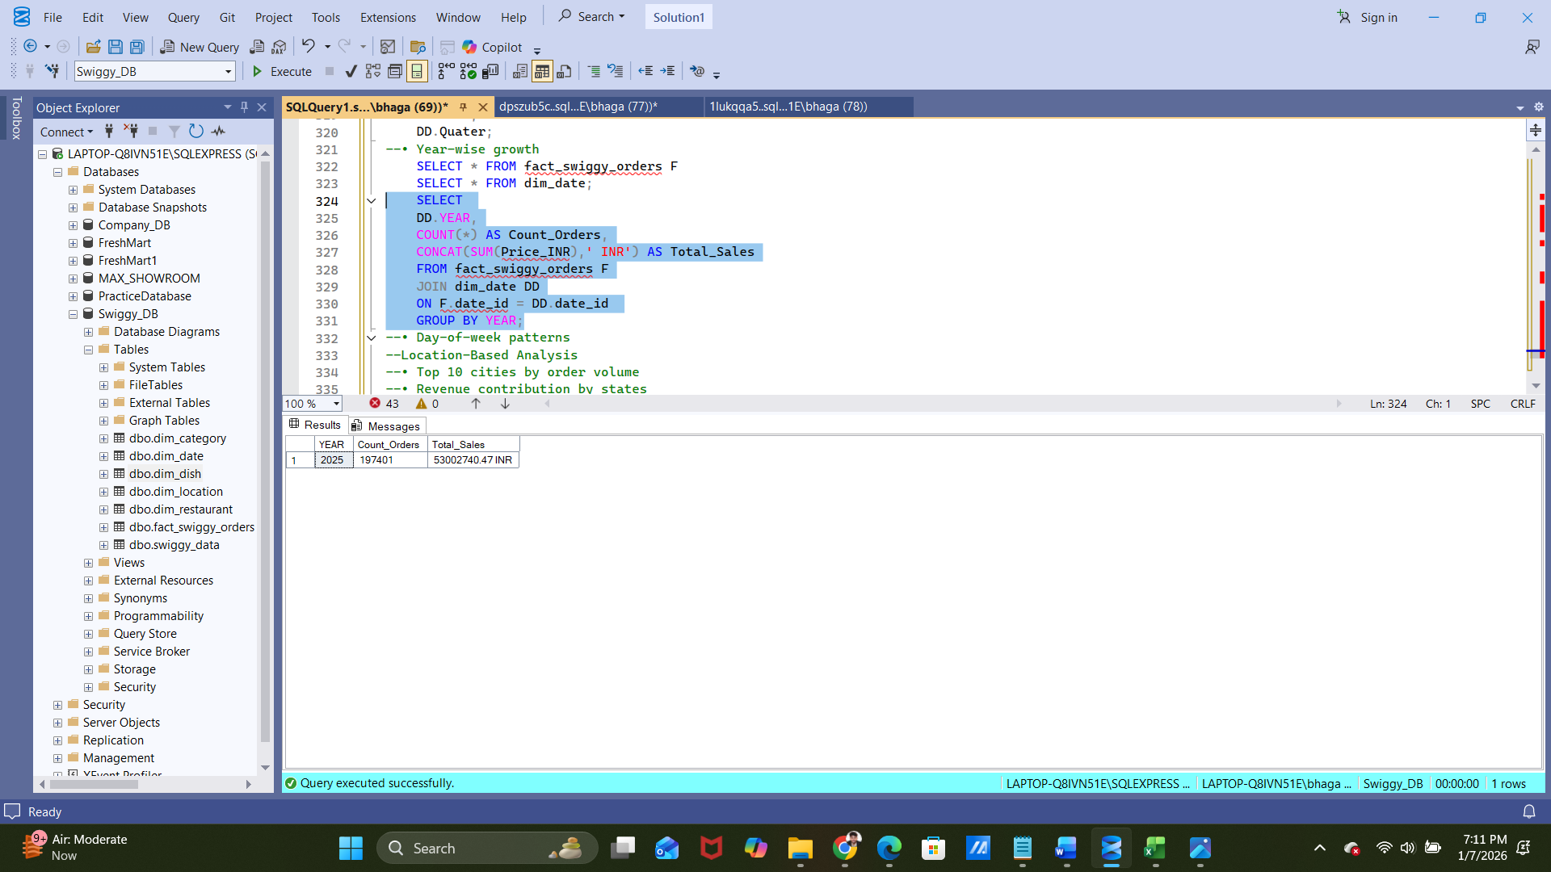
- Day-of-week patterns
Code:-
SELECT * FROM fact_swiggy_orders F
SELECT * FROM dim_date;
Select
datename(dw, full_date) as Day_Name,
count(*) Count_Orders
from fact_swiggy_orders F
join dim_date dm
on f.date_id = dm.date_id
group by datename(dw, full_date)
order by Day_Name asc;
Output:-
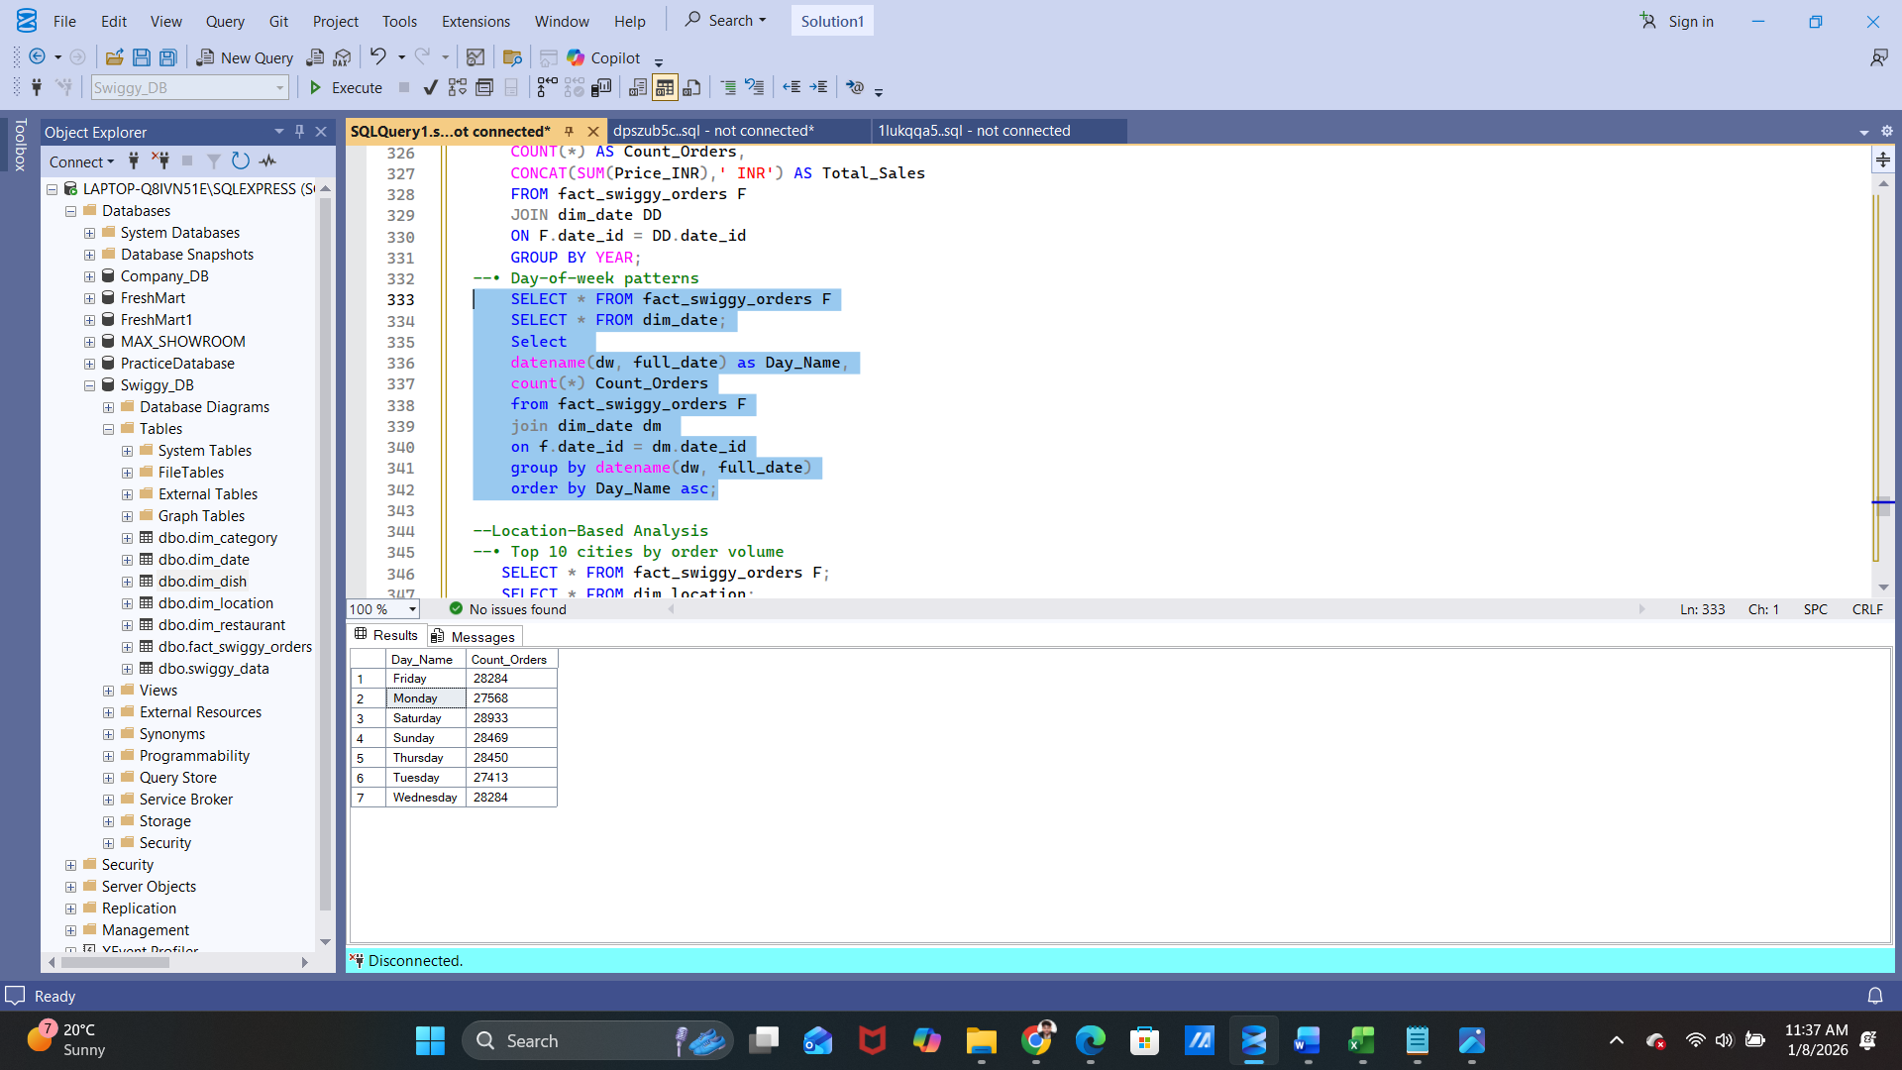
Location-Based Analysis
- Top 10 cities by order volume
Code:-
SELECT TOP 10
DM.CITY,
COUNT(*) Order_Volume
FROM fact_swiggy_orders F
JOIN dim_location DM
ON F.location_id = DM.location_id
GROUP BY DM.CITY
ORDER BY Order_Volume DESC;
Output:-
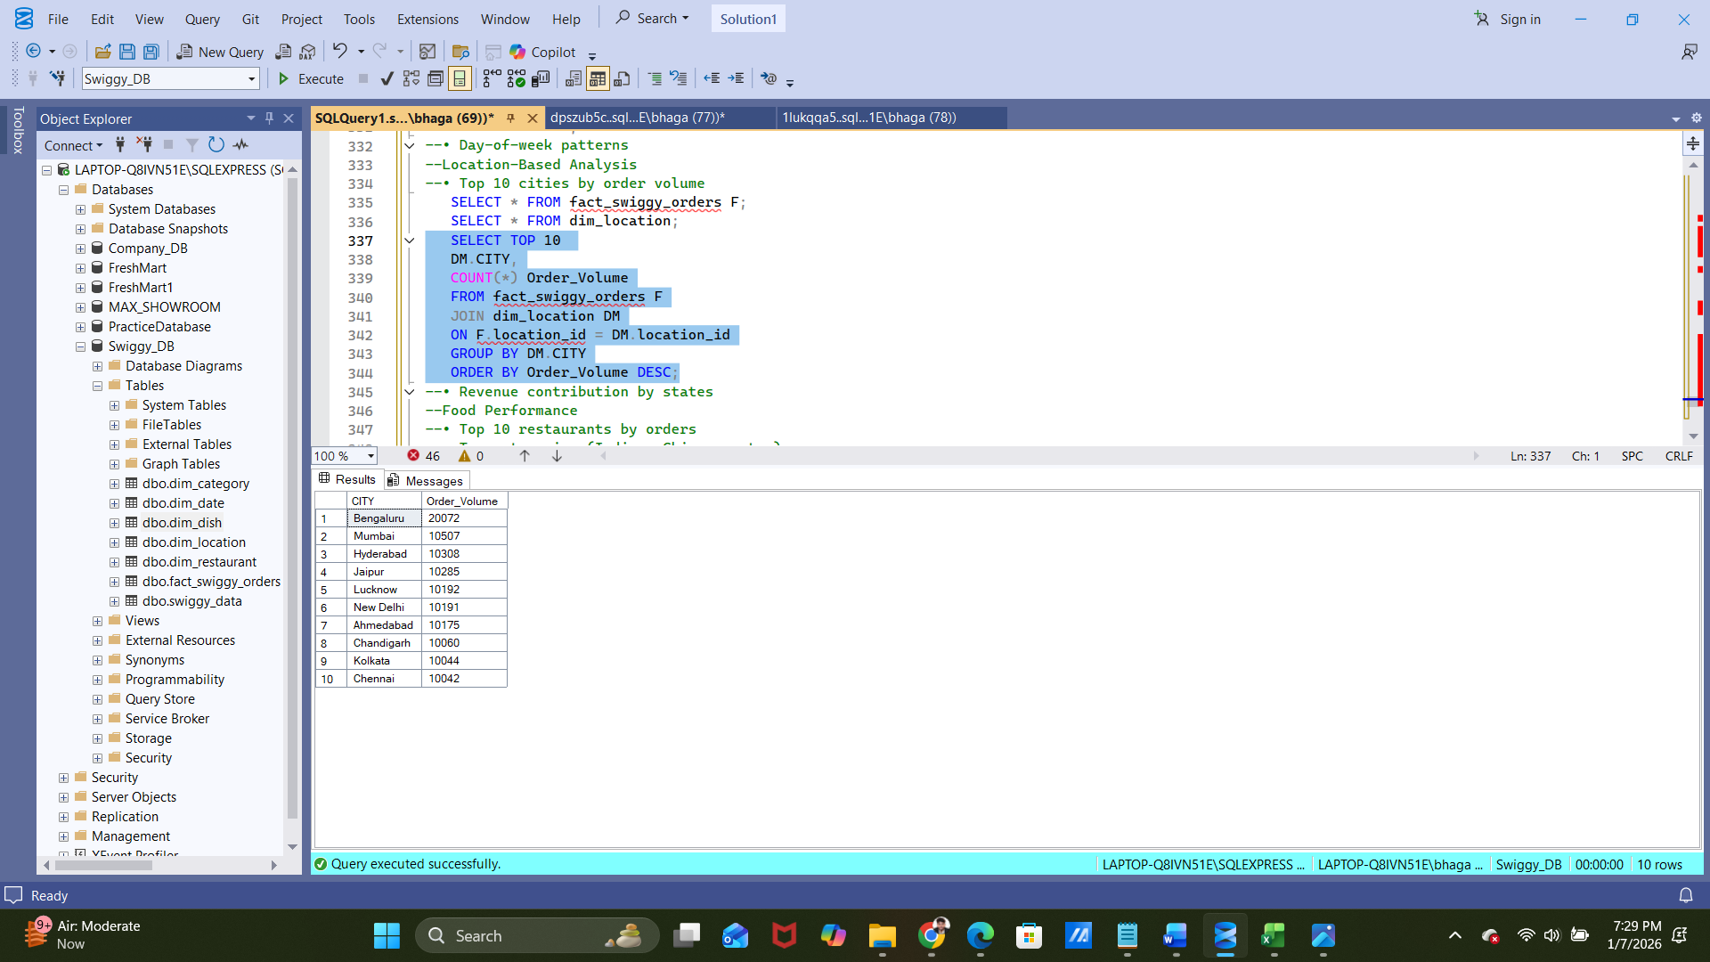
- Revenue contribution by states
Code:-
SELECT
DL.STATE,
SUM(Price_INR) AS Total_Revenue
FROM fact_swiggy_orders F
JOIN dim_location DL
ON F.location_id = DL.location_id
GROUP BY DL.STATE;
Output:-
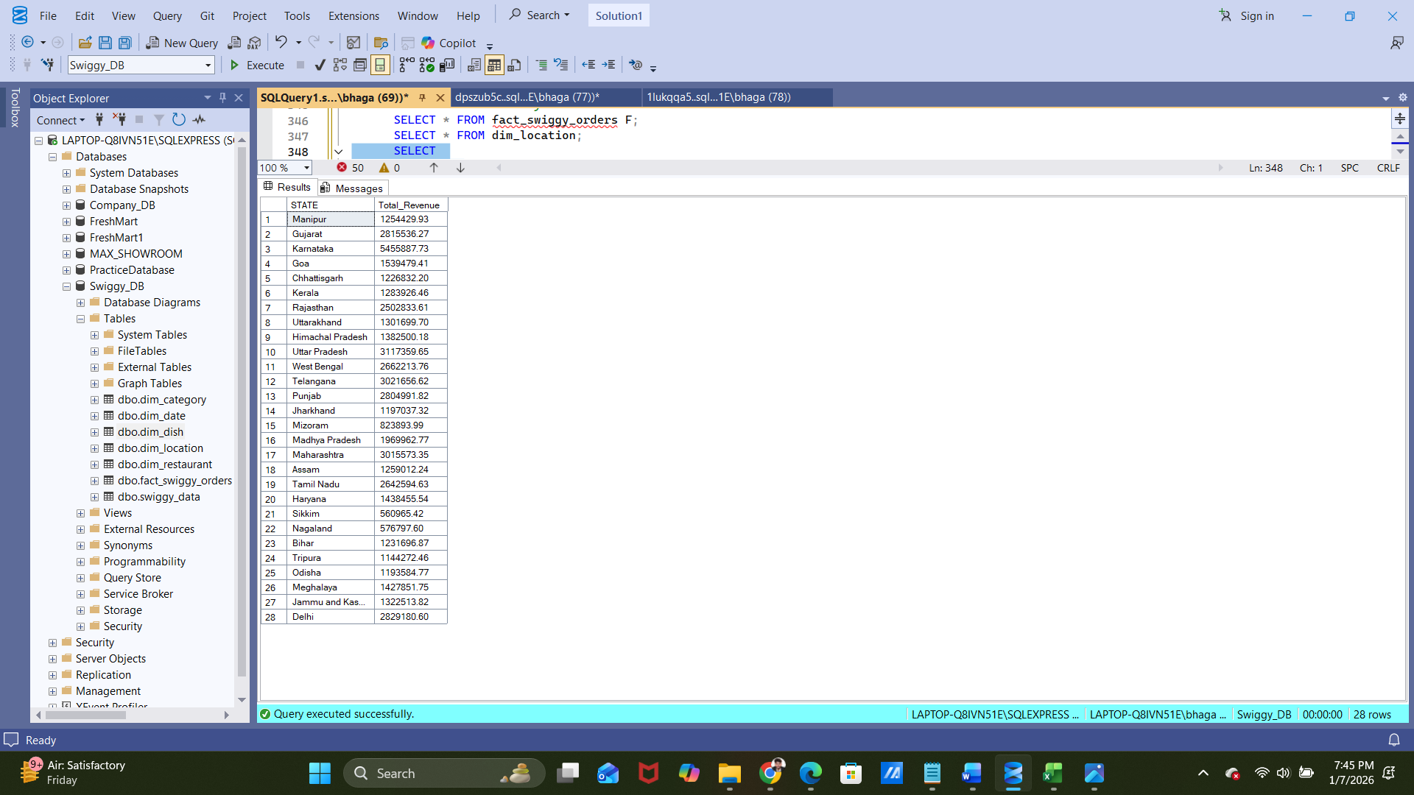
Food Performance
- Top 10 restaurants by orders
Code:-
SELECT
DR.Restaurant_Name,
COUNT(*) AS Orders
FROM fact_swiggy_orders F
JOIN dim_restaurant DR
ON F.restaurant_id = DR.restaurant_id
GROUP BY DR.Restaurant_Name;
Output:-
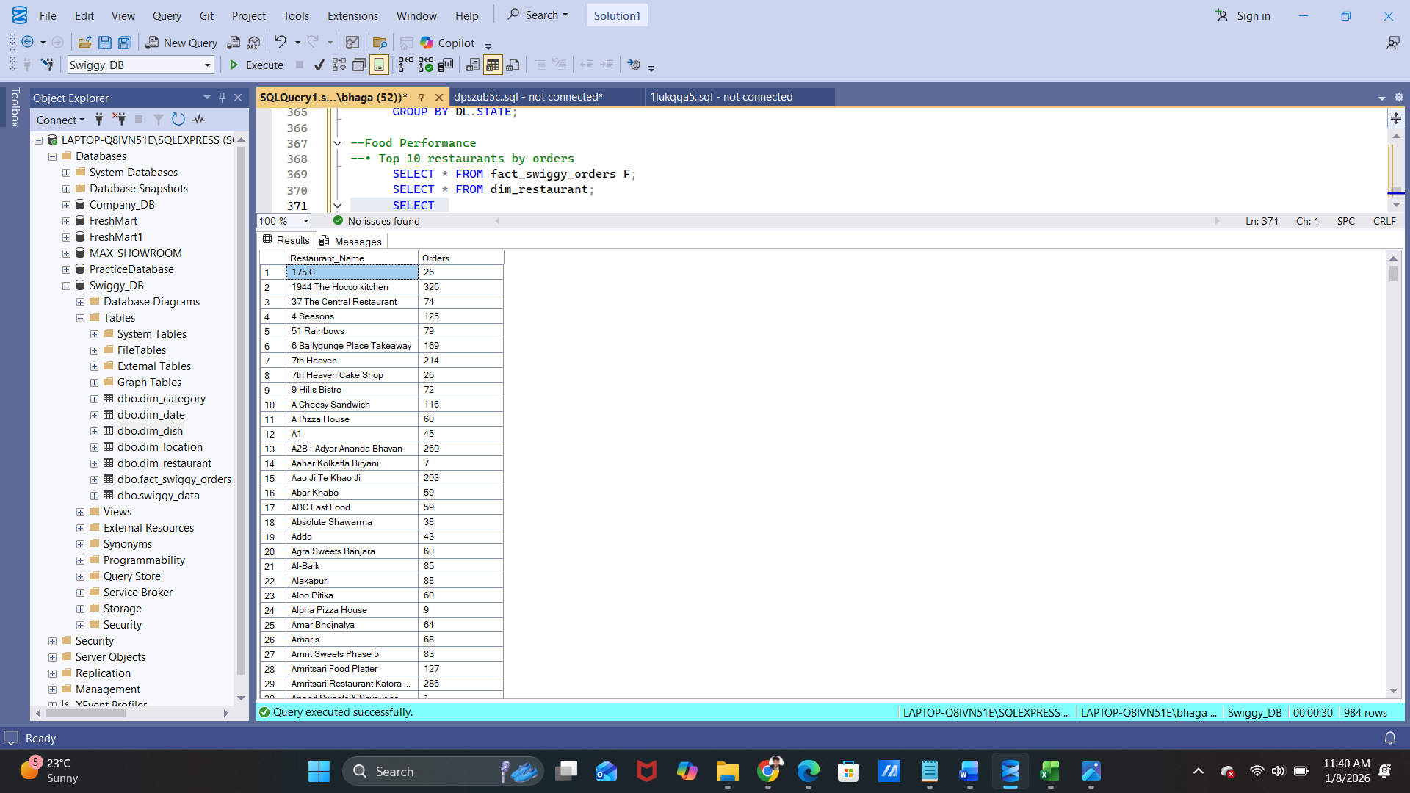
- Top categories (Indian, Chinese, etc.)
Code:-
SELECT
DC.Category,
COUNT(*) AS Total_Orders
FROM fact_swiggy_orders F
JOIN dim_category DC
ON F.category_id = DC.category_id
GROUP BY DC.Category
ORDER BY Total_Orders DESC;
Output:-
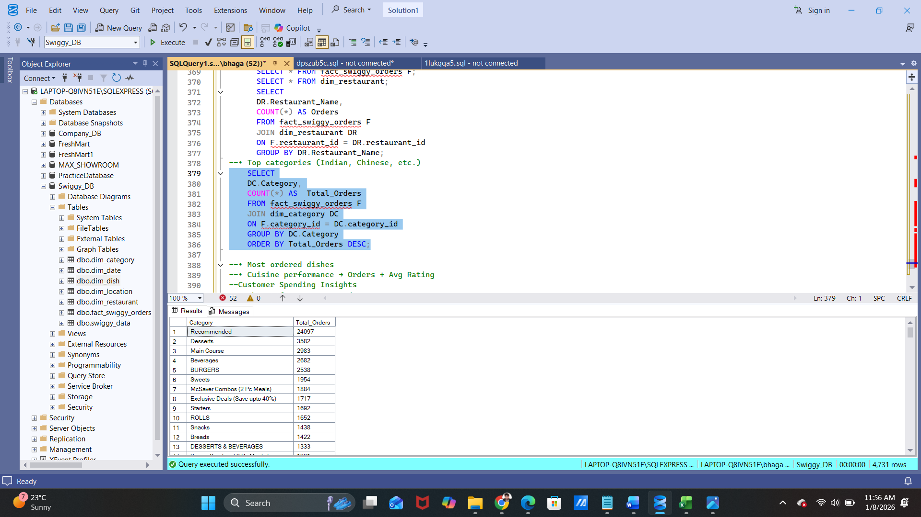
- Most ordered dishes
Code:-
SELECT
DSH.Dish_Name,
COUNT(*) Total_Orders
FROM fact_swiggy_orders F
JOIN dim_dish DSH
ON F.dish_id = DSH.dish_id
GROUP BY DSH.Dish_Name
ORDER BY Total_Orders DESC;
Output:-
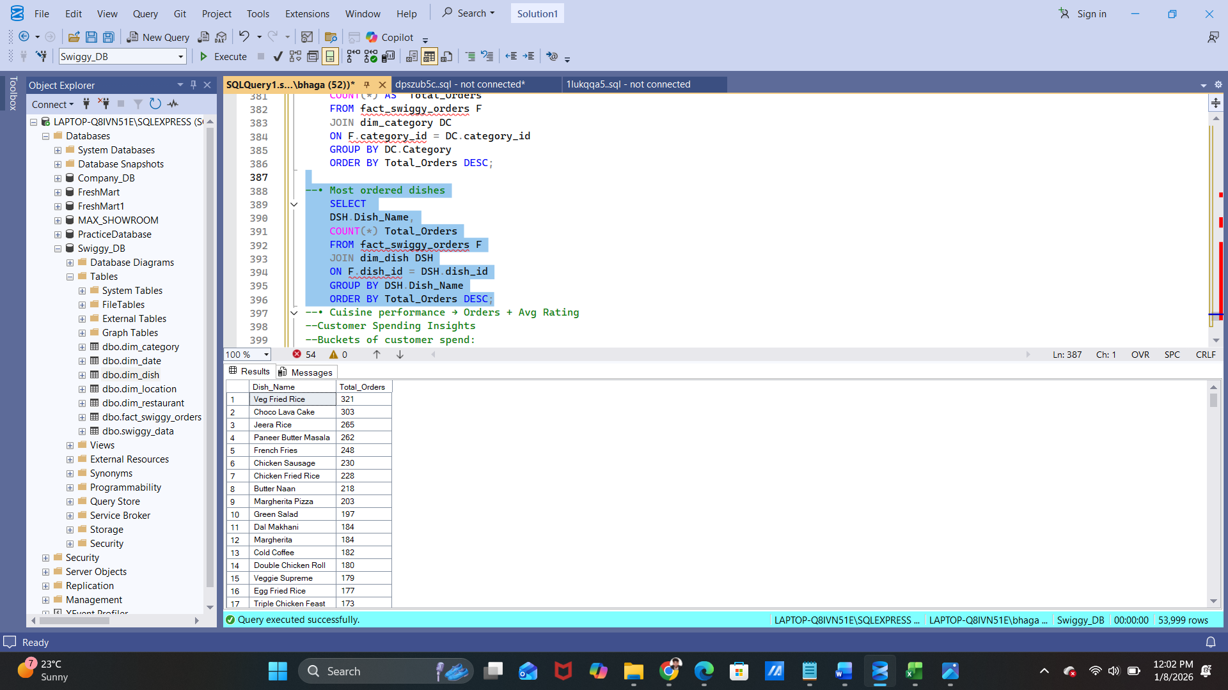
- Cuisine performance → Orders + Avg Rating
Code:-
SELECT
COUNT(*) AS Total_Orders,
FORMAT(AVG(CONVERT(FLOAT,Rating)), 'N2') + ' INR' AS Average_Rating
FROM fact_swiggy_orders F;
Output:-
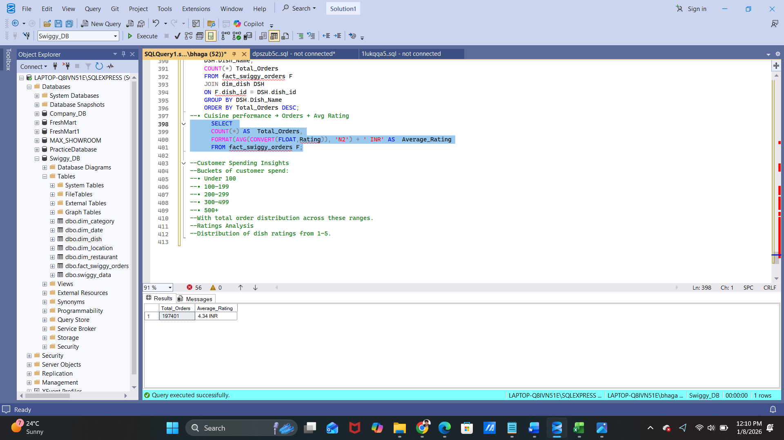
Customer Spending Insights
Buckets of customer spend:
- Under 100
Code:-
SELECT
F.Order_id,
F.Price_INR
FROM fact_swiggy_orders F
WHERE Price_INR < 100;
Output:-
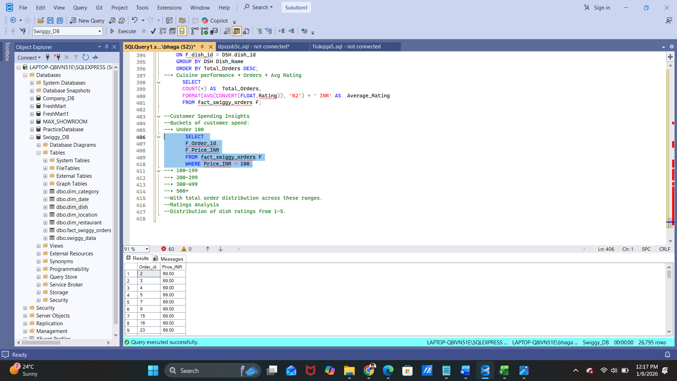
- 100–199
Code:- SELECT
F.Order_id,
F.Price_INR
FROM fact_swiggy_orders F
WHERE Price_INR BETWEEN 100 AND 199;
Output:-
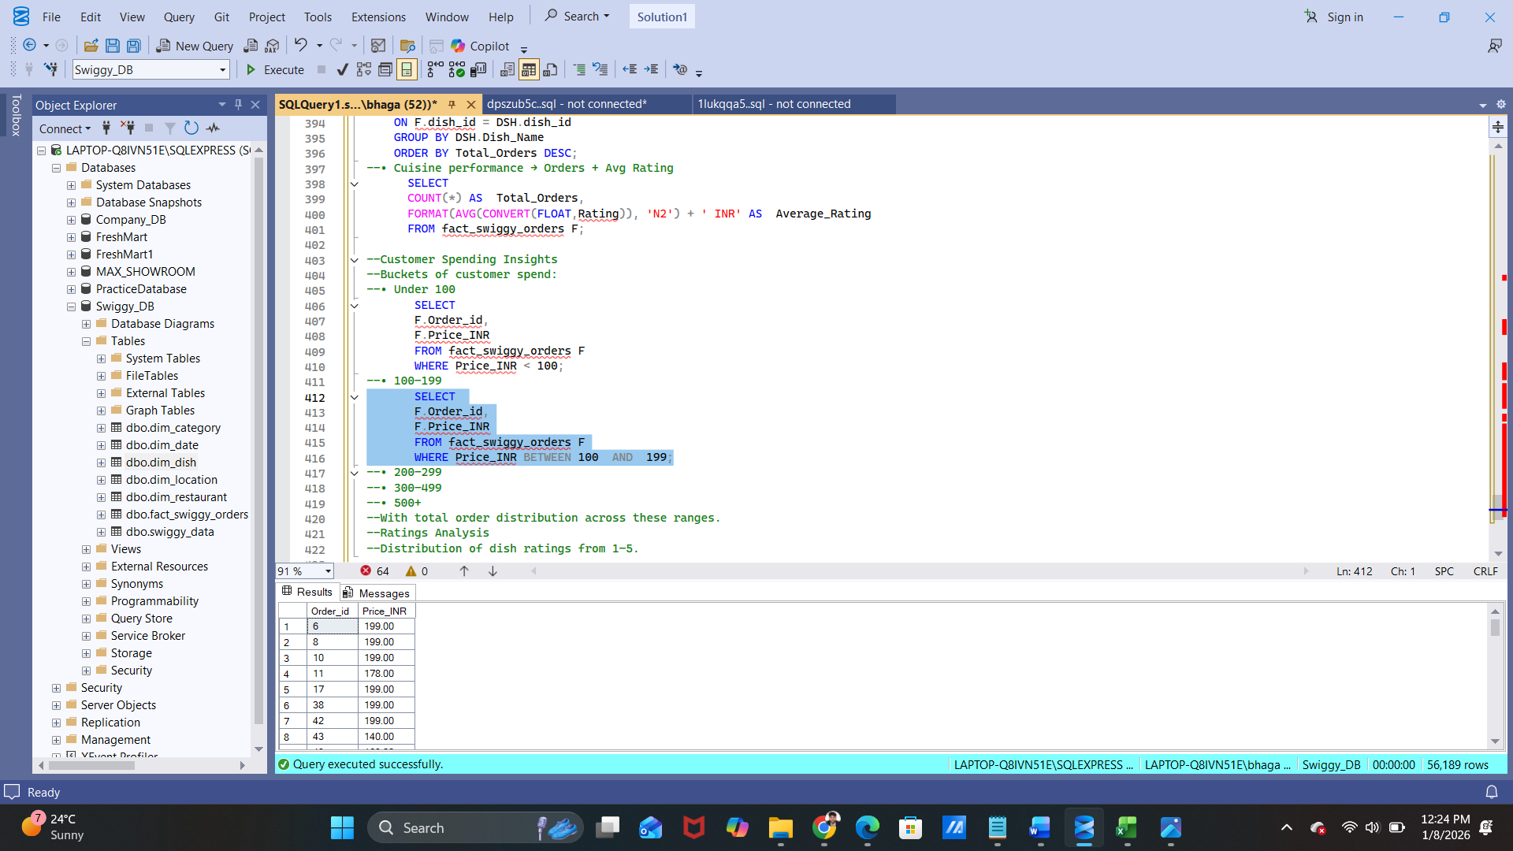

- 200–299
Code:-
SELECT
F.Order_id,
F.Price_INR
FROM fact_swiggy_orders F
WHERE Price_INR BETWEEN 200 AND 299;
Output:-
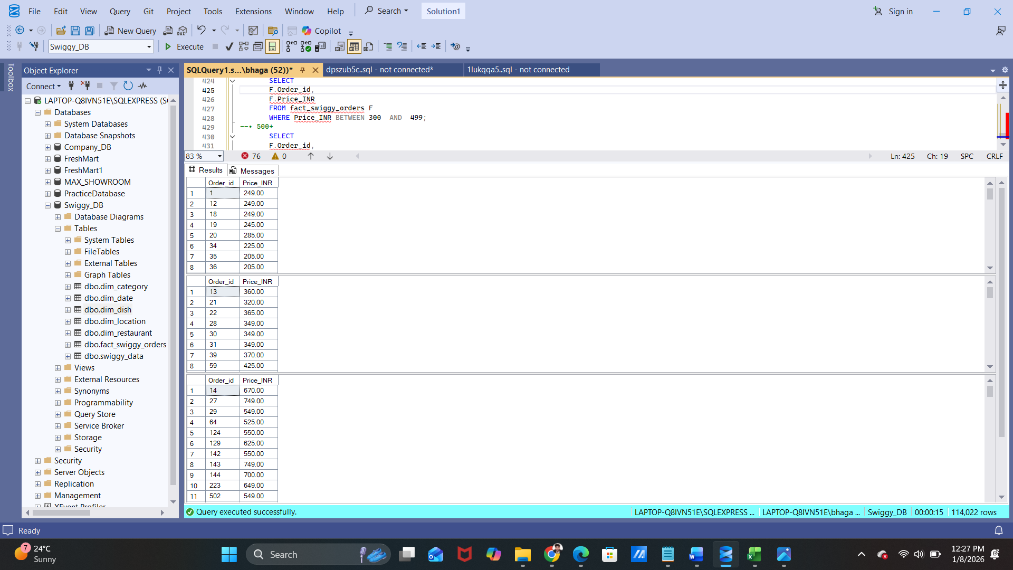
- 300–499
Code:-
SELECT
F.Order_id,
F.Price_INR
FROM fact_swiggy_orders F
WHERE Price_INR BETWEEN 300 AND 499;
Output:-

- 500+
Code:-
SELECT
F.Order_id,
F.Price_INR
FROM fact_swiggy_orders F
WHERE Price_INR >= 500;
Output:-


With total order distribution across these ranges.
Ratings Analysis
Distribution of dish ratings from 1–5.
Code:-
SELECT
F.Rating,
COUNT(*) AS Rating_Count
FROM fact_swiggy_orders F
GROUP BY F.Rating
ORDER BY Rating_Count;
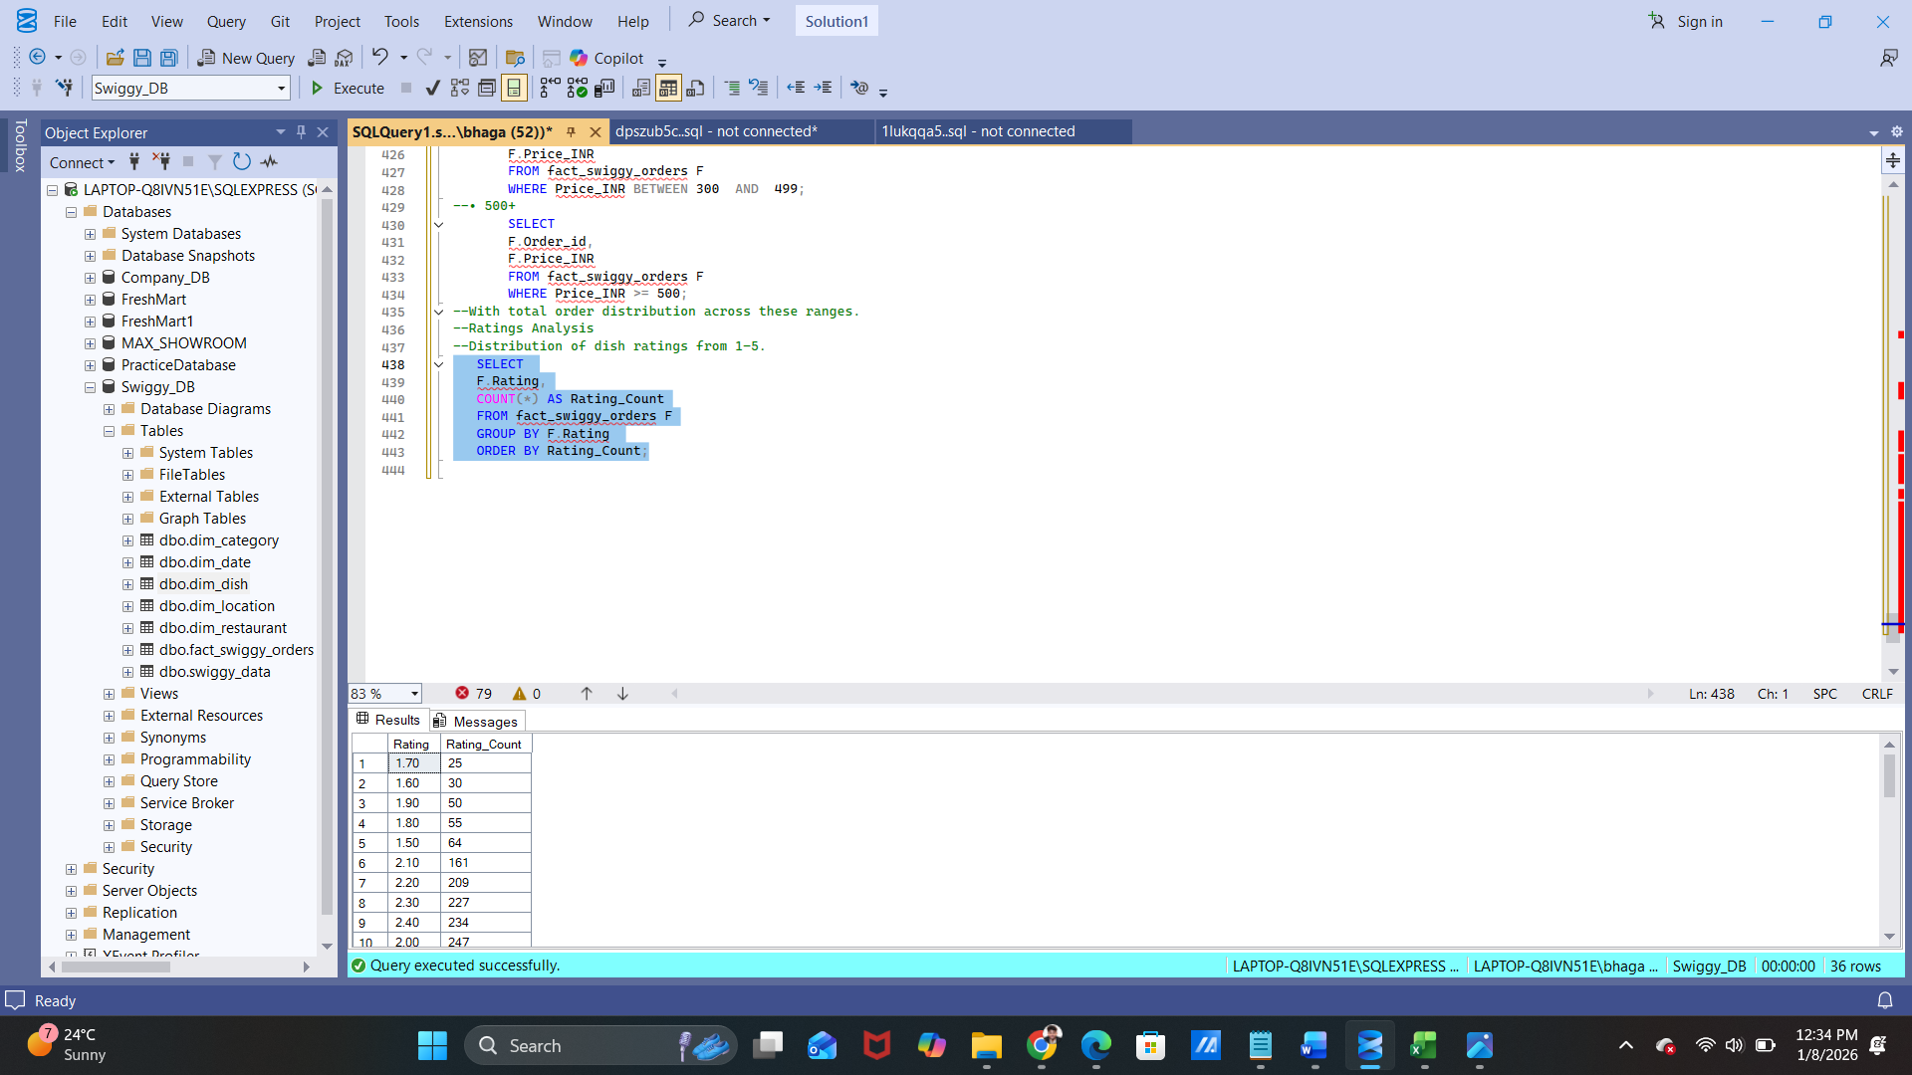
Output:-

1️⃣2️⃣ Export Data to Excel
- Export SQL query results
- Use Excel for:
  - Pivot tables
  - Summary sheets
  - Charts
This step bridges technical → business.

1️⃣3️⃣ Data Visualization (Excel)
Charts Used
- Bar chart → Total Revenue Trend (Monthly / Daily)
- Line chart → Orders by City (Top Cities Performance)
- Pie chart → Revenue Contribution by Food Category
- Column Chart → Top 10 Restaurants by Revenue
- Column / Area Chart → Order Volume by Day of Week
- Line Chart → Average Order Value (AOV) Trend
- KPI cards → Total Revenue, Total Orders, AOV

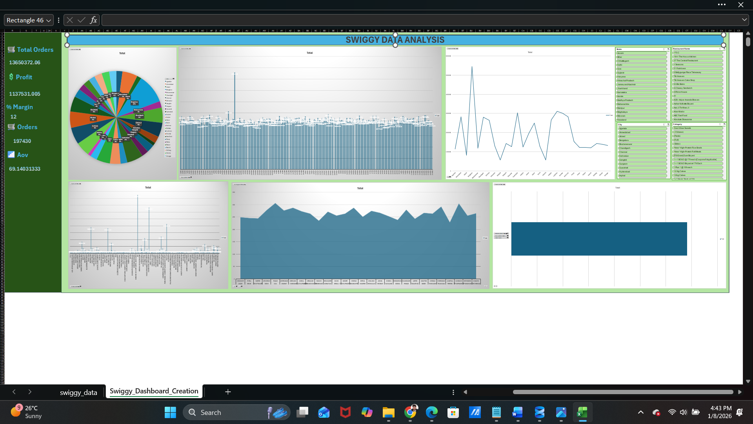
1️⃣4️⃣ Reporting to Stakeholders
Final Output Shared With:
- CEO
- Director
- Sales Head
Format:
- Excel dashboard
- Summary insights (bullet points)
- Recommendations

Summary:
“I handle end-to-end data management — from receiving raw Excel files via email, validating and cleaning data, performing ETL, integrating data into SQL databases, running analysis queries, creating Excel dashboards, and finally sharing actionable insights with stakeholders.”

Overrall View of This Project:-
