Data Driven Demand Analysis and Forecasting for Grocery Retail Operations
Final MBA Project Report
Operations Management supported by Data Science
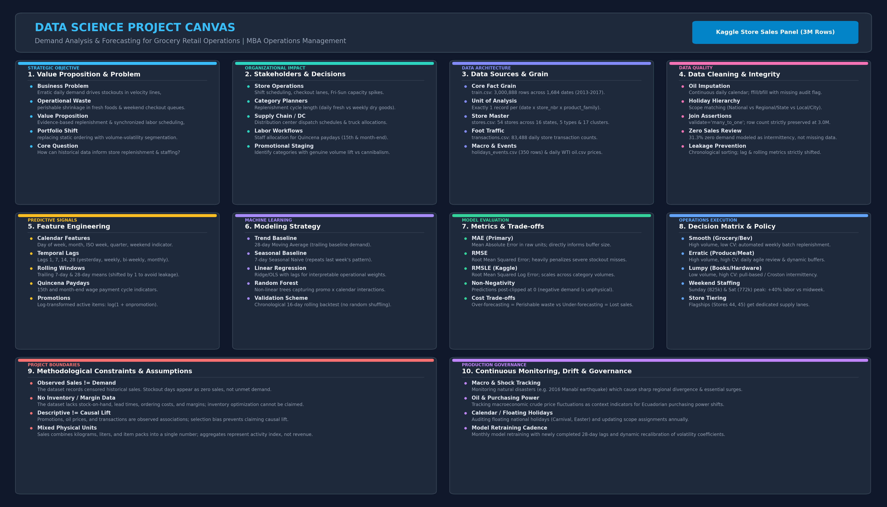
Dataset Kaggle Store Sales Time Series Forecasting
Historical coverage 1 January 2013 to 15 August 2017
Prepared for MBA Year 1 Operations Management
Report date November 2026

Report Purpose and Main Conclusion
This report explains how historical sales and operational context can support grocery retail planning. It documents the full analytical workflow, the evidence behind each finding, the forecasting design, the managerial implications, and the limits of the available data.
The main conclusion is that retail demand should not be managed through one network-wide rule. Product families differ in scale and variability, stores differ in maturity and operating profile, and predictable calendar peaks create recurring pressure. Forecasting adds value when each store-family series is compared with a transparent baseline and monitored over time.
The project does not claim causal promotion effects or optimal inventory policies. The data contains observed sales, not unconstrained demand, and does not include stock positions, stockouts, supplier lead times, costs, margins, or service targets.

Contents
- Executive Summary
- 1 Introduction and Business Context
- 2 Project Objectives
- 3 Dataset and Analytical Scope
- 4 Data Preparation and Quality Decisions
- 5 Exploratory Data Analysis
- 6 Operations Analysis
- 7 Forecasting as Operational Support
- 8 Managerial Recommendations
- 9 Inventory Implications
- 10 Limitations
- 11 Conclusion
- 12 Implementation and Monitoring Plan
- 13 Additional Data Requirements
- Appendix A Detailed Analytical Workflow
- Appendix B Metric Definitions
- Appendix C Detailed Forecast Results
- Appendix D Reproducibility
- Appendix E Viva Questions and Answers

Executive Summary
This project examines how historical sales and operational context can support grocery retail planning. The analysis uses the Kaggle Store Sales – Time Series Forecasting data and keeps forecasting as one decision-support component rather than treating model accuracy as the entire project.
The main conclusions are:
- Demand is concentrated. Grocery I, Beverages, Produce, and Cleaning represent approximately 72.7% of observed family-level sales. Store 44 has the highest observed store sales at approximately 62.1 million mixed units.
- Demand follows a strong operating calendar. Average network sales are highest on Sunday (825.2k mixed units) and Saturday (772.2k), while December averages 808.6k per observed day.
- Volume and uncertainty are different operational problems. The portfolio contains 13 high-demand/stable families but also 4 high-demand/volatile families, including Produce, Home Care, and Frozen Foods.
- Store lifecycle matters. Seven stores have less than 90% transaction or active-sales coverage and are therefore separated from mature-store variability comparisons. Among comparable stores, Store 25 has the highest daily-demand coefficient of variation at 0.702.
- Promotions and holidays are associated with higher observed sales, but the evidence is not causal. Holiday store-days average 19.1% more sales than non-holiday store-days, and promoted/non-promoted ratios vary materially by family.
- Forecasting provides useful but series-dependent support. A rolling one-day Random Forest has the lowest average MAE across three selected series (414.4 versus 718.6 for weekly seasonal naive), while Holt-Winters performs best for one of the three series.
- Advanced diagnostics reinforce the need for differentiation. Across 1,782 store–family series, 630 are Smooth, 593 Intermittent, 324 Lumpy, and 235 Erratic under the ADI/CV² screening framework. Semi-month boundary dates average 4.52% higher network sales before calendar controls.
The central managerial implication is to avoid one network-wide planning rule. Stable high-volume families can support regular routines, while volatile important categories, recurring peaks, promotion periods, and high-variability stores require shorter review cycles and more operating flexibility.

1 Introduction and Business Context
Grocery operations must coordinate staffing, checkout capacity, receiving, shelf replenishment, promotions, and suppliers under changing demand. Historical data can reveal recurring patterns and identify where uniform planning rules are unlikely to work.
The project addresses the following broad business question:
How can historical sales and operational factors be analyzed to understand demand patterns and support better retail planning decisions?
The dataset contains observed sales rather than unconstrained customer demand. It does not contain inventory positions, stockouts, lead times, ordering costs, margins, or service-level targets. The project can therefore discuss inventory implications, but it cannot calculate optimal reorder points, safety stocks, or financial benefits.

2 Project Objectives
1. Understand historical retail demand patterns.
2. Identify factors associated with changes in sales.
3. Examine differences across stores and product families.
4. Explore the operational impact of promotions, holidays, and demand variability.
5. Develop a suitable forecasting approach for selected demand series.
6. Translate analytical findings into practical operational insights.

3 Dataset and Analytical Scope

3 1 Source files
The project uses all seven files supplied in the Kaggle competition archive.
File | Rows | Analytical role
train.csv | 3,000,888 | Historical sales and promotion observations
test.csv | 28,512 | Competition forecast horizon and output alignment
stores.csv | 54 | Store geography, type, and cluster
transactions.csv | 83,488 | Daily store-traffic proxy
holidays_events.csv | 350 | National, regional, and local events
oil.csv | 1,218 | Exploratory macroeconomic context
sample_submission.csv | 28,512 | Competition output structure

The training panel covers 1 January 2013 to 15 August 2017, with 54 stores, 33 product families, and 1,684 observed dates.

3 2 Unit of analysis
The core grain is one date × store × product-family observation. The 3,000,888 training rows equal 1,684 dates × 54 stores × 33 families, and the key is unique.
This matters because store attributes, daily transactions, oil prices, and holidays exist at different grains. Merging them without validation could multiply sales rows or incorrectly apply a local holiday to every store.

3 3 Detailed analysis subset
The full panel is retained for network-level findings. A smaller subset supports detailed store-family analysis and forecasting:
- Stores: 44, 45, 17, 32, and 25
- Families: Grocery I, Beverages, Produce, Cleaning, and Frozen Foods
- Period: 16 August 2015 to 15 August 2017
Store selection required at least 90% transaction coverage and 90% active-sales coverage. The chosen stores represent two high-volume stores, a near-median store, a low-volume store, and a relatively volatile mature store. This prevents late-opening stores from being selected merely because pre-opening zero rows inflate their variability.

4 Data Preparation and Quality Decisions

4 1 Structural quality
- No exact duplicate rows or duplicate core sales keys were found.
- No negative sales, promotion, or transaction values were found.
- There are 939,130 zero-sales rows (31.30%).
- Oil contains 43 missing reported values.
- Transaction data is absent for 7,448 of 90,936 store-dates (8.19%).
- Holiday data contains 350 records but only 312 distinct dates because multiple events or geographic scopes can occur on one date.

4 2 Cleaning decisions
- Zero sales and extreme sales were retained. They may represent genuine low demand, closures, opening history, promotions, holidays, or disruptions.
- Missing transaction records were kept as missing rather than converted to zero traffic.
- Oil was placed on a daily calendar and filled through time, while retaining an imputation flag.
- Non-transferred national holidays were applied to all stores; regional holidays were matched to state and local holidays to city.
- Every join used validation rules and preserved all 3,000,888 sales rows.
- Calendar features included year, month, quarter, ISO week, weekday, day of month, and weekend status.
These choices preserve raw observations and make uncertainty visible instead of removing inconvenient records.

5 Exploratory Data Analysis

5 1 Overall demand changes over time
Observed average daily network sales increased from approximately 385.8k in 2013 to 790.8k in 2016. The 2017 data is partial, ending on 15 August, so its total cannot be compared with a full year; its observed daily average is approximately 855.6k.
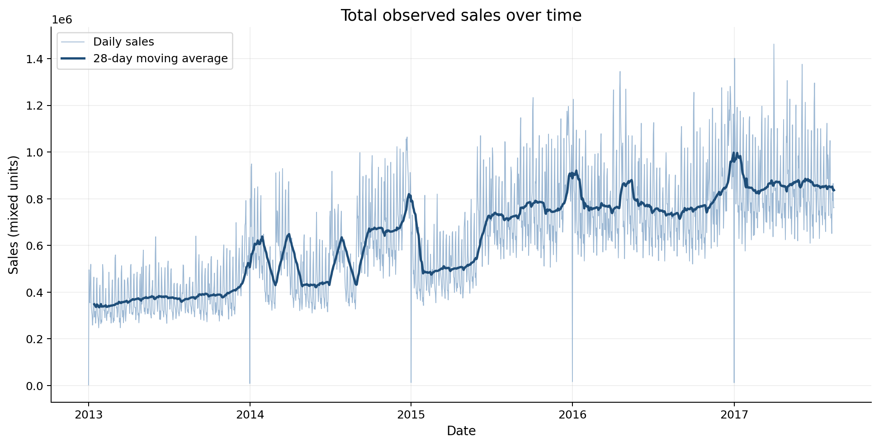
Figure 1 Total observed sales and 28-day moving average
The moving average shows growth alongside recurring weekly movement, sharp peaks, and several near-zero network dates. The increase is an observed network trend, not necessarily same-store growth: openings, assortment expansion, promotions, and other changes may contribute.
Operations meaning: capacity and supplier requirements appear to have increased over the historical period, but planning should separate organic demand changes from store-network changes before setting long-term commitments.

5 2 Calendar patterns
Sunday has the highest average daily network sales at 825.2k, followed by Saturday at 772.2k. Thursday is lowest at approximately 505.3k. December is the highest month at 808.6k average daily sales, well above the remaining monthly averages.
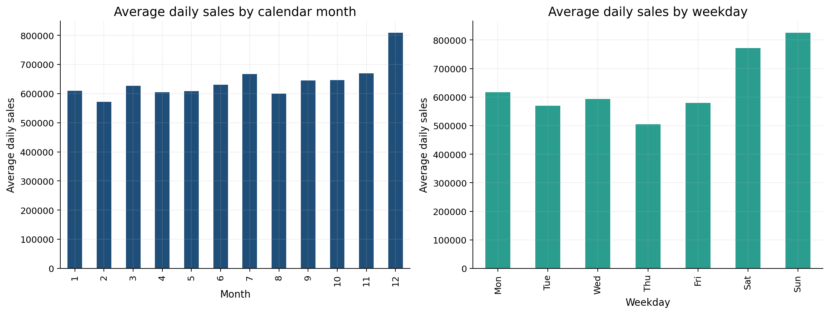
Figure 2 Average daily sales by month and weekday
Operations meaning: weekend and year-end planning should review staffing, checkout capacity, delivery timing, shelf replenishment, and supplier coordination. These network patterns should be refined by store and family before implementation.

5 3 Store differences
Store 44 has the highest total observed sales at approximately 62.1 million mixed units, followed by Stores 45, 47, 3, and 49. Average daily sales also differ substantially across anonymized store types.
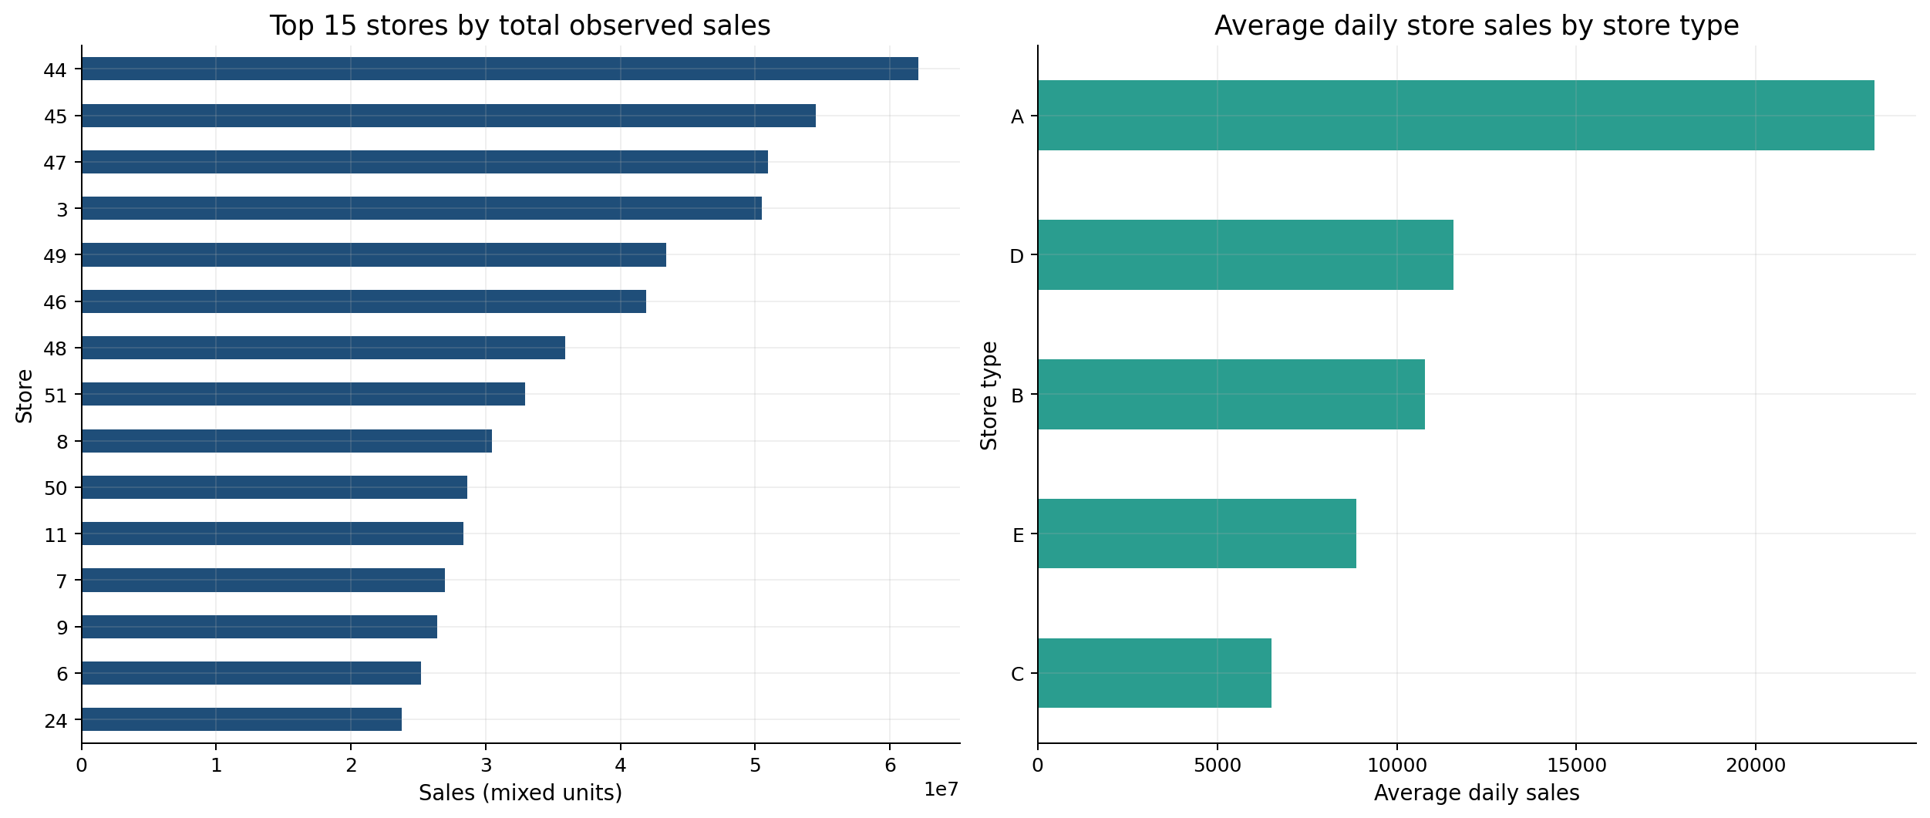
Figure 3 Store sales rankings and store-type comparison
Raw store rankings must be interpreted with lifecycle coverage. Stores 20, 21, 22, 29, 42, 52, and 53 do not meet the 90% mature-store coverage rule and are reported separately for variability analysis.
Operations meaning: store scale, format, local market, and opening history should influence labor and replenishment policies. A small or newer store should not automatically be classified as underperforming.

5 4 Product family concentration and variability
Family | Sales share | Daily-demand CV | Interpretation
Grocery I | 31.99% | 0.303 | Very high volume, relatively stable
Beverages | 20.21% | 0.490 | High volume, moderate variability
Produce | 11.43% | 0.849 | High volume, volatile
Cleaning | 9.08% | 0.263 | High volume, relatively stable
Dairy | 6.01% | 0.358 | Important and comparatively stable

The leading four families contribute approximately 72.7% of family-level observed sales. Produce combines commercial importance with much greater variability than Grocery I or Cleaning.
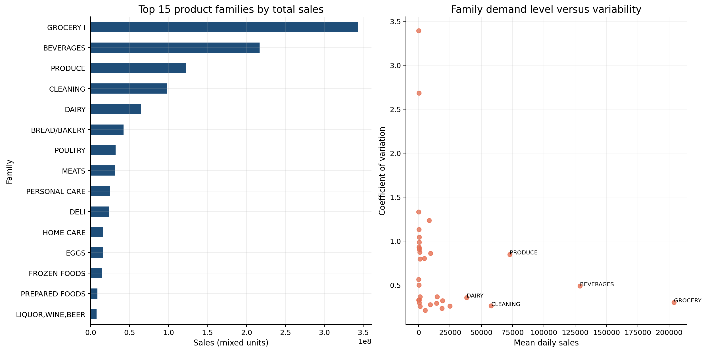
Figure 4 Family importance and variability
Operations meaning: high-volume stable families can anchor routine supplier and capacity cycles. High-volume volatile categories require closer monitoring, shorter review intervals, and scenario-based planning.

5 5 Store family concentration
The selected-store heatmap shows that category importance differs substantially by location. Stores 44 and 45 have much larger selected-family sales than Stores 17, 25, and 32, while Grocery I dominates most selected stores.
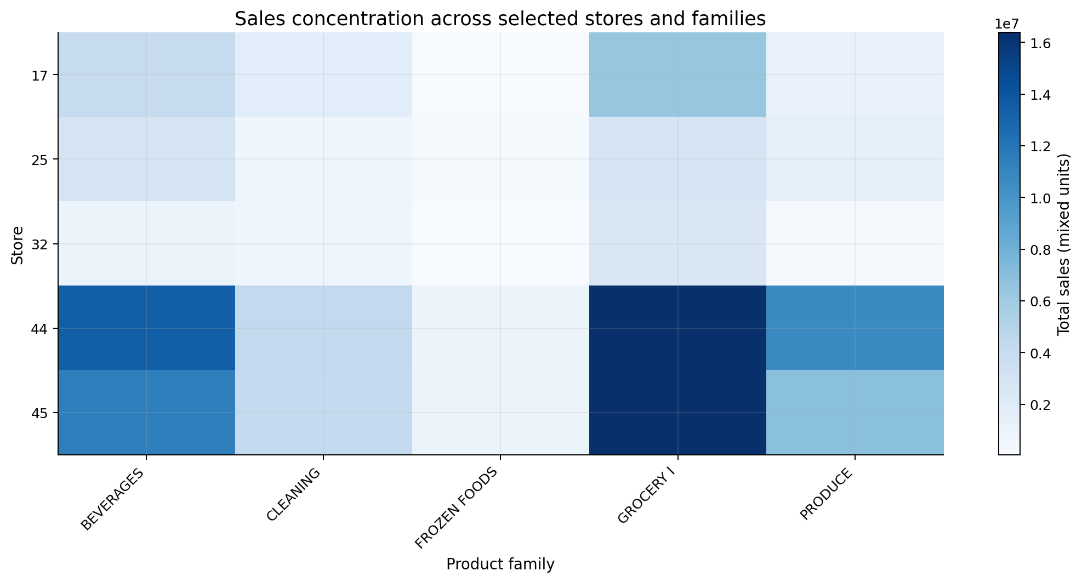
Figure 5 Selected store-family sales concentration
Operations meaning: network-level category policies should allow store-level exceptions. The same product family can create different workload and replenishment requirements across locations.

5 6 Promotions
Promoted rows generally show higher mean observed sales, but the ratios are heterogeneous. Among high-volume families, the promoted/non-promoted mean-sales ratio is approximately:
- Produce: 3.08
- Home Care: 3.04
- Beverages: 2.49
- Dairy: 1.95
- Grocery I: 1.62
- Cleaning: 1.43
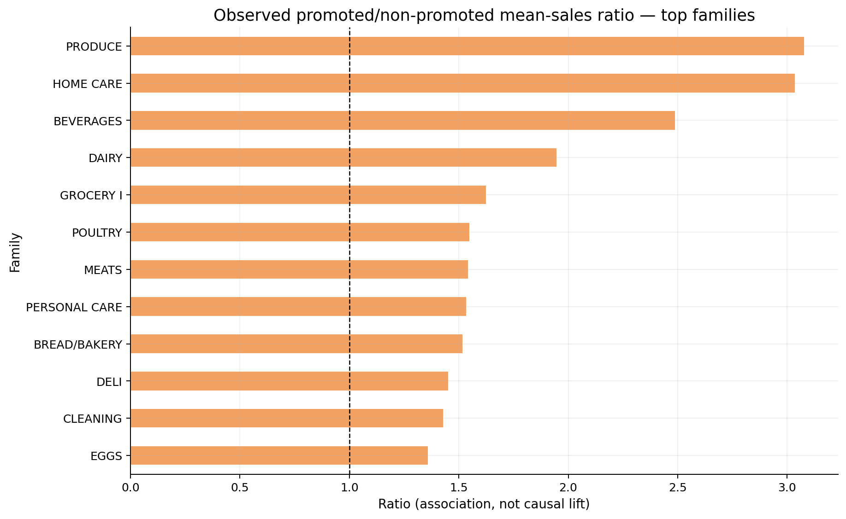
Figure 6 Promotion association among important families
These ratios are associations, not causal promotion lift. Promotions may be targeted to periods, products, or stores already expected to sell differently. Low-volume families can also produce unstable ratios when the non-promoted denominator is small.
Operations meaning: promotion calendars should be coordinated with replenishment, staffing, receiving, and shelf capacity. Incremental lift should be estimated through a stronger causal design before financial claims are made.

5 7 Holidays and events
Holiday store-days average approximately 13.8k mixed units, compared with 11.6k on non-holiday store-days—a descriptive difference of 19.1%.
This comparison does not isolate holiday impact from month, weekday, promotion, location, or event selection. National, regional, and local holidays were matched to the correct stores to avoid attributing local events to the whole network.
Operations meaning: holidays should be treated as potential peak and disruption windows. Planning should use event scope and local history rather than one universal holiday multiplier.

5 8 Transactions and store traffic
The store-day Pearson correlation between transactions and observed sales is 0.837 for available records.
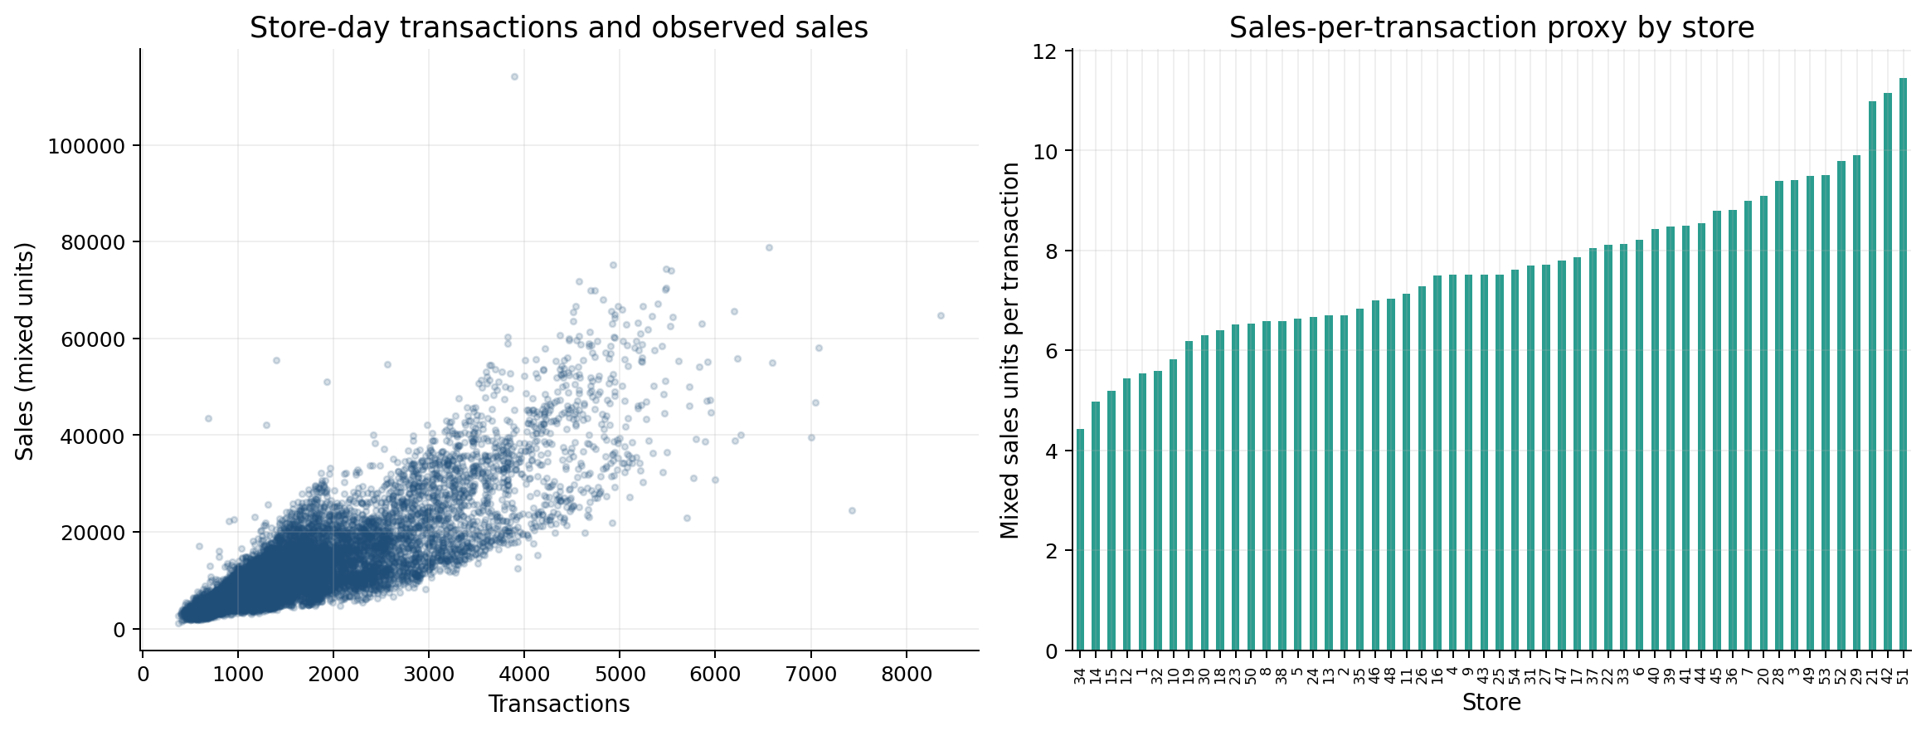
Figure 7 Transactions, observed sales, and sales-per-transaction proxy
The relationship supports the use of transactions as a store-traffic proxy, but the sales measure combines different product units. Sales divided by transactions is therefore only a mixed-unit basket proxy, not revenue per transaction.
Operations meaning: traffic information is useful for staffing and checkout-capacity planning, but it should not replace product-family demand forecasts.

5 9 Oil prices
Monthly sales and oil prices have a contemporaneous correlation of approximately -0.788 in this historical period.
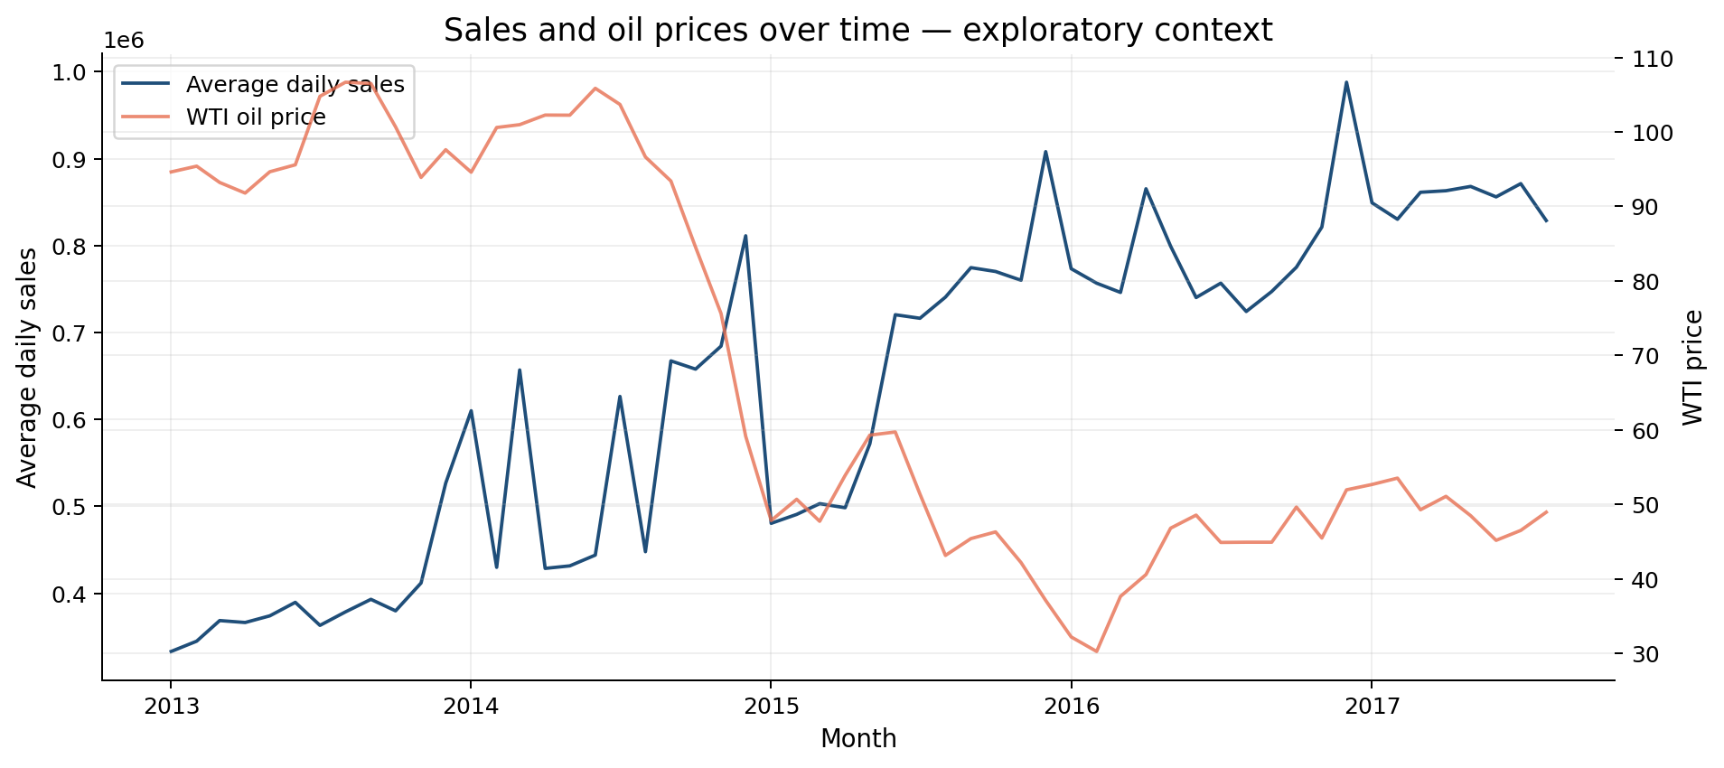
Figure 8 Sales and oil prices over time
The chart shows opposite broad trends, but this is not decision-ready evidence of an oil-demand relationship. Time trends, inflation, store openings, product changes, and other omitted factors can create a high correlation between unrelated series.
Operations meaning: oil price should remain exploratory context unless additional analysis establishes a stable, time-aware relationship.

5 10 Store family demand intermittency
The Syntetos–Boylan ADI/CV² framework was applied separately to all 1,782 store–family time series, avoiding the methodological error of pooling multiple stores into one sequence.
Demand category | Store–family series | Interpretation
Smooth | 630 | Frequent positive demand with lower positive-demand variation
Intermittent | 593 | Less frequent demand with comparatively stable positive quantities
Lumpy | 324 | Less frequent demand with variable positive quantities
Erratic | 235 | Frequent positive demand with high positive-demand variation

Fifty-three store–family series contain no positive sales in the historical window. They are retained and flagged rather than forced into an ordinary forecast model.
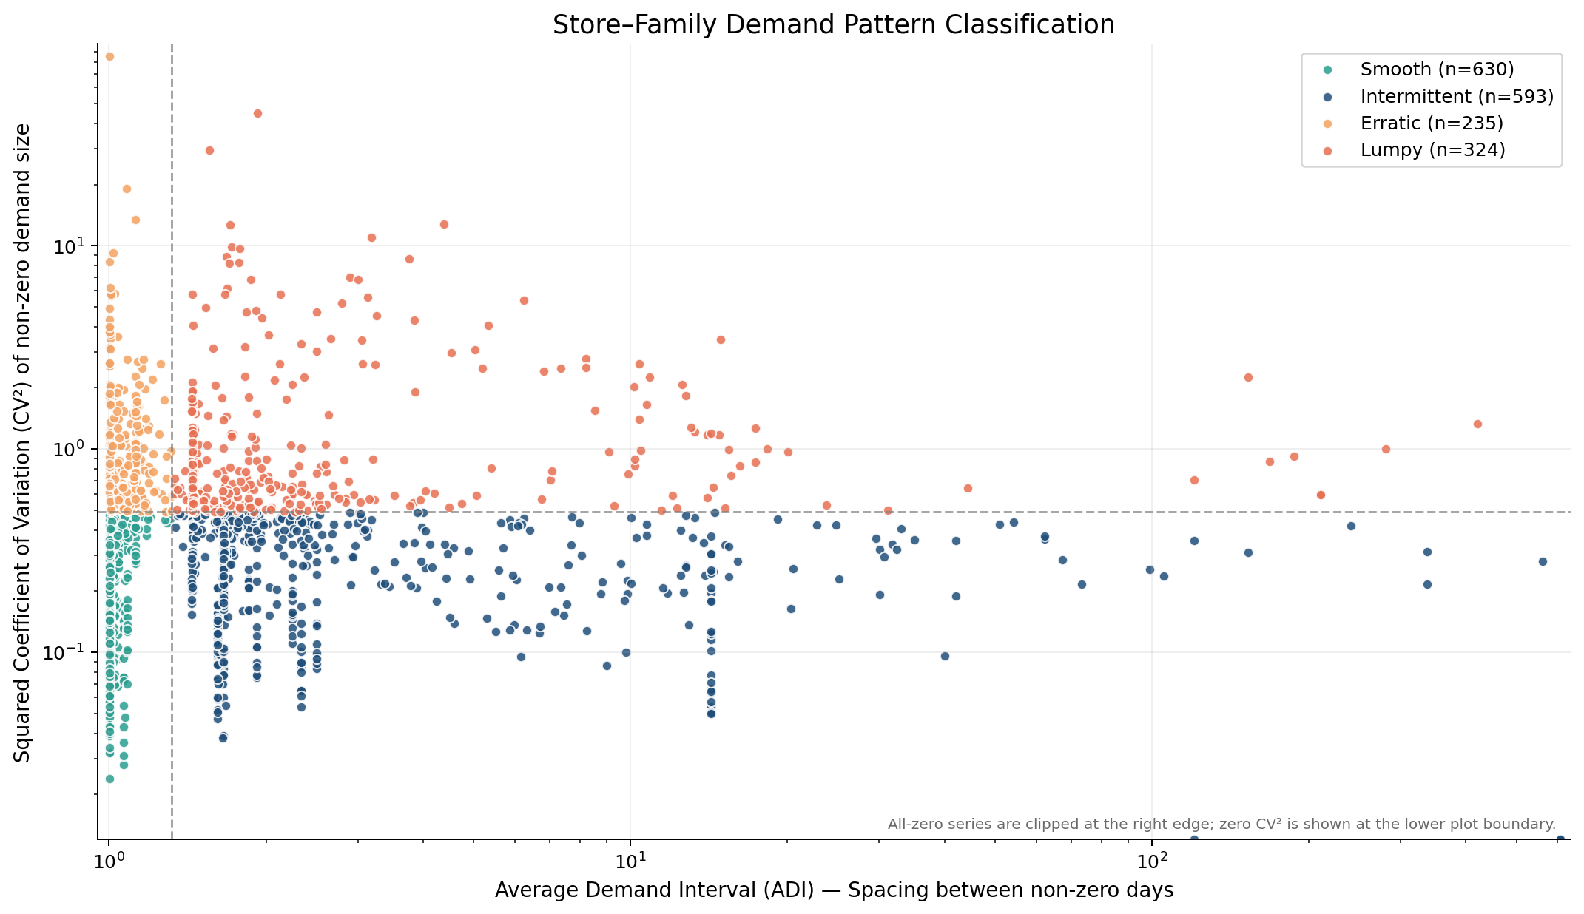
Figure 9 Store-family demand classification
Operations meaning: forecast evaluation and review cadence should differ across series. The classification does not determine safety stock or ordering policy because lead time, stock, service, and cost data are unavailable.

5 11 Semi month boundary pattern
The competition context identifies the 15th and month-end as potentially relevant pay-cycle dates. Using those dates plus the following day as a descriptive window, average network sales are 4.52% higher than on other dates. Among larger or operationally important families, observed differences include Personal Care 9.66%, Cleaning 6.40%, Grocery I 5.81%, and Beverages 3.41%.
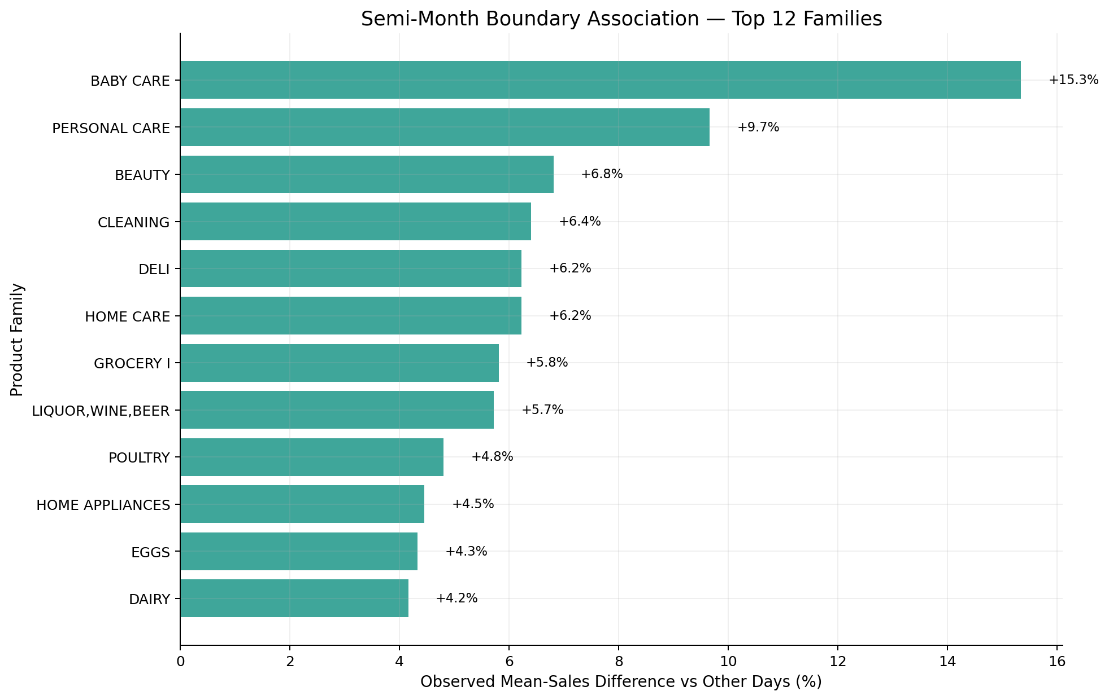
Figure 10 Semi-month boundary sales association
This comparison does not control for weekday, holidays, trend, promotions, or month mix. It is therefore a planning signal to test, not a causal payday estimate.

5 12 April 2016 structural shock window
Equal 30-day windows before and from 16 April 2016 were compared using average daily sales. Manabí is 64.91% higher in the post window and Guayas 24.92% higher, while Santa Elena is 38.77% lower. The regional divergence suggests that exceptional events can create very different local operating conditions.
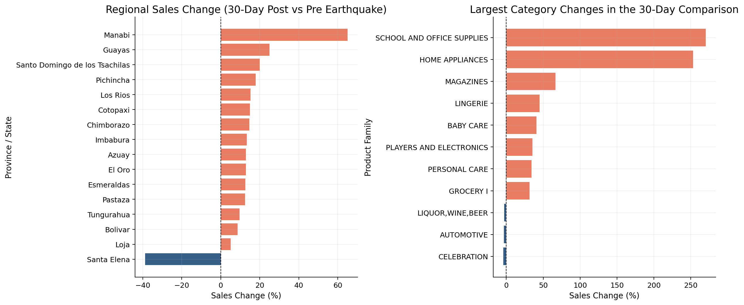
Figure 11 April 2016 pre/post comparison
The pre/post design does not isolate causality. Seasonality, trend, promotions, closures, relief activity, and other concurrent changes may contribute.

5 13 Cross family co movement
Correlations were calculated on daily log-sales changes, not raw sales levels, and each date's cross-family mean change was removed. This reduces spurious correlation from shared growth and common network movement so the matrix emphasizes relative category changes.
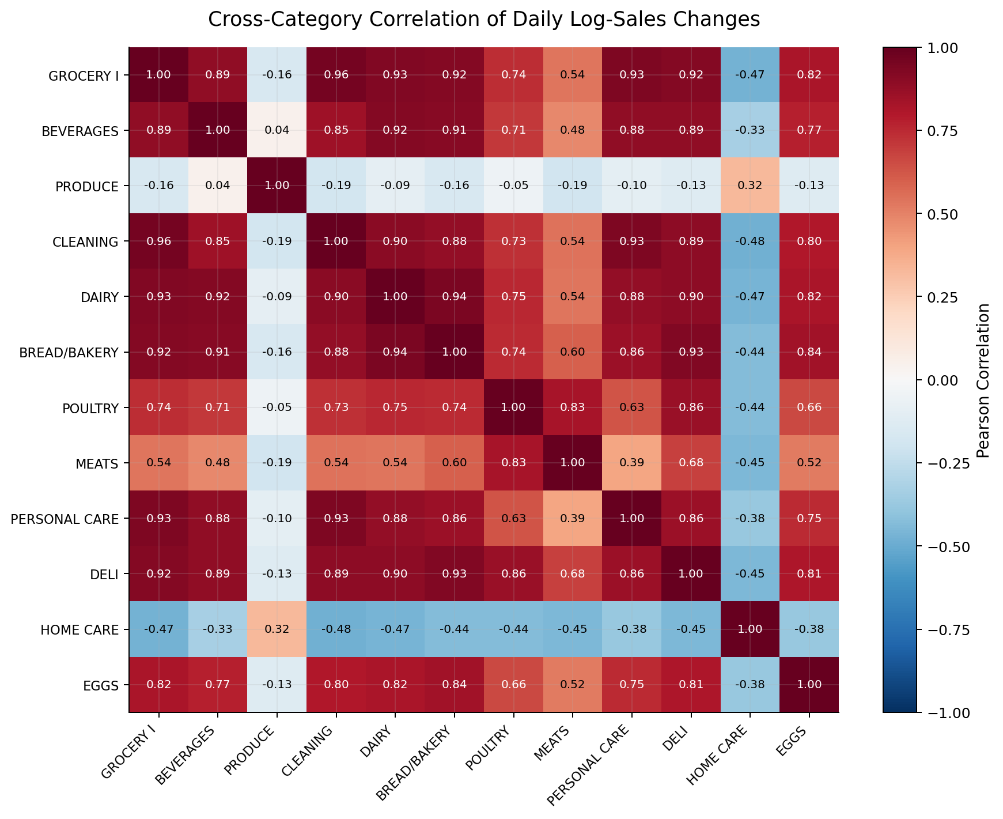
Figure 12 Cross-family correlation of daily log-sales changes
Operations meaning: related planning workloads may peak together, but correlation does not establish product complementarity, substitution, or cross-selling effects.

6 Operations Analysis

6 1 Demand and variability segmentation
Families were divided using median daily demand and median CV. The result is:
Segment | Families | Suggested planning posture
High demand / Stable | 13 | Standard routines with exception monitoring
High demand / Volatile | 4 | Shorter review cycles and flexible capacity
Low demand / Stable | 3 | Lower-frequency review where service risk permits
Low demand / Volatile | 13 | Selective monitoring; avoid overreacting to percentage changes

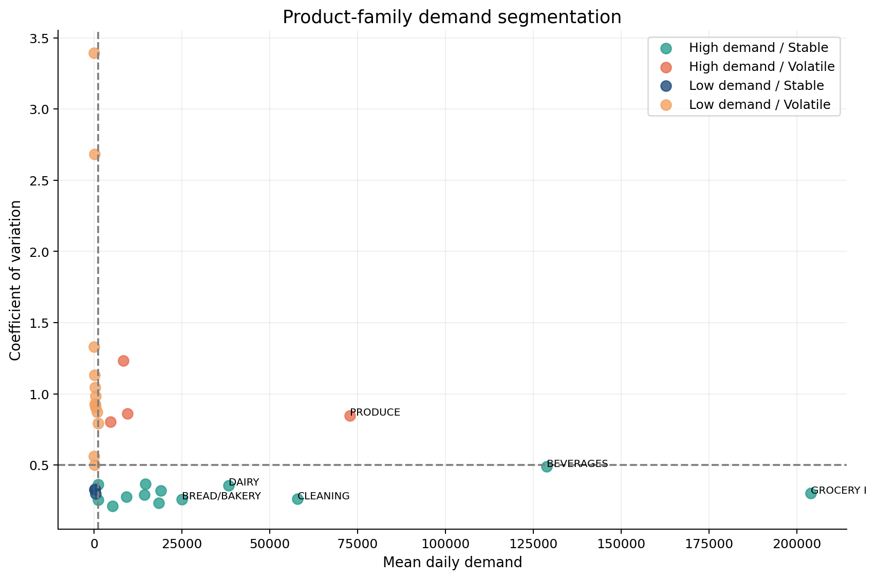
Figure 13 Product-family demand segmentation
This segmentation is a transparent portfolio framework, not a universal industry classification.

6 2 Store operating profiles
Among stores with at least 90% transaction and active-sales coverage, Store 25 has the highest daily-demand CV at 0.702. Stores with incomplete lifecycle coverage are excluded from this comparison rather than labeled volatile because of pre-opening zeros.
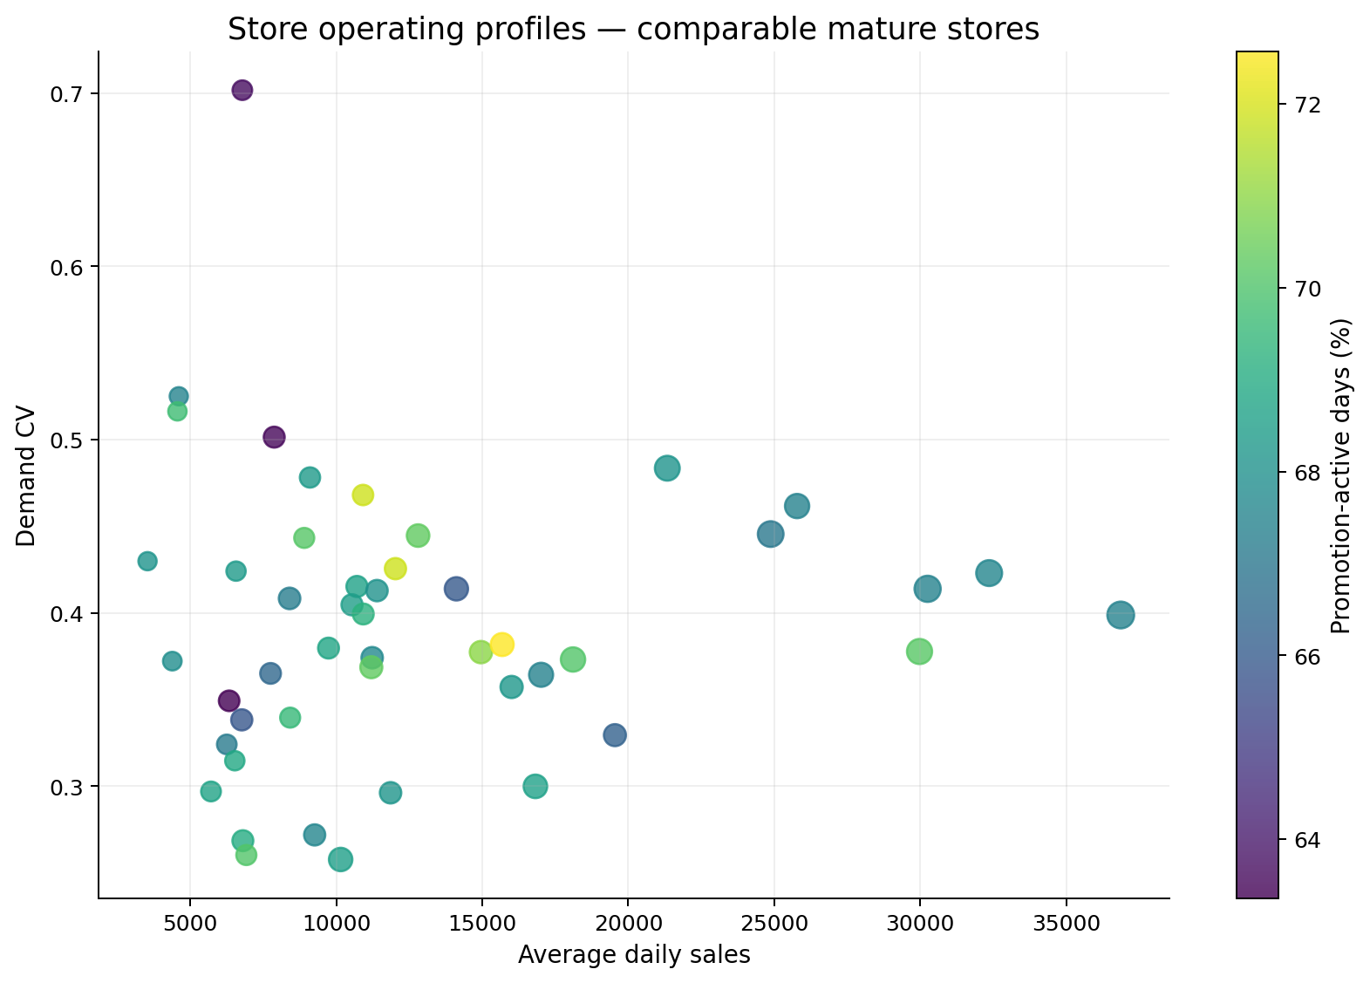
Figure 14 Comparable mature-store operating profiles
Operations meaning: comparable mature stores still show meaningful differences in scale and variability. Store-specific staffing, receiving flexibility, and review tolerances are more defensible than one network rule.

6 3 Peak demand planning
Weekend and December peaks can affect several linked processes:
- labor scheduling and checkout coverage;
- receiving and backroom capacity;
- shelf replenishment frequency;
- supplier delivery windows;
- promotion execution and availability monitoring.
The data supports planning reviews ahead of these periods, but not exact capacity targets without service-time, labor-productivity, stock, or delivery-capacity data.

7 Forecasting as Operational Support

7 1 Forecast design
The target is daily sales for three representative store-family series. The final 60 observations form a chronological validation period. Models include:
- one-day naive;
- weekly seasonal naive;
- Holt-Winters exponential smoothing;
- Random Forest using lagged sales, rolling means, calendar fields, promotions, and holiday indicators.
Lag and rolling features are shifted before use. Realized future transactions are excluded because they would not be known at forecast time.

7 2 Why there is no confusion matrix
A confusion matrix evaluates classification, where each observation belongs to a category such as yes/no, high/low, or fraud/not fraud. This project forecasts a continuous numerical value: daily sales. Creating a confusion matrix would require arbitrarily converting sales into classes and would discard information about the size of forecast errors.
The appropriate evaluation measures are:
- MAE: average absolute error in sales units; easy to interpret operationally.
- RMSE: penalizes large misses more strongly; useful when peak errors are costly.
- RMSLE: evaluates proportional error and reduces domination by high-volume series.
- Series-level comparison: checks whether the same model works consistently across different store-family patterns.
- Validation plot: shows whether models miss peaks, timing, or level changes.

7 3 Model results
Model | Average MAE | Average RMSE | Average RMSLE
Random Forest, rolling one-day | 414.41 | 592.87 | 0.258
Holt-Winters | 647.09 | 789.75 | 0.286
Seasonal naive, lag 7 | 718.64 | 945.90 | 0.315
Naive, lag 1 | 910.54 | 1,104.41 | 0.334

The Random Forest's average MAE is 42.3% lower than the weekly seasonal-naive baseline in this validation design. However, averaging MAE across differently scaled series gives more influence to high-volume series, so RMSLE and series-level winners are also reported.
Store-family series | Best model | MAE
Store 45 — Grocery I | Random Forest | 982.09
Store 32 — Grocery I | Random Forest | 252.30
Store 32 — Frozen Foods | Holt-Winters | 7.51

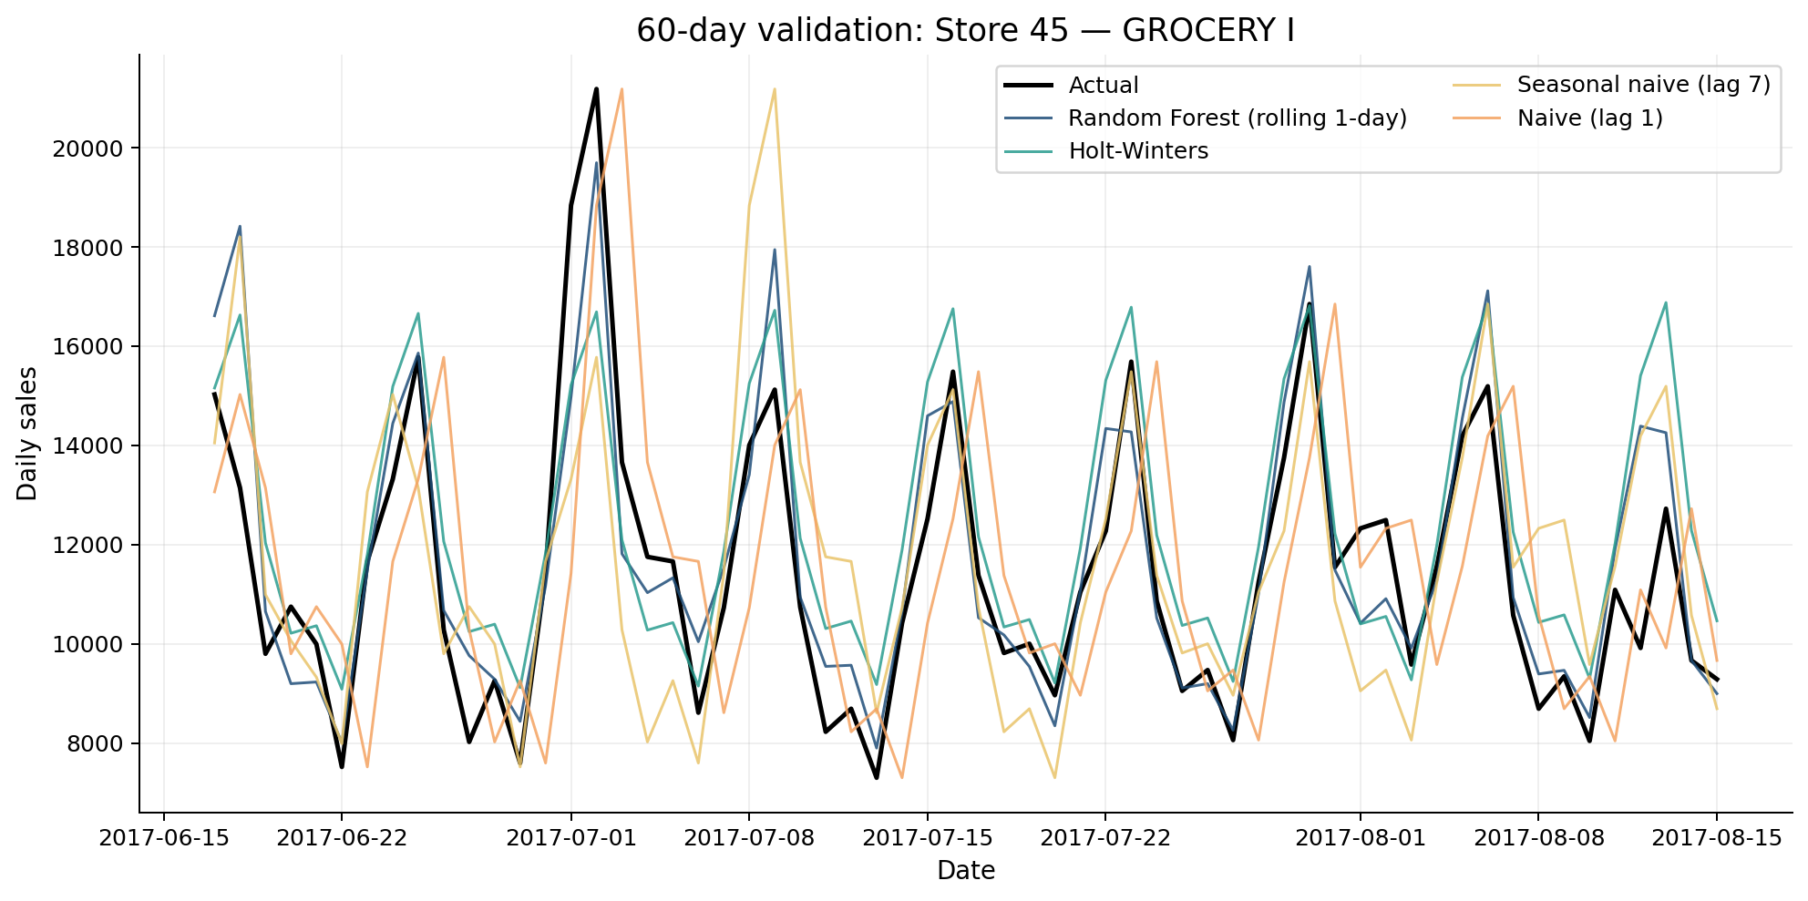
Figure 15 Forecast validation comparison
The Random Forest uses rolling one-day realized history, while Holt-Winters produces a fixed 60-day path from the training cutoff. The results therefore compare useful operational procedures, but not perfectly identical information-update schedules.
Conclusion: forecasting adds evidence beyond simple baselines, but the winning method varies by series. A pilot should retain the weekly seasonal-naive forecast as a transparent benchmark and monitor errors by store-family.

8 Managerial Recommendations
Evidence-based finding | Operational implication | Possible action
Grocery I and Cleaning are high-volume and relatively stable | Large predictable flows can support repeatable routines | Use regular review and supplier cycles, with exception monitoring
Produce and other high-demand/volatile families combine importance with uncertainty | Long fixed planning cycles may respond slowly to demand changes | Use shorter review cycles, scenario ranges, and closer supplier coordination
Sunday, Saturday, and December have the highest average demand | Recurring peaks can strain labor, checkout, receiving, and shelves | Review rosters, delivery windows, and replenishment frequency ahead of peaks
Mature-store variability differs across the network | One store rule may over- or under-prepare locations | Use store-specific planning tolerances and treat opening/ramp-up stores separately
Promotion associations differ by family | Promotion pressure is category-specific | Coordinate promotions with replenishment and staffing; test causal lift separately
Forecast winners vary by series | One universal forecasting model may be fragile | Run model-versus-seasonal-baseline monitoring by store-family

9 Inventory Implications
The findings suggest where inventory processes may need differentiation:
- stable high-volume families may support regular replenishment rhythms;
- volatile important families may require more frequent review and flexible supplier arrangements;
- weekend, holiday, and December periods may require advance availability checks;
- promotion planning should include supply and shelf-capacity coordination;
- forecast uncertainty should be retained rather than converted into a single unquestioned order quantity.
These are planning implications, not an inventory optimization result. Safety stock, reorder points, order quantities, and service-level trade-offs require stock-on-hand, stockout history, lead times, supplier constraints, costs, margins, and target service levels.

10 Limitations
1. Sales are observed outcomes and may be constrained by stockouts or closures.
2. Product-family sales combine different physical units and are not revenue or margin.
3. Promotion, holiday, transaction, and oil analyses are observational.
4. Store openings and coverage differences affect network comparisons; mature-store rules were used where appropriate.
5. The detailed subset is representative by transparent rules but is not a statistical sample.
6. Forecast evaluation covers three series and one 60-day historical holdout.
7. The Random Forest and Holt-Winters results reflect different forecast-update procedures.
8. Results describe one retailer and historical period and may not generalize without revalidation.
9. Demand intermittency categories are historical screening labels, not inventory-policy prescriptions.
10. Semi-month and earthquake comparisons are uncontrolled observational windows.
11. Cross-family correlations may reflect common network shocks rather than direct category relationships.

11 Conclusion
Historical sales and operational context provide useful support for grocery retail planning when the analysis distinguishes demand scale, variability, calendar peaks, store lifecycle, promotion association, and forecast uncertainty.
The strongest evidence supports differentiated operations:
- prioritize high-volume families without assuming they are equally predictable;
- prepare for recurring weekend and year-end peaks;
- compare mature stores separately from opening or incomplete-history stores;
- coordinate promotions with operating capacity while avoiding causal claims from descriptive ratios;
- treat semi-month dates and exceptional events as scenario-planning signals that require local validation;
- use forecasts alongside transparent baselines and monitor performance by series.
The project demonstrates how data science can support Operations Management without reducing the work to a model leaderboard. The analytical value lies in connecting trustworthy evidence to planning choices and clearly stating where additional operational data is required.

Appendix Reproducibility and Evidence
- Executed notebooks: notebooks/01_data_understanding.ipynb through notebooks/06_managerial_insights.ipynb
- Running findings: reports/findings.md
- Evidence tables: reports/tables/
- Presentation-ready figures: reports/figures/
- Reusable code: src/
- Raw data setup instructions: data/README.md
- Detailed step-by-step project summary: PROJECT_SUMMARY.md
All figures and numerical statements in this report are derived from the locally verified Kaggle competition files. Raw competition files are excluded from Git.

12 Implementation and Monitoring Plan
The findings support a controlled planning pilot rather than immediate network-wide automation. The pilot should preserve current decision ownership while measuring whether differentiated reviews and forecast monitoring improve planning reliability.
Stage | Operational work | Evidence to retain
1 Establish baselines | Define current review cadence for selected stores and families. Record weekly seasonal-naive forecast errors. | MAE, RMSE, RMSLE, coverage, zero-sales frequency, and exceptions
2 Pilot differentiated reviews | Use shorter review cycles for high-demand volatile families and routine cycles for stable high-volume families. | Planner overrides, peak-period exceptions, and supplier or capacity constraints
3 Add model monitoring | Compare Random Forest and Holt-Winters with the seasonal baseline by store-family series. | Error by horizon and series, model winner, stability, and failure cases
4 Review operating outcomes | Assess whether peak preparation and promotion coordination reduce avoidable surprises. | Service, waste, availability, labor, and receiving measures when available

Monitoring Principles
- Retain the seasonal-naive forecast as a transparent benchmark.
- Evaluate errors by store-family series rather than relying only on network averages.
- Record model update frequency because rolling and fixed-path forecasts use different information.
- Separate forecast error from execution problems such as stockouts, closures, and supplier constraints.
- Revalidate calendar and promotion patterns periodically because historical associations can change.

13 Additional Data Requirements
The current dataset supports descriptive planning and forecast comparison. The following data would be required before calculating inventory policies, estimating financial effects, or attributing causal impact.
Data required | Decision enabled | Reason
Stock on hand and stockouts | Estimate unconstrained demand and availability | Observed zero sales can represent either no demand or unavailable stock
Orders and receipts | Evaluate replenishment execution | Sales alone does not show planned quantities or delivery performance
Supplier lead times and variability | Design reorder points and safety stock | Buffer requirements depend on replenishment uncertainty
Costs, prices, and margins | Estimate financial trade-offs | Mixed sales units cannot measure profit, holding cost, or waste
Service-level targets | Set policy objectives | Inventory choices require an explicit availability or fill-rate goal
Labor and capacity measures | Translate peaks into staffing and receiving plans | Sales volume does not directly measure workload or bottlenecks
Promotion assignment and controls | Estimate causal lift | Descriptive promoted versus non-promoted ratios are confounded

Appendix A Detailed Analytical Workflow

Data understanding
Verified all seven source files, documented grains and keys, checked dates, shapes, missing values, duplicates, invalid values, and orphan store keys.

Cleaning and integration
Added calendar fields, prepared daily oil data with imputation flags, retained missing transactions, matched holiday scope, and validated every merge.

Exploratory analysis
Measured network trends, calendar patterns, store and family differences, promotion and holiday associations, traffic relationships, and oil co-movement.

Advanced analysis
Classified 1,782 store-family series by ADI and CV squared, tested semi-month windows, compared the April 2016 shock period, and examined cross-family log-change correlations.

Operations analysis
Segmented families by demand level and variability, profiled mature stores, and identified recurring peak periods and promotion-planning needs.

Forecasting
Evaluated naive, seasonal-naive, Holt-Winters, and rolling Random Forest procedures on a chronological 60-day holdout for three representative series.

Managerial synthesis
Linked each validated finding to an operational implication, a possible action, and a stated limitation.

Appendix B Metric Definitions
Metric | Definition | Interpretation
Coefficient of variation | Standard deviation divided by mean demand | Relative variability across differently scaled series
ADI | Average interval between positive-demand observations | Frequency of nonzero demand for intermittency screening
CV squared | Squared coefficient of variation for positive demand | Variation in nonzero demand quantities
MAE | Mean absolute error | Average forecast miss in sales units
RMSE | Square root of mean squared error | Gives more weight to large misses
RMSLE | Root mean squared logarithmic error | Emphasizes proportional error
Pearson correlation | Linear association from minus one to plus one | Descriptive association, not causation

Appendix C Detailed Forecast Results
The table reports every evaluated model and store-family series from the 60-day validation window. Results should be interpreted with the update-schedule caveat described in Section 7.
Store | Family | model | MAE | RMSE | RMSLE
45 | GROCERY I | Naive (lag 1) | 2,406.58 | 2,886.34 | 0.239
45 | GROCERY I | Seasonal naive (lag 7) | 1,761.32 | 2,332.82 | 0.187
45 | GROCERY I | Holt-Winters | 1,507.48 | 1,847.24 | 0.150
45 | GROCERY I | Random Forest (rolling 1-day) | 982.09 | 1,433.04 | 0.110
32 | FROZEN FOODS | Naive (lag 1) | 9.17 | 13.08 | 0.520
32 | FROZEN FOODS | Seasonal naive (lag 7) | 8.72 | 12.27 | 0.458
32 | FROZEN FOODS | Holt-Winters | 7.51 | 9.66 | 0.389
32 | FROZEN FOODS | Random Forest (rolling 1-day) | 8.83 | 19.71 | 0.475
32 | GROCERY I | Naive (lag 1) | 315.87 | 413.82 | 0.244
32 | GROCERY I | Seasonal naive (lag 7) | 385.88 | 492.61 | 0.301
32 | GROCERY I | Holt-Winters | 426.26 | 512.35 | 0.318
32 | GROCERY I | Random Forest (rolling 1-day) | 252.30 | 325.87 | 0.189

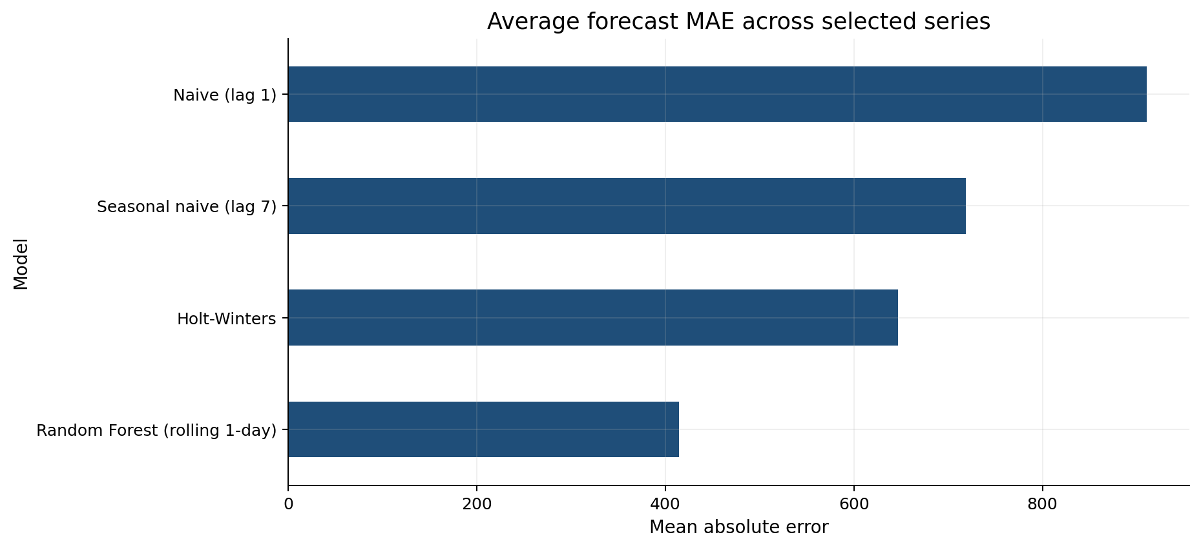
Figure 16 Average validation MAE by forecasting procedure

Appendix D Reproducibility
The repository separates raw data, reusable code, executed notebooks, evidence tables, figures, forecast outputs, and written reporting. Raw Kaggle files remain unchanged and are excluded from Git.
Component | Location | Purpose
Raw data | data/raw | Seven Kaggle competition files
Executed analysis | notebooks/01 through 06 | Auditable end-to-end workflow
Reusable functions | src | Loading, preparation, EDA, features, visualization, and forecasting
Evidence tables | reports/tables | Values supporting report claims
Figures | reports/figures | Presentation and report visuals
Generated outputs | outputs | Validated subset and forecast records
Detailed walkthrough | PROJECT_SUMMARY.md | Step-by-step record of methods and controls

Execution Controls
- All six notebooks were executed from top to bottom with no recorded cell errors.
- The sales panel retained 3,000,888 rows and a unique date-store-family key after integration.
- Chronological validation and shifted lag features protected the forecast comparison from leakage.
- Numerical report claims are linked to executed notebooks and exported evidence tables.

Appendix E Viva Questions and Answers

Why retain zero sales
Zeros may reflect genuine low demand, closures, store lifecycle, or suppressed sales. Deleting them without operational evidence could bias the demand distribution.

Why not use a confusion matrix
Daily sales is a continuous target. MAE, RMSE, RMSLE, and actual-versus-forecast plots preserve the magnitude and timing of errors.

Why are promotion ratios not promotion lift
Promotions were not randomly assigned. Timing, product selection, store selection, seasonality, and expected demand can influence both promotion decisions and sales.

Why treat oil cautiously
Sales and oil both trend through time and may respond to omitted variables. A contemporaneous correlation does not prove that oil prices drive grocery demand.

Why use a subset
The subset makes detailed store-family analysis and forecasting interpretable. Transparent eligibility and selection rules reduce arbitrary choices while the full panel remains available for network findings.

Can the project calculate safety stock
No. Safety stock requires inventory positions, stockouts, replenishment lead times, demand during lead time, service targets, costs, and supplier constraints.

Why compare multiple forecast models
Demand behavior differs by series. A model that performs well for a high-volume stable family may not perform well for a low-volume or intermittent series.

