

**My Recent Work**

**About Client**

**Name-** Sarwar Ali

**Work –** Bussman

**Phone -** +91 8270130666

**Objective**

**T**ransform the Existing Room into a **M**odern and **C**lassic room… For Newly Marriage Couple.

**Challenge**

The wall and roof slab are **W**eak. As the structure is built in early 90s.

**About Client**

**Name-** Ronit Singh

**Work –** CA

**Phone -** +91 8249499081

**Objective**

**T**ransform the Newly Built Duplex into a **M**odern and **C**omparative Habitants, for the occupants… with Budget Friendly.

**Challenge**

**C**lient requirement was **M**odern and **C**omparative **D**uplex Interior Design with Budget Friendly.

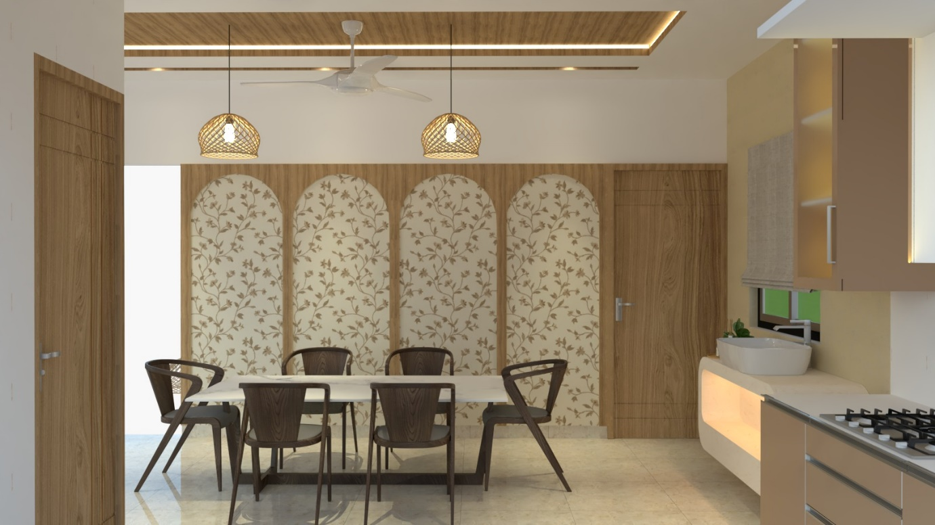

Dining Area

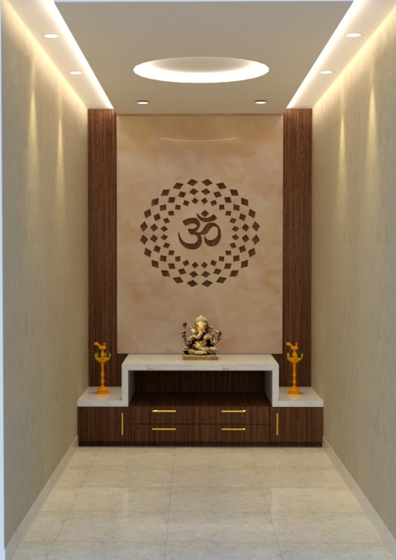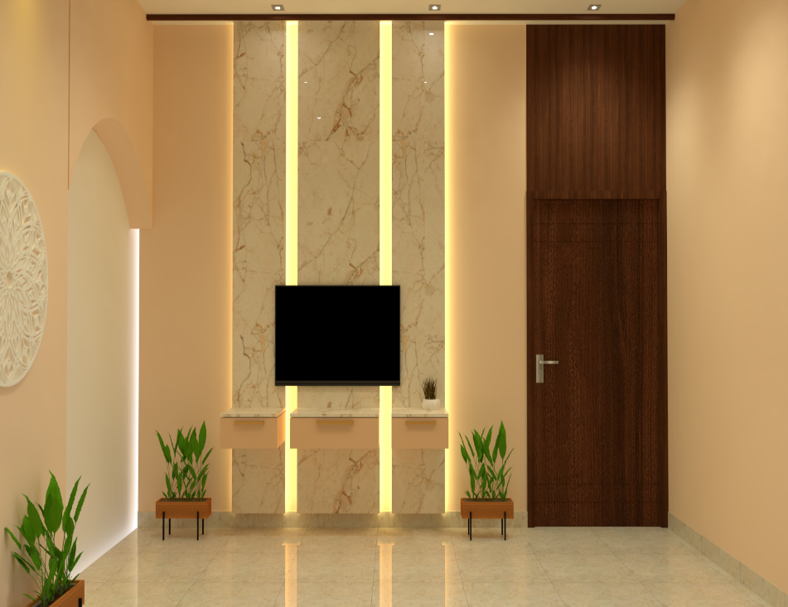

Pooja Room Living Area (TV Unit)

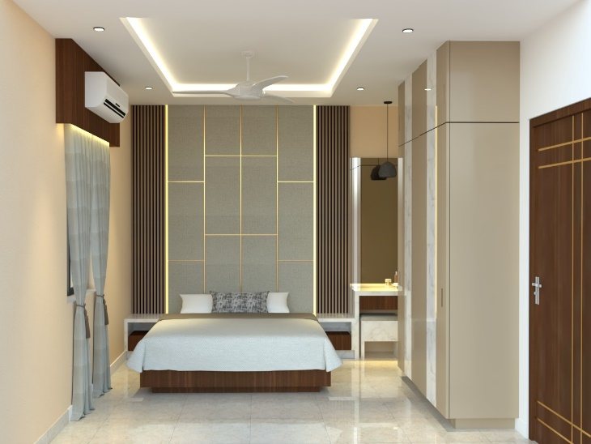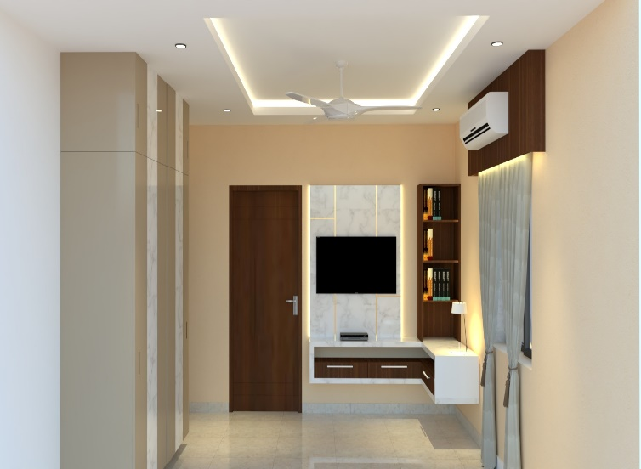

Master Bed Room