Saurabh Bhagat

**EDUCATION**

[](https://github.com/saurabh-prosoft)[](https://www.linkedin.com/in/saurabh-bhagat)

[**GitHub**](https://github.com/saurabh-prosoft)

[**LinkedIn**](https://www.linkedin.com/in/saurabh-bhagat)

**EXPERIENCE**

**Bachelor of Engineering, Computer Science**

2019, University of Mumbai

Cumulative Grade: 8.7 / 10

**Front-end Engineer / Agile Developer** [**@ TCS**](https://www.tcs.com/)

July 2019 – Present

**PROJECTS (PROFESSIONAL)**

**DoD**

*Angular, Vue, Spring Boot, IBM DB2*

A set of applications that are part of compliance and risk analysis systems in banking

**AutoDoc**

*Java, JavaFX, WebCanvas API*

A proof-of-concept project including tools to automatically generate TDD’s (Technical Design Documents) given a documented COBOL program as input and to generate basic stub programs

**PROJECTS (INDIVIDUAL)**

**EqPlot**

*Android, Java*

An app for evaluating mathematical equations and visualizing its 2D/3D representation.

**NodeIP**

*NodeJS, JavaScript, WebCanvasAPI*

An online tool for Image processing through an easy-to-use node editor.

**OpenChat**

*Vue, Firebase, NodeJS, Indexed DB, Socket.io*

Online group-based chat application with image, video, and file sharing.

**Menu Visualizer**

*Android ARCore, Unity, C#*

An Augmented Reality app to show various restaurant menu items, their price, nutritional information, etc. virtually served on the table.

**Painting Livifier**

*Android ARCore, Unity, C#*

An Augmented Reality app to showcase how real paintings in art galleries, exhibitions can be made virtually alive.

**TankMe**

*JavaScript, NodeJS, PeerJS, Firebase, Socket.io*

Web multi-player PvP survival game with matchmaking logic and survival stats

**Online Sound Mixer**

*JavaScript, WebAudio API, CSS3*

Online web app for audio mixing, filtering, and recording of small audio samples.

**Percept**

*TypeScript, WebCanvas API, NPM*

An HTML5 canvas rendering framework that provides a scene graph, lifecycle hooks, image rendering, etc. via easy-to-use API

**Visual Audio Processor**

*JavaScript, WebAudio API, WebCanvasAPI*

An online web app that provides an easy-to-use node editor for audio processing, synthesis, and visualization in three different domains.

**HiDE (Academic)**

*TypeScript, Angular, NodeJS, Socket.io, PeerJS, WebAudio API, WebRTC, Linux, SSH etc.*

A Cloud-based platform for project creation and development in teams with real-time collaboration tools.

**SKILLS**

**Languages**



**JavaScript TypeScript**

**Technologies**

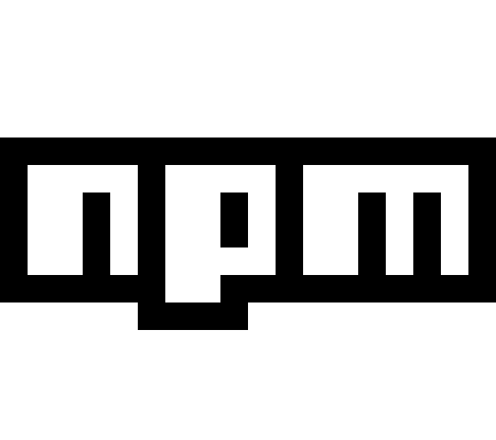******

** **Vue NodeJS NPM**

 **React ReST**

**Angular Web APIs**

**ACHIEVEMENTS**

**Rajasthan Hackathon Rajasthan Hackathon**

Jaipur Bikaner

Merit Participated

**TCS Codevita 5**

Participated

2016

2018

**Rajasthan Hackathon, Udaipur**

Participated

**Texas Instruments IICDC**

Participated

**TCS Codevita 6**

Participated

2017

**Smart India Hackathon / Amadeus IT Group**

Finalist

2019



[**saurabhbhagat98die@gmail.com**](mailto:saurabhbhagat98die@gmail.com) **+91 9370622127**