**Designing a load-balancer for file transfer**

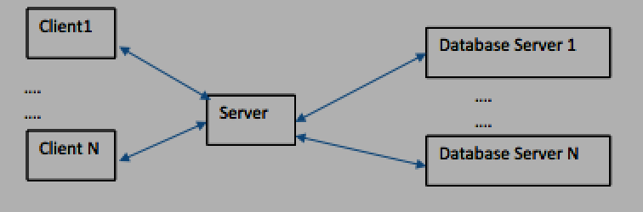

In the above topology, files are replicated on N Database Servers D1, D2,… DN.

Each database server has a set of files. Each of the database server can support fixed number of parallel sessions represented by tokens. The tokens will be replenished once the task is complete.

Say:

D1 (2): file1, file2, file3, file4

D2 (3): file1, file2, file5,

D3 (1): file1, file2, file3, file4, file5, file6,

e.g. For database server1, files ( file1, file2, file3, file4) are available with database server 1 and the number of tokens are 2. Similarly, number of tokens available with database server2 is 3.

There is a central server. Clients send file requests to central server which load balances and directs query to database servers.

[1] Implement a load balancing algorithm in the Central Server to distribute / divert file transfer requests to different database servers based on the token implementation. Implement using socket programming.

[2] Simulate errors in transmission

[3] State the scale your program can achieve.