OSS_IB_DSCORE_AccountUsageDataExport (1.0)

Recommendations:
#1
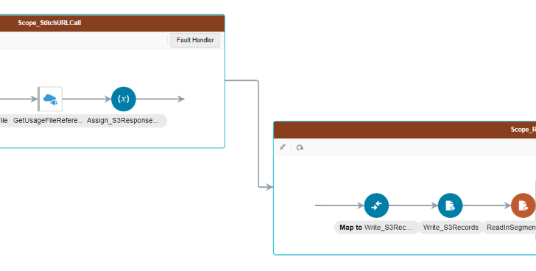
Implemented Logic:
- GetUsageFileReference -> Fetch binary file from S3 (Output Stream reference)
- Assign_S3Response -> Convert to base 64 encoded format which stores in OIC Virtual File System
- Write_S3 Records -> Write to stage file using opaque schema
- ReadInSegments -> Read the reference file (#3) in segments

Recommendation:
From #1 File is already available in VFS so, Steps 2,3 is redundant and unnecessarily doing base64 encode/decode
So, Use File StreamReference in #1 and assign to Global Variable
And in ReadInSegments directly refer to Global variable Reference

#2
Starting “May Release” OIC - ATP Adapter supports bulk upload operation. Given a File Reference it pushes the file into OCI object storage and does a bulk load of data into ATP which is a high performant way.
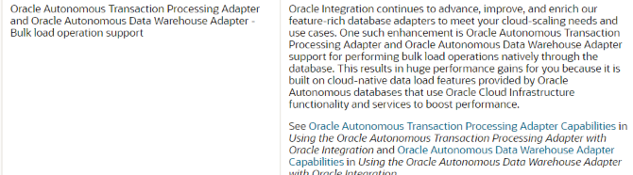
Ref: https://docs.oracle.com/en/cloud/paas/integration-cloud/whats-new/index.html#INTWN-GUID-225B02AD-4432-417D-B64B-BF3DECA39B9F

Which basically replaces this block of design
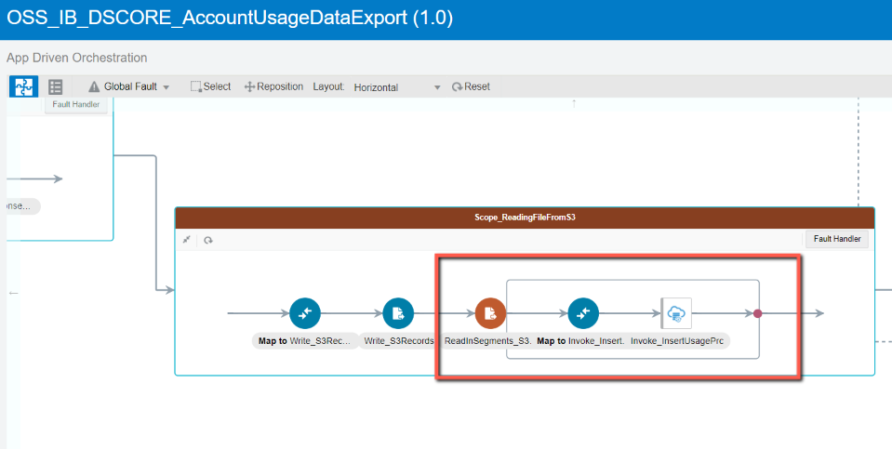

OSS_IB_DSCORE_AccountUsageBillingSync (1.0)

#1
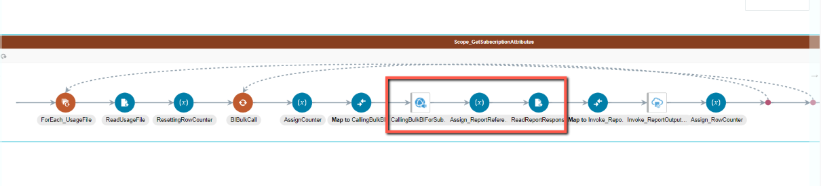
CallBIReportForSubscriptionAttributes- Calls a BIP Report

Recommendation
Use REST API -> https://docs.oracle.com/en/cloud/saas/sales/21b/faaps/api-subscriptions.html

#2
Multiple ATP calls being made to log information.
Recommendation
Suggest to update ATP with all the log information at logical termination point of ATP

#3
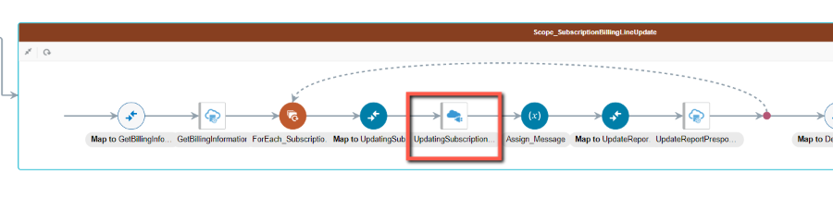
Rest adapter used to update Subscription bill lines and several other invokes
Recommendation
Use engagement cloud adapter for every API call to Subscription Management. Adapter takes care to fetch any Object interface changes seamlessly

