**LAB MANUAL**



**ROLLNO:AV.SC.U4CSE24132**

**NAME: j.bhagiradha**

**SECTION: CSE-B**

**WEEK-1:**

**Aim:** How to install jdk and first program on

printing student details*.*

**Step-1:** Download JDK-21 from oracle website

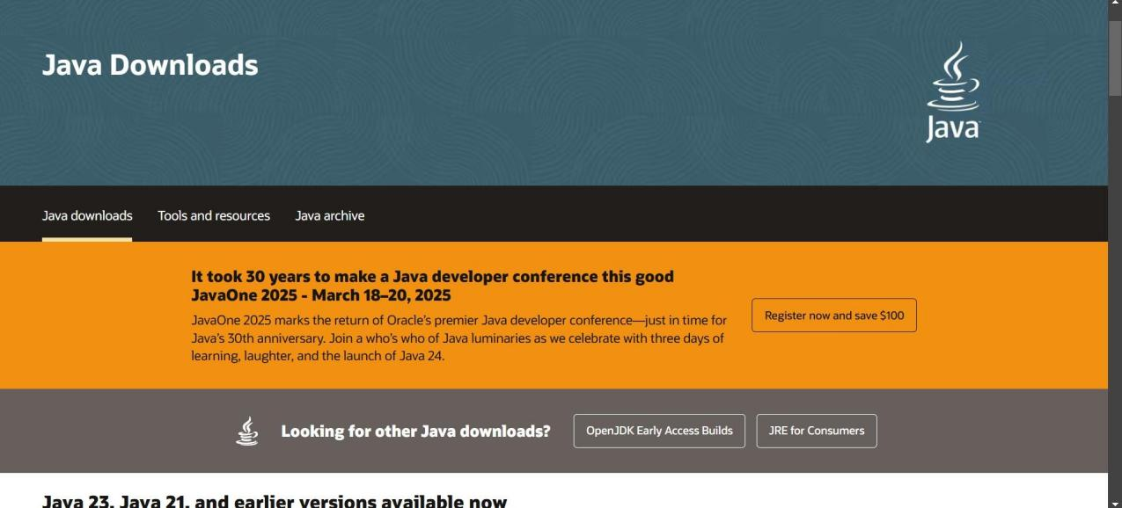

**Step-2:**Install the JDK-21 with accepting terms and

conditions according to the respective windows.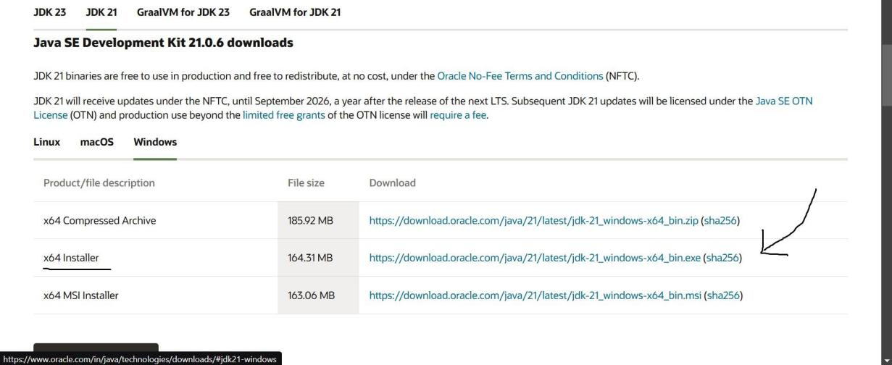

**Step-3**:Setting up environmental variables.

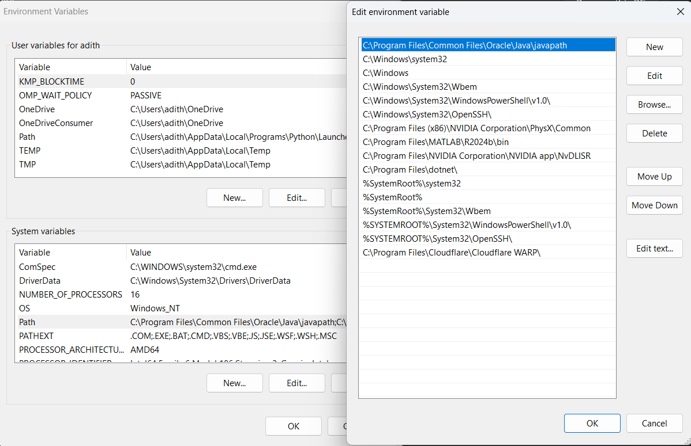

*Windows c -> C-drive -> program files ->Java -

>JDK-21->select bin

*Select and open environmental variable in search

bar-> either select system variables or user

variables-> select path-> click edit->New-> paste

the bin-> finish the setup(apply the changes).

~for verifying the installed version

Open cmd-> type java --version

~command propt

Javac filename.java ->compiling.

Java filename.java ->displaying

**PROGRAM-1(Rectified):**

**Output:**

**WEEK-2:**

**PROGRAM-1:**

**Aim:**Write a java program for SI

**Output:**

**ERROR TABLE*:***

|  |  |
| --- | --- |
| **Code Error** | **Code rectification** |
| 1.Giving space between next and Double.  2.Not giving parenthesis after closing the input. | 1.Should not give space between next and Double.  2.We must put parenthesis after closing the input. |

**PROGRAM-2:**

**Aim:**Write a program in java for area of

rectangle.

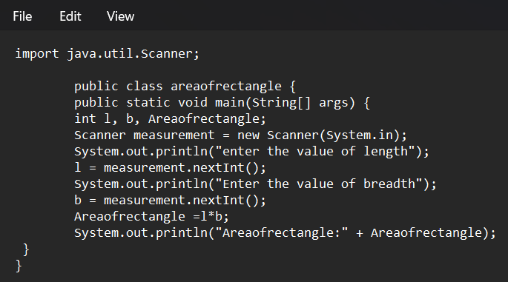

**Output:**

**ERROR TABLE:**

|  |  |
| --- | --- |
| **Code Error** | **Code rectification** |
| 1.While using for iteration, not giving the conditions correctly.  2.Declaring the data type as double instead of int. | 1.We should give iterative statements correctly.  2.We should give the data type as int for integers. |

**PROGRAM-3:**

**Aim:**Write a program in java for area of triangle using heron’s formula.

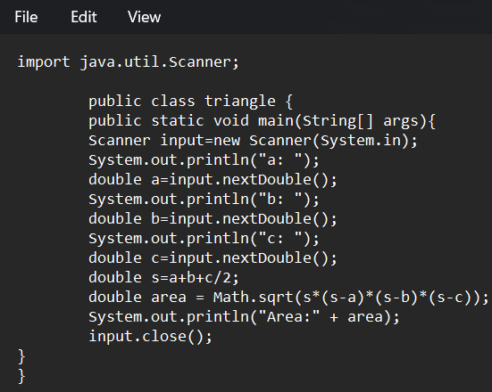

**Output:**

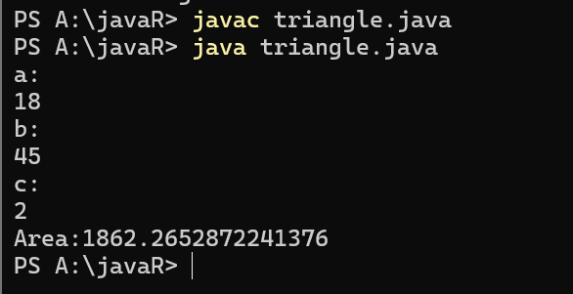

ERROR TABLE:

|  |  |
| --- | --- |
| **Code Error** | Code rectification |
| 1.While printing the variable not giving + sign.  2.Not closing the scanner. | 1.We should give correct indentation.  2.Closing the scanner is must. |

**PROGRAM-4(a):**

**Aim:**Write a program in java for converting temperature from celsius to fahrenite.

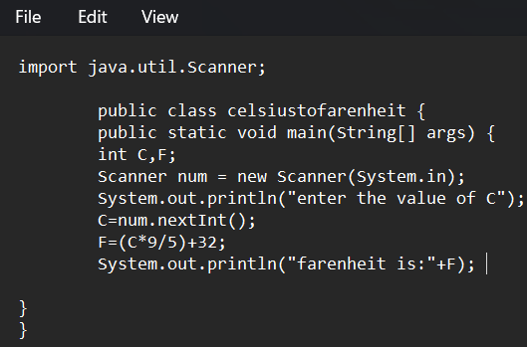

OUTPUT:

**PROGRAM-4(b):**

**Aim:**Write a program in java for converting temperature from fahrenite to celsius.

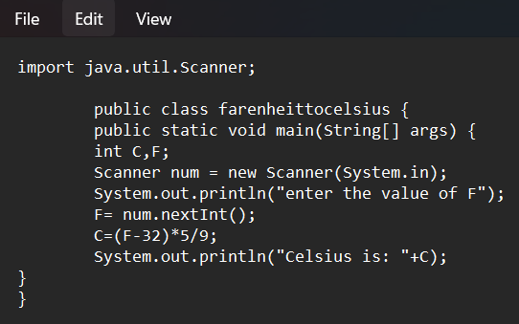

**Output:**

**ERROR TABLE:**

|  |  |
| --- | --- |
| **Code Error** | **Code rectification** |
| 1.While printing the variable not giving + sign.  2.Not closing the scanner. | 1.We should give correct indentation.  2.Closing the scanner is must. |

**PROGRAM-5:**

**Aim:**Write a program in java for factorial of a number.

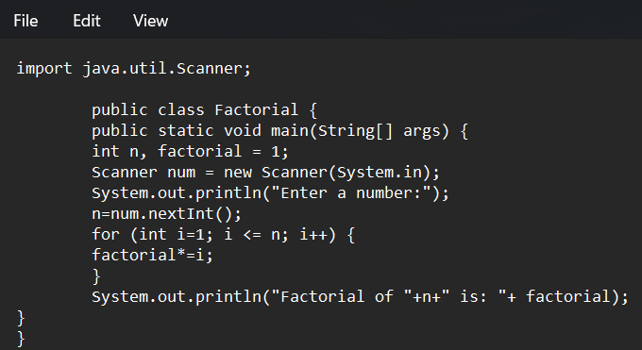

OUTPUT:

ERROR TABLE:

|  |  |
| --- | --- |
| **Code Error** | **Code rectification** |
| 1.While using for iteration, not giving the conditions correctly.  2.Declaring the data type as double instead of int. | 1.We should give iterative statements correctly.  2.We should give the data type as int for integers. |

**PROGRAM-6:**

**Aim:**Write a program in java for fibonacci series.

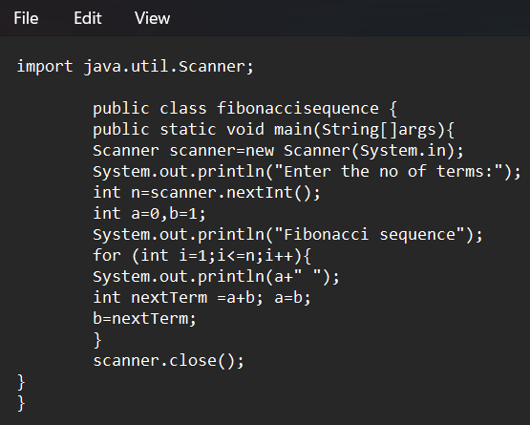

OUTPUT:

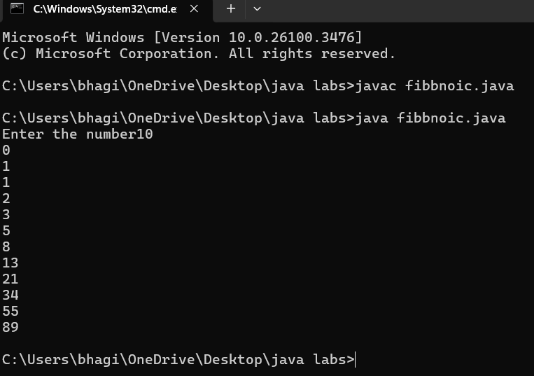

ERROR TABLE:

|  |  |
| --- | --- |
| **Code Error** | **Code rectification** |
| 1.Giving space between next and Double.  2.Not giving parenthesis after closing the input. | 1.Should not give space between next and Double.  2.We must put parenthesis after closing the input. |

**WEEK -3:**

**PROGRAM-1:**

**AIM: To create java program with following instructions :**

**1.Create a class with name Car**

**2.Create four attributes named car_color,car_brand, fuel_type, mileage**

**3.Create these methods named start(),stop(),service()**

**4.Create the objects named car, car1,car2**

**CODE :**

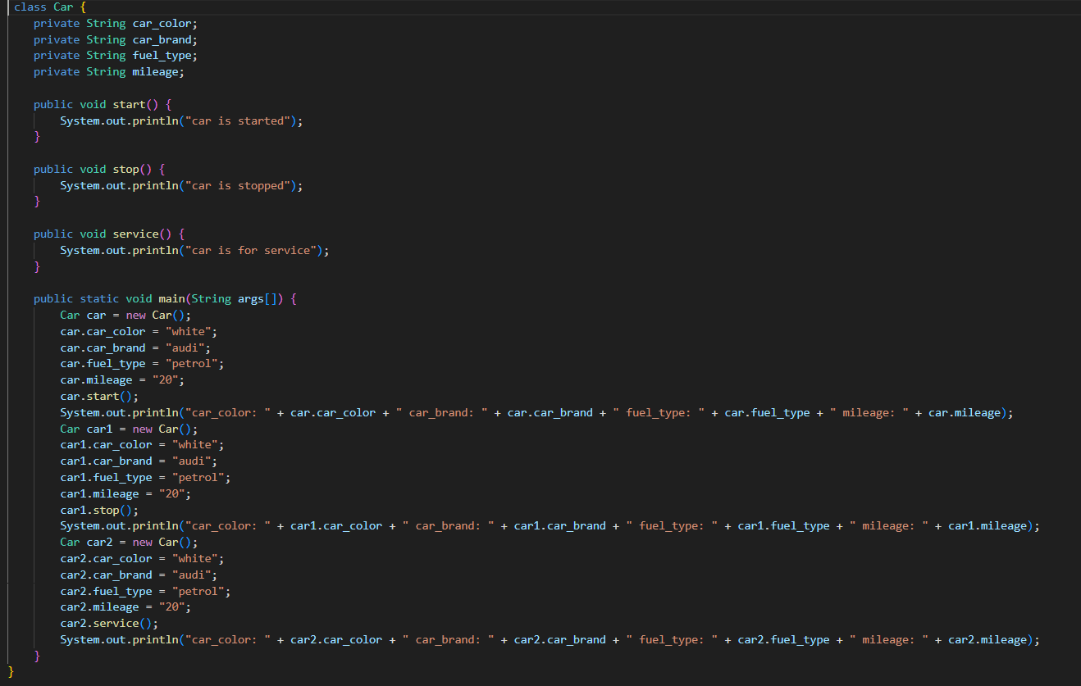

**OUTPUT:**

**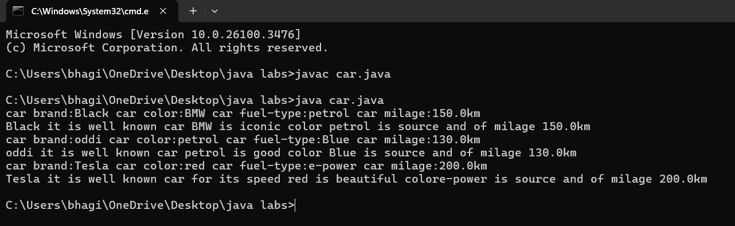  
  
  
  
  
  
  
Error table :**

|  |  |  |  |
| --- | --- | --- | --- |
| **S.no** | **Error name** | **Cause of error** | **Rectification** |
| **1** | **Syntax Error** | **Missing ‘{‘** | **‘{‘ added** |
| **2** | **Compile time Error** | **Mispelled Variable call** | **Rectified with**  **Correct variable name** |
| **3** | **Case sensitive error** | **Uppercase and lowercase** | **rectified** |

**Class diagram:**

|  |
| --- |
| **car**  **---------------------- --- -**  **-car_color:string**  **-car_brand:string -**  **-fuel_type:string**  **-milage:double**  **---------------------- ---**  **+start():void**  **+stop():void**  **+service():void** |

**PROGRAM-2:**

**Aim : To create a class BankAccount with methods deposit() and withdraw() create two subclasses savingsaccount and checkingaccount override the withdraw method in each subclass to impose different withdrawal limits and fees  
  
CODE :**

**OUTPUT:**

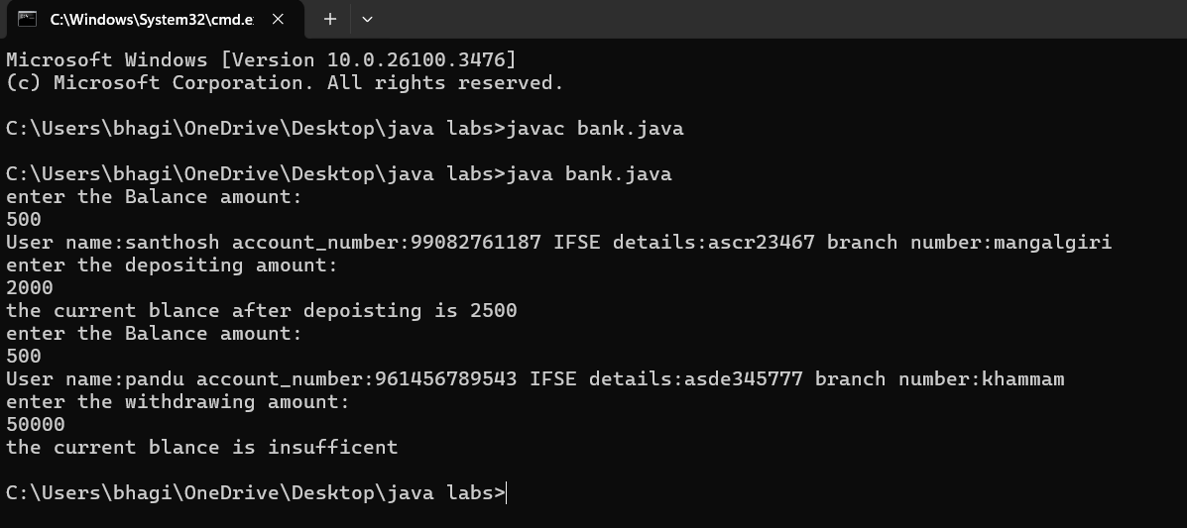

**Error table:**

|  |  |  |  |
| --- | --- | --- | --- |
| **S.no** | **Error name** | **Error name** | **Rectification** |
| **1** | **Name Error** | **Undefined name** | **Correct variable**  **Name replaced** |
| **2** | **Syntax Error** | **Missing Parenthesis** | **Parenthesis Added** |
| **3** | **Logical Error** | **Incorrect Condition** | **Condition Rectified** |

**Class diagram:**

|  |
| --- |
| **BankAccount**  **----------------------------------------------------------**  **-balance: double**  **----------------------------------------------------------**  **+BankAccount(intialBalance: double)**  **+deposit(amount: double):void**  **+withdraw(amount: double):void** |

**Week 4:**

**Program 1**

**Aim: Write a java program with class named ‘Book’ the class should contain various attributes such as title ,author, year of publish it should also contain a constructor with parameters which inisalizes title, author, year of publish .Create a method which display’s the details of the books ,Display the detailes of two books i.e create two objects and display their detailes.**

Output:

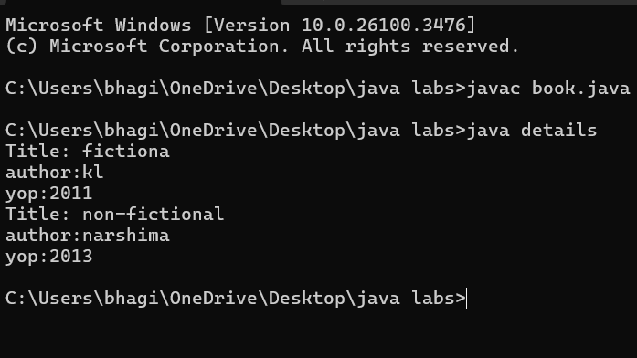

ERROR TABLE:

|  |  |
| --- | --- |
| **Code Error** | **Code rectification** |
| 1. Not defining the function in a file. 2. Two public class files should not be saved in the same file. | 1. To call the method we must define a function in a file. 2. Two public class files should be saved in different files. |

IMPORTANT POINTS:

1. While defining two classes for a code, we must be sure that we save both the classes in separate files.
2. While defining a method we should also define a function to call that method.

CLASS DIAGRAM:

|  |
| --- |
| Book   * Title: String * Author: String * Year of publication: int   + Book(title: String,  Author: String;  Year of publication: int  + displayDetails( ): void |

**Program 2:**

**Aim:** Create a java program with class named “MyClass”, with a static variable count of int datatype and inisalized to zero and a constant variable ‘pi’

of type “double” insilaize to 3.145 as attributes of the class, Now define a count variable each time an object of “MyClass” is created.Finally print the final values of count and ‘pi’ variables.

**Program:**

ERROR TABLE:

|  |  |
| --- | --- |
| **Code Error** | **Code rectification** |
| 1. Not Putting the semi-colon after calling a function, 2. Not giving the indentation properly. | 1. Put the semi-colon after calling a function. 2. All the indentation must be correct to run the code correct. |

IMPORTANT POINTS:

1. We must declare the initial value of the variable before declaring the final one.
2. Here the main objective is to increase the count according to the number of objects we make, i.e the count increases when the no.of objects are increasing.

CLASS DIAGRAM:

|  |
| --- |
| Myclass   * Count: int * Pi: double   + myclass( )  + main(args: String[]): void |

**Week-5**

**Program 1:**

**Aim:** Create a calculator using the operations including addition, subtraction, multiplication and division using multilevel in heritance and display the desired output.

**Program:**

class bcalc {

int a, b;

int sum, diff;

bcalc(int a, int b) {

this.a = a;

this.b = b;

}

public void add()

{ diff = a - b;

sum = a + b;

System.out.println("Difference: " + diff);

System.out.println("Sum: " + sum);

}

}

class acalc extends bcalc {

int mul; acalc(int a, int b) {

super(a, b);

}

public void mult() {

mul = a * b;

System.out.println("Multiplication: " + mul);

}

}

class aacalc extends acalc {

float div;

aacalc(int a, int b) {

super(a, b);

}

public void divi()

{

if (b != 0) { // Check to avoid division by zero

div = (float) a / b;

System.out.println("Division: " + div);

}

else {

System.out.println("Division by zero error!");

}

} }

class ocalc {

public static void main(String[] args) {

aacalc c = new aacalc(10, 2);

c.divi();

c.mult();

c.add();

}

}

Output:

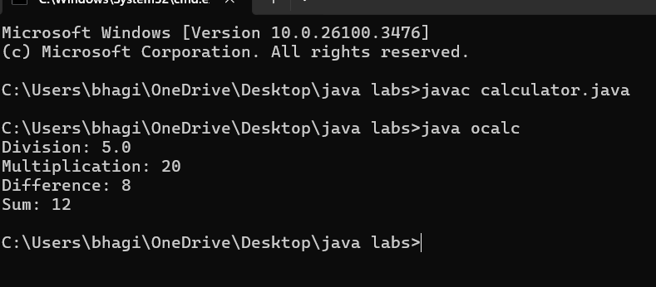

**Errors:**

|  |  |  |
| --- | --- | --- |
| **Sl.No** | **Error name** | **Error Rectification** |

|  |  |  |
| --- | --- | --- |
| **1.** | **Semi colon (;)** | **Givethe semi colon (;) in each line where it is**  **required** |
| **2.** | **Syntax Error** | **Giving Capital ‘S’ in printing statements (System.out.println)** |

**Class Diagram:**

+add(doublea,doubleb): void

+subs(doublea,double b): void

calculator

+multiplication

(double a,double b): void

**Calculator1**

+div(doublea,double b): void

**Calculator2**

**Program 2:**

**Aim:** A vehicle rental company wants to develop a system that maintains information about different types of vehicles available for rent. The company rents out cars and bikes and they need a program to store details about each vehicle such as brand and speed**.**

**Questions:**

1. Which OOPS concepts used in the above program? Explain why itis useful in this scenario.
2. If the company decides to add a new type of vehicle ‘Truck’, how would you modify the program?

Truck should include and additionalpropertycapacity (in tons).

* + - 1. CreateashowTruck()methodtodisplaythetruck’s capacity.
      2. Write a constructor for truck that initializes all properties.
      3. Implementthetruck classandupdatethemainmethodto createaTruckobjectand alsocreateanobjectforcarand bikesubclasses. Finallydisplay the details

**Program:**

class Vehicle {

    protected String brand;

    protected int speed;

    public Vehicle(String brand, int speed) {

        this.brand = brand;

        this.speed = speed;

    }

    public void start() {

        System.out.println(brand + " is starting.");

    }

    public void displayDetails() {

        System.out.println("Brand: " + brand);

        System.out.println("Speed: " + speed + " km/h");

    }

}

class Car extends Vehicle {

    private int numberOfDoors;

    private int seatingCapacity;

    public Car(String brand, int speed, int numberOfDoors, int seatingCapacity) {

        super(brand, speed);

        this.numberOfDoors = numberOfDoors;

        this.seatingCapacity = seatingCapacity;

    }

    @Override

    public void displayDetails() {

        super.displayDetails();

        System.out.println("Number of Doors: " + numberOfDoors);

        System.out.println("Seating Capacity: " + seatingCapacity);

 }

}

class Bike extends Vehicle {

    private boolean hasGears;

    public Bike(String brand, int speed, boolean hasGears) {

  super(brand, speed);

        this.hasGears = hasGears;

    }

    @Override

    public void displayDetails() {

        super.displayDetails();

        System.out.println("Has Gears: " + (hasGears ? "Yes" : "No"));

    }

}

class Truck extends Vehicle {

    private double capacity; // in tons

    public Truck(String brand, int speed, double capacity) {

        super(brand, speed);

        this.capacity = capacity;

    }

    public void showTruckDetails() {

        System.out.println("Truck Capacity: " + capacity + " tons");

    }

    @Override

    public void displayDetails() {

        super.displayDetails();

        showTruckDetails();

    }

}

 class Main {

    public static void main(String[] args) {

        // Create a Car object

        Car car = new Car("Toyota", 180, 4, 5);

        car.start();

        car.displayDetails();

        System.out.println();

        // Create a Bike object

        Bike bike = new Bike("Yamaha", 120, true);

        bike.start();

        bike.displayDetails();

        System.out.println();

        // Create a Truck object

        Truck truck = new Truck("Volvo", 100, 10.5);

        truck.start();

        truck.displayDetails();

    }

}

Output:

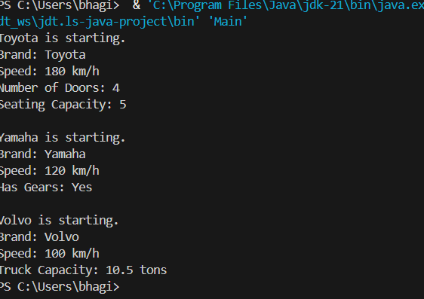

**Errors:**

|  |  |  |
| --- | --- | --- |
| **Sl.No** | **Error name** | **Error Rectification** |
| **1.** | **Semi colon (;)** | **Give the semi colon (;) in each line where it is required** |
| **2.** | **Syntax Error** | **Giving Capital ‘S’ in printing statements (System.out.println)** |

**Class Diagram:**

|  |
| --- |
| **Vehicle** |
| **brand: string speed: string** |
| **+Vehicle(String brand, int speed)**  **+Details(): void** |

|  |
| --- |
| **CARS** |
| **doors: int** |

|  |
| --- |
| **capacity: int** |
| **+ CARS (String brand, int speed, int doors, int capacity)**  **+cardetails(): void** |

|  |
| --- |
| **Bikes** |
| **gears: Boolean** |
| **+ Bikes(String brand, int speed, Boolean gears)**  **+bikedetails(): void** |



|  |
| --- |
| **Trucks** |
| **tons: int** |
| **+ Trucks(String brand,int speed,int tons)**  **+truckdetails(): void** |

**Important points:**

Multi-inheritance: It is one of the types of the inheritance where subclass 2 inherits subclass1 and subclass1 inherits superclass.

Here Vehicle is the super class or parent class and remaining cars, bikes, trucks are the subclasses or child classes

**Week 6:**

**Program 1:**

**Aim:** Write a Java program to create a vehicle class with a method displayInfo(). Override this method in the car subclass to provide specific information about a car, model, fuel type, and colour using the constructor

**Syntax:**

**Super class extends subclass**

Here extends is the main key word which represents the extending relation from parent class to child class.

**Program:**

class Vehicle { String Brand; String model;

    String fuel; String color; int capacity;

    Vehicle(String Brand, String model, String fuel, int capacity, String color) { this.Brand = Brand;

    this.model = model; this.fuel = fuel; this.capacity = capacity; this.color = color;

    }

    void displayInfo(String Brand, String model, String fuel, int capacity, String color) { System.out.println("Vehicle Details: ");

    System.out.println("Brand: " + Brand); System.out.println("Model: " + model); System.out.println("Fuel: " + fuel); System.out.println("Capacity: " + capacity); System.out.println("Color: " + color);

    }

    }

    class Car extends Vehicle {

    Car(String Brand, String model, String fuel, int capacity, String color) { super(Brand, model, fuel, capacity, color);

    }

    void displayInfo() { System.out.println("Car Details: "); System.out.println("Brand: " + Brand); System.out.println("Model: " + model); System.out.println("Fuel: " + fuel);

    System.out.println("Capacity: " + capacity); System.out.println("Color: " + color);

    }

    }

    class oops{

    public static void main(String[] args) {

    // Creating an instance of Car

    Car car1 = new Car("royals roce", "X5", "Petrol", 6, "Red"); car1.displayInfo(); // x

    }

    }

Output:

**Errors:**

|  |  |  |
| --- | --- | --- |
| **Sl.No** | **Error name** | **Error Rectification** |
| 1. | Semi colon (;) | Give the semi colon (;) in each line where it is required |
| 2. | Syntax Error | Giving Capital ‘S’ in printing statements (System.out.println) |

**Class Diagram:**

|  |
| --- |
| **Vehicle** |
| **+displayinfo():void** |

|  |
| --- |
| **Car_model:String Brand:String Fuel_type:String** |
| **+ car(String car_model,String Brand,String Fuel_type)**  **+displayinfo(): void** |

**Important points:**

In order to do this, we have to use inheritance concept. Here we used the multi-inheritance concept**.**

**Program 2:**

**Aim:** Create a Java program for the scenario.

A college is developing an automated admission system that verifies student eligibility for undergraduate (UG) and postgraduate(PG) programs. Each program has different eligibility criteria based on the student's percentage in their previous qualification.

1. UG admissions require aminimum of 60%
2. PG admissions require aminimum of 70%

**Program:**

class College{ String name; int percentage;

void geteligibility(String name,int percentage){ this.name=name; this.percentage=percentage;

}

}

class UG extends College{

void geteligibility(String name,int percentage){ if (percentage>=60){

System.out.println(name+" is eligible");

}

else{

System.out.println(name+" is not eligible");

}

}

}

class PG extends College{

void geteligibility(String name,int percentage){ if (percentage>=70){

System.out.println(name+" is eligible");

}

else{

System.out.println(name+" is not eligible");

}

}

}

class answer{

public static void main(String[] args){ UG ug=new UG(); ug.geteligibility("simha",45); PG pg=new PG(); pg.geteligibility("singh",80);

**Output:**

**Errors:**

|  |  |  |
| --- | --- | --- |
| **Sl.No** | **Error name** | **Error Rectification** |
| **1.** | **Semi colon (;)** | **Give the semi colon (;) in each line where it is required** |
| **2.** | **Syntax Error** | **Giving Capital ‘S’ in printing statements (System.out.println)** |

**Important points:**

Super keyword is used take the method,variable,constructor from the super class.

**Class diagram:**

**Student**

name: String

percentage:double

+Student(String name,double percentage)

+geteligibility():void

+UG(String name,double

UG

**Program-3:**

**Aim:** Write a Java Program to create a Calculator class with overloaded methods to perform addition: Take the integer values a and b from the user.

* 1. Addtwointegers
  2. Addtwodoubles
  3. Addthreeintegers

**Important points:**

We should carefully pass the double and integer and different types of input to an constructor when creating an object to access the different constructors based on the parameter.

**Program:**

class Calc{

public int add(int a,int b){ return a+b;

}

public double add(double a,double b){ return a+b;

}

public int add(int a,int b,int c){ return a+b+c;

}

}

class ayyayo{

public static void main(String[] args){ Calc C1=new Calc();

System.out.println("Sum of 24 and 10 is: "+C1.add(24,10)); System.out.println("Sum of 8.9 and 7.5 is: "+C1.add(7.6,8.6)); System.out.println("Sum of 2,4 and 6 is: "+C1.add(2,4,6));

}

}

**Output:**

**Class diagram:**

|  |
| --- |
| **Calculatoroverloading** |
| **+ add(int a,int b):int**  **+add(double a,double b):double**  **+ add(int a,int b,int c):int** |

**Errors:**

|  |  |  |
| --- | --- | --- |
| **Sl.No** | **Error name** | **Error Rectification** |
| **1.** | **Semi colon (;)** | **Give the semi colon (;) in each line where it is**  **required** |
| **2.** | **Syntax Error** | **Giving Capital ‘S’ in printing statements (System.out.println)** |

**Program 4:**

**Aim: Write a Java Program to create a shape class with a method calculateArea() that is overloaded for different shapes(e.g., Square, Rectangle ). Then create a subclass Circle that overrides the**

**calculateArea() method for a circle.**

**Important points:**

**In this program we use both method overloading and overriding to calculate area of different shapes.**

**Class Diagram:**

|  |
| --- |
| **shape** |
| **+calculatearea(int l,intb):void**  **+calculatearea(int x):void** |

|  |
| --- |
| **circle** |
| **+void calculatearea(double pi,double r):void** |

**PROGRAM:**

class Shape {

double calculateArea(double side) { return side * side;

}

double calculateArea(double width, double height) { return width * height;

}

}

class Circle extends Shape {

double calculateArea(double radius) { return 3.14 * radius * radius;

}

}

class ghible {

public static void main(String[] args) { Shape S1 = new Shape();

System.out.println("Area of square: " + S1.calculateArea(3)); System.out.println("Area of rectangle: " + S1.calculateArea(5, 2)); Circle C1 = new Circle();

System.out.println("Area of circle: " + C1.calculateArea(5));

}

}

**Output:**

**Errors:**

|  |  |  |
| --- | --- | --- |
| **Sl.No** | **Error name** | **Error Rectification** |
| **1.** | **Semi colon (;)** | **Give the semi colon (;) in each line where it is**  **required** |
| **2.** | **Syntax Error** | **Giving Capital ‘S’ in printing statements (System.out.println)** |