**CSC 8851 Deep Learning**

**Assignment 1**

**Due Date: 9/3/2021 (by 11:59 pm)**

Name: Bhagirath Tallapragada Campus ID: 002575358

Background Knowledge Test

**Problem 1**. (1 point) We are machine learners with a slight gambling problem (very different from gamblers with a machine learning problem!). Our friend, Bob, is proposing the following payout on the roll of a dice:

Where is the outcome of the roll, (+) means payout to us and (-) means payout to Bob. Is this a good bet for us? Are we expected to make money?

Solution: **The probability of making $1 is 1/6 whereas the probability of losing $1/4 is 5/6. There is a higher chance of losing $1/4 than making a dollar in this bet. Therefore, this is not a good bet for us.**

**Problem 2**. (1 point) is a continuous random variable with the probability density function

What is the equation for the corresponding cumulative density function (cdf) ?

[Hint: Recall that CDF is defined as .]

Solution:

**Problem 3.** (1 point) Recall that the variance of a random variable is defined as , where . Use the properties of expectation to show that we can rewrite the variance of a random variable as

Solution:

**Problem 4**. (1 point) A random variable x in standard Gaussian distribution has following probability density

Evaluate following integral

[Hint: This is not a calculus question!]

Solution: (scroll down)

**Problem 5**. (3 points) Consider the following function of :

where log(x) is the natural log function, and is the sigmoid function

Evaluate at . Then, compute the gradient and evaluate it at the same point.

Solution:

**Problem 6**. (3 points) Set up your Python programming environment by following the instruction below.

Setting up a Python programming environment for deep learning can be challenging. Depending on the system and privilege you have, it can be as easy as running a few scripts or completely a headache. In this class, we will use Python3+ and Numpy for programming assignments. In generally, you can set up your environment in Linux, Mac and Windows. Linux and Mac are preferred as they have better support to python and DL frameworks; you may just need to run a few scripts and complete this task. Otherwise, you may set up your environment in Windows, but it’s a little bit more involved. So the windows’ route is not recommended, and you should avoid it whenever possible.

1. Download assignment1.zip from iCollege “homework” section

**Linux (Preferred. Setup in Mac is similar to this.):**

1. set up python3 environment (e.g., install virtual environment or install anaconda)
2. unzip assignment1.zip
3. cd assignment1
4. pip install -r requirements.txt (if you don’t have sudo, you can install virtual box or anaconda)
5. cd assignment1/lib/datasets
6. source get_datasets.sh
7. cd assignment1
8. jupyter notebook (and save your results)
9. If your notebook runs without problem, then press “ctrl + s” to save your notebook, run “. collectSubmission.sh” to collect your results, and send your zip file along with your completed problem set to iCollege hw1 dropbox.

**Windows: (Not recommended, but just for your information)**

* Install Cygwin <https://cygwin.com/install.html>

Select packages: wget, zip and unzip

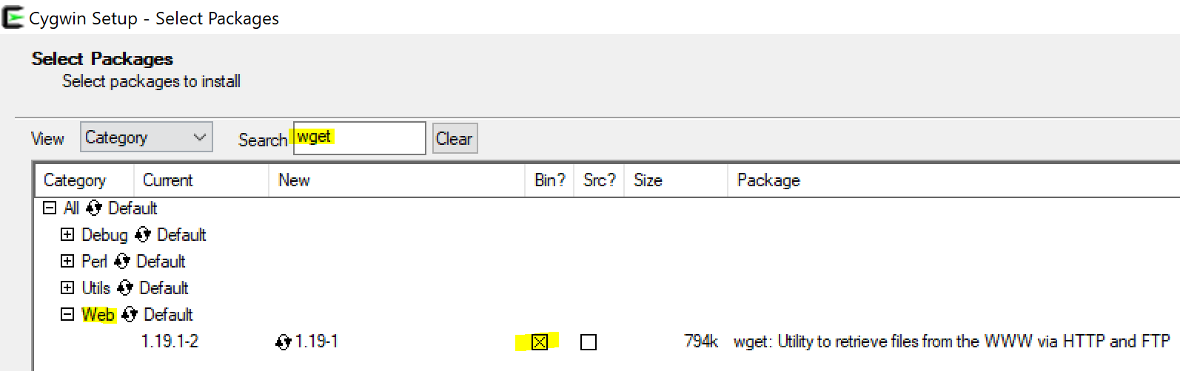

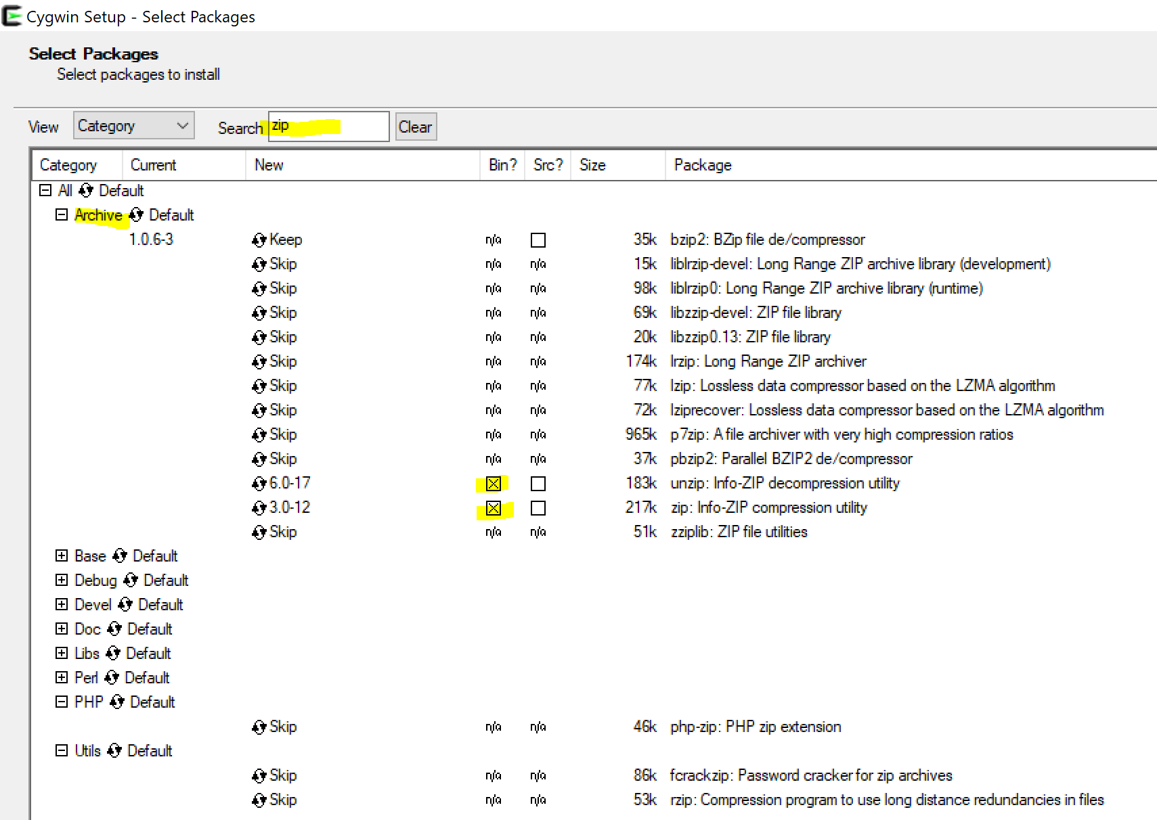

1. Run cygwin64 Terminal
2. Unzip assignment1.zip

* Install Anaconda <https://www.anaconda.com/download/>

1. Run “**Anaconda Powershell Prompt**” as Adminstrator
2. cd assignment1
3. pip install -r requirements.txt
4. cd assignment1/lib/datasets
5. source get_datasets.sh
6. cd assignment1
7. jupyter notebook (and save your results)
8. If your notebook runs without problem, press “ctrl + s” to save your notebook, run “. collectSubmission.sh” to collect your results and send your zip file along with your completed problem set to iCollege hw1 dropbox.