JsTask : Create the tea-coffee bill generator application in javascript

Folow the design below , use dropdown element to select tea/coffee and show the price in unitprice

Give total amount in total after giving quantity value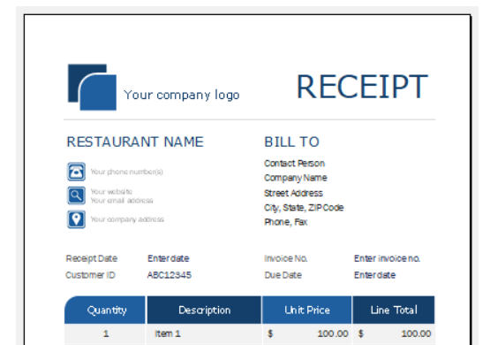

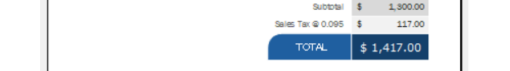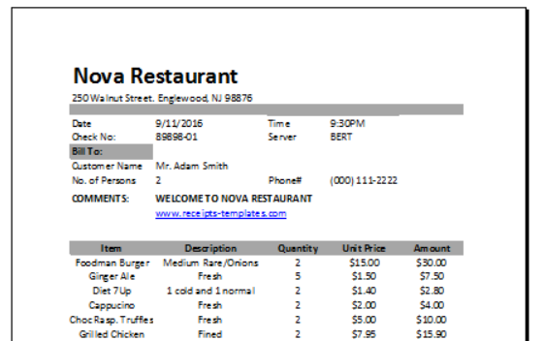

JsTask: