**CDAC MUMBAI**

**PG-DBDA Cdac Kharghar**

**DATA VISUALIZATION**

**DAY : SATURDAY, 20TH AUGUST 2022 TIME : 2:00 PM to 4:00 PM**

Roll no - 220340325012

**Q1. Create a sample table in postgres/mysql with following columns (15 Marks)**

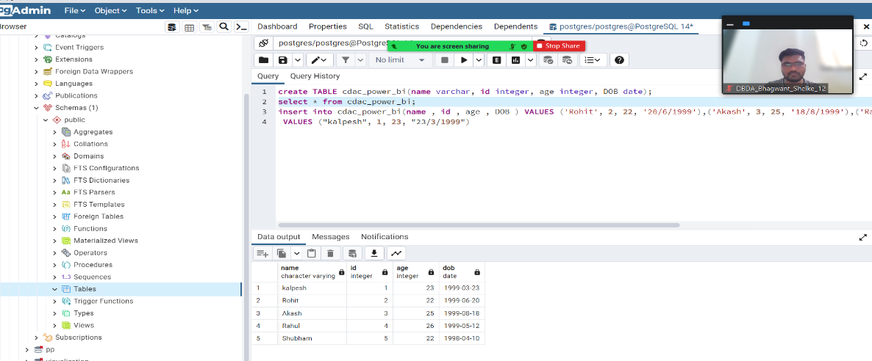

**Table Chart**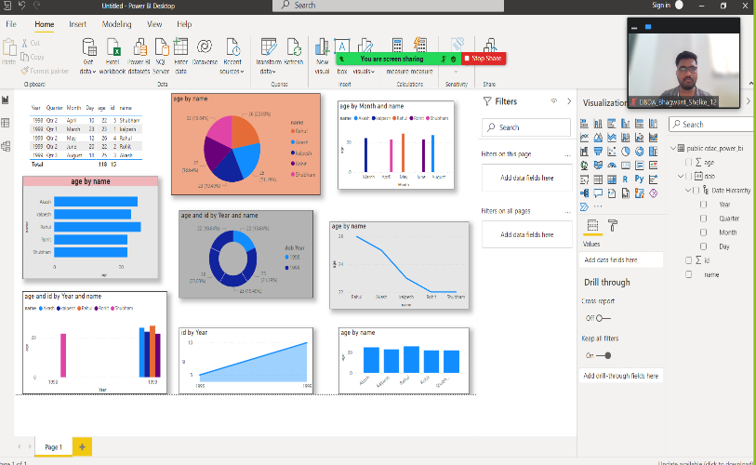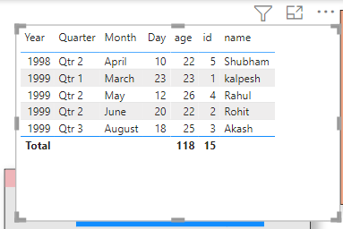

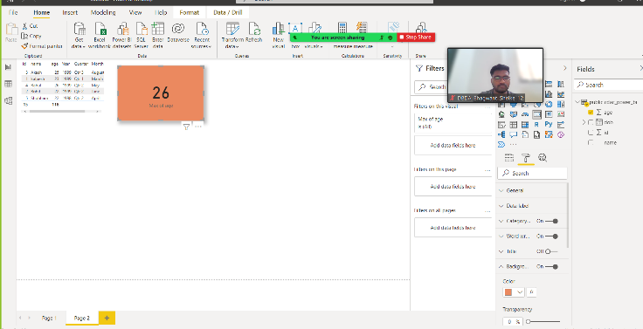**Card chart showing max age-**

Max age is 26

**Q2. On product_table data set do the following (25 Marks)**

● Create table chart with title , vendor,customer name,quantity,price,city

● Add new calculated column naming total_sales which is derived from quantity * price

