**Student ID - 220340325012**

**Problem 1 : Accelerate the Car (20 Marks)**

**class** Car{

**private** **int** year;

**private** String make;

**private** **double** speed;

Car(**int** y, String m , **double** s){

**this**.year = y;

**this**.make = m;

**this**.speed = s;

}

**public** **int** getYear(){

**return** year;

}

**public** String getMake(){

**return** make;

}

**public** **double** getSpeed (){

System.***out***.println("Speed is "+**this**.speed+ "mph");

**return** speed;

}

**void** Accelerate(){

speed = speed+1;

}

}

**class** Racetrack {

**public** **static** **void** main (String [] args){

Car c = **new** Car(2015,"Hundai",30.99);

System.***out***.println("Year of model is :"+c.getYear());

System.***out***.println("Current Speed of car is :"+c.getSpeed());

c.Accelerate();

System.***out***.println("Current Speed of car is :"+c.getSpeed());

}

}

**OUTPUT**

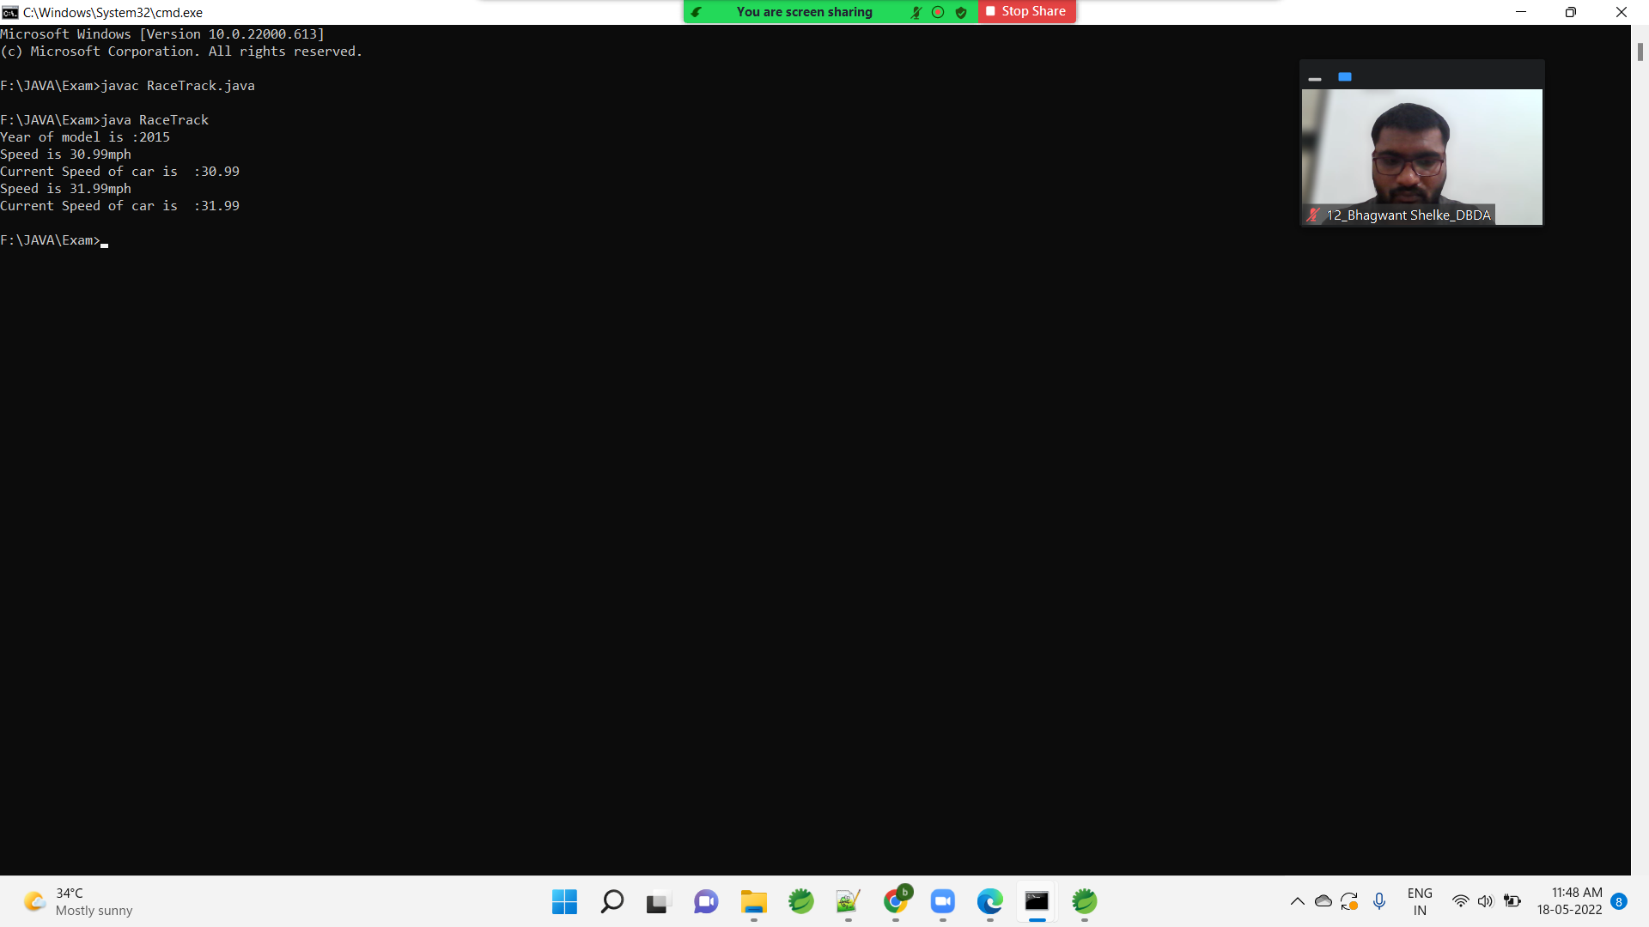

**Problem 2 : Inventory Management (20 Marks)**

**import** java.util.ArrayList;

**import** java.util.Collections;

**import** java.util.Comparator;

**import** java.util.Scanner;

**class** Item{

Integer itemId;

String itemName;

Item(**int** itemId, String itemName){

**this**.itemId = itemId;

**this**.itemName = itemName;

}

**public** Integer getId(){

**return** **this**.itemId;

}

**public** String getName(){

**return** **this**.itemName;

}

@Override

**public** String toString()

{

**return** **this**.itemId+ " " +**this**.itemName;

}

@Override

**public** **boolean** equals(Object o)

{

**if**(o **instanceof** Item){

Item temp = (Item)o;

**if**(**this**.itemId.equals(temp.itemId) && **this**.itemName.equals(temp.itemName)){

**return** **true**;

}

}

**return** **false**;

}

}

**class** idSort **implements** Comparator<Item>

{

**public** **int** compare(Item i1, Item i2){

**return** i1.getId().compareTo(i2.getId());

}

}

**class** nameSort **implements** Comparator<Item>

{

**public** **int** compare(Item i1, Item i2){

**return** i1.getName().compareTo(i2.getName());

}

}

**public** **class** ItemDemo {

**public** **static** **void** main(String args[]){

Scanner sc = **new** Scanner(System.***in***);

ArrayList<Item> inv = **new** ArrayList<Item>();

**while**(**true**)

{

System.***out***.println("***********************************");

System.***out***.println("Please enter your choice (1-4)");

System.***out***.println("1. Add Item");

System.***out***.println("2. Display ");

System.***out***.println("3. Remove");

System.***out***.println("4. Exit");

System.***out***.println("***********************************");

**int** choice = sc.nextInt();

**if**(choice == 1){

System.***out***.println("Enter item id and item name separated by space.");

**int** itemId = sc.nextInt();

String itemName = sc.next();

Item ob = **new** Item(itemId, itemName);

**if**(!inv.contains(ob))

{

inv.add(ob);

}

}

**else** **if**(choice == 2)

{

idSort is = **new** idSort();

Collections.*sort*(inv, is);

System.***out***.println("id sorted list : " + inv);

nameSort ns = **new** nameSort();

Collections.*sort*(inv, ns);

System.***out***.println("Name sorted list : " + inv);

}

**else** **if**(choice == 3)

{

System.***out***.println("Enter item to be removed");

System.***out***.println("Enter item id and item name separated by space.");

**int** itemId = sc.nextInt();

String itemName = sc.next();

Item ob2 = **new** Item(itemId, itemName);

**if**(inv.contains(ob2))

inv.remove(ob2);

**else**

System.***out***.println("Item not found");

}

**else** **if**(choice == 4) // Exit

**break**;

**else**

System.***out***.println("Invalid choice");

}

}

}

OUTPUT

***********************************

Please enter your choice (1-4)

1. Add Item

2. Display

3. Remove

4. Exit

***********************************

1

Enter item id and item name separated by space.

10 book

***********************************

Please enter your choice (1-4)

1. Add Item

2. Display

3. Remove

4. Exit

***********************************

1

Enter item id and item name separated by space.

11 pen

***********************************

Please enter your choice (1-4)

1. Add Item

2. Display

3. Remove

4. Exit

***********************************

1

Enter item id and item name separated by space.

12 rubber

***********************************

Please enter your choice (1-4)

1. Add Item

2. Display

3. Remove

4. Exit

***********************************

2

id sorted list : [10 book, 11 pen, 12 rubber]

Name sorted list : [10 book, 11 pen, 12 rubber]

***********************************

Please enter your choice (1-4)

1. Add Item

2. Display

3. Remove

4. Exit

***********************************

3

Enter item to be removed

Enter item id and item name separated by space.

11 pen

***********************************

Please enter your choice (1-4)

1. Add Item

2. Display

3. Remove

4. Exit

***********************************

2

id sorted list : [10 book, 12 rubber]

Name sorted list : [10 book, 12 rubber]

***********************************

Please enter your choice (1-4)

1. Add Item

2. Display

3. Remove

4. Exit

***********************************