NAME-bhagwant shelke

Rollno.-12

Python Exam

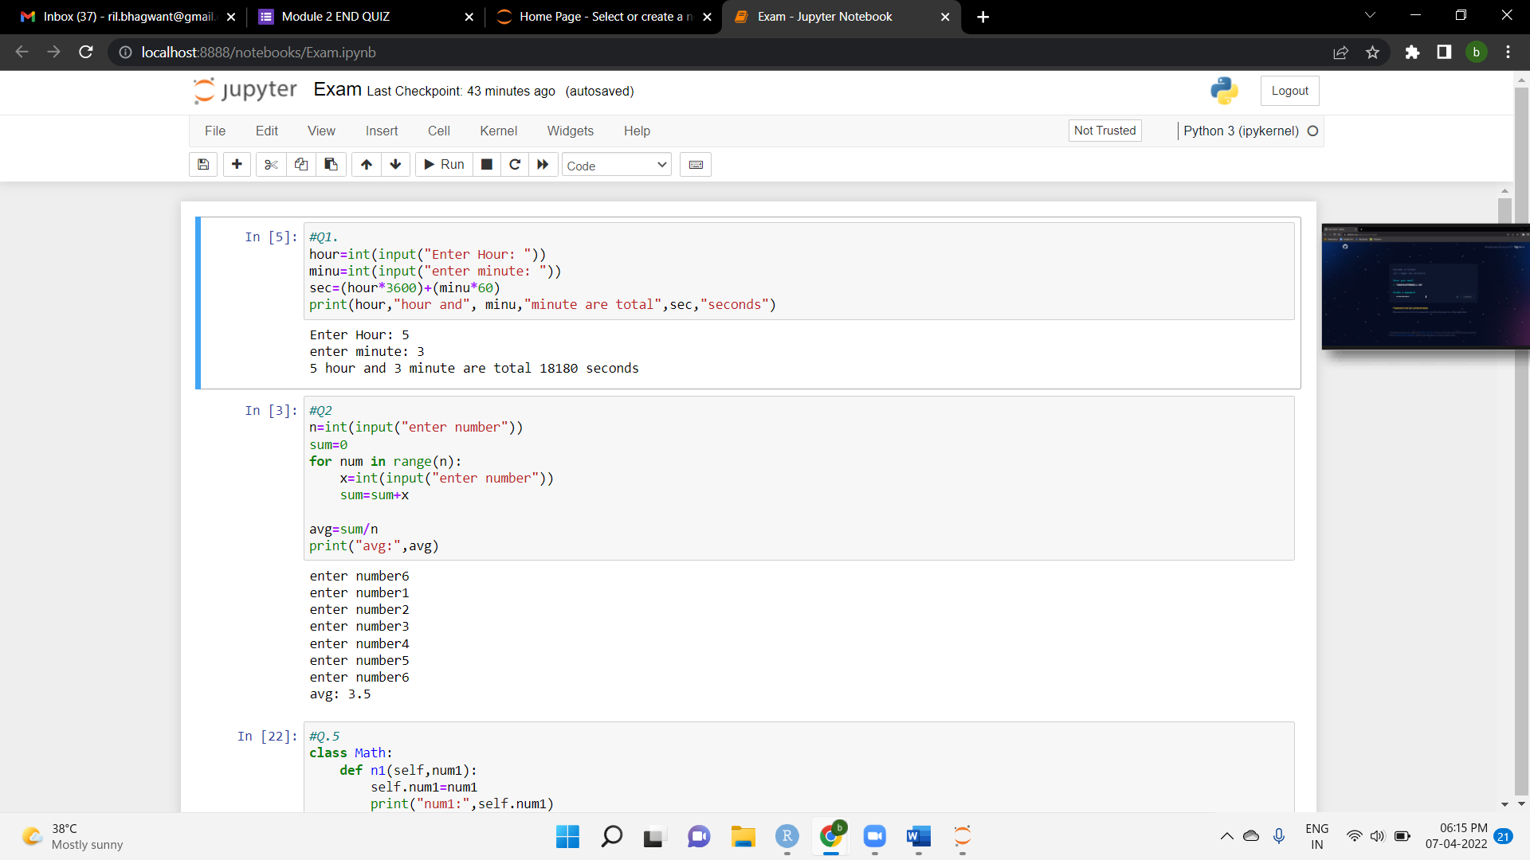

**#Q.5**

class Math:

def n1(self,num1):

self.num1=num1

print("num1:",self.num1)

def n2(self,num2):

self.num2=num2

print("num2",self.num2)

def Add(self):

self.add=self.num1+self.num2

print("addition: ", self.add)

def Div(self):

self.div=self.num1/self.num2

print("Div: ", self.div)

def sub(self):

self.sub=self.num1-self.num2

print("sub: ", self.sub)

def Mul(self):

self.mul=self.num1*self.num2

print("Multiplication: ", self.mul

output-

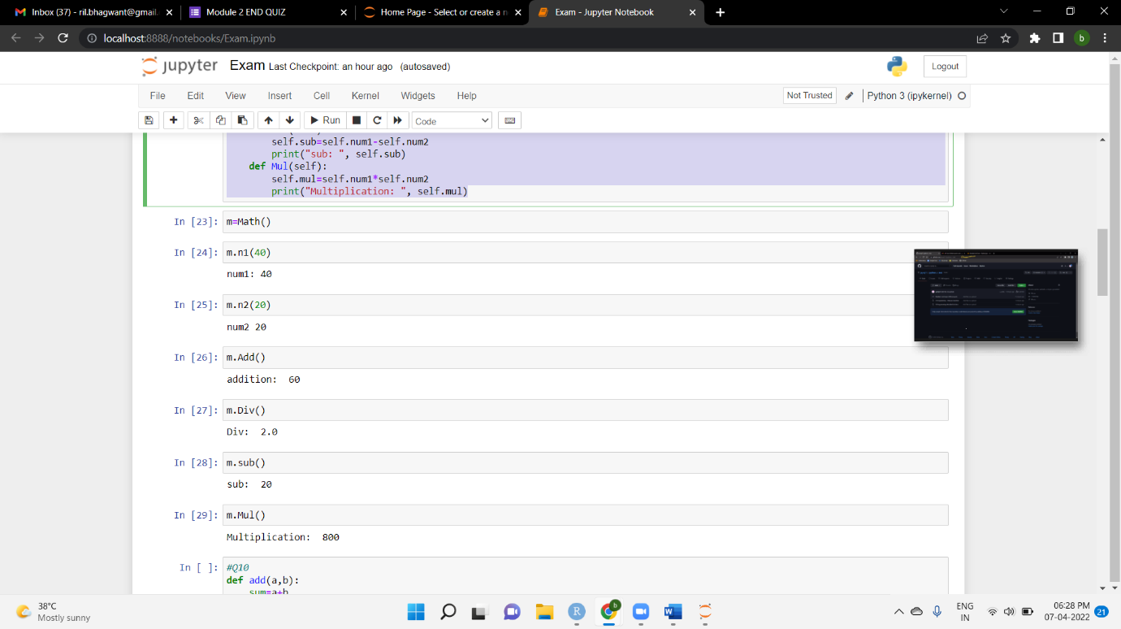

**#Q10**

def add(a,b):

sum=a+b

print("sum:",sum)

def sub(a,b):

sum=a-b

print("sum:",sum)

def mul(a,b):

sum=a*b

print("sum:",sum)

def div(a,b):

sum=a/b

print("sum:",sum)

while True:

print("\nMENU:")

print("1. Sum of numbers")

print("2. sub of numbers")

print("3. mul of numbers")

print("4. div of numbers")

print("5. Exit")

choice=int(input("\nEnter Choice: "))

if choice==1:

print("addition")

a=int(input("frist num:"))

b=int(input("second num:"))

add(a,b)

elif choice==2:

print("sub:")

a=int(input("frist num:"))

b=int(input("second num:"))

add(a,b)

elif choice==3:

print("mul")

a=int(input("frist num:"))

b=int(input("second num:"))

add(a,b)

elif choice==4:

print("div:")

a=int(input("frist num:"))

b=int(input("second num:"))

add(a,b)

elif choice==5:

break

else:

print("provide valid input!")

**Output-**

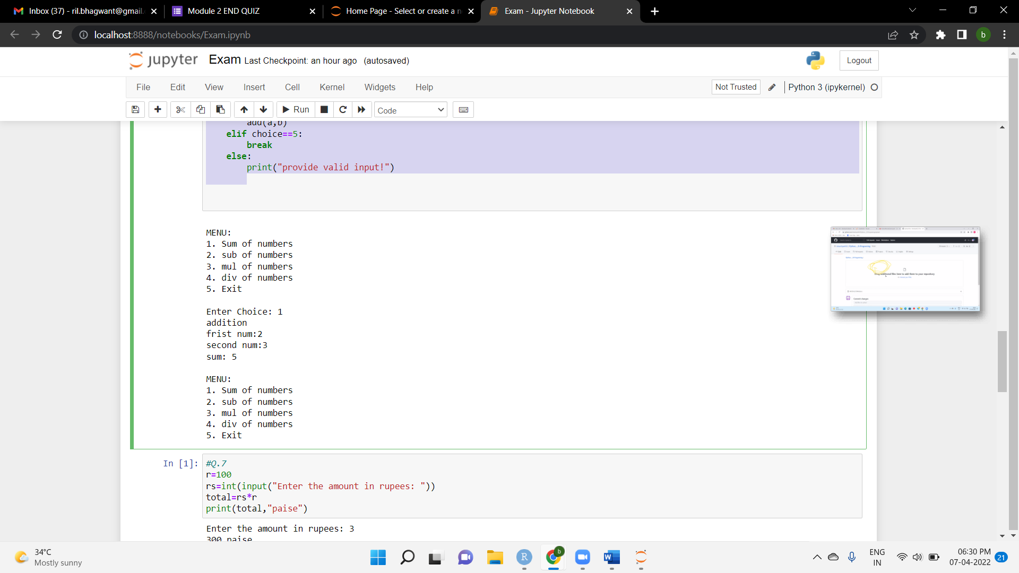

**#Q.7**

r=100

rs=int(input("Enter the amount in rupees: "))

total=rs*r

print(total,"paise")**output-**

Enter the amount in rupees: 3

300 paise

**Q.4**

