Query Enhancement in RAG

🔹 What is Query Enhancement?
In a RAG pipeline, the quality of the query sent to the retriever determines how good the retrieved context is — and therefore, how accurate the LLM’s final answer will be.
Query Enhancement (or Query Expansion) refers to techniques that improve or reformulate the user query to retrieve better, more relevant, and diverse documents from the knowledge base (e.g., vector store).

🔹 Why Query Enhancement is Needed
- The original query may be short, ambiguous, or under-specified.
- The query may miss synonyms, related terms, spelling variants, or domain-specific phrases.
- Retrieval quality directly impacts LLM grounding → better queries = better chunks = better final answers.

🔹 Example: Query Expansion
Problem (Original Query) | Solution (Enhanced Query)
"LangChain memory" | "LangChain memory modules, conversation memory"
"tools in LLM" | "LangChain tools, APIs, calculator, agent tools"
"retrieval" | "vector retrieval, dense search, BM25, MMR"
✅ Better queries → Better retrieved chunks → Better grounded LLM answers.

🔹 How Query Enhancement Works (Flow)
- User provides Query.
- LLM + Prompt Chain (or rules/templates) enhances the query.
- Enhanced query is sent to Retriever (e.g., FAISS, Hybrid).
- Retriever fetches Top-K documents.
- Re-Ranker reorders documents (based on relevance/diversity).
- LLM consumes final context to generate the answer.
(As shown in diagram: Query → Enhancement → VectorStore → Retriever → Re-Ranker → LLM → Output)
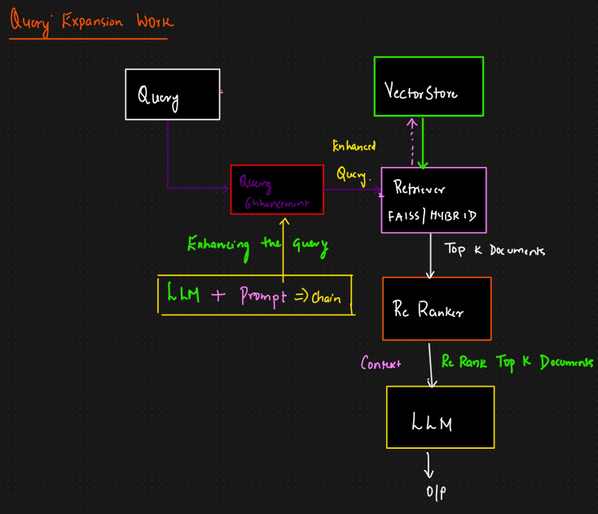

🔹 Techniques for Query Enhancement
- Synonym Expansion
  - Add synonyms, abbreviations, or domain-specific equivalents.
  - Example: "AI" → "Artificial Intelligence, Machine Learning, Deep Learning"
- Semantic Expansion using Embeddings
  - Use embedding similarity to expand query with semantically close terms.
- Knowledge Graph Expansion
  - Expand with linked entities and relations from a KG.
  - Example: "Tesla" → "Elon Musk, EV, Gigafactory, Model 3"
- Prompt-based Expansion (LLM-driven)
  - Ask an LLM to rewrite the query in multiple variations for broader recall.
- Relevance Feedback (Pseudo-Relevance Expansion)
  - Use top retrieved results to expand/refine the query.
- Spelling & Morphological Variants
  - Handle typos, plural/singular forms, tense variations.
- Contextual Expansion
  - Incorporate metadata (user profile, domain, session history).

🔹 Benefits of Query Enhancement
- Improves recall (fetches more relevant results).
- Improves precision (fetches fewer irrelevant results).
- Makes RAG pipelines more robust to vague or incomplete queries.
- Reduces chances of LLM hallucination by grounding it better.

🔹 Real-Time Applications of Query Enhancement
- Enterprise Search – Employees can find relevant policies, documents, or FAQs even with vague queries.
- E-commerce Search – Expands “Nike shoes” to include “sneakers, trainers, running shoes” for better recall.
- Healthcare RAG – Expands “flu treatment” to include “influenza, antiviral drugs, Tamiflu” for more comprehensive retrieval.
- Legal & Compliance – Expands “contract breach” to include “agreement violation, non-performance” for better coverage.
- Customer Support Chatbots – Expands customer queries into multiple technical variations to improve support accuracy.

🔹 When Not to Use Query Enhancement
- When query expansion risks adding noise (irrelevant terms).
- If the query is already specific and precise.
- When response time is critical (extra expansion steps can add latency).

✨ Final Takeaway:
Query Enhancement is a frontline optimization in RAG systems. It ensures that retrievers fetch high-quality, relevant, and diverse context for the LLM, directly improving answer accuracy, robustness, and trustworthiness.

