Hypothetical Document Embeddings (HyDE)

🔹 What is HyDE?
HyDE (Hypothetical Document Embeddings) is a retrieval technique where instead of embedding the user’s query directly, you:
- Generate a hypothetical answer (document) to the query using an LLM.
- Embed that hypothetical document.
- Use this embedding to search the vector store for relevant documents.
➡️ Retrieval happens based on the semantic meaning of the expected answer rather than the literal query words.

🎯 Why Use HyDE?
Problem | How HyDE Helps
User query and document use different words | Embeds answer-style content instead of question
Query is too vague | LLM-generated answer gives richer semantics
Better grounding needed | Embeds what the answer might look like
Zero-shot retrieval | Works well even without prior training

🔹 Workflow (RAG + HyDE)
- Query → User input.
- LLM → Generates a Hypothetical Answer.
- Embedding → Convert answer into a vector.
- Retriever (FAISS / Chroma / Hybrid) → Search Top-K documents.
- LLM → Consumes retrieved documents + query → Final grounded answer.
(HyDE acts as a middle layer between raw query and retriever.)

✅ Benefits of HyDE
Feature | Why It Helps
Semantic intent modeling | Better than literal keyword matching
LLM-aware retrieval | Query is expanded into more context
Generalization | Works well even if document phrasing differs from question
Plug-and-play | No need for retraining; works with OpenAI, Cohere, Hugging Face
Additional benefits:
- Produces semantically richer embeddings for vague/short queries.
- Improves recall in domains with varied terminology.
- Reduces reliance on keyword overlap.
- Useful in knowledge-heavy RAG tasks where answers are more descriptive than queries.

🔹 Real-Time Applications
- Medical Retrieval → Query: “diabetes treatment” → HyDE generates hypothetical answer about insulin/medications → retrieves research papers.
- Legal QA → Query: “breach of contract” → HyDE creates legal-style explanation → retrieves case law.
- Customer Support → Query: “refund policy?” → HyDE generates policy answer → retrieves FAQ docs.
- E-commerce Search → Query: “iPhone heating issue” → HyDE generates a hypothetical complaint → retrieves reviews/knowledge base articles.
- Scientific Research → Query: “protein folding” → HyDE generates a research-style answer → retrieves journal papers.

✨ Final Takeaway
HyDE is a query enhancement technique that transforms vague or underspecified queries into answer-like embeddings.
It bridges the gap between user intent and relevant content, making RAG pipelines more robust, precise, and semantically rich.

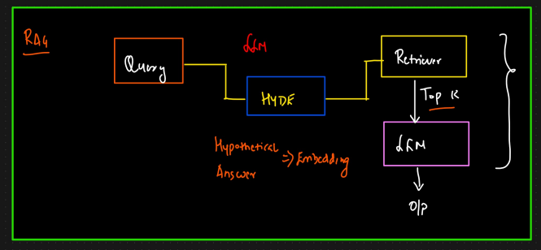

Query Enhancement Approaches Comparison
Aspect | Query Expansion | Query Decomposition | HyDE
Pros | - Improves recall with synonyms/variants  - Handles vague queries - Simple to implement | - Breaks down complex, multi-part queries  - Enables multi-hop reasoning - Allows parallel retrieval  - Ensures completeness | - Bridges user intent vs document mismatch  - Richer semantic embeddings  - Works in zero-shot settings  - Plug-and-play with OpenAI, Cohere, HF
Cons | - Can add noise  - May reduce precision  - Increased latency with large expansions | - Extra cost & latency (multiple queries)  - Requires synthesizer to combine answers  - Over-splitting may fragment context | - Relies on quality of LLM-generated answer  - Extra inference step adds cost/latency  - Risk of biased / misleading hypothetical answers
Optimal Scenarios | - Short/ambiguous queries - Vocabulary mismatch between user & docs  - Need for broader coverage (e.g., FAQ, enterprise search) | - Multi-concept or comparative queries  - Analytical/step-by-step reasoning  - Legal, healthcare, financial QA | - Short/vague queries  - Terminology mismatch - Knowledge-heavy RAG (medical, legal, research)  - Zero-shot retrieval
Misc / Notes | Works best with Hybrid Retrieval (BM25 + Vector DBs) | Pairs well with Answer Synthesizers / Multi-agent frameworks | Embeds hypothetical answers instead of queries → great for intent matching

