**Wafer Fault Detection**

Business statement:

The inputs of various sensors for different wafers have been provided. In electronics, a wafer (also called a slice or substrate) is a thin slice of semiconductor used for the fabrication of integrated circuits. The goal is to build a machine learning model which predicts whether a wafer needs to be replaced or not (i.e. whether it is working or not) based on the inputs from various sensors. These are two classes: +1 and -1.

**+1**: Wafer is in a working condition, doesn’t need to be replaced

**-1**: Wafer is not in a working condition, do need to be replaced

Continued…

**Functional Architecture:**

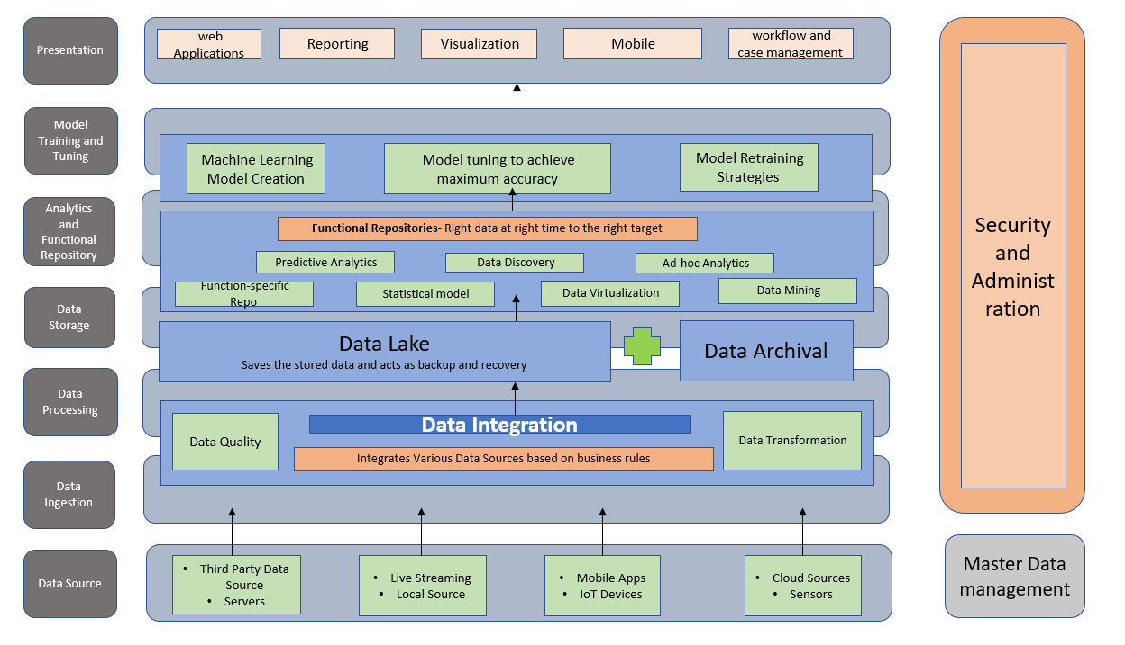

**Technical Architecture:**

