Assignment_2_(Conditional_Statements)
Conditional Statements
1. Take a list of numbers as input. Print whether the average is even or odd.
Ans: numbers = list(map(int, input("Enter numbers separated by space: ").split()))
# Calculate average
avg = sum(numbers) / len(numbers)
# Check even or odd — average must be an integer to check properly
if avg.is_integer(): # checks if average has no decimal part
if int(avg) % 2 == 0:
print("Average is Even")
else:
print("Average is Odd")
else:
print("Average is not an integer, cannot check even/odd:", avg)
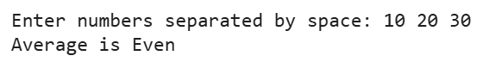
2. Take three strings as input. Calculate the number of words in each string and find out the list having highest number of words.
Ans: # Take three strings as input
s1 = input("Enter first string: ")
s2 = input("Enter second string: ")
s3 = input("Enter third string: ")

# Count number of words in each string
c1 = len(s1.split())
c2 = len(s2.split())
c3 = len(s3.split())

# Store counts and strings together
word_counts = [(c1, s1), (c2, s2), (c3, s3)]

# Find the string with the highest word count
max_string = max(word_counts, key=lambda x: x[0])

print("\nString with the highest number of words:")
print(max_string[1])
print("Word count:", max_string[0])

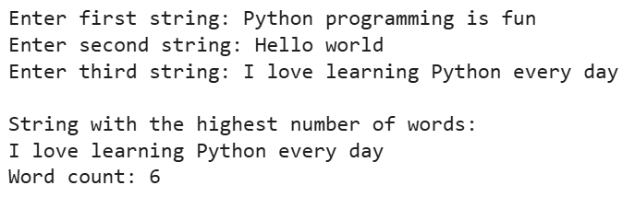
3. Take four numbers as input in a single line. Find out the largest number.
Ans: # Take four numbers as input in one line
a, b, c, d = map(int, input("Enter four numbers separated by space: ").split())

# Find largest number
largest = max(a, b, c, d)

print("The largest number is:", largest)

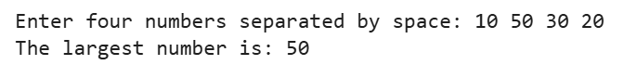
4. Take four numbers as input and find the second largest number.
Ans: # Take four numbers as input in one line
nums = list(map(int, input("Enter four numbers separated by space: ").split()))

# Find second largest
nums_sorted = sorted(nums, reverse=True)
second_largest = nums_sorted[1]

print("The second largest number is:", second_largest)
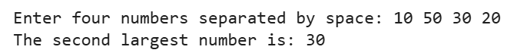
5. Create a dictionary having three items. Key of each item is the name of a student, value associated with each key is a list of marks in five subjects. Given this dictionary print the top and lowest scorers.
students={'Tom':[89,98,45,67,89], 'Jon':[92,41,43,66,87], 'Bob':[67,53,89,89,34]}
Ans: students={'Tom':[89,98,45,67,89], 'Jon':[92,41,43,66,87], 'Bob':[67,53,89,89,34]}

# Calculate total marks of each student
totals = {name: sum(marks) for name, marks in students.items()}

# Find top and lowest scorers
top_scorer = max(totals, key=totals.get)
lowest_scorer = min(totals, key=totals.get)

print("Top Scorer:", top_scorer, "with total marks =", totals[top_scorer])
print("Lowest Scorer:", lowest_scorer, "with total marks =", totals[lowest_scorer])

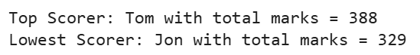
6. Create a dictionary (called data) of having at least 5 items : Usernames as keys and Passwords as values. Write a program that takes a username and a password as input. If the credentials match any iteam in the given dictionary data then print acces granted otherwise print whether username, password or both are wrong.
Ans: # Dictionary with usernames and passwords
data = {
"user1": "pass123",
"admin": "admin@123",
"tom": "tom456",
"emma": "emma789",
"john": "john999"
}

# Take inputs
username = input("Enter username: ")
password = input("Enter password: ")

# Check conditions
if username in data:
if data[username] == password:
print("Access Granted")
else:
print("Incorrect Password")
else:
if password in data.values():
print("Incorrect Username")
else:
print("Both Username and Password are incorrect")

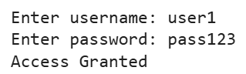
7. Take a list as input in a single line containing 15 numbers as marks out of 100. The first five numbers in the list are marks of Tom, the middle 5 numbers are marks of Bob and the last 5 are the marks of Jon. Find out the top and lowest scorer.
Ans: # Take 15 marks as input
marks = list(map(int, input("Enter 15 marks separated by space: ").split()))

# Split marks for each student
tom_marks = marks[0:5]
bob_marks = marks[5:10]
jon_marks = marks[10:15]

# Calculate total scores
totals = {
"Tom": sum(tom_marks),
"Bob": sum(bob_marks),
"Jon": sum(jon_marks)
}

# Find top and lowest scorer
top_scorer = max(totals, key=totals.get)
lowest_scorer = min(totals, key=totals.get)

print("\nTop Scorer:", top_scorer, "with total =", totals[top_scorer])
print("Lowest Scorer:", lowest_scorer, "with total =", totals[lowest_scorer])

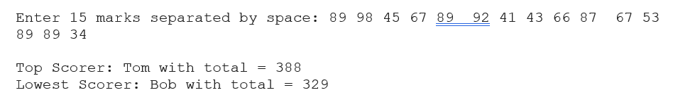
8. Take a number as input and print whether the number is a multiple of 3,5 or both.
Ans: num = int(input("Enter a number: "))

if num % 3 == 0 and num % 5 == 0:
print("The number is a multiple of both 3 and 5")
elif num % 3 == 0:
print("The number is a multiple of 3")
elif num % 5 == 0:
print("The number is a multiple of 5")
else:
print("The number is not a multiple of 3 or 5")

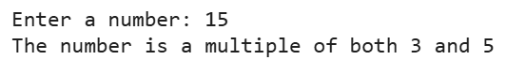
9. Write a program to take three strings as input and print the string having second largest number of words.
Ans: # Take three strings as input
s1 = input("Enter first string: ")
s2 = input("Enter second string: ")
s3 = input("Enter third string: ")

# Count words in each string
counts = [
(len(s1.split()), s1),
(len(s2.split()), s2),
(len(s3.split()), s3)
]

# Sort by word count
counts_sorted = sorted(counts, key=lambda x: x[0], reverse=True)

# Print second largest
print("\nString with second largest number of words:")
print(counts_sorted[1][1])
print("Word count:", counts_sorted[1][0])

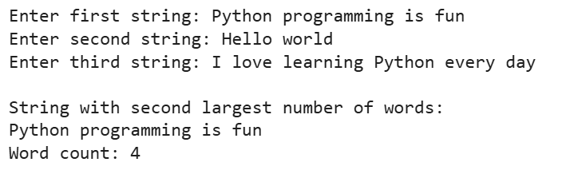
10. Write a program to take four strings as input and print the string having third highest number of words.
Ans: # Take four strings as input
s1 = input("Enter first string: ")
s2 = input("Enter second string: ")
s3 = input("Enter third string: ")
s4 = input("Enter fourth string: ")

# Count words in each string
counts = [
(len(s1.split()), s1),
(len(s2.split()), s2),
(len(s3.split()), s3),
(len(s4.split()), s4)
]

# Sort by word count (descending)
counts_sorted = sorted(counts, key=lambda x: x[0], reverse=True)

# Print third highest
print("\nString with third highest number of words:")
print(counts_sorted[2][1])
print("Word count:", counts_sorted[2][0])
