Assignment_4_(Functions,_Loops,_Conditional_Statements,_Files)_checkpoint
1. Create a function that takes a list of numbers as input and returns the median.
Ans: def find_median(nums):
nums = sorted(nums) # Sort the list
n = len(nums)

if n % 2 == 1:
# If odd, return the middle value
return nums[n // 2]
else:
# If even, return the average of the two middle values
mid1 = nums[n // 2 - 1]
mid2 = nums[n // 2]
return (mid1 + mid2) / 2

# Example tests
print(find_median([5, 3, 1, 4, 2])) # 3
print(find_median([10, 20, 30, 40])) # 25.0

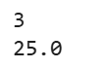
2. Create a function that takes a list of numbers as input and returns the mean.
Ans: def find_mean(nums):
if len(nums) == 0:
return None # or you can raise an error
return sum(nums) / len(nums)

# Example tests
print(find_mean([10, 20, 30, 40])) # 25.0
print(find_mean([5, 15, 25])) # 15.0

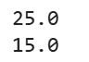
3. Create a function that takes a list of numbers as input and returns the standard deviation.
Ans: import math

def standard_deviation(nums):
if len(nums) == 0:
return None

mean = sum(nums) / len(nums)

# Calculate variance
variance = sum((x - mean) ** 2 for x in nums) / len(nums)

# Standard deviation is the square root of variance
return math.sqrt(variance)

# Example tests
print(standard_deviation([10, 20, 30, 40])) # 11.1803398875
print(standard_deviation([5, 15, 25])) # 8.1649658093

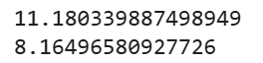
4. Create a function that takes a number as input and return True if the number is prime, False if not.
Ans: def is_prime(num):
if num <= 1:
return False

# Check divisibility from 2 to sqrt(num)
for i in range(2, int(num**0.5) + 1):
if num % i == 0:
return False
return True

# Examples
print(is_prime(7)) # True
print(is_prime(12)) # False
print(is_prime(1)) # False

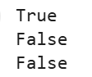
5. Create a function that takes a list of numbers as input and returns the variance.
Ans: def variance(nums):
if len(nums) == 0:
return 0

mean = sum(nums) / len(nums)
var = sum((x - mean) ** 2 for x in nums) / len(nums) # population variance
return var

# Example
numbers = [10, 20, 30, 40, 50]
print(variance(numbers)) # Output: 200.0

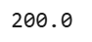
6. Create a function that takes a number as input and returns the factorial.
Ans: def factorial(n):
if n < 0:
return "Factorial not defined for negative numbers"

fact = 1
for i in range(1, n + 1):
fact *= i
return fact

# Example
print(factorial(5)) # Output: 120

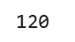

7. Create a function that takes two lists of same length as input and returns a list consisting of larger element at each position after comparing the corresponding elements in the given lists.
Ans: def larger_elements(list1, list2):
result = []
for a, b in zip(list1, list2):
result.append(max(a, b))
return result

# Example
l1 = [10, 25, 7, 40]
l2 = [5, 30, 9, 35]

print(larger_elements(l1, l2))

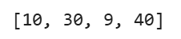
8. Create a function that takes a string and returns a string after joining the words that are having even lengths.
Ans: def join_even_words(s):
words = s.split() # Split the string into words
even_words = [w for w in words if len(w) % 2 == 0] # Filter even-length words
return ' '.join(even_words) # Join them back into a string

# Example
sentence = "I know how to print every word in this sentence"
print(join_even_words(sentence))

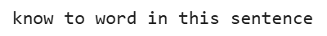
9. Create a function that takes a string and a character as input and returns a list after splitting the string based on the given character. By Default split based on whitespace. (Create a function similar to the inbuilt split function without using it).
Ans: def my_split(s, sep=' '):
result = []
word = ''

for char in s:
if char != sep:
word += char
else:
if word: # Avoid adding empty strings for consecutive separators
result.append(word)
word = ''

if word: # Add the last word if exists
result.append(word)

return result

# Example usage
text = "I-love-Python-programming"
print(my_split(text, '-')) # ['I', 'love', 'Python', 'programming']

text2 = "This is a test"
print(my_split(text2)) # ['This', 'is', 'a', 'test']

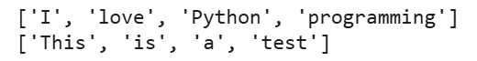
10. Create a function which takes a txt filename as input and returns the number of words in that file.
Ans: # Step 1: Create a test file
with open("example.txt", "w") as f:
f.write("Hello world\nThis is a test file")

# Step 2: Function to count words
def count_words_in_file(filename):
try:
with open(filename, 'r') as file:
text = file.read()
words = text.split()
return len(words)
except FileNotFoundError:
print("File not found!")
return 0

# Step 3: Call the function
print("Number of words:", count_words_in_file("example.txt"))

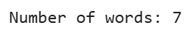
11. Create a function which takes a txt filename as input and returns the number of line in the file.
Ans: def count_lines_in_file(filename):
try:
with open(filename, 'r') as file:
lines = file.readlines() # Read all lines into a list
return len(lines) # Number of lines
except FileNotFoundError:
print("File not found!")
return 0

# Example usage
filename = "example.txt"
print("Number of lines:", count_lines_in_file(filename))

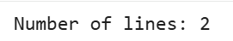
12. Create a function that takes two txt filenames and returns a file after merging the cintents of two given files. (Print the merged content and then return the filename, content of original files should be unchanged).
Ans: def merge_files(file1, file2, merged_filename="merged.txt"):
try:
# Read content from first file
with open(file1, 'r') as f1:
content1 = f1.read()

# Read content from second file
with open(file2, 'r') as f2:
content2 = f2.read()

# Merge the contents
merged_content = content1 + "\n" + content2

# Write merged content to a new file
with open(merged_filename, 'w') as mf:
mf.write(merged_content)

# Print merged content
print("Merged Content:\n")
print(merged_content)

# Return merged filename
return merged_filename

except FileNotFoundError as e:
print("Error: File not found!", e)
return None

# Example usage
# First, create two test files for demonstration
with open("file1.txt", "w") as f:
f.write("This is file 1.\nIt has some text.")

with open("file2.txt", "w") as f:
f.write("This is file 2.\nIt also has some text.")

merged_file = merge_files("file1.txt", "file2.txt")
print("\nMerged file created:", merged_file)

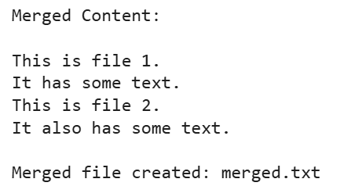
13. Write a program that takes a string as input and returns a list of all words having even length in that string (Using Map/Filter and Lambda expression).
Ans: # Take input from the user
sentence = input("Enter a string: ")

# Split the string into words
words = sentence.split()

# Use filter and lambda to get words with even length
even_words = list(filter(lambda w: len(w) % 2 == 0, words))

# Print the result
print("Words with even length:", even_words)

