Iterative_Statements,Assignment
1. Tom and Bob are playing a game of dice. Each time a multiple of two comes up Tom gets a point and if a multiple of 3 comes up bob gets a point. If a multiple of both comes up then a point is deducted from both. Write a program to take a list as input consisting of 10 outcomes of the dice throw. Print the scores of both Tom and bob and the winner.
Ans: # Take input from the user as space-separated numbers
dice_throws = list(map(int, input("Enter 10 dice outcomes (space-separated): ").split()))

# Ensure exactly 10 numbers
if len(dice_throws) != 10:
print("Please enter exactly 10 numbers.")
else:
tom_score = 0
bob_score = 0

for throw in dice_throws:
if throw % 2 == 0 and throw % 3 == 0:
tom_score -= 1
bob_score -= 1
elif throw % 2 == 0:
tom_score += 1
elif throw % 3 == 0:
bob_score += 1

# Print scores
print(f"Tom's score: {tom_score}")
print(f"Bob's score: {bob_score}")

# Determine winner
if tom_score > bob_score:
print("Winner: Tom")
elif bob_score > tom_score:
print("Winner: Bob")
else:
print("It's a tie!")

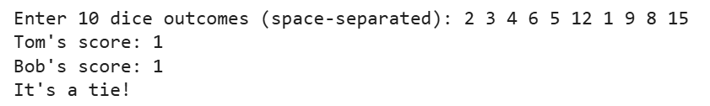
2. Write a program to take a list of 10 numbers as input in single line and find out the largest element.
Ans: # Take input from the user as space-separated numbers
numbers = list(map(int, input("Enter 10 numbers separated by space: ").split()))

# Ensure exactly 10 numbers
if len(numbers) != 10:
print("Please enter exactly 10 numbers.")
else:
largest = max(numbers) # Find the largest number
print("The largest number is:", largest)

3. Write a program to take a number as input and find out whether it is prime or not.
Ans: # Take input from the user
num = int(input("Enter a number: "))

# Check for prime
if num <= 1:
print(num, "is not a prime number.")
else:
is_prime = True
for i in range(2, int(num**0.5) + 1):
if num % i == 0:
is_prime = False
break

if is_prime:
print(num, "is a prime number.")
else:
print(num, "is not a prime number.")

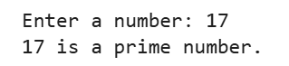
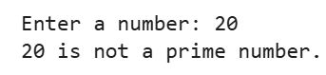
4. Take a list and a number as input, print all consecutive pairs of two numbers from the list having sum equal to the given number.
Ans: # Take list input
nums = list(map(int, input("Enter numbers (space-separated): ").split()))

# Take target sum
target = int(input("Enter the target sum: "))

# Check consecutive pairs
found = False
for i in range(len(nums) - 1):
if nums[i] + nums[i + 1] == target:
print(f"Pair found: ({nums[i]}, {nums[i+1]})")
found = True

if not found:
print("No consecutive pairs found with the given sum.")

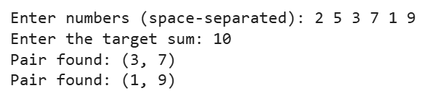
5. Take a string as input and find out the number of words with even length and number of words with odd length.
Ans: # Take string input
text = input("Enter a string: ")

# Split into words
words = text.split()

even_count = 0
odd_count = 0

# Count even and odd length words
for word in words:
if len(word) % 2 == 0:
even_count += 1
else:
odd_count += 1

print("Number of even-length words:", even_count)
print("Number of odd-length words:", odd_count)

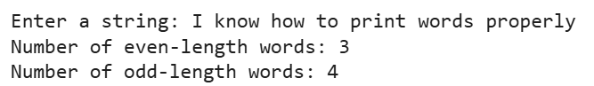
6. Write a program to sort a given list using selection sort algorithm. (study selection sort and implement)
Ans: # Selection Sort Implementation
def selection_sort(arr):
n = len(arr)

for i in range(n):
min_index = i

# Find the minimum element in the remaining unsorted list
for j in range(i + 1, n):
if arr[j] < arr[min_index]:
min_index = j

# Swap the found minimum element with the first element
arr[i], arr[min_index] = arr[min_index], arr[i]

return arr

# Take input from user
nums = list(map(int, input("Enter numbers (space-separated): ").split()))

# Sort using selection sort
sorted_list = selection_sort(nums)

print("Sorted list:", sorted_list)

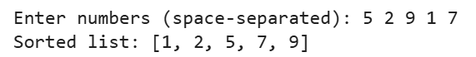
7. Write a program to sort a given list using bubble sort algorithm. (Study bubble sort and implement)
Ans: # Bubble Sort Implementation
def bubble_sort(arr):
n = len(arr)

for i in range(n - 1):
for j in range(n - 1 - i):
if arr[j] > arr[j + 1]:
# Swap the elements
arr[j], arr[j + 1] = arr[j + 1], arr[j]

return arr

# Take input from user
nums = list(map(int, input("Enter numbers (space-separated): ").split()))

# Sort using bubble sort
sorted_list = bubble_sort(nums)

print("Sorted list:", sorted_list)

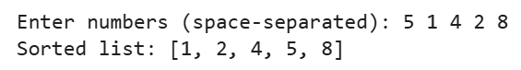
8. Take a string and a word and input. Find the frequenecy of occurrence of the word in the given string. (Without using any inbuilt function)
Ans: def find_word_positions(text, word):
current_word = ""
count = 0
positions = []
index = 0 # word index tracker

# Add space at end to capture last word
for ch in text + " ":
if ch != " ":
current_word += ch
else:
if current_word == word:
count += 1
positions.append(index)
current_word = ""
index += 1

return count, positions

# --- Input ---
string = input("Enter a string: ")
target_word = input("Enter the word to find: ")

# --- Processing ---
freq, pos_list = find_word_positions(string, target_word)

# --- Output ---
print("\nFrequency:", freq)
print("Positions (0-based index):", pos_list)
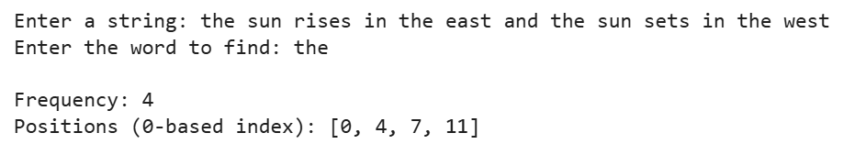
9. Write a program to print the following pattern:
'''
5 4 3 2 1
4 3 2 1
3 2 1
2 1
1
'''
print()
Ans: for i in range(5):
# Print leading spaces
print(" " * i, end="")

# Print decreasing numbers
for j in range(5 - i, 0, -1):
print(j, end=" ")

print() # Move to next line
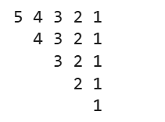
10. Write a program to print the following pattern:
'''
5 4 3 2 1
4 3 2 1
3 2 1
2 1
1
'''
print()
Ans: n = 5

for i in range(n, 0, -1):
for j in range(i, 0, -1):
print(j, end=" ")
print()
