SQL_Assignments_2(EmployeeDetails_EmployeeSalary)

Basics and Intermediate Questions:
PART-1
- SQL Query to fetch records that are present in one table but not in another table.
Ans: a) Employees in EmployeeDetails but not in EmployeeSalary –

SELECT E.EMPID, E.FULLNAME, E.CITY
FROM EmployeeDetails E
LEFT JOIN EmployeeSalary S ON E.EMPID = S.EMPID
WHERE S.EMPID IS NULL;

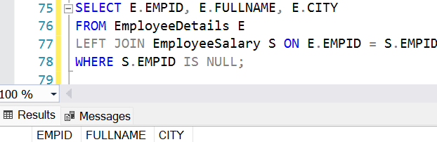
b) Employees in EmployeeSalary but not in EmployeeDetails –

SELECT S.EMPID, S.PROJECT, S.SALARY
FROM EMPLOYEESALARY S
LEFT JOIN EmployeeDetails E ON S.EMPID = E.EMPID
WHERE E.EMPID IS NULL;

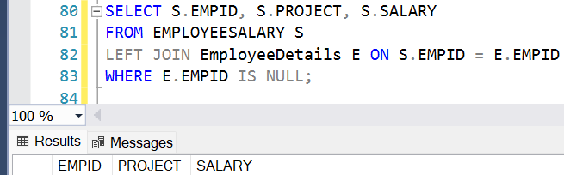

c) All mismatched records from both sides –

SELECT E.EMPID, E.FULLNAME, E.CITY, S.PROJECT, S.SALARY
FROM EmployeeDetails E
FULL OUTER JOIN EmployeeSalary S ON E.EMPID = S.EMPID
WHERE E.EMPID IS NULL OR S.EMPID IS NULL;
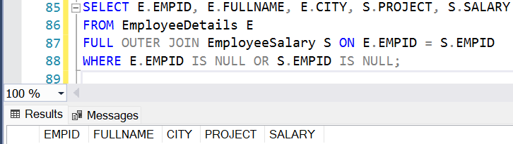

- SQL query to fetch all the employees who are not working on any project.
Ans: SELECT E.EMPID, E.FULLNAME, E.CITY
FROM EmployeeDetails E
LEFT JOIN EmployeeSalary S ON E.EMPID = S.EMPID
WHERE S.EMPID IS NULL OR S.Project IS NULL;

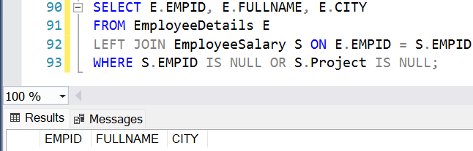

- SQL query to fetch all the Employees from EmployeeDetails who joined in the Year 2020.
Ans: SELECT EMPID, FULLNAME, MANAGERID, DATEOFJOINING, CITY
FROM EmployeeDetails
WHERE YEAR(DateOfJoining) = 2020;

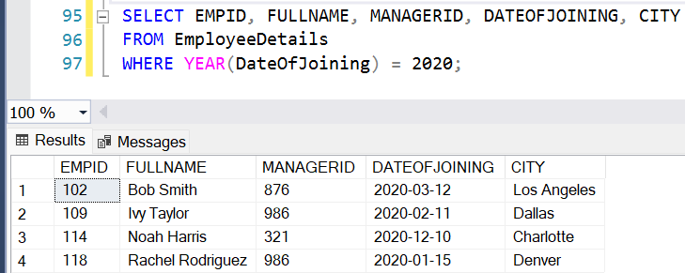

- Fetch all employees from EmployeeDetails who have a salary record in EmployeeSalary.
Ans: SELECT E.EMPID, E.FULLNAME, E.MANAGERID, E.DATEOFJOINING, E.CITY,
S.PROJECT, S.SALARY, S.VARIABLE
FROM EmployeeDetails E
INNER JOIN EmployeeSalary S ON E.EMPID = S.EMPID;

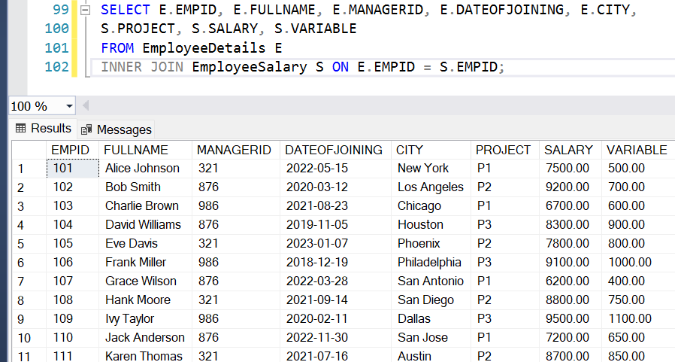
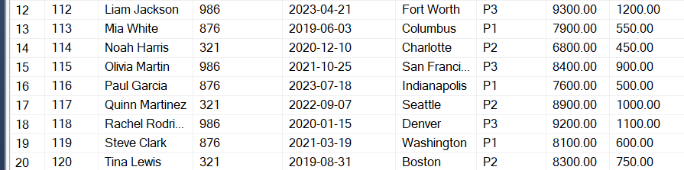

- Write an SQL query to fetch a project-wise count of employees.
Ans: SELECT S.PROJECT, COUNT(E.EMPID) AS EMPLOYEECOUNT
FROM EmployeeDetails E
INNER JOIN EmployeeSalary S ON E.EMPID = S.EMPID
GROUP BY S.PROJECT;
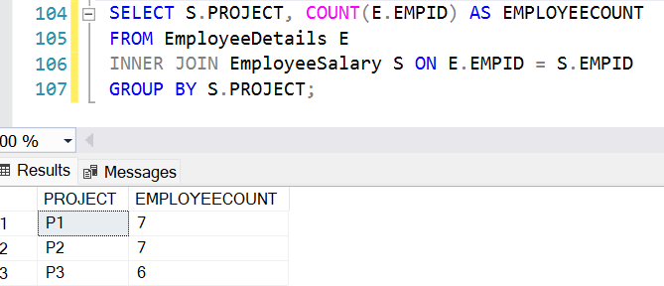

- Fetch employee names and salaries even if the salary value is not present for the employee.
Ans: SELECT E.EMPID, E.FULLNAME, S.SALARY
FROM EmployeeDetails E
LEFT JOIN EmployeeSalary S ON E.EmpId = S.EmpId;
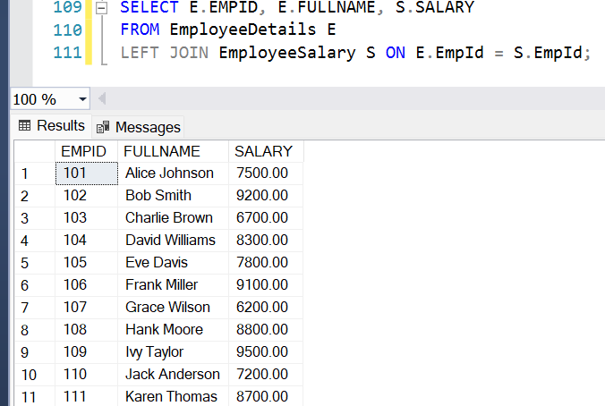
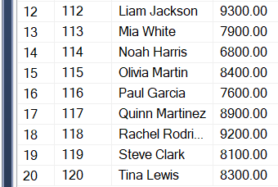

- Write an SQL query to fetch all the Employees who are also managers.
Ans: SELECT DISTINCT M.EMPID, M.FULLNAME,
M.CITY, M.DATEOFJOINING
FROM EmployeeDetails E
JOIN EmployeeDetails M
ON E.ManagerId = M.EMPID;
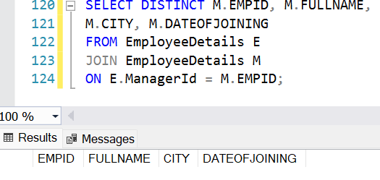
There are no employees who are also managers.

- Write an SQL query to fetch duplicate records from EmployeeDetails.
Ans: SELECT FULLNAME, MANAGERID,
DATEOFJOINING, CITY, COUNT(*) AS DUPLICATECOUNT
FROM EmployeeDetails
GROUP BY FullName, ManagerId,
DateOfJoining, City
HAVING COUNT(*) > 1;
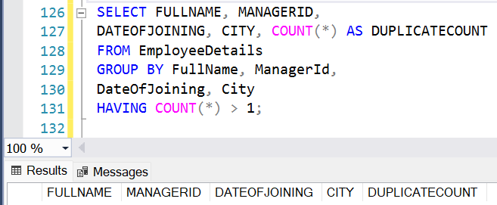
There are no duplicate records.

- Write an SQL query to fetch only odd rows from the table.
Ans: Odd rows from EmployeeDetails:
WITH CTE AS (
SELECT *,
ROW_NUMBER() OVER (ORDER BY EMPID) AS RN
FROM EmployeeDetails)
SELECT EMPID, FULLNAME, MANAGERID, DATEOFJOINING, CITY
FROM CTE
WHERE RN % 2 = 1;
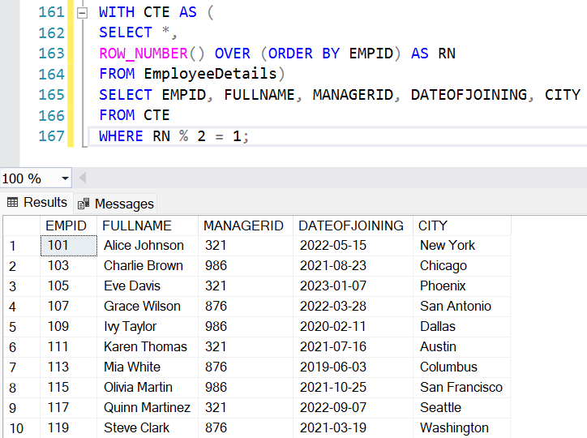

Odd rows from EmployeeSalary:
WITH CTE AS (
SELECT *,
ROW_NUMBER() OVER (ORDER BY EMPID) AS RN
FROM EMPLOYEESALARY)
SELECT EMPID, PROJECT, SALARY, VARIABLE FROM CTE
WHERE RN % 2 = 1;
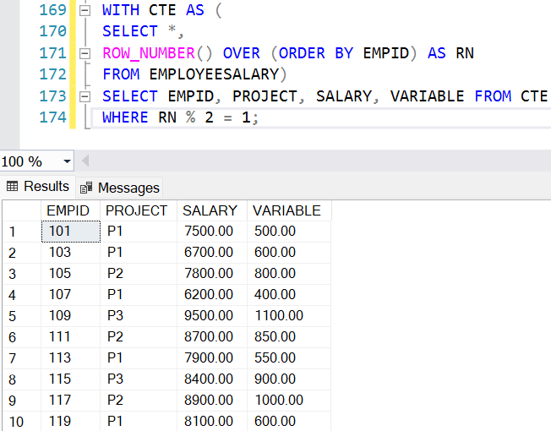

Odd rows from both the tables in one go:
WITH DETAILS AS (
SELECT 'EMPLOYEEDETAILS' AS TABLENAME, EMPID, ROW_NUMBER() OVER (ORDER BY EMPID) AS RN
FROM EmployeeDetails),
SALARY AS (
SELECT 'EMPLOYEESALARY' AS TABLENAME, EMPID, ROW_NUMBER() OVER (ORDER BY EMPID) AS RN
FROM EmployeeSalary)
SELECT TABLENAME, EMPID
FROM DETAILS WHERE RN % 2 = 1
UNION ALL
SELECT TABLENAME, EMPID
FROM SALARY WHERE RN % 2 = 1;
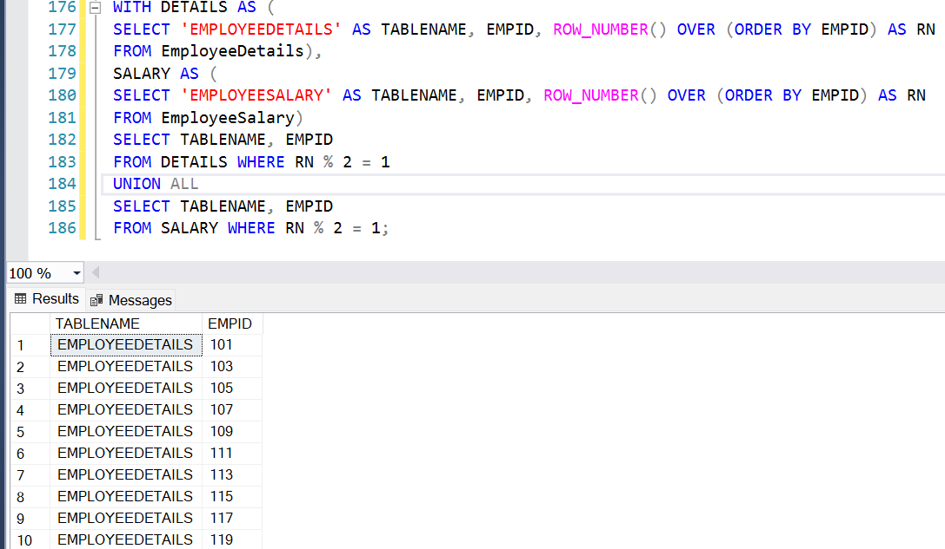
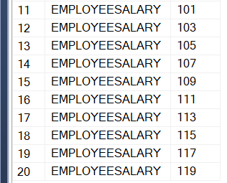

- Write a query to find the 3rd highest salary from a table without top or limit keyword.
Ans: SELECT SALARY
FROM EmployeeSalary S1
WHERE 2 = (
SELECT COUNT(DISTINCT S2.SALARY)
FROM EmployeeSalary S2
WHERE S2.Salary > S1.Salary);
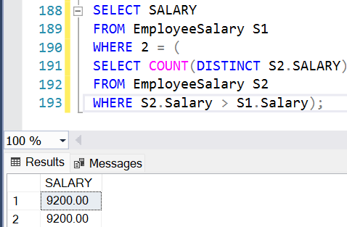

PART- 2
- Write an SQL query to fetch the EmpId and FullName of all the employees working under the Manager with id – ‘986’.
Ans: SELECT EMPID, FULLNAME
FROM EmployeeDetails
WHERE ManagerId = 986;
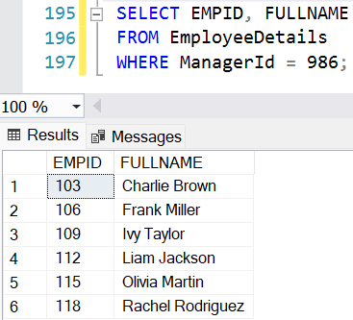

- Write an SQL query to fetch the different projects available from the EmployeeSalary table.
Ans: SELECT DISTINCT PROJECT
FROM EmployeeSalary;
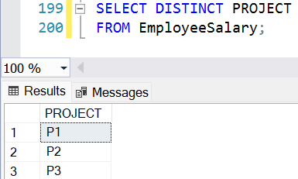

- Write an SQL query to fetch the count of employees working in project ‘P1’.
Ans: SELECT COUNT(EMPID) AS EMPLOYEECOUNT
FROM EmployeeSalary
WHERE Project = 'P1';
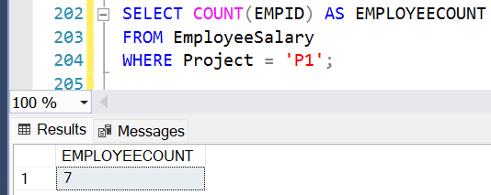

- Write an SQL query to find the maximum, minimum, and average salary of the employees.
Ans: SELECT
MAX(SALARY) AS MAXSALARY,
MIN(SALARY) AS MINSALARY,
AVG(SALARY) AS AVGSALARY
FROM EmployeeSalary;
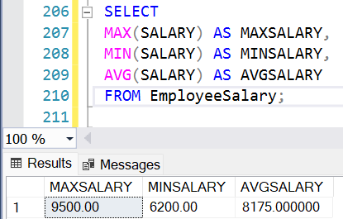

- Write an SQL query to find the employee id whose salary lies in the range of 9000 and 15000.
Ans: SELECT EMPID
FROM EmployeeSalary
WHERE Salary BETWEEN 9000 AND 15000;
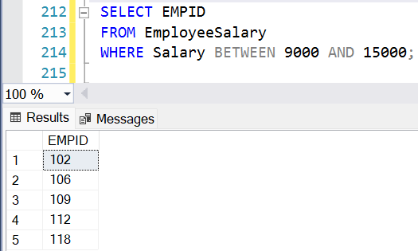

- Write an SQL query to fetch those employees who live in Toronto and work under the manager with ManagerId – 321.
Ans: SELECT EMPID, FULLNAME
FROM EmployeeDetails
WHERE CITY = 'TORONTO'
AND ManagerId = 321;
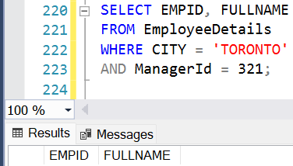

- Write an SQL query to fetch all the employees who either live in California or work under a manager with ManagerId – 321.
Ans: SELECT EMPID, FULLNAME
FROM EmployeeDetails
WHERE CITY = 'CALIFORNIA'
OR ManagerId = 321;
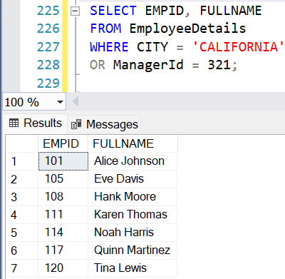

- Write an SQL query to fetch all those employees who work on Projects other than P1.
Ans: SELECT EMPID, PROJECT
FROM EmployeeSalary
WHERE Project <> 'P1';
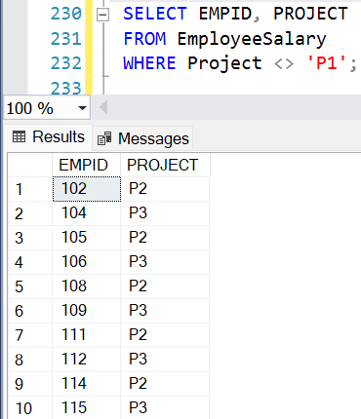
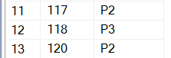

- Write an SQL query to display the total salary of each employee adding the Salary with Variable value.
Ans: SELECT EMPID, (SALARY + VARIABLE) AS TOTALSALARY
FROM EmployeeSalary;
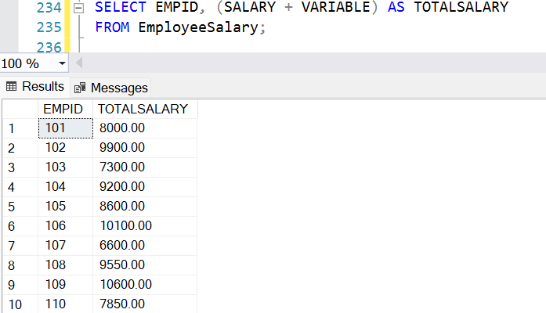
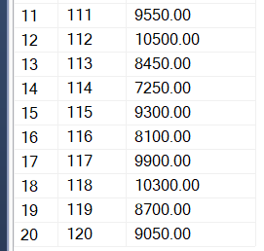

- Write an SQL query to fetch the employees whose name begins with any two characters, followed by a text “hn” and ends with any sequence of characters.

Ans: SELECT EMPID, FULLNAME
FROM EmployeeDetails
WHERE FULLNAME LIKE '%hn%';

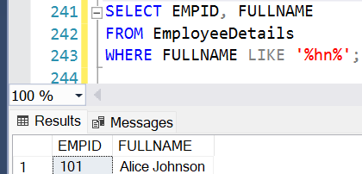

PART- 3
- Write an SQL query to fetch all the EmpIds which are present in either of the tables – ‘EmployeeDetails’ and ‘EmployeeSalary’.
Ans: SELECT EMPID
FROM EmployeeDetails
UNION
SELECT EMPID
FROM EmployeeSalary;
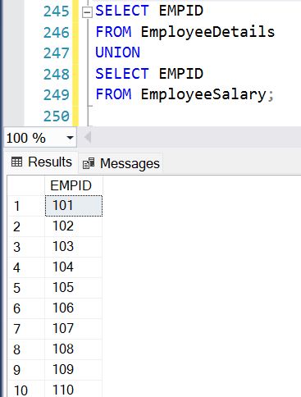
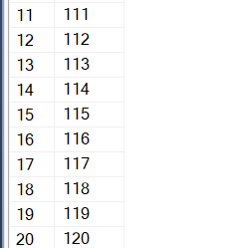

- Write an SQL query to fetch common records between two tables.
Ans: SELECT E.EMPID
FROM EmployeeDetails E
INNER JOIN EmployeeSalary S
ON E.EMPID = S.EMPID;
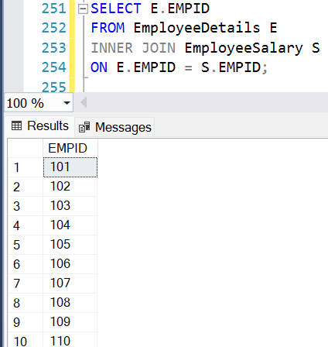
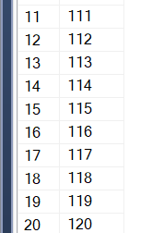

- Write an SQL query to fetch records that are present in one table but not in another table.
Ans: a) Employees in EmployeeDetails but not in EmployeeSalary –
SELECT E.EMPID, E.FULLNAME, E.MANAGERID, E.DATEOFJOINING, E.CITY
FROM EmployeeDetails E
LEFT JOIN EmployeeSalary S ON E.EmpId = S.EmpId
WHERE S.EmpId IS NULL;
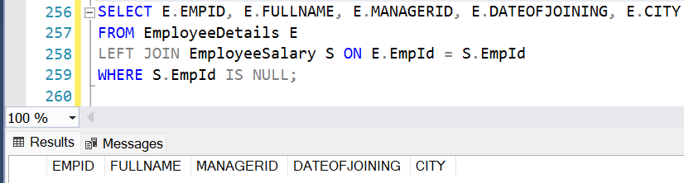
b) Employees in EmployeeSalary but not in EmployeeDetails –
SELECT S.EMPID, S.PROJECT, S.SALARY,S.VARIABLE
FROM EmployeeSalary S
LEFT JOIN EmployeeDetails E ON S.EMPID = E.EMPID
WHERE E.EMPID IS NULL;
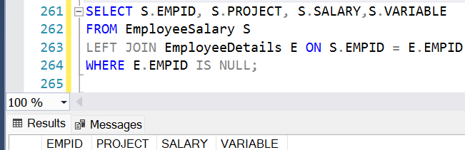
c) Employees that exist only in one table but not both –
SELECT EMPID FROM EmployeeDetails
EXCEPT
SELECT EMPID FROM EmployeeSalary
UNION
SELECT EMPID FROM EmployeeSalary
EXCEPT
SELECT EMPID FROM EmployeeDetails;
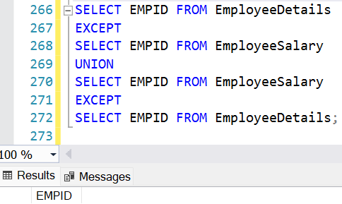

- Write an SQL query to fetch the EmpIds that are present in both the tables – ‘EmployeeDetails’ and ‘EmployeeSalary’.
Ans: SELECT EMPID FROM EmployeeDetails
INTERSECT
SELECT EMPID FROM EmployeeSalary;
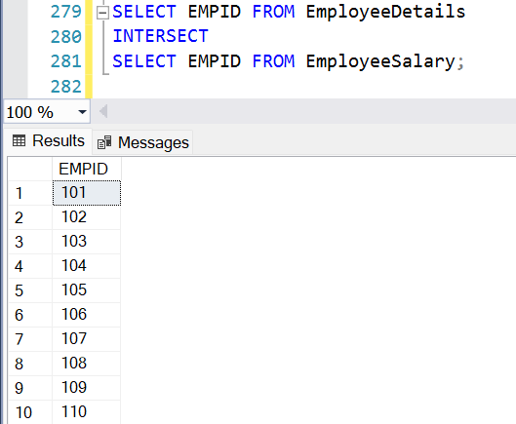
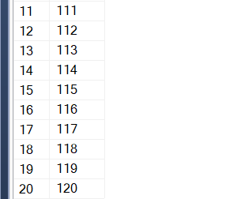

- Write an SQL query to fetch the EmpIds that are present in EmployeeDetails but not in EmployeeSalary.
Ans: SELECT E.EMPID
FROM EmployeeDetails E
LEFT JOIN EmployeeSalary S ON E.EMPID = S.EMPID
WHERE S.EMPID IS NULL;
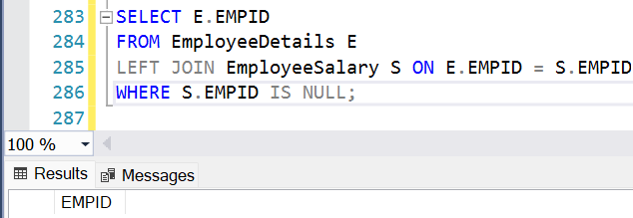

- Write an SQL query to fetch the employee‟s full names and replace the space
Ans: SELECT EMPID, REPLACE(FULLNAME, ' ', '_') AS FULLNAME_NOSPACE
FROM EmployeeDetails;
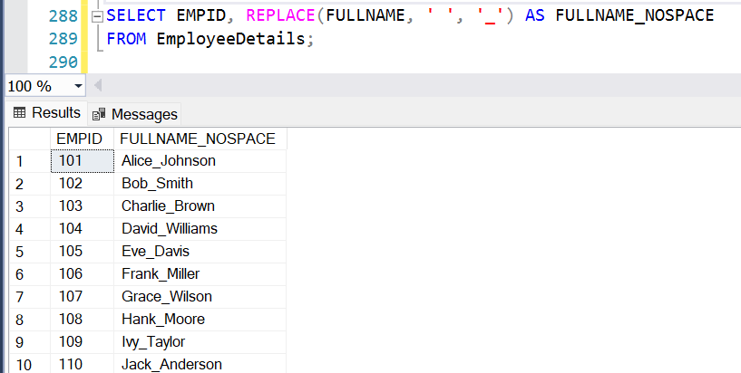


- Write an SQL query to fetch the position of a given character(s) in a field.
Ans: SELECT EMPID, FULLNAME,
CHARINDEX('HN', FULLNAME) AS POSITIONOFCHAR
FROM EmployeeDetails;
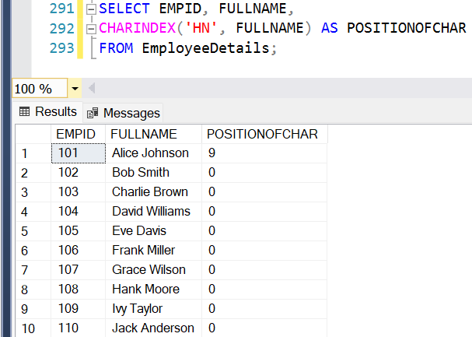


- Write an SQL query to display both the EmpId and ManagerId together.
Ans: SELECT EMPID, MANAGERID,
CAST(EMPID AS VARCHAR) + '_' + CAST(MANAGERID AS VARCHAR) AS EMP_MANAGER
FROM EMPLOYEEDETAILS;
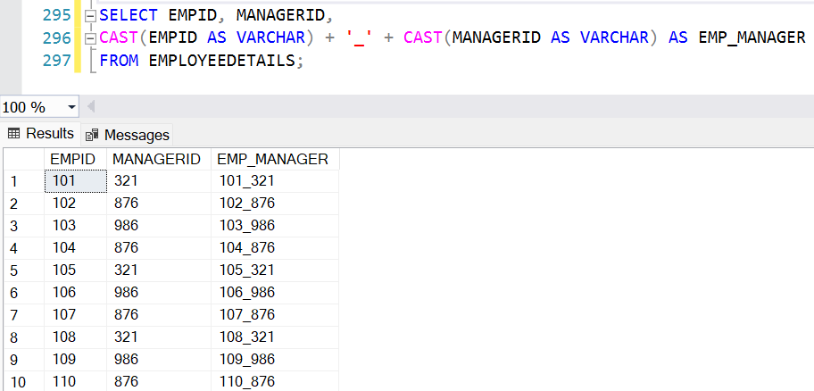


- Write a query to fetch only the first name(string before space) from the FullName column of the EmployeeDetails table.
Ans: SELECT EMPID,
LEFT(FULLNAME, CHARINDEX(' ', FULLNAME) - 1) AS FIRSTNAME
FROM EmployeeDetails;
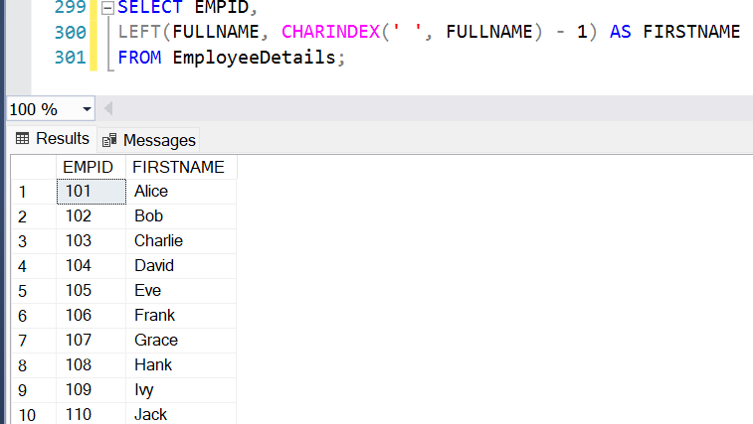


- Write an SQL query to uppercase the name of the employee and lowercase the city values.
Ans: SELECT EMPID,
UPPER(FULLNAME) AS UPPERCASENAME,
LOWER(CITY) AS LOWERCASECITY
FROM EmployeeDetails;
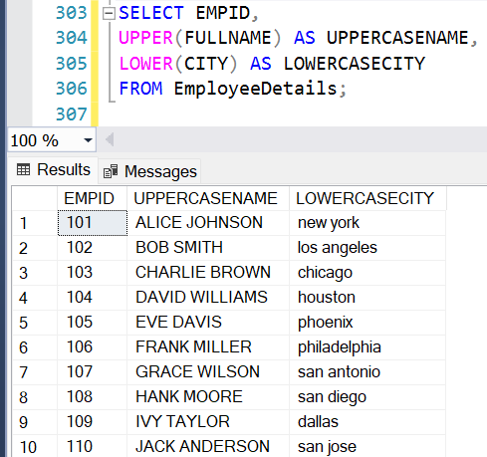
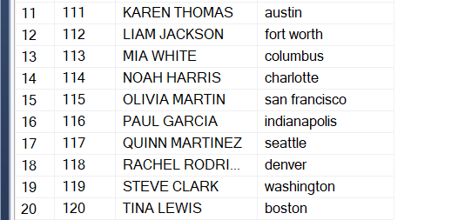

PART- 4
- Write an SQL query to find the count of the total occurrences of a particular character – ‘n’ in the FullName field.
Ans: SELECT EMPID, FULLNAME,
(LEN(FULLNAME) - LEN(REPLACE(FULLNAME, 'N', ' '))) AS N_COUNT
FROM EmployeeDetails;
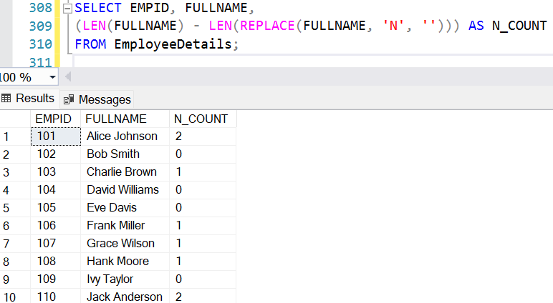


- Write an SQL query to update the employee names by removing leading and trailing spaces.
Ans: UPDATE EmployeeDetails
SET FULLNAME = LTRIM(RTRIM(FULLNAME));
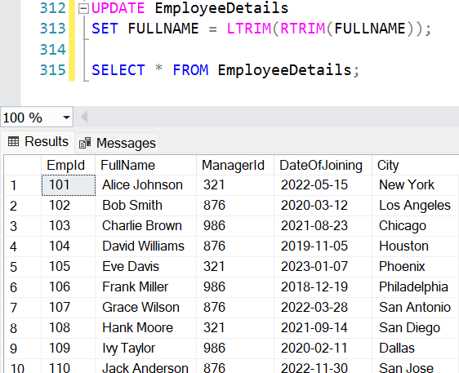
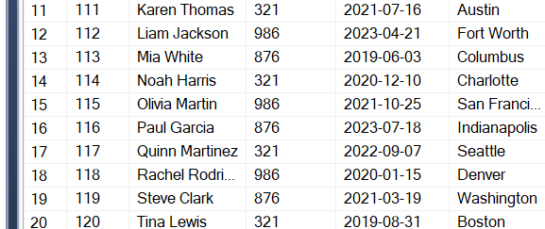

- Fetch all the employees who are not working on any project.
Ans: SELECT E.EMPID, E.FULLNAME, E.CITY
FROM EmployeeDetails E
LEFT JOIN EmployeeSalary S ON E.EMPID = S.EMPID
WHERE S.Project IS NULL OR S.Project = ' ';
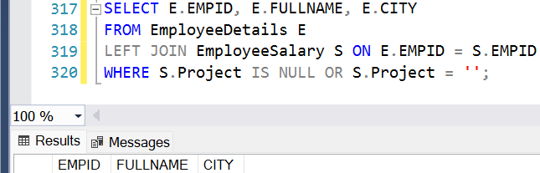

- Write an SQL query to fetch employee names having a salary greater than or equal to 5000 and less than or equal to 10000.
Ans: SELECT E.EMPID, E.FULLNAME, S.SALARY
FROM EmployeeDetails E
INNER JOIN EmployeeSalary S ON E.EMPID = S.EmpId
WHERE S.Salary BETWEEN 5000 AND 10000;
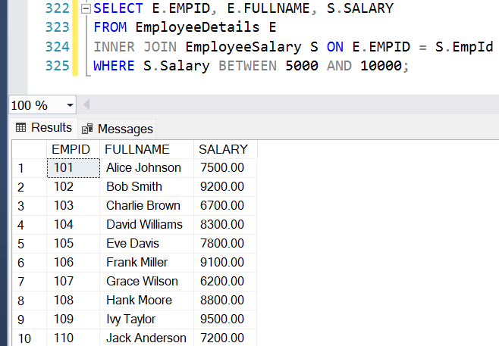


- Write an SQL query to find the current date-time.
Ans: SELECT GETDATE() AS CURRENTDATETIME;
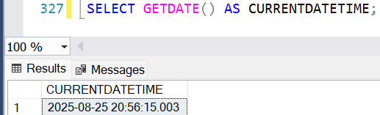

- Write an SQL query to fetch all the Employee details from the EmployeeDetails table who joined in the Year 2020.
Ans: SELECT * FROM EmployeeDetails
WHERE YEAR(DATEOFJOINING) = 2020;
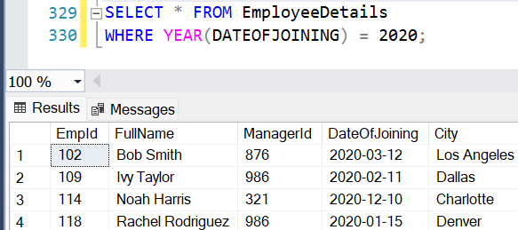

- Write an SQL query to fetch all employee records from the EmployeeDetails table who have a salary record in the EmployeeSalary table.
Ans: SELECT E.*
FROM EmployeeDetails E
INNER JOIN EmployeeSalary S
ON E.EmpId = S.EmpId;
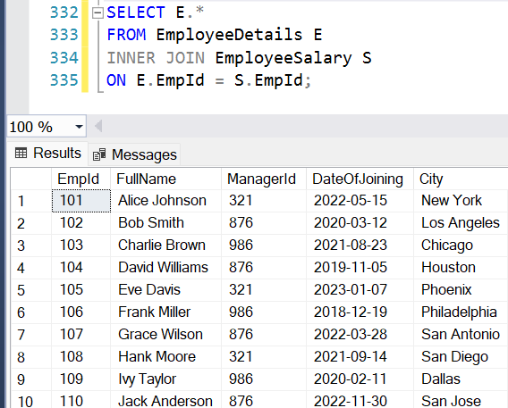
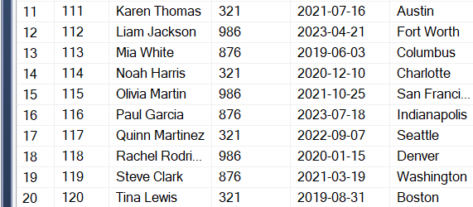

- Write an SQL query to fetch the project-wise count of employees sorted by project’s count in descending order.
Ans: SELECT S.PROJECT, COUNT(S.EMPID) AS EMPLOYEECOUNT
FROM EmployeeSalary S
GROUP BY S.PROJECT
ORDER BY EMPLOYEECOUNT DESC;
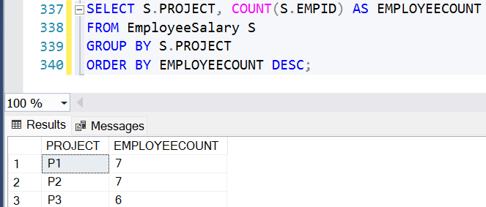

- Write a query to fetch employee names and salary records. Display the employee details even if the salary record is not present for the employee.
Ans: SELECT E.EMPID, E.FULLNAME,
E.MANAGERID, E.DATEOFJOINING,
E.CITY, S.PROJECT,
S.SALARY, S.VARIABLE
FROM EmployeeDetails E
LEFT JOIN EmployeeSalary S
ON E.EMPID = S.EMPID;
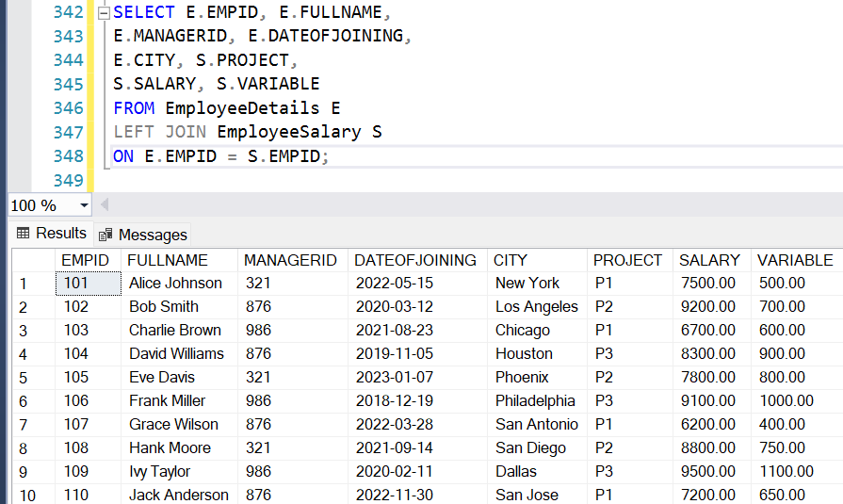
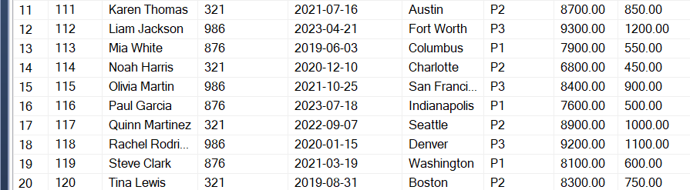

- Write an SQL query to join 3 tables.
Ans: General query:
SELECT A.COLUMN1, B.COLUMN2, C.COLUMN3
FROM TABLEA A
INNER JOIN TABLEB B
ON A.COMMON_COLUMN = B.COMMON_COLUMN
INNER JOIN TABLEC C
ON B.COMMON_COLUMN = C.COMMON_COLUMN;
--Query for above 2 tables and additional 3rd table as Department —
SELECT E.EMPID, E.FULLNAME,
E.CITY, S.PROJECT,
S.SALARY, D.DEPTNAME
FROM EmployeeDetails E
INNER JOIN EmployeeSalary S
ON E.EMPID = S.EmpId
INNER JOIN DEPARTMENT D
ON E.EmpId = D.EMPID;

