**Weather App Client Setup and Instructions**

Client: ** Part II of assignment

**GitHub URL** 🡪 <https://github.com/bhagyaShilagani/WeatherApp/tree/master/client/>

1. Download(**weatherApp.zip**) and extract files to any local web server. I am using a json-server, copy files into the public folder of a webserver.
2. To install json-server go to 🡪 <https://github.com/typicode/json-server>
3. 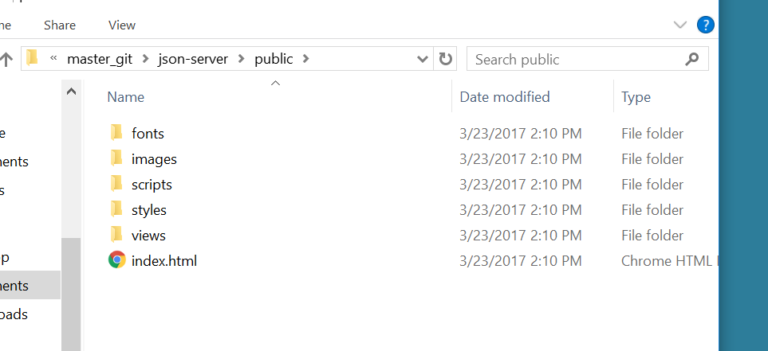
4. Start json-server, client can be accessed at <http://localhost:3000/#!/>
5. Client Weather App shows weather forecast for Zipcode: 60203 as default
6. 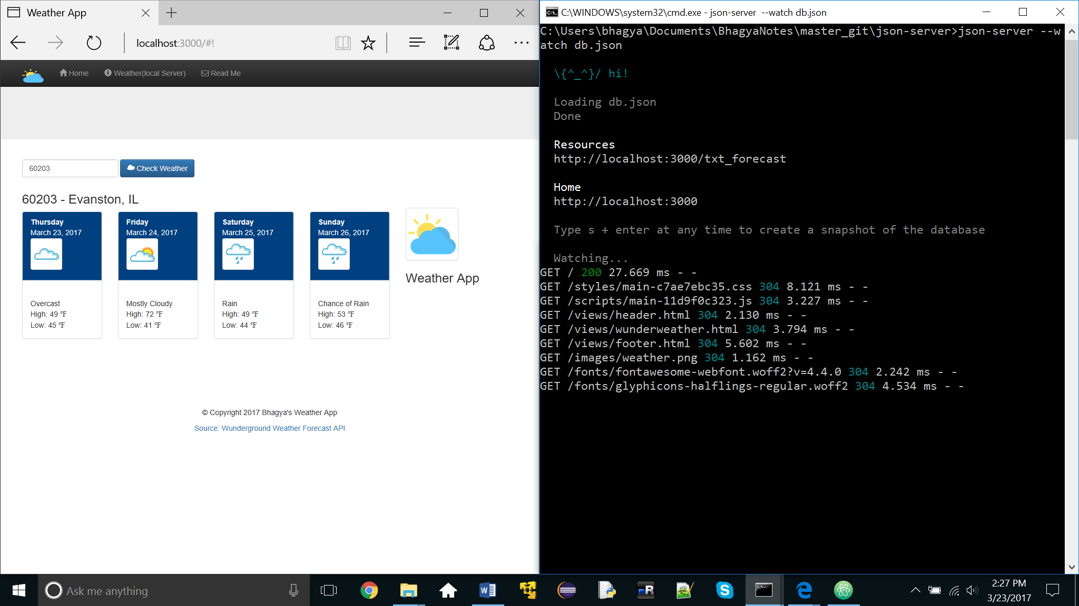
7. Server log file on start up
8. 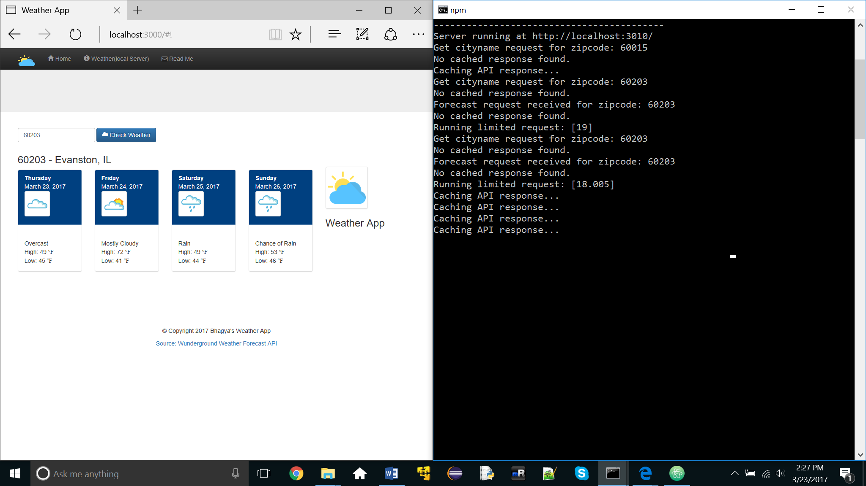
9. If server is not running following error message is displayed
10. 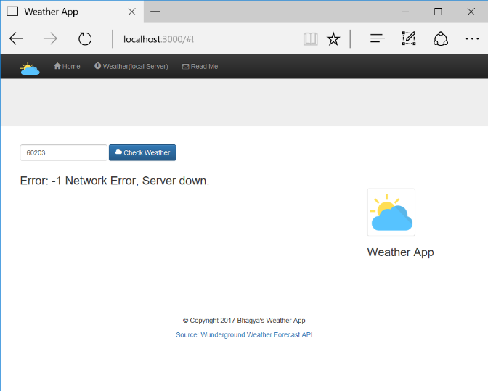
11. While client is waiting for server response, following message is displayed
12. 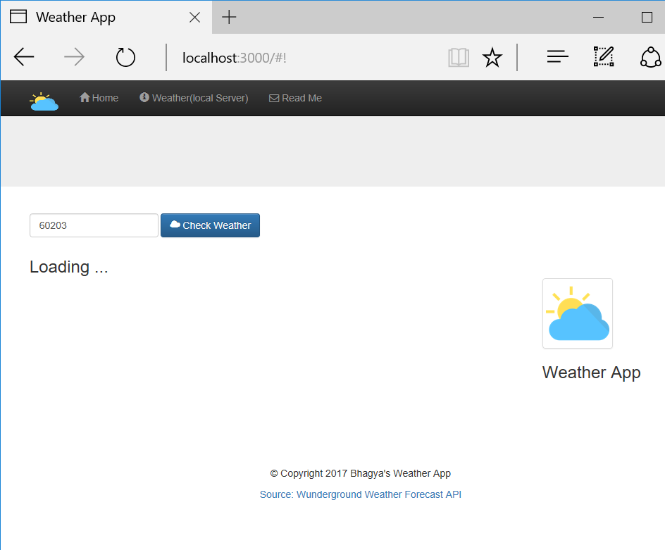
13. No Results found for wrong input
14. 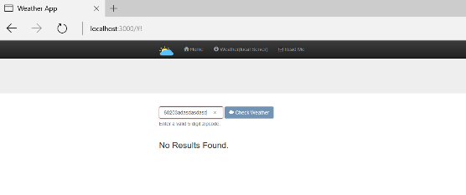

**\*\* AngularJS Client Setup and Instructions**

**Server runs on port: 3010**

**Client App runs on port: 3001, Start server before starting client**

1. download zip file (weatherApp.zip) from

**GitHub URL** 🡪 <https://github.com/bhagyaShilagani/WeatherApp/tree/master/client/weatherApp.zip>

1. Extract weatherApp.zip to ..\weatherApp folder
2. Install following node modules under ..\weatherApp\. Skip this step if you already have these modules installed
   1. Install Node and npm, to install Node on your machine, go to → https://nodejs.org and click on the Download button
   2. To check if they were installed check version: node -v, npm -v
   3. npm bower
   4. npm install -g gulp
   5. npm install gulp --save-dev
   6. npm install jshint gulp-jshint jshint-stylish gulp-imagemin gulp-concat gulp-uglify gulp-minify-css gulp-usemin gulp-cache gulp-changed gulp-rev gulp-rename gulp-notify browser-sync del --save-dev
3. bower update
4. npm install
5. gulp
6. gulp watch 🡪 Starts Client
7. Folder Structure

