Backend: \*\* Part I of assignment

\*\* Installation Instructions

Install Node and npm

To install Node on your machine, go to https://nodejs.org and click on the Download button

npm install express-generator -g

express server

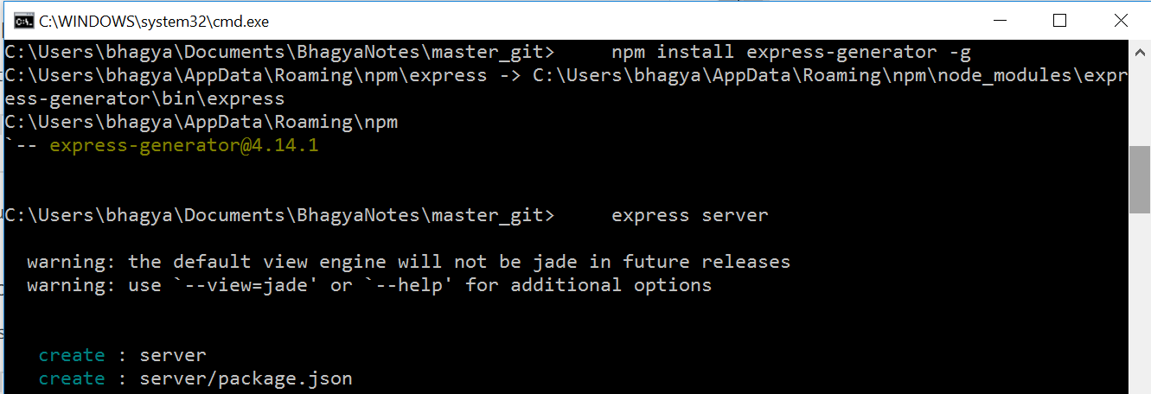

cd server && npm install

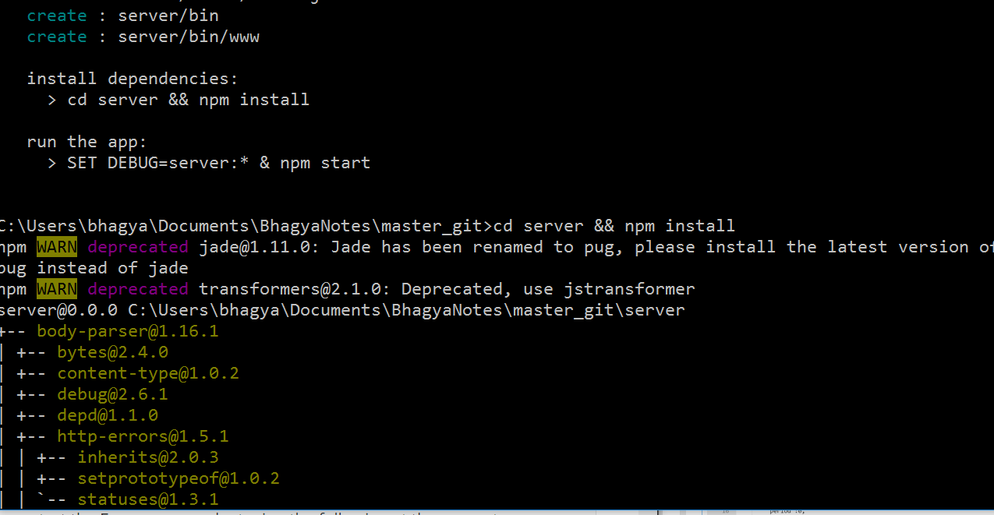

npm install request –save

npm install limiter –save

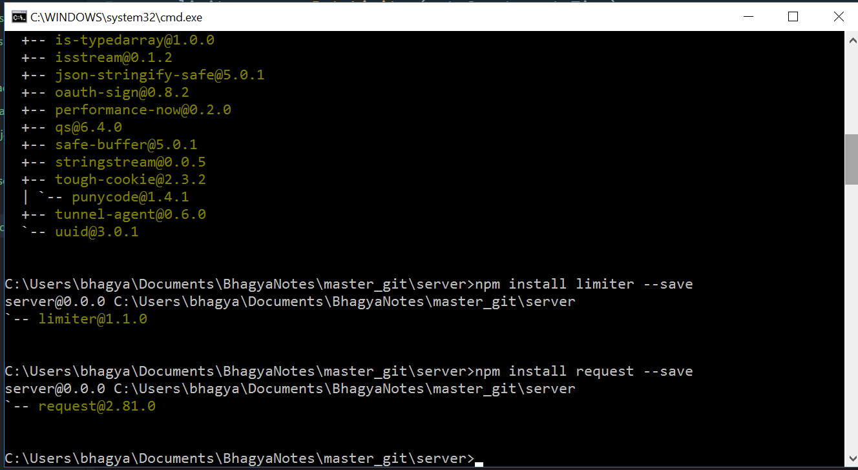

Download from GitHub to ..\server\ folder

app.js: <https://github.com/bhagyaShilagani/WeatherApp/blob/master/server/app.js>

weatherNode.js: https://github.com/bhagyaShilagani/WeatherApp/blob/master/server/weatherNode.js

npm start

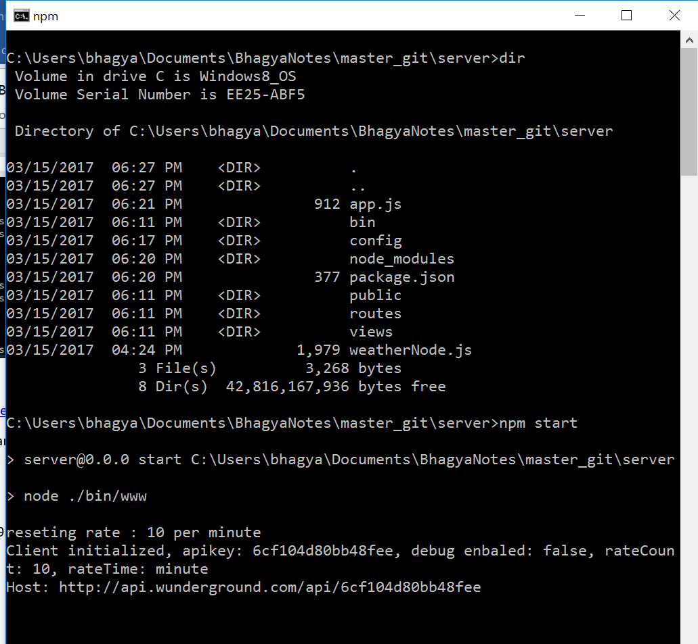

Tested Server operation using Postman (https://www.getpostman.com/)

Make a get request: localhost:3000/forecast?60089

