SIMATS ENGINEERING
ASSESSMENT TOOL 2
COURSE CODE: CSA04 COURSE NAME: Operating Systems
COURSE OUTCOME COVERED
CO1: Apply the concepts of Operating System types, structures, and system calls to demonstrate their functions in various computing environments. (BL2, BL3)
Assessment Tool Weightage: 35%
QUESTIONS: 5 Total Marks:25 Annexure A
Concept Mapping
Code of Conduct:
I M Bhagyalakshmi(192525439) (Name / Reg No) certify that this submission is my original work and that I have adhered to the guidelines specified for this assessment.
I understand that any violation of academic integrity rules will result in disciplinary action. Signature of the student:M Bhagyalakshmi
Annexure A
Concept Mapping
Question 1 10 Marks
Concept Mapping: Operating System Components and Services
An Operating System provides several services to users and application programs. Task:
Match each Operating System Component with the most appropriate Operating System Service and explain the relationship.
Components | Services
Process Manager | File Management
Memory Manager | Process Execution
File Manager | Memory Allocation
Device Manager | I/O Operations
Security Manager | Protection & Security

After mapping, explain how these components collectively improve overall system performance.
Question 2 10 Marks
Concept Mapping: System Calls and Operating System Services
An application performs the following operations:
• Creates a new process
• Reads a file
• Allocates memory
• Sends data through a pipe
• Terminates execution
Task:
Map each operation to the appropriate system call category.
Operations | Categories
Create Process | Communication
Read File | File Management
Allocate Memory | Process Control
Send Data | Memory Management
Exit Process | Process Control

Write one example system call corresponding to each mapped category.
RUBRICS FOR CALCULATION
Criteria | Weightage | Level 4 (Exemplary) | Level 3 (Proficient) | Level 2  (Developing) | Level 1  (Beginning)
Concept  Identification | 25% | Identifies all key  concepts from literature accurately and  comprehensively | Identifies most key concepts with minor omissions | Identifies limited concepts; some  are irrelevant or missing | Fails to  identify  essential  concepts
Linkages | 25% | Establishes clear,  meaningful, and accurate relationships between concepts | Shows correct  relationships with  minor gaps | Relationships are weak, unclear, or partially incorrect | No  meaningful  relationships established
Organization | 20% | Concepts are well  structured hierarchically with logical flow and grouping | Mostly organized  with minor structural issues | Some  organization but lacks clear  hierarchy | No logical  organization  or structure
Integration of Literature | 20% | Integrates multiple  studies effectively to  show connections and comparisons | Shows some  integration of  literature | Limited  integration;  mostly isolated  concepts | No integration of literature  evidence
Clarity | 10% | Concept map is clear, neat, visually structured, and easy to interpret | Generally clear with minor readability  issues | Clarity is  reduced; difficult to interpret in  parts | Poorly  presented and hard to  understand

Marks Evaluation:
Question  No. | Concept  Identification (25%) | Linkages  (25%) | Organization  (20%) | Integration of Literature  (20%) | Clarity  (10%) | Total Marks  (100%)
Q1
Q2
Total

Question 1: Concept Mapping – Operating System Components and Services
In the question, the two columns are listed in a mixed-up order. Matching each component with the service it actually provides gives the following mapping:
Component | Matched Service | Relationship (how the component provides the service)
Process Manager | Process Execution | Creates, schedules, synchronizes and terminates processes. It decides which process gets the CPU and for how long (using the PCB, scheduler and dispatcher), so that programs are actually executed.
Memory Manager | Memory Allocation | Keeps track of free and used memory, allocates memory to a process when it is loaded and takes it back when the process ends. Uses paging, segmentation and virtual memory, and keeps one process’s memory separate from another’s.
File Manager | File Management | Organizes data into files and directories and handles create, open, read, write and delete operations. Manages disk space, file naming and file permissions.
Device Manager | I/O Operations | Controls hardware devices through device drivers. Uses buffering, caching, spooling and interrupt handling to carry out input/output requests of programs.
Security Manager | Protection & Security | Authenticates users, enforces access rights, isolates processes and protects data and resources from unauthorized access, so the system stays safe and reliable.

Concept map: the next page shows the concept map of the above mapping (Operating System → Components → Services → Overall performance).
How these components collectively improve overall system performance
CPU utilization and throughput: The Process Manager keeps the CPU busy by scheduling another process whenever one is waiting for I/O (multiprogramming), so more work is completed in less time.
Efficient use of memory: The Memory Manager allows many processes to stay in main memory together and uses virtual memory, so memory is not wasted and the CPU is rarely idle.
Faster data access: The File Manager’s directory structure, free-space management and caching reduce the time needed to find and read data.
Overlapped I/O: The Device Manager’s buffering and spooling let slow devices work in the background while the CPU continues computing.
Stability and safety: The Security Manager prevents faulty or malicious programs from damaging other processes or data, which avoids crashes and slow-downs.
Coordination: The components work together. For example, when a program reads a file, the Security Manager checks permission, the File Manager locates the file, the Memory Manager provides a buffer, the Device Manager drives the disk, and the Process Manager runs another process while the first one waits.
Conclusion: Each component handles one specific service, but together they provide fast, fair, efficient and secure use of the computer’s resources, which improves the overall system performance.

Concept Map – Question 1: Operating System Components and Services
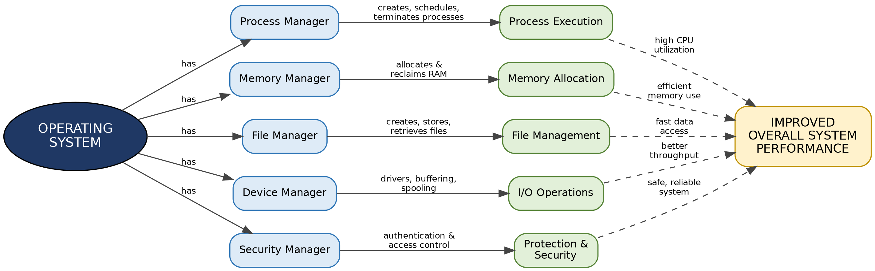
Reading the map: solid arrows show which service each component provides; dashed arrows show how each service contributes to overall system performance.

Question 2: Concept Mapping – System Calls and Operating System Services
A system call is the way a user program requests a service from the operating system kernel (the program switches from user mode to kernel mode, the OS performs the service, then control returns to the program). The operations of the application are mapped to the system call categories as follows (the categories in the question are also listed in mixed-up order):
Operation | System Call Category | Example System Call (Linux / Windows)
Create Process | Process Control | fork() (then exec()) / CreateProcess()
Read File | File Management | open() and read() / ReadFile()
Allocate Memory | Memory Management | brk() or mmap() / VirtualAlloc()
Send Data (through a pipe) | Communication | pipe() to create, write() to send / CreatePipe(), WriteFile()
Exit Process | Process Control | exit() / ExitProcess()

Note: malloc() is a C library function; internally it uses the system calls brk() or mmap() to get memory from the OS.
One example system call for each mapped category
Category | Example System Call | Purpose
Process Control | fork() | Creates a new (child) process by duplicating the calling process. exit() ends a process.
File Management | read() | Reads data from an open file (opened with open()) into a buffer in memory.
Memory Management | mmap() | Maps memory into the process’s address space, i.e. allocates memory to the process.
Communication | pipe() | Creates a pipe (one-way channel); data written with write() at one end is read at the other end by another process.

Explanation of the mapping
Create Process → Process Control: starting a new process changes the set of running processes, which is controlled by the OS (creating, loading, executing, ending, waiting).
Read File → File Management: the program asks the OS to open a file and read its data; the OS checks permissions and performs the disk access.
Allocate Memory → Memory Management: the OS gives the process more memory in its address space and keeps track of it.
Send Data → Communication: a pipe is an inter-process communication (IPC) mechanism, so sending data through it is a communication call.
Exit Process → Process Control: the OS releases all resources of the process (memory, open files) and informs the parent process.
Conclusion: The application never touches hardware or kernel data directly. It uses system calls grouped into categories, and the OS performs the corresponding service safely on its behalf. The concept map is on the next page.
References: Silberschatz, Galvin and Gagne, Operating System Concepts; Tanenbaum and Bos, Modern Operating Systems.

Concept Map – Question 2: System Calls and Operating System Services
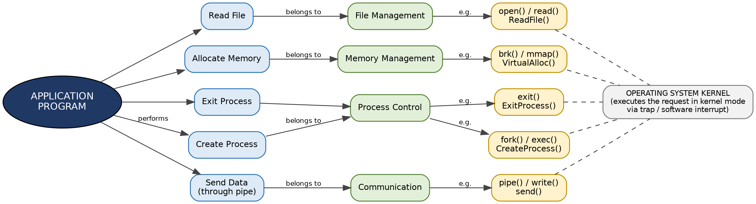
Reading the map: each operation of the application belongs to a system call category; each category has example system calls (Linux / Windows), which are all executed by the OS kernel.

