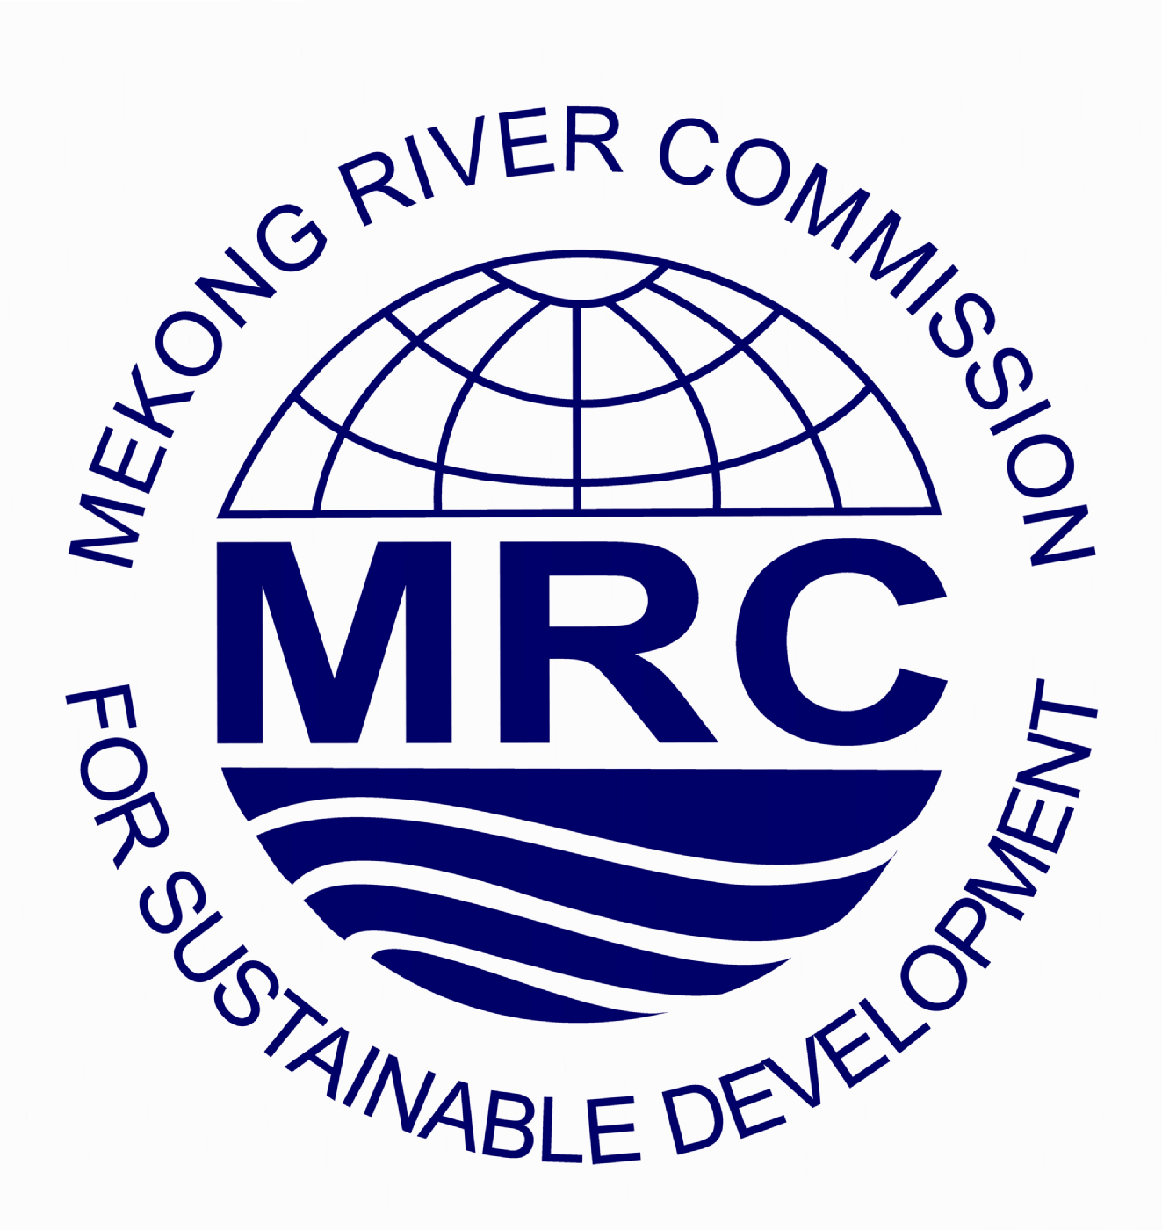

Mekong River Commission

The role of MRC is to promote and coordinate sustainable management and development of water and related resources for the countries’ mutual benefit and the people’s well-being

MRC Secretariat is now recruiting a highly qualified consultant for the following consultancy

International Technical Advisor

Consultant type  Division/Section | :  : | International Consultant (Individual)  Drought Management Programme (DMP), Operations Division (OPD)
Work location | : | Office of MRC Secretariat in Phnom Penh, Cambodia
Contract type/ Duration | : | 12 months service contract

Key Responsibilities:

- Support DMP Coordinator in identification of scope, technical requirements and required resources for analyses of vulnerability, capacity need and formulation of strategy, as scenario and other assessment of water demand and supply;
- Guide the Drought Specialists to work closely with MRC Programmes, working groups and other partners to ensure the delivery of quality analyses and assessments;
- Assist DMP Coordinator in formulating, managing the DMP activities relating to programme level review and assessment, including provision of technical inputs of expertise areas;
- Assist DMP team in drafting inception report, manage and contribute to the drafting of the important reports and strategic documents of DMP;
- Guide DMP team on development of drought monitoring and forecasting system for the LMB focussing on meteorological, hydrological, and agricultural indicators;
- Advise DMP team on assessment of water resources availability and needs for different land uses/crops in drought risk areas of the LMB;
- Provide advice to the DMP team on implementation of basin-wide assessment on climate change impacts in drought severity occurrence;
- Support DMP Coordinator in preparing progress reports and other routine reports in accordance with MRCS procedures and specific requirements of the programme;
- Identify training and capacity building needs with emphasis on complex drought vulnerability;
- Assist the DMP Coordinator in the analysis of the needs for training/capacity building for drought mitigation planning at country and regional level;
- Work closely with the Integrated Capacity Building Programme and other DMP specialists to support the design and implementation of DMP-related training/capacity building activities;
- Provide technical directions and inputs including preparation of training materials and guidelines for the design and implementation of training/capacity development activities of the DMP;
- Assist the DMP Team in the facilitation, technical support and monitoring of the capacity development activities at country level;
- Provide inputs under areas of responsibility to the Programme Implementation Plan (PIP), Annual work plan and reporting;
- Perform other relevant tasks assigned by the DMP Coordinator.

Qualifications/Requirements:
  - Advanced University or higher degree(s) in agriculture, environment, natural resource management or related fields (PhD degree is an advantage) with at least 15 years work experience;
  - At least 10 years of experience with drought management project/programme;
  - Advanced knowledge and experience with drought vulnerability and impact assessment analysis using various drought indicator indices;
  - Knowledge of land use planning and socio economic analysis is an advantage;
  - Advanced knowledge and experience in GIS and remote sensing analysis is an advantage;
  - Good knowledge of modern planning techniques is highly desirable;
  - Practical experience in the region with international technical cooperation and/or funding and development agencies;
  - Previous experience in the Mekong basin, preferably working with or for the Mekong River Commission;
  - Fluency in English, both written and spoken, is required;
  - Good knowledge on Microsoft Office.

The Terms of Reference and other information can be obtained from the MRC website http://www.mrcmekong.org/working-with-mrc/employment. Qualified female candidates are encouraged to apply. Only short-listed candidates will be notified.

Application procedures:
The application should include (i) a cover letter outlining clearly how the candidate meets the requirements of the position, (ii) a detailed CV, and (iii) MRC Personal History Form. The position title and section/division must be indicated in the cover letter.

The application should be sent to:
Mekong River Commission
Office of the Secretariat in Vientiane (OSV)
P.O. Box 6101, 184 Fa Ngoum Road
Vientiane 01000, Lao PDR
Email: mrcs@mrcmekong.org
Closing date for applications: 27 March 2015

