1.True Mobile Corporation Thailand

|  |
| --- |
| 18 True Tower Ratchapisek Road Huay Kwang, Bangkok 10310 Thailand |
|  | Tel: +66 2643 1111 Fax: +66 2643 1651 |

2. TP Link Thailand

3. Seagate Thailand

4. Thai Com PLC

5. Fuji Electric

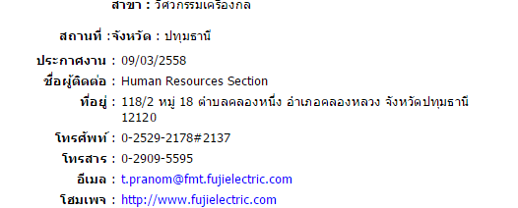

6. Digital Com

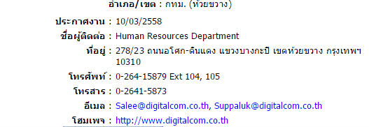

7. CAT Telecom

8. Netksystem (<http://netkasystem.co.th/>)

9. CAT Telecom

10. AIS

11. Dtac

12. Cisco Thailand

13. Jasmine international

14`. Job Top Gun

This is a recruitment agency, they do visit carrier fair, they have visited the Kmutt career fair last month , so hope fully they will come if you invite