**Human Activity Recognition**

**Dataset description**

The experiments have been carried out with a group of 30 volunteers within an age bracket of 19-48 years. Each person performed six activities (WALKING, WALKING_UPSTAIRS, WALKING_DOWNSTAIRS, SITTING, STANDING, LAYING) wearing a smartphone (Samsung Galaxy S II) on the waist. Using its embedded accelerometer and gyroscope, we captured 3-axial linear acceleration and 3-axial angular velocity at a constant rate of 50Hz. The experiments have been video-recorded to label the data manually. The obtained dataset has been randomly partitioned into two sets, where 70% of the volunteers was selected for generating the training data and 30% the test data.The sensor signals (accelerometer and gyroscope) were pre-processed by applying noise filters and then sampled in fixed-width sliding windows of 2.56 sec and 50% overlap (128 readings/window). The sensor acceleration signal, which has gravitational and body motion components, was separated using a Butterworth low-pass filter into body acceleration and gravity. The gravitational force is assumed to have only low frequency components, therefore a filter with 0.3 Hz cutoff frequency was used. From each window, a vector of features was obtained by calculating variables from the time and frequency domain. Check the README.txt file for further details about this dataset. A video of the experiment including an example of the 6 recorded activities with one of the participants can be seen in the following link: [[Web Link]](http://www.youtube.com/watch?v=XOEN9W05_4A)  
An updated version of this dataset can be found at [[Web Link]](http://archive.ics.uci.edu/ml/datasets/Smartphone-Based+Recognition+of+Human+Activities+and+Postural+Transitions). It includes labels of postural transitions between activities and also the full raw inertial signals instead of the ones pre-processed into windows.

**Attribute Information:**

For each record in the dataset it is provided: - Triaxial acceleration from the accelerometer (total acceleration) and the estimated body acceleration. - Triaxial Angular velocity from the gyroscope. - A 561-feature vector with time and frequency domain variables. - Its activity label. - An identifier of the subject who carried out the experiment.

**EDA (Exploratory data analysis)**

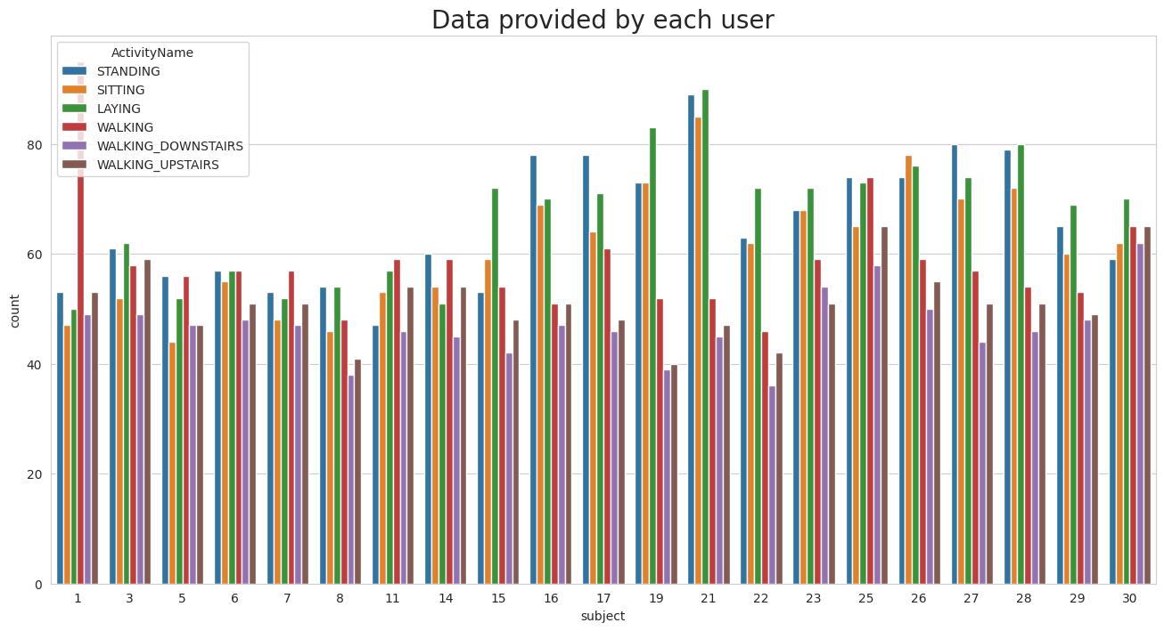

Fig.1 participant’s activity durations

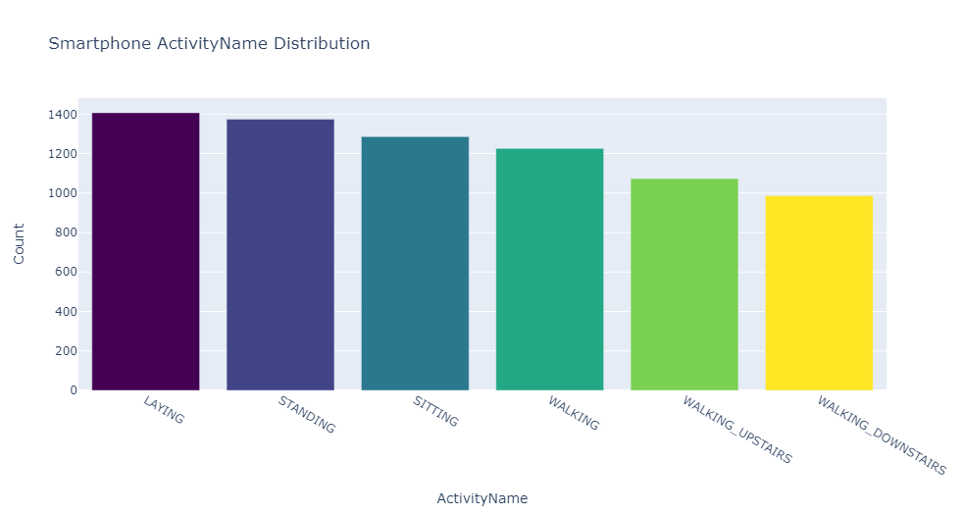

Fig 2. Smart phone activity distribution

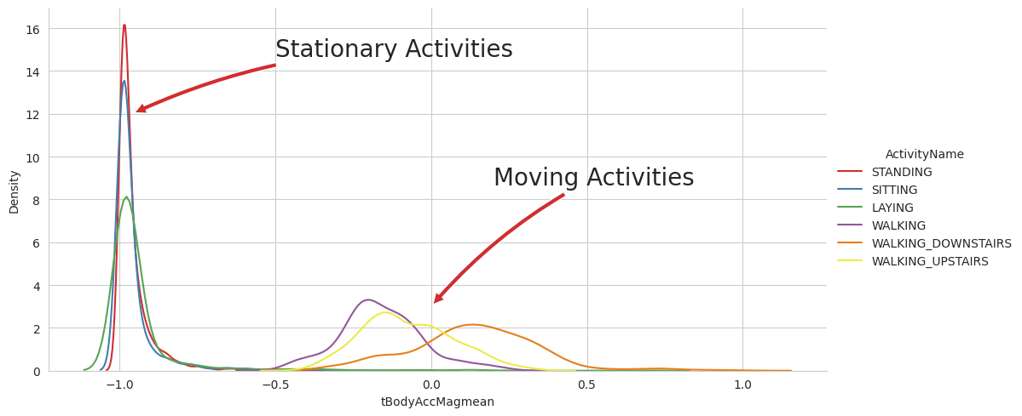

Fig.3 the distribuation of Stationary Activities and Moving Activities

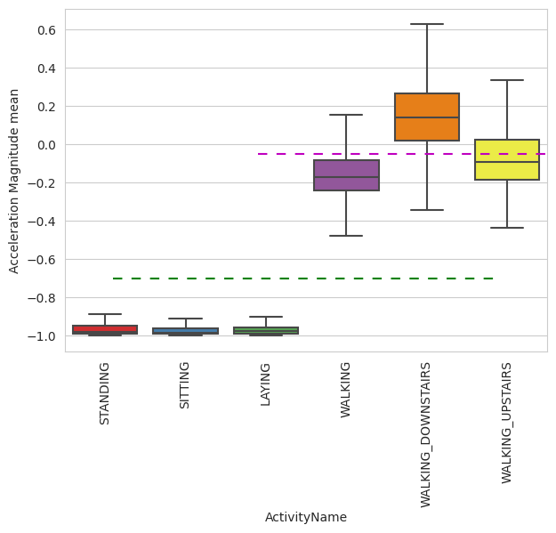

### Fig 4 Magnitude of an acceleration

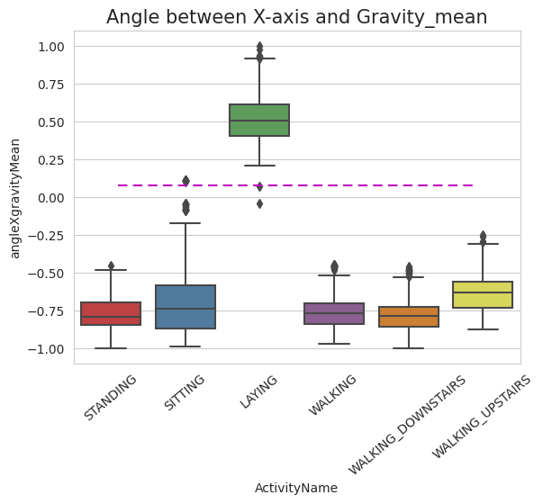

### Fig 5. Position of GravityAccelerationComponants

## **Apply t-sne on the data**

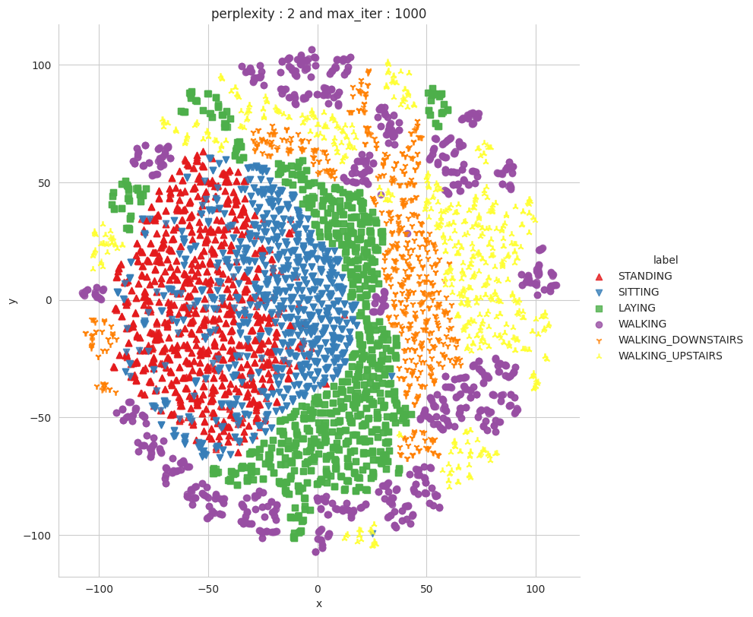

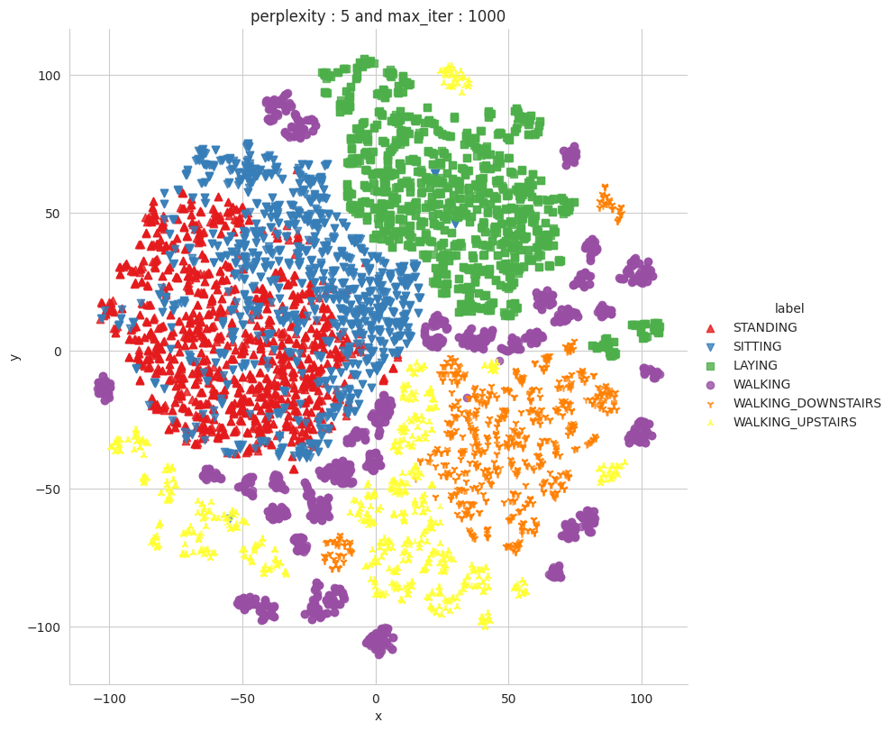

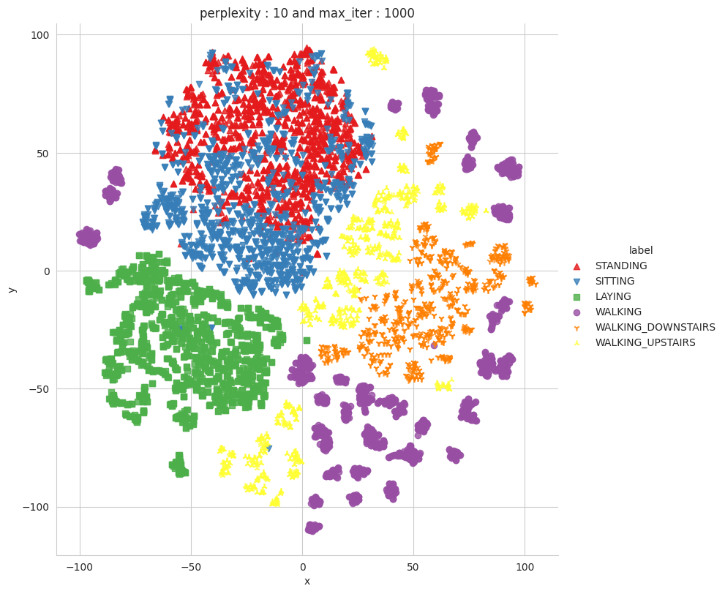

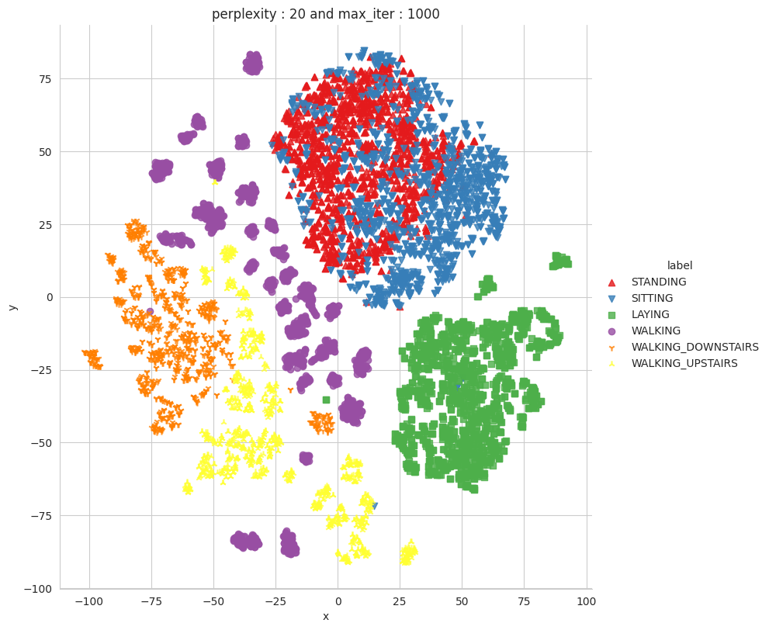

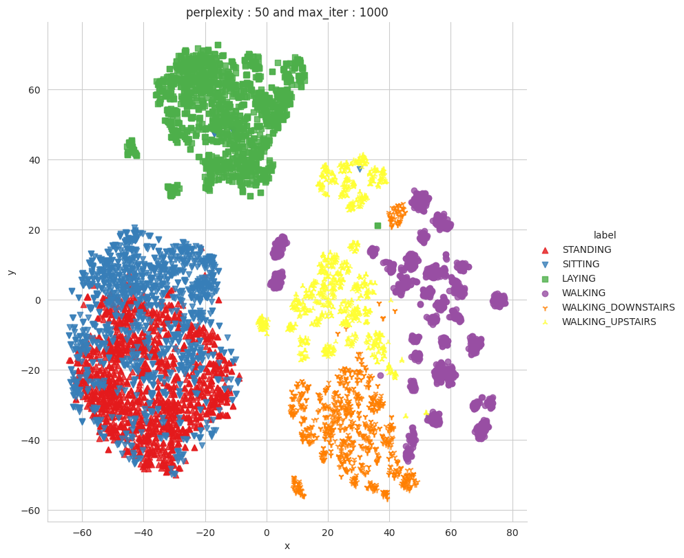

* **We can clearly see the TSNE cluster, All the Activity are clean seperate except "Standing" and "Sitting".**

**Model Report**

|  |  |  |  |
| --- | --- | --- | --- |
| Model Name | Hyper parameter Tuning | categorical_crossentropy | Accuracy |
| LSTM With 1_Layer(neurons:32) | Done | 0.47 | 0.8992195725440979 |
| LSTM With 2_Layer(neurons:48, neurons:32) | Done | 0.39 | 0.9110960364341736 |
| LSTM With 2_Layer(neurons:64, neurons:48 | Done | 0.27 | 0.9199185371398926 |