INSERT INTO Employee VALUES
(108,'Neha',65000,1,'2025-04-15'),
(109,'Karan',85000,2,'2025-03-20'),
(110,'Pooja',72000,3,'2025-02-10');
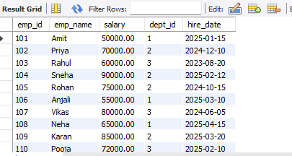
-- Window Function
SELECT emp_id, emp_name, salary,
RANK() OVER(ORDER BY salary DESC) AS salary_rank
FROM Employee;
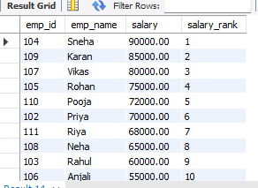
SELECT emp_id, emp_name, salary,
ROW_NUMBER() OVER(ORDER BY salary DESC) AS row_num
FROM Employee;
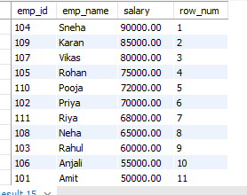
SELECT emp_id, emp_name, dept_id, salary,
RANK() OVER(PARTITION BY dept_id ORDER BY salary DESC) AS dept_rank
FROM Employee;
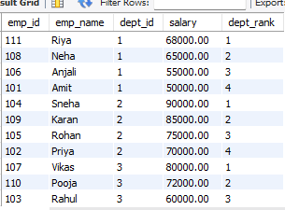
-- View
CREATE VIEW Employee_Details AS
SELECT e.emp_id,
e.emp_name,
e.salary,
d.dept_name
FROM Employee e
INNER JOIN Department d
ON e.dept_id = d.dept_id;
SELECT * FROM Employee_Details;
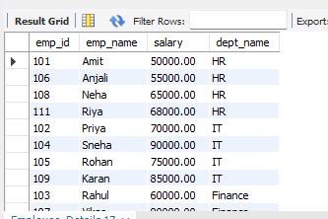
-- Trigger
CREATE TABLE Employee_Log (
log_id INT AUTO_INCREMENT PRIMARY KEY,
emp_id INT,
action_type VARCHAR(20),
action_time TIMESTAMP DEFAULT CURRENT_TIMESTAMP
);
CREATE TRIGGER employee_insert_trigger
AFTER INSERT ON Employee
FOR EACH ROW
INSERT INTO Employee_Log(emp_id, action_type)
VALUES (NEW.emp_id,'INSERT');
INSERT INTO Employee
VALUES (111,'Riya',68000,1,'2025-06-20');
SELECT * FROM Employee_Log;
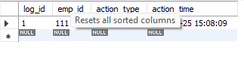
-- CASE WHEN
SELECT emp_name,
salary,
CASE
WHEN salary >= 80000 THEN 'High Salary'
WHEN salary >= 60000 THEN 'Medium Salary'
ELSE 'Low Salary'
END AS salary_category
FROM Employee;
