Assignment : Creating a database for the lift Management System

(Updated based on feedback )

Coordinator: Suresh Burde

Submitted by : Bhagyashree Dattatray Watpade.

Entity Relationship Diagram:

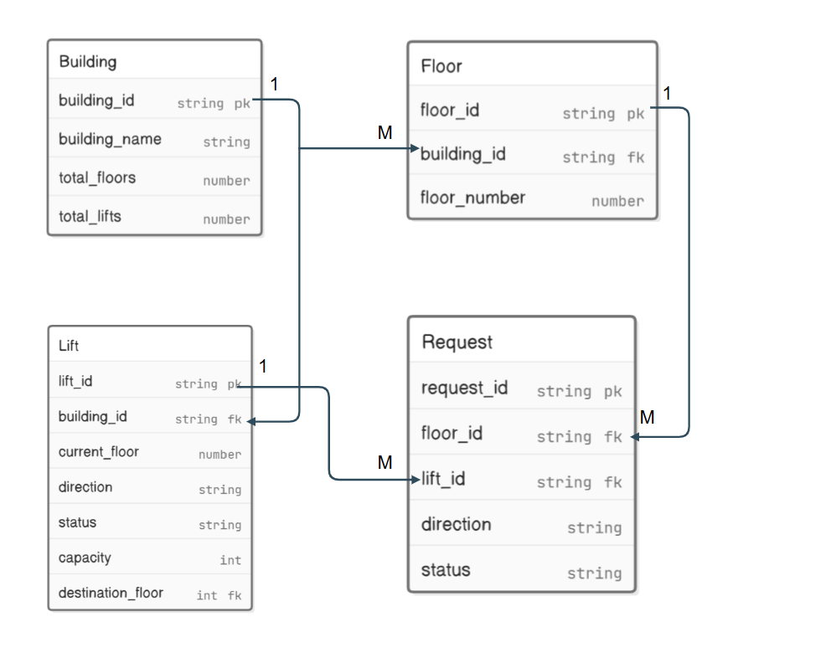

Database : PostgreSQL

Tables : Building, Floor, Lift, Request

>> Code :

CREATE TABLE Building (

building_id SERIAL PRIMARY KEY,

building_name VARCHAR(10),

total_floors INT CHECK (total_floors > 0),

total_lifts INT CHECK (total_lifts > 0) DEFAULT 1

);

CREATE TABLE Floor (

floor_id SERIAL PRIMARY KEY,

floor_number INT,

building_id INT REFERENCES Building(building_id) ON DELETE CASCADE

);

CREATE TABLE Lift (

lift_id SERIAL PRIMARY KEY,

current_floor INT NOT NULL DEFAULT 0,

direction VARCHAR(10),

status VARCHAR CHECK (status IN ('ACTIVE', 'INACTIVE', 'MAINTENANCE')),

capacity INT,

destination_floor INT ,

lift_building_id INT REFERENCES Building(building_id) ON DELETE CASCADE,

lift_destination_floor INT REFERENCES Floor(floor_id) ON DELETE CASCADE

);

CREATE TABLE Request (

request_id SERIAL PRIMARY KEY,

floor_id INT,

lift_id INT ,

direction VARCHAR ,

status VARCHAR CHECK (status IN ('PENDING', 'COMPLETED', 'CANCELLED')),

request_floor_id INT REFERENCES Floor(floor_id) ON DELETE CASCADE,

request_lift_id INT REFERENCES Lift(lift_id) ON DELETE CASCADE

);

-- INSERT DATA INTO TABLES

INSERT INTO Building (building_name, total_floors, total_lifts) VALUES ('Building 1', 10, 3);

INSERT INTO Building (building_name, total_floors, total_lifts) VALUES ('Building 2', 15, 4);

INSERT INTO Building (building_name, total_floors, total_lifts) VALUES('Building 3', 10, 4);

INSERT INTO Floor (building_id, floor_number) VALUES (1, 0);

INSERT INTO Floor (building_id, floor_number) VALUES (1, 1);

INSERT INTO Floor (building_id, floor_number) VALUES(2, 2);

INSERT INTO Floor (building_id, floor_number) VALUES (3, 5);

INSERT INTO Lift (current_floor, direction, status, capacity, destination_floor) VALUES (1, 'UP', 'ACTIVE', 7, 5);

INSERT INTO Lift (current_floor, direction, status, capacity, destination_floor) VALUES (4, 'UP', 'ACTIVE', 15, 3);

INSERT INTO Lift (current_floor, direction, status, capacity, destination_floor) VALUES (2, 'DOWN','INACTIVE', 20, 3);

INSERT INTO Request (floor_id, lift_id, direction, status) VALUES (2, 2, 'UP', 'COMPLETED');

INSERT INTO Request (floor_id, lift_id, direction, status) VALUES (3, 1, 'DOWN', 'PENDING');

INSERT INTO Request (floor_id, lift_id, direction, status) VALUES (1, 1, 'UP', 'PENDING');

-- getting data of each table

SELECT * FROM Building

SELECT * FROM Floor

SELECT * FROM Lift

SELECT * FROM Request

--Q1 retriving the list of lifts whose destination floor is 5

SELECT * FROM Lift WHERE destination_floor = 5;

-- Q2 get the details of lift which is currently active and moving up :

SELECT * FROM Lift WHERE status = 'ACTIVE' AND direction = 'UP';

-- Q3 update lift status :

UPDATE Lift SET status = 'INACTIVE' WHERE lift_id = 3;

SELECT * FROM Lift

-- Q4 delete request where request id is 1

DELETE FROM Request WHERE request_id = 1;

SELECT * FROM Request

-- Q5 get list of floors where floor number is greater than 4

SELECT * FROM Floor WHERE floor_number > 4;

-- Q6 get all lift requests with floor, building details

SELECT Req.request_id, Build.building_name, Fl.floor_number, Li.lift_id, Req.status

FROM Request Req

JOIN Floor fl ON Req.floor_id = Fl.floor_id

JOIN Lift Li ON Req.lift_id = Li.lift_id

JOIN Building Build ON Fl.building_id = Build.building_id;

OUTPUT : Output of the above queries is available in the below csv file.

