GET http://localhost:8080/allStudent
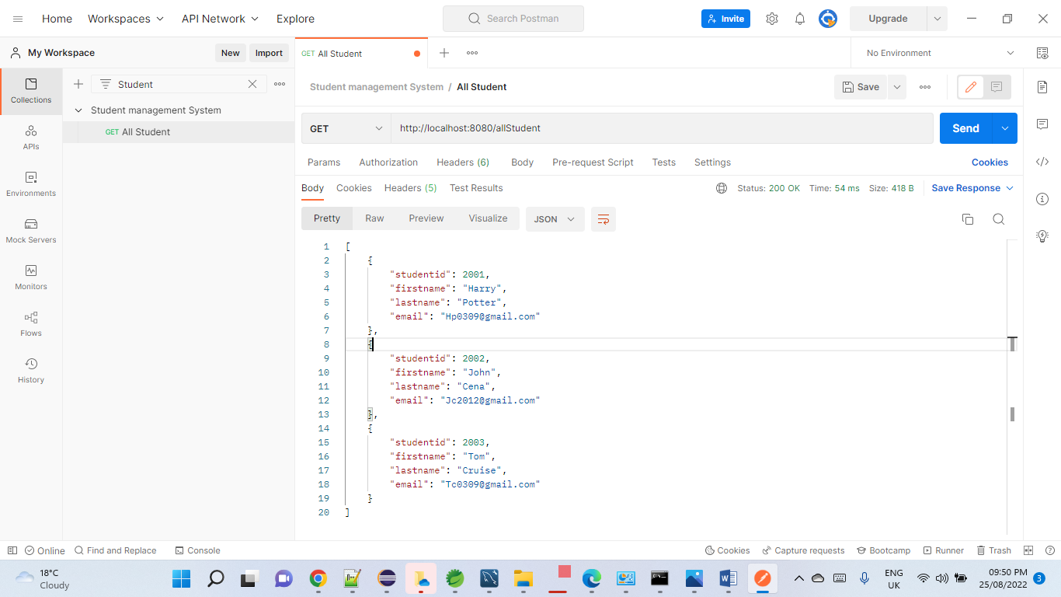

Get http://localhost:8080/Student/2001
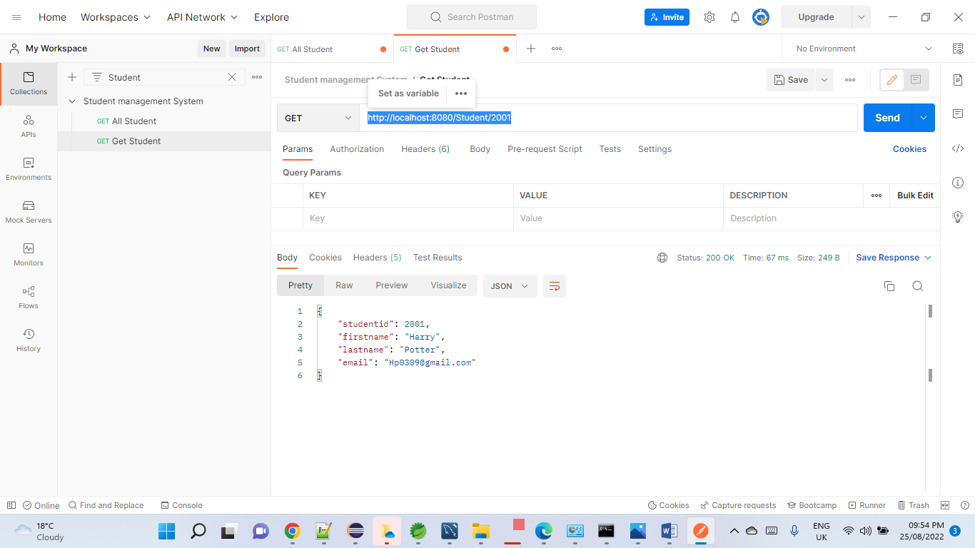

Post - http://localhost:8080/saveorupdateStudent
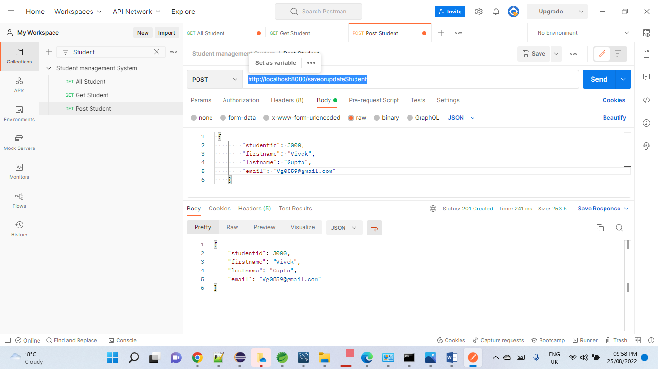

Put - http://localhost:8080/saveStudent

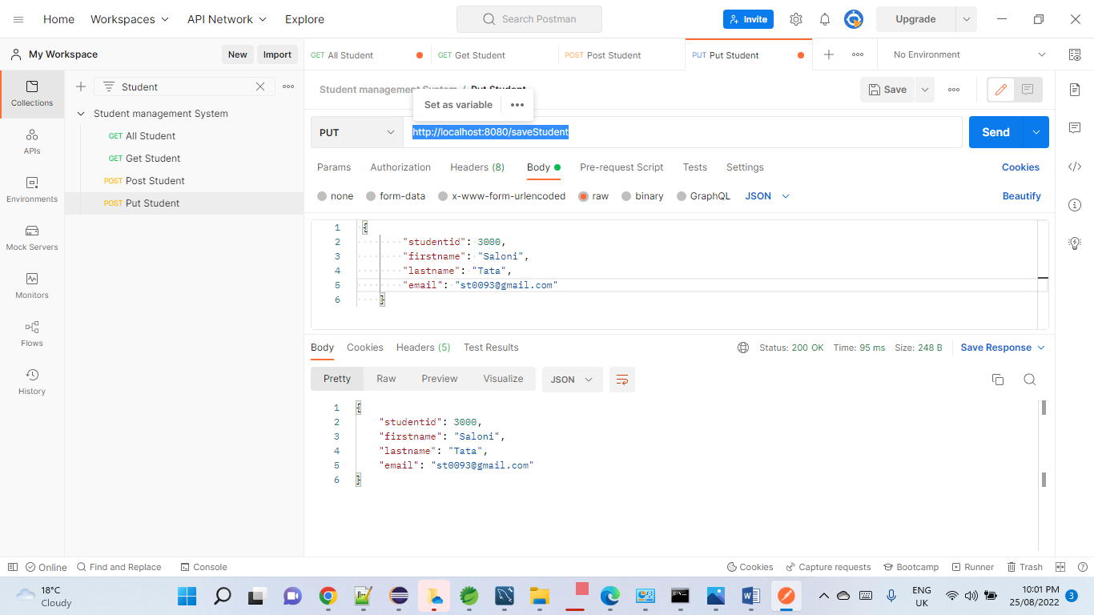

Delete - http://localhost:8080/deleteStudent/3000

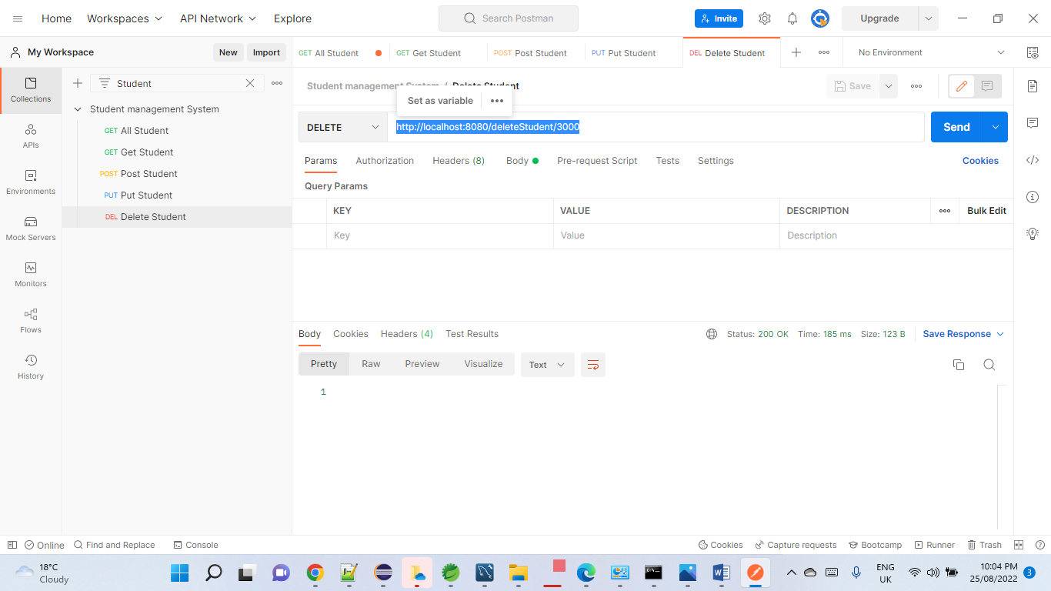

http://localhost:8080/Student/3000

