VISVESVARAYA TECHNOLOGICAL UNIVERSITY
Jnana Sangama, Belgaum-590018
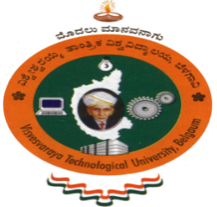

Mini Project Report
on
“GPS TRACKING SYSTEM IN FREE RANGE POULTRY”
Submitted in partial fulfillment of the requirements for the
First Semester of the Bachelor of Engineering Degree, towards the completion of the Mini Project under the Innovation & Design Thinking Laboratory,
Department of Basic Sciences.

by

SN | Name | USN/Roll number
1 | BAGYASHREE | 1CR25AD025
2 | BHAGYASHREE CHIGARI | 1CR25AD026
3 | SHREEYAM SHREE | 1CR25IS158
4 | SHREYA P | 1CR25IS159

Under the Guidance of
Dr. Satyabrata
Asst. Professor, Dept. of basic science

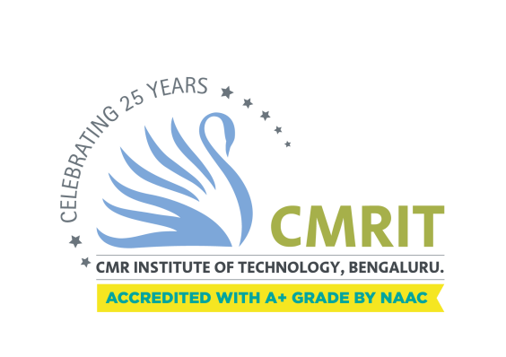

CMR INSTITUTE OF TECHNOLOGY
#132, AECS LAYOUT, IT PARK ROAD, KUNDALAHALLI,
BANGALORE-560037

CMR INSTITUTE OF TECHNOLOGY
#132, AECS LAYOUT, IT PARK ROAD, KUNDALAHALLI,
BANGALORE-560037
DEPARTMENT OF BASIC SCIENCES


CERTIFICATE
This is to certify that the File Structures mini project entitled “ gps tracking system for free range poultry” has been successfully carried out by Bagyashree (1CR25AD025), Bhagyashree chigari (1CR25AD026), Shreeyam shree (1CR25IS158), Shreya p(1CR25IS159) Bonafide students of CMR Institute of Technology.
The project is submitted in partial fulfillment of the requirements for the First Semester of the Bachelor of Engineering Degree, towards the completion of the Mini Project under the Innovation & Design Thinking Laboratory, Department of Basic Sciences.
It is further certified that all corrections and suggestions indicated during the Internal Assessment have been duly incorporated in the project report submitted to the departmental library. This File Structures mini project report has been reviewed and approved as it satisfies the academic requirements prescribed for the said degree.
----------------------- ----------------------

Signature of Guide Signature of HOD
Dr.satyabrata Dr. Raveesha K H
Asst. Professor HoD,
Dept. of basic science, CMRIT Dept. of Physics,CMRI me of the examiners Signature with date
Signature with date
1.
2.
ACKNOWLEDGEMENT

I sincerely express my gratitude to Dr. Sanjay Jain, Principal, CMR Institute of Technology, Bangalore, for providing a supportive academic environment.
I extend my thanks to Dr. Raveesha K H, HoD, Dept. of Physics, CMRIT for his valuable guidance and support.
I am especially grateful to my internal guide, Dr. Assistant Professor, Department of Information Science and Engineering, for her/his constant encouragement and guidance throughout this project.
I also thank all the faculty members, non-teaching staff, and others who contributed directly or indirectly to the successful completion of this work.

Bagyashree(1CR25AD025),
Bhagyashree Chigari(1CR25AD026),
Shreeyam shree(1CR25IS158),
Shreya p (1CR25IS159)

Abstract

The GPS Tracking System for Free-Range Poultry is an IoT-based smart farming solution designed to monitor and manage the movement of poultry birds in open farming environments. The main objective of the project is to improve poultry safety, reduce bird loss, and assist farmers in efficient farm management through real-time location tracking. The system uses GPS modules, microcontrollers, and wireless communication technology to collect and transmit location data continuously. The tracked data can be viewed through a software interface that helps farmers monitor bird movement patterns and identify unusual activity. The project also supports better health supervision and security by reducing the chances of theft or predators affecting the poultry. The proposed system is cost-effective, easy to use, and suitable for modern poultry farming practices. The outcome of the project demonstrates that GPS-based monitoring can increase productivity, improve bird management, and support the adoption of smart agricultural technologies in free-range poultry farming.

Keywords
GPS tracking, Free-range poultry, IoT, Smart farming, Real-time monitoring, Poultry management

