FlyAway
Index

1.Project scope
2.Risks and assumptions
3.Product overview
4.Use cases
5.Requirements
6.Configuration
7.Non-functional Requirements
8.Error reporting
9.Flow Chart
10.Core concepts and Algorithms

Document version 1.0

Author
Name | Role | Department
Bhagyashree | SDE1 | IT(Development)

1.Project scope:
FlyAway is a ticket-booking portal that lets people book flights on their website. It should include a search form to allow entries of travel details, list the available flights with the ticket prices, and a confirmation of ticket and the journey details.
2.Risks and assumptions:
Despite the following process, there could be some risks, which can be minimized by proper planning in the earlier stages. The Risks could be misunderstanding the requirements, not having minimum resources (hardware, software, human), not leading the agile methodologies. To overcome these risks we need to have proper documentation on product requirements. We should have enough resources and also should follow agile process in stage of the development

3.Product overview:
The application Flyaway is to provide services to end-use for perform ticket booking, meanwhile admin can login to perform various operations like changing password, creating new record or updating record
- For End users, who visited the site for ticket boking should follow following process
• A search form on the homepage to allow entry of travel details, like the date of travel, source, destination, and the number of persons.
• Based on the travel details entered, it will show the available flights with their ticket prices.
• Once a person selects a flight to book, they will be taken to a registration page where they must fill in their details.
• On the next page, the details of the preferred flight will be displayed, and the payment will be done via a dummy payment gateway.
• On completion of the payment, a confirmation page will appear with the details of the booking.
Admin should be able to perform following:
• An admin login page where the admin can change the password after login as per their wish
• A master list of places for source and destination
• A master list of airlines
• A list of flights where each flight has a source, destination, airline, and ticket price Implement the appropriate concepts such as exceptions, collections, and sorting techniques for source code optimization and increased performance

4.Use cases:
UC-1 | <Use case name>
Primary Actor(s) | < primary actors that participate in this use case>
Stakeholders and Interest | <One sentence describing other stakeholders>
Trigger | <Condition/action that initiates/starts the use-case>
Pre-conditions | <Condition assumed to be true before the first step>
Post-conditions | <Condition after the use case is successfully executed >
Main Success Scenario | - <visit STARTING-POINT  - Step  - Step  - Make sure GOAL-ACHIEVED>
Extensions | If Condition, then Alternative Steps  <List any extended steps/ scenarios that occur, other than the main success scenario.>
Priority | <indicate priority of high, medium or low)
Special Requirements | <Any system related special requirements needed to fulfill the use case>
Open Questions | <Notes and questions>

5.Requirements:
Below are the functional requirements to be developed to enhance the product:
1.User login
2.Ticket Booking
3.Payment gateway
4.Admin login
5.Admin operations

6.Configuration:
To work on this application development, it is recommended to have following hardware configurations:
- 4GB RAM
- 258 GB memory
- Core processor with 1 GHz
- Windows 8 or above
- Latest chrome browser
- Internet connectivity
We also should have following:
- Eclipse/IntelliJ: An IDE to code for the application
- Java: A programming language to develop the prototype
- Git: To connect and push files from the local system to GitHub
- GitHub: To store the application code and track its versions
- Scrum: An efficient agile framework to deliver the product incrementally
- Search and Sort techniques: Data structures used for the project
- Specification document: Any open-source document or Google Docs

7.Non-functional Requirements:
SLA document should be available and Application should meet performance limitations.

8.Error reporting:
Applications must be tested within the sprint and testcases covered for a story must be automated within the same sprint. Defects raised will be retested once it is fixed. Defects will be picked up and resolved based on their priority

9.Flow Chart

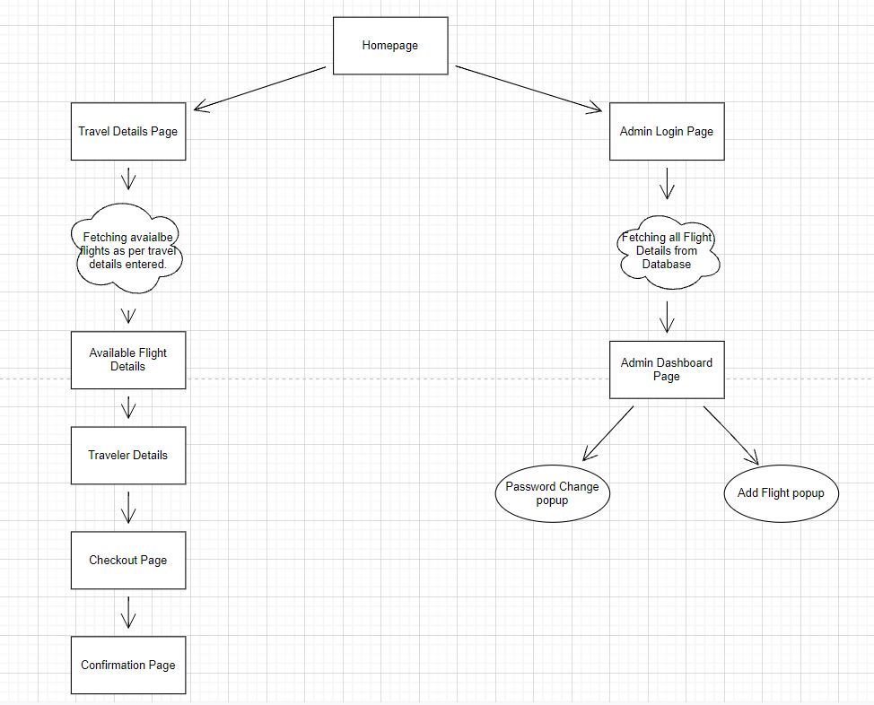

10.Core concepts and algorithms used
Java core concepts are used with the combination of Jjsp and servlets and java beans are created to represent the state of the object. Following tools /softwares are used for project development

