PROJECT REPORT
E-Commerce Sales, Customer & Shipping Analytics Dashboard
A Python-based Data Analytics Project using pandas, SciPy, Plotly and Streamlit

Submitted by: [Student Name]
Programme: [Course / Programme]
Institution: [College / University Name]
Project Guide: [Guide / Supervisor Name]
Academic Year: 2026

Dataset: realistic_e_commerce_sales_data.csv (provided with this project)

Certificate / Declaration
This is to certify that the project report titled "E-Commerce Sales, Customer & Shipping Analytics Dashboard" is a bonafide record of work carried out by [Student Name] of [College / University Name] in partial fulfilment of the requirements of [Course / Programme], under the guidance of [Guide / Supervisor Name].
Declaration: I hereby declare that this project is my own work. All analytical results in this report were calculated from the supplied dataset using the Python code submitted with this project. No data, results or links have been fabricated, and sources consulted are listed in the References section.
Student signature: ______________________ Guide signature: ______________________
Date: ____ / ____ / ________ Place: ______________________

Acknowledgement
I would like to thank my project guide, [Guide / Supervisor Name], for the guidance and feedback received during this project, and the faculty of [College / University Name] for the learning environment that made it possible.
I also acknowledge the open-source communities behind Python, pandas, NumPy, SciPy, Matplotlib, Plotly and Streamlit, whose documentation and tools made it possible to build a complete analytics application using only Python.
Finally, I thank my family and friends for their encouragement.

Abstract
This project builds an end-to-end analytics system for an e-commerce transaction dataset of 1,000 orders placed by 292 customer IDs between 01 Jan 2023 and 03 Jan 2024. The data were loaded, profiled, cleaned (missing Region, Shipping Status and Age values handled without deleting rows; 20 inconsistent Unit Price values repaired), and analysed using descriptive statistics, group aggregations, confidence intervals and hypothesis tests. The results are delivered through an interactive Streamlit dashboard with six pages and sidebar filters.
Total revenue (sum of Total Price) is 1,346,600 from 3,008 units, with an average order value of 1,347. Laptop is the top product (51.7% of revenue) and Electronics the top category (89.2%). Revenue is spread evenly across regions, but West has the highest return rate (39.9%), a difference that is statistically significant (chi-square p = 0.0004). Overall, 32.4% of orders with a known status were returned.
Keywords: e-commerce analytics, exploratory data analysis, KPI, return rate, Streamlit, Plotly, pandas.

Table of Contents
1. Introduction 6
2. Background 6
3. Problem Statement 6
4. Objectives 6
5. Scope of the Project 7
6. Dataset Description 7
7. Data Dictionary 8
8. Tools and Technologies 9
9. System / Project Architecture 9
10. Data Cleaning and Preprocessing 10
Key decisions 10
Data-quality observations that limit interpretation 11
11. Exploratory Data Analysis 11
12. Statistical Analysis 12
Correlation analysis 12
Hypothesis tests 13
13. KPI Analysis 13
14. Customer Analysis 14
15. Product Analysis 15
16. Category Analysis 16
17. Regional Analysis 17
18. Shipping Analysis 18
19. Time-Series Analysis 19
20. Dashboard Design 21
21. Key Findings 22
22. Business Insights 22
23. Business Recommendations 23
24. Limitations 23
25. Future Scope 23
26. Conclusion 23
27. References 24

1. Introduction
E-commerce businesses record every order: who bought, what was bought, how much it cost, how it was shipped and what happened to the shipment. These records are valuable only when they are turned into answers for managers: which products earn the most, where sales are strong or weak, and where operational problems such as returns occur.
This project develops a Python-based analytics application for such data. It processes 1,000 historical transactions, performs exploratory and statistical analysis, and presents the results in an interactive dashboard so that a non-technical business user can monitor revenue, quantity, product performance, customer demographics, regional sales and shipping outcomes.

2. Background
Data-driven decision making means replacing intuition with measured evidence. For an online retailer, three questions recur: (1) What is selling? (2) To whom and where? (3) Is fulfilment working? Spreadsheet summaries answer these only for a single fixed view. A dashboard with filters lets users change the view (for example, only the West region or only Electronics) and see all indicators update instantly.
Python is widely used for this work because of its data libraries. pandas handles data preparation, NumPy and SciPy provide numerical and statistical functions, and Plotly with Streamlit allows an interactive web dashboard to be written entirely in Python without separate frontend or backend code.

3. Problem Statement
An e-commerce business has accumulated sales and order data but lacks a centralized analytical system to understand sales performance, customer behavior, product/category performance, regional trends, and shipping outcomes. The objective of this project is to develop a Python-based interactive analytics application that processes historical e-commerce transaction data, performs exploratory and statistical analysis, identifies important business trends and underperforming areas, and presents actionable insights through an interactive frontend dashboard. The system should help business users monitor revenue, order quantity, product performance, customer demographics, regional sales, and shipping status to support data-driven business decisions.

4. Objectives
- Load, profile and clean the transaction data, documenting every cleaning decision.
- Calculate sales, order, customer and shipping KPIs without double counting.
- Analyse performance by product, category, region, customer group (age and gender) and time.
- Analyse shipping status and return rates, using confidence intervals and statistical tests to judge whether differences are real.
- Build an interactive Streamlit dashboard with filters, charts and automatically generated insights.
- Provide evidence-based business recommendations and state the limitations of the data.

5. Scope of the Project
In scope: historical analysis (descriptive and diagnostic) of the supplied CSV file; a six-page dashboard; automatically generated insights; hypothesis tests on shipping status and order value. Out of scope: forecasting or machine-learning models, real-time data feeds, a database back end, profit analysis (cost data are not available), and any analysis requiring fields that are not in the file (for example Order ID, payment method, customer location below region, or currency).

6. Dataset Description
The dataset file realistic_e_commerce_sales_data.csv was provided with the project. It has 1,000 rows and 12 columns and covers orders from 01 January 2023 to 03 January 2024. It does not have a public source URL, so none is cited. Each row is treated as one order because the file has no Order ID.
Table 1: Structure of the raw dataset (inspected from the CSV)
Column | Type | Non-null | Missing | Missing % | Unique
Customer ID | str | 1000 | 0 | 0.0 | 292
Gender | str | 1000 | 0 | 0.0 | 2
Region | str | 950 | 50 | 5.0 | 4
Age | float64 | 900 | 100 | 10.0 | 52
Product Name | str | 1000 | 0 | 0.0 | 7
Category | str | 1000 | 0 | 0.0 | 3
Unit Price | float64 | 1000 | 0 | 0.0 | 13
Quantity | int64 | 1000 | 0 | 0.0 | 5
Total Price | int64 | 1000 | 0 | 0.0 | 26
Shipping Fee | float64 | 1000 | 0 | 0.0 | 730
Shipping Status | str | 950 | 50 | 5.0 | 3
Order Date | str | 1000 | 0 | 0.0 | 340

Duplicate rows: 0. Numeric columns: Age, Unit Price, Quantity, Total Price, Shipping Fee. Text/date columns: Customer ID, Gender, Region, Product Name, Category, Shipping Status, Order Date (Order Date is stored as text in dd-mm-yyyy format and was converted to a date).
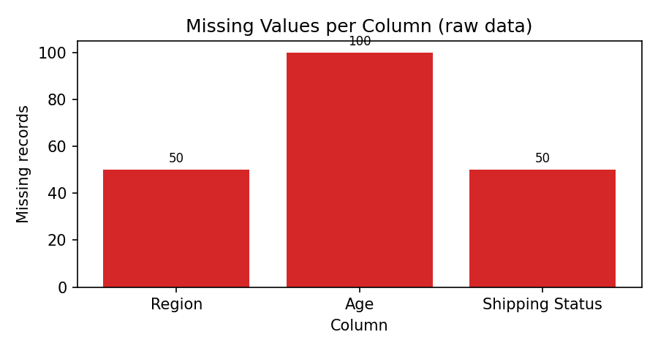
Figure 1: Missing values per column in the raw data
Three columns have missing values: Age (100), Region (50) and Shipping Status (50). All other columns are complete.

7. Data Dictionary
Table 2: Data dictionary
Column | Description | Raw type | Missing
Customer ID | Customer identifier (CUSTxxxx). Repeats across orders. | str | 0
Gender | Customer gender (Male/Female). | str | 0
Region | Sales region of the order (East, North, South, West). | str | 50
Age | Customer age in years. | float64 | 100
Product Name | Product sold (7 products). | str | 0
Category | Product category (Accessories, Electronics, Wearables). Each product belongs to exactly one category. | str | 0
Unit Price | Price per unit. | float64 | 0
Quantity | Units ordered (1-5). | int64 | 0
Total Price | Order value = Unit Price x Quantity (product value only). Used as revenue. | int64 | 0
Shipping Fee | Shipping charge for the order. Not part of Total Price. | float64 | 0
Shipping Status | Delivered, In Transit or Returned. | str | 50
Order Date | Date of the order (dd-mm-yyyy). | str | 0

Derived columns created during cleaning: age_group, month, month_label, weekday, is_returned, order_value_with_shipping, and two flags (unit_price_corrected, age_imputed) so that every changed value stays traceable.

8. Tools and Technologies
Table 3: Technologies used
Tool | Purpose
Python 3 | Main programming language
pandas / NumPy | Data loading, cleaning, aggregation
SciPy | Chi-square, Kruskal-Wallis, Mann-Whitney and Spearman tests
Plotly | Interactive charts in the dashboard
Streamlit | Interactive web dashboard (run with streamlit run app.py)
Matplotlib | Static figures used in this report
python-docx | Generation of this report from the data

9. System / Project Architecture
The project follows a simple three-layer design, which keeps each file small and understandable:
- Data layer (src/data_cleaning.py): loads the CSV, profiles it, cleans it and returns a cleaning log.
- Analysis layer (src/analysis.py): all KPIs, group summaries, customer segmentation, statistical tests and automatic insights.
- Presentation layer (src/visualizations.py and app.py): Plotly chart builders and the Streamlit pages, sidebar filters and download button.
Data flow: CSV -> clean_data() -> sidebar filters -> analysis functions -> Plotly charts -> dashboard page. Because everything after loading is calculated on the filtered data, no result is hard-coded and every KPI changes when the user changes a filter. The application tolerates missing files (an upload box is shown), empty filter selections (a warning is shown) and errors on any page (a message instead of a crash).
Table 4: Project files
File / folder | Content
app.py | Streamlit entry point: filters, six pages, error handling
src/data_cleaning.py | Loading, profiling, cleaning, data-quality checks
src/analysis.py | Calculations, statistics and insights
src/visualizations.py | Plotly figures
data/ | Dataset
report/ | Report, figure and report-building scripts
requirements.txt | Python dependencies

10. Data Cleaning and Preprocessing
The cleaning rules were designed after inspecting the data. The principle was to keep as many rows as possible, because deleting rows removes real sales from the totals.
Table 5: Cleaning log generated by the code
Step | Issue | Action | Rows
Text standardisation | Possible stray spaces / inconsistent letter case in text columns | Trimmed whitespace; Title Case for labels; upper case for Customer ID | 0
Type conversion | Order Date stored as text (dd-mm-yyyy); numeric fields checked for invalid values | Converted to datetime/numeric. Rows with unparseable date, missing price/quantity/fee or non-positive quantity/price are removed | 0
Duplicate records | Exact duplicate rows | Removed duplicates (kept first occurrence) | 0
Missing values | Region is missing | Labelled 'Unknown' instead of deleting the row, so sales/quantity are still counted. 'Unknown' is excluded from rate denominators where a known value is needed | 50
Missing values | Shipping Status is missing | Labelled 'Unknown' instead of deleting the row, so sales/quantity are still counted. 'Unknown' is excluded from rate denominators where a known value is needed | 50
Inconsistent values | Unit Price x Quantity does not equal Total Price (these Unit Prices have unrealistic decimals and differ from the product's usual price, while Total Price follows the product's price list) | Unit Price recomputed as Total Price / Quantity and flagged in 'unit_price_corrected' | 20
Missing values | Age is missing | Filled from the same Customer ID's known age where available (93 rows), otherwise with the median age (49; 7 rows). Flag 'age_imputed' kept. Median is robust to outliers | 100
Feature engineering | Analysis needs extra fields | Added age_group, month, weekday, is_returned, order_value_with_shipping | 1000
Summary | 1000 raw rows | 1000 rows kept after cleaning | 0

Key decisions
- Region and Shipping Status (50 missing each): labelled "Unknown" rather than dropped, so revenue and quantity remain complete. Unknown is excluded from return-rate denominators and from region comparisons.
- Age (100 missing, 10%): missing values were first filled with the same Customer ID's known age (age is consistent within each customer ID), and any still missing with the median age. The median was chosen because it is not affected by extreme values. An age_imputed flag is kept.
- Unit Price (20 rows): in these rows Unit Price x Quantity did not match Total Price. The Unit Prices had long decimals and were a constant multiple of the product's normal price, whereas Total Price matched the product's price list. Total Price was therefore treated as correct and Unit Price recomputed as Total Price / Quantity. Using the uncorrected values would have inflated average unit price.
- Revenue definition: revenue = sum of Total Price; shipping fees are reported separately, so nothing is double counted. Net revenue = revenue minus returned orders.
After cleaning, 1,000 rows remain (no rows removed) and no missing values are left in the analysis columns.

Data-quality observations that limit interpretation
Table 6: Additional data-quality checks
Check | Count | Implication
Customer IDs recorded with more than one gender | 192 | Customer ID is not a fully reliable identity; customer-level results are indicative.
Customer IDs recorded in more than one region | 217 | Region behaves like a property of the order, not of the customer.
Distinct order days in last month (2024-01) | 1 | A very short last month is partial and should not be compared with full months.
Order ID column present (0 = no) | 0 | No Order ID: each row is treated as one order.
Currency stated in data (0 = no) | 0 | Currency not specified; values shown as plain numbers.

11. Exploratory Data Analysis
Descriptive statistics of the numeric fields after cleaning are shown below.
Table 7: Descriptive statistics
Field | count | mean | median | std | min | 25% | 75% | max | skew
age | 1,000.00 | 46.70 | 49.00 | 14.96 | 18.00 | 35.00 | 59.00 | 69.00 | -0.28
unit_price | 1,000.00 | 446.63 | 200.00 | 510.90 | 30.00 | 50.00 | 800.00 | 1,500.00 | 1.20
quantity | 1,000.00 | 3.01 | 3.00 | 1.40 | 1.00 | 2.00 | 4.00 | 5.00 | -0.01
total_price | 1,000.00 | 1,346.60 | 600.00 | 1,834.04 | 30.00 | 200.00 | 1,500.00 | 7,500.00 | 1.93
shipping_fee | 1,000.00 | 12.42 | 12.32 | 4.41 | 5.00 | 8.56 | 16.08 | 19.98 | 0.05

Order values are strongly right-skewed (mean 1,347 vs median 600) because a few high-priced Electronics orders are very large, while many Accessories orders are small. Quantity is between 1 and 5 with an average of 3.01. Age ranges from 18 to 69 (median 49). Shipping fees range from 5.00 to 19.98 with a mean of 12.42.
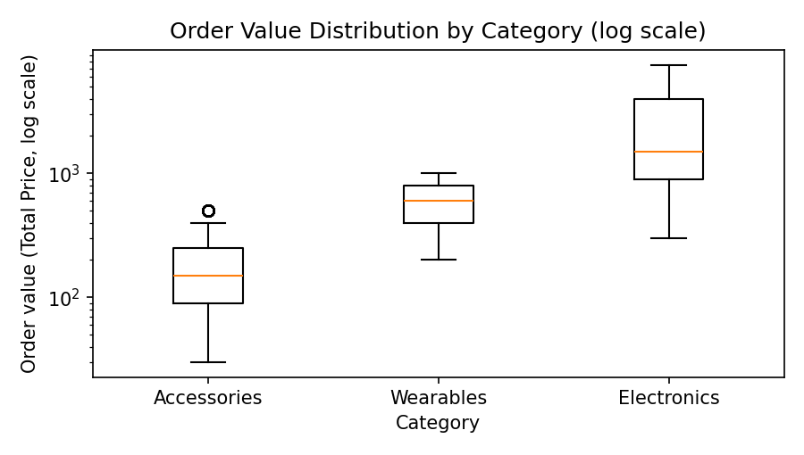
Figure 2: Distribution of order value by category (log scale)
The three categories have clearly different price levels. Electronics orders are the most valuable; Accessories orders are the smallest. The log scale is used because the values differ by more than an order of magnitude.

12. Statistical Analysis

Correlation analysis
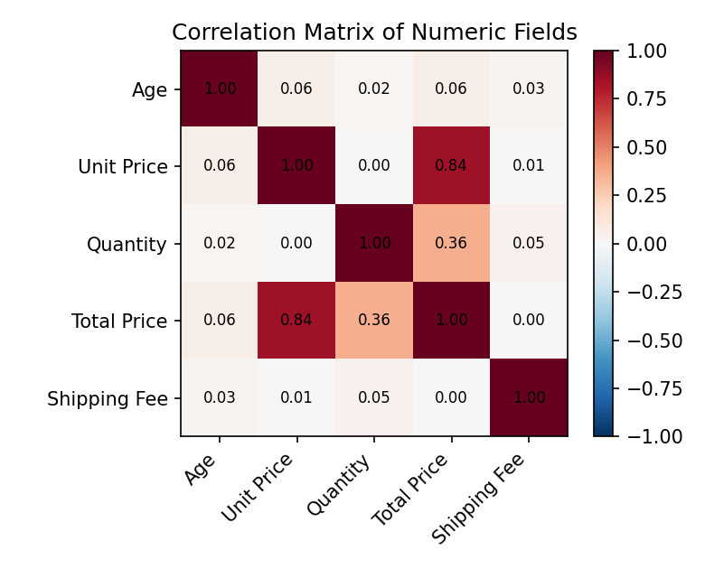
Figure 3: Correlation matrix of numeric fields
Total Price is strongly related to Unit Price (r = 0.84) and moderately to Quantity (r = 0.36), which is expected because Total Price = Unit Price x Quantity. Shipping Fee has almost no correlation with any other field (largest absolute value 0.05), so shipping fees do not depend on order value. Age is only very weakly related to the other fields.

Hypothesis tests
Each test answers a business question at the 5% significance level (a p-value below 0.05 means the pattern is unlikely to be chance). Chi-square tests compare shipping-status mix between groups. Kruskal-Wallis and Mann-Whitney tests are used for order value because it is highly skewed (a non-normal distribution), and Spearman correlation for age and order value.
Table 8: Statistical test results
Business question | Test | Statistic | p-value | Result
Is shipping status related to Region? | Chi-square independence | 24.91 | 0.0004 | Significant difference/relationship
Is shipping status related to Category? | Chi-square independence | 1.306 | 0.8604 | No significant evidence
Is shipping status related to Gender? | Chi-square independence | 2.233 | 0.3275 | No significant evidence
Does order value differ between regions? | Kruskal-Wallis | 1.468 | 0.6896 | No significant evidence
Does order value differ between Male and Female customers? | Mann-Whitney U | 128791.5 | 0.3706 | No significant evidence
Is customer age related to order value? | Spearman correlation | 0.068 | 0.0306 | Significant difference/relationship

In plain language: shipping status is related to region (p = 0.0004), so the differences in return rate between regions are unlikely to be random. Shipping status is not related to category or gender, and order value does not differ significantly between regions or genders. Age and order value show a correlation of 0.07 (p = 0.031); this is statistically significant but so weak that it has little practical importance. With many tests, one borderline result could also arise by chance, so it should not be over-interpreted.

13. KPI Analysis
Table 9: Key performance indicators (all orders)
KPI | Value
Total Revenue | 1,346,600
Net Revenue (excl. returned orders) | 930,960
Returned Revenue | 415,640
Total Orders | 1,000
Total Quantity Sold | 3,008
Average Order Value | 1,346.60
Average Unit Price (after correction) | 446.63
Total Shipping Fees | 12,416.39
Average Shipping Fee | 12.42
Shipping Fees as % of Revenue | 0.92%
Unique Customer IDs | 292
Average Orders per Customer | 3.42
Return Rate (known status) | 32.4%
Delivered Rate (known status) | 32.9%
In Transit Rate (known status) | 34.6%
Orders with unknown status | 5.0%

Returned orders represent 30.9% of revenue. Shipping fees are small compared with revenue (0.92%). Currency is not stated in the dataset, so values are shown as plain numbers. Rates use orders with a known shipping status (950 of 1,000).

14. Customer Analysis
The data contain 292 distinct Customer IDs. Important limitation: 192 of these IDs appear with more than one gender and 217 appear in more than one region, so the ID is not a fully reliable customer identity. Customer-level results below are therefore indicative, not exact.
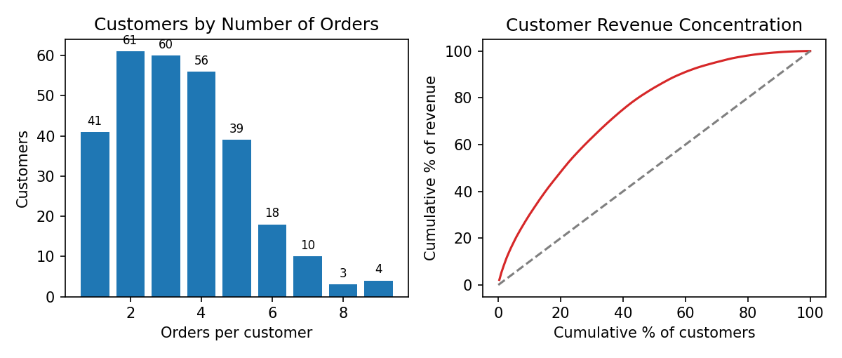
Figure 4: Purchase frequency and customer revenue concentration
86.0% of customer IDs have more than one order, and the average is 3.42 orders per ID. The top 20% of customer IDs generate 48.7% of revenue, which shows moderate concentration (a perfectly even spread would give 20%).
Table 10: Customer segmentation by purchase frequency
Frequency band | Customers | Revenue | Revenue share
One-time | 41 | 46,360 | 3.4%
Occasional (2-3) | 121 | 377,070 | 28.0%
Regular (4-5) | 95 | 584,290 | 43.4%
Frequent (6+) | 35 | 338,880 | 25.2%

Table 11: Customer segmentation by value tier (top 25% = High, bottom 25% = Low revenue)
Value tier | Customers | Revenue | Avg orders
High value | 73 | 755,690 | 4.64
Low value | 73 | 41,890 | 1.77
Medium value | 146 | 549,020 | 3.64

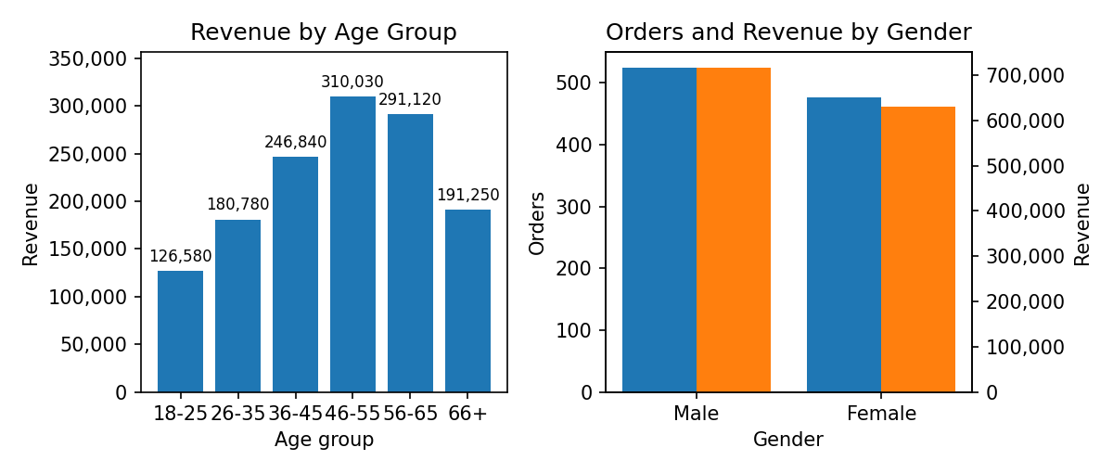
Figure 5: Revenue by age group and orders/revenue by gender
The age group 46-55 contributes the most revenue (23.0%), and 18-25 the least (9.4%); differences partly reflect the number of customers in each age group, as ages from 18 to 69 are spread widely. Male customers place 524 orders and generate 53.1% of revenue versus 46.9% for Female; the order-value difference between genders is not statistically significant.

15. Product Analysis
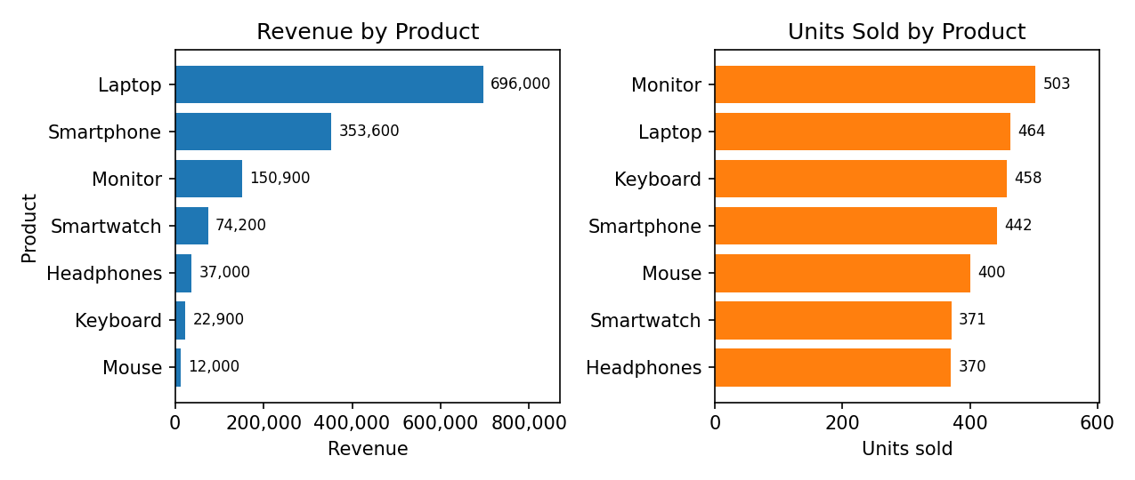
Figure 6: Revenue and units sold by product
Laptop generates 51.7% of total revenue, far more than any other product. The best-selling product by units is Monitor (503 units), which shows that the top product by revenue is not the top by volume: price level matters more than unit count.
Table 12: Product performance comparison
Product | Category | Orders | Units | Revenue | Share | Avg price | AOV | Return rate
Laptop | Electronics | 154 | 464 | 696,000 | 51.7% | 1,500 | 4,519 | 34.0%
Smartphone | Electronics | 142 | 442 | 353,600 | 26.3% | 800 | 2,490 | 31.6%
Monitor | Electronics | 181 | 503 | 150,900 | 11.2% | 300 | 834 | 30.2%
Smartwatch | Wearables | 122 | 371 | 74,200 | 5.5% | 200 | 608 | 32.5%
Headphones | Accessories | 120 | 370 | 37,000 | 2.7% | 100 | 308 | 34.5%
Keyboard | Accessories | 145 | 458 | 22,900 | 1.7% | 50 | 158 | 31.4%
Mouse | Accessories | 136 | 400 | 12,000 | 0.9% | 30 | 88 | 33.6%

The three highest-priced products (Laptop, Smartphone and Monitor) provide 89.2% of revenue from 47.7% of orders. Order counts per product are fairly similar (between 120 and 181), so product revenue differences are driven mainly by price, not by popularity.

16. Category Analysis
Table 13: Category performance
Category | Orders | Units | Revenue | Revenue share | Order share | Avg order value
Electronics | 477 | 1,409 | 1,200,500 | 89.2% | 47.7% | 2,517
Wearables | 122 | 371 | 74,200 | 5.5% | 12.2% | 608
Accessories | 401 | 1,228 | 71,900 | 5.3% | 40.1% | 179

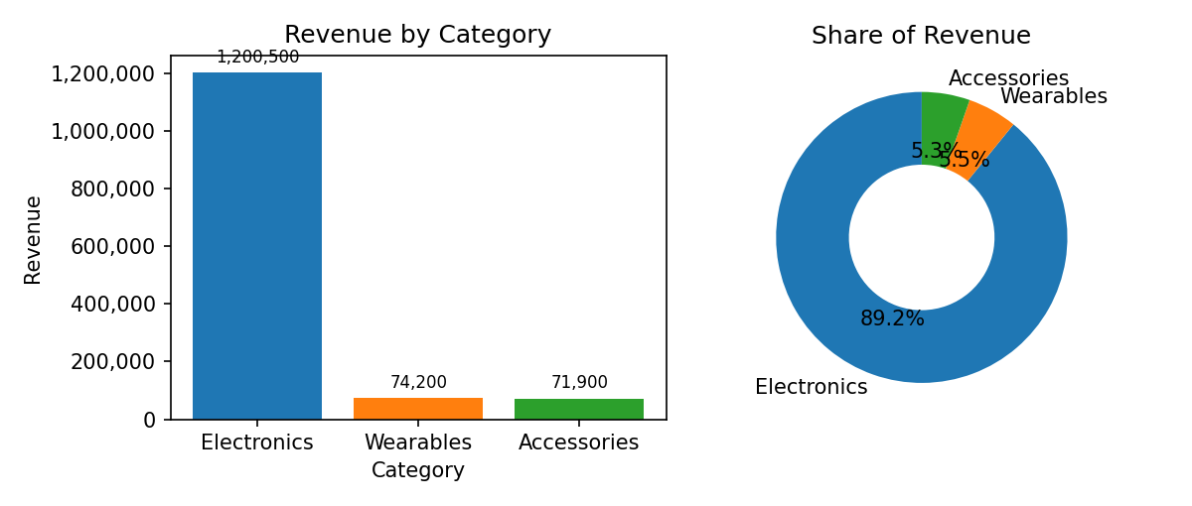
Figure 7: Revenue by category and share of revenue
Electronics contributes 89.2% of revenue from 47.7% of orders, with an average order value of 2,517. Accessories has 40.1% of orders but only 5.3% of revenue. The business is therefore highly dependent on Electronics.
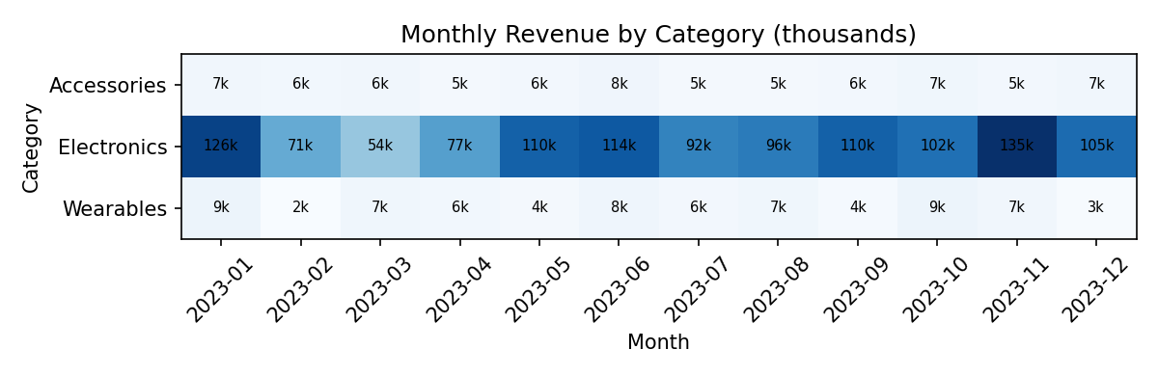
Figure 8: Monthly revenue by category (complete months, thousands)
Electronics dominates every month; the monthly variation in total revenue mostly follows the variation in Electronics sales.

17. Regional Analysis
Table 14: Regional performance (orders with known region)
Region | Orders | Units | Revenue | Revenue share | AOV | Return rate
East | 231 | 715 | 329,950 | 25.8% | 1,428 | 28.6%
North | 229 | 702 | 324,990 | 25.4% | 1,419 | 30.5%
West | 246 | 733 | 323,390 | 25.3% | 1,315 | 39.9%
South | 244 | 726 | 301,040 | 23.5% | 1,234 | 27.5%

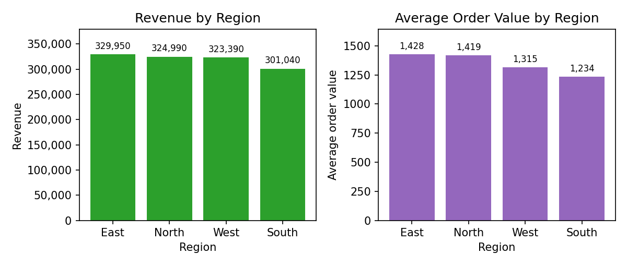
Figure 9: Revenue and average order value by region
East has the highest revenue (329,950) and South the lowest (301,040); the best region is only 9.6% above the lowest. Each region contributes between 23.5% and 25.8% of total revenue, and the difference in order value between regions is not statistically significant. Sales are therefore well balanced geographically. 50 orders (5%) have no region recorded and are excluded from these comparisons.

18. Shipping Analysis
Table 15: Shipping status distribution
Shipping status | Orders | % of all orders
Delivered | 313 | 31.3%
In Transit | 329 | 32.9%
Returned | 308 | 30.8%
Unknown | 50 | 5.0%

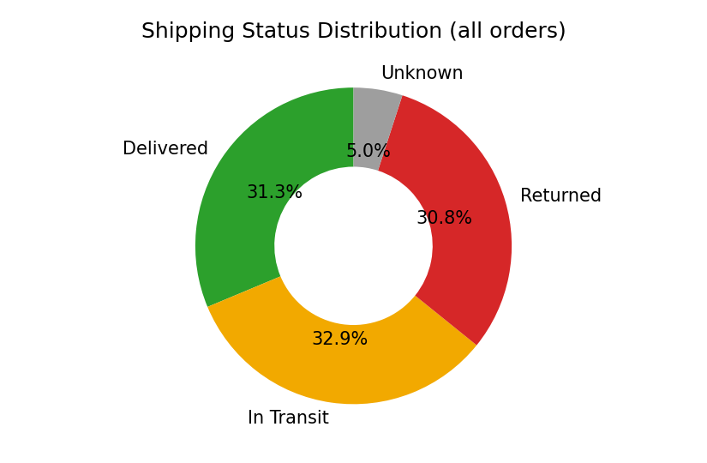
Figure 10: Shipping status distribution
Among orders with a known status, 32.9% are delivered, 34.6% in transit and 32.4% returned. The share of returned orders is almost as large as delivered orders, which is a major concern for profitability. 5.0% of orders have no status recorded.
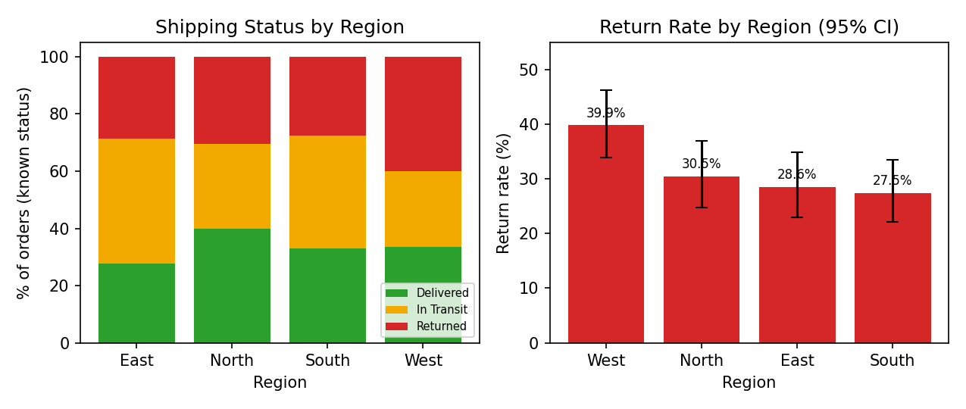
Figure 11: Shipping status mix and return rate by region
West has the highest return rate (39.9%, 95% CI 33.9-46.3%) and South the lowest (27.5%). The chi-square test (p = 0.0004) confirms that status mix differs between regions, and the West interval does not overlap with the lowest region's interval.
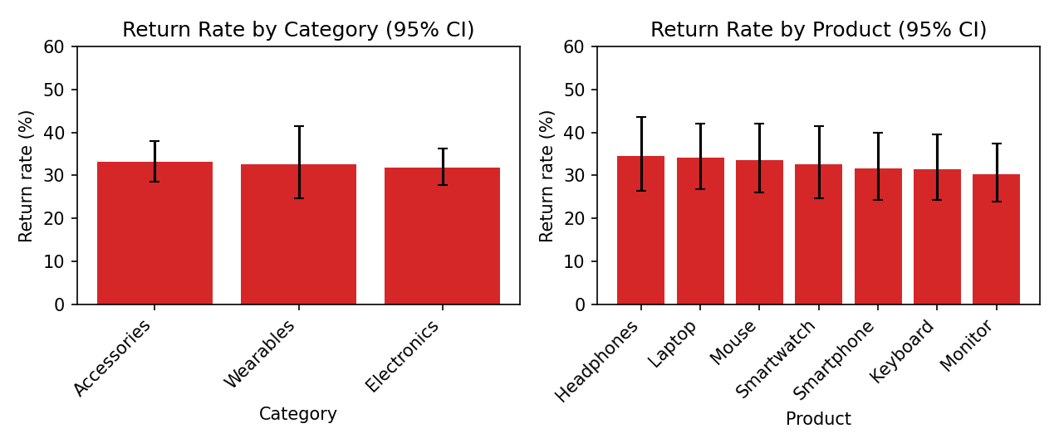
Figure 12: Return rate by category and product with 95% confidence intervals
Category return rates are between 31.8% and 33.1% and product return rates between 30.2% (Monitor) and 34.5% (Headphones). All confidence intervals overlap and the category test is not statistically significant, so no category or product can be said to have a truly higher return rate. The apparent differences are consistent with random variation, so the return problem seems to be company-wide.
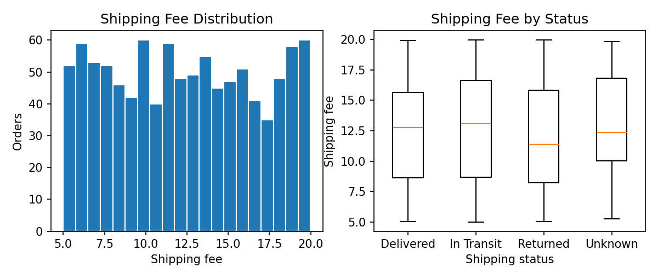
Figure 13: Shipping fee distribution and shipping fee by status
Shipping fees are spread fairly evenly between 5.00 and 19.98 (mean 12.42), and the distribution is nearly the same for each shipping status. Fees do not appear to depend on order value or on return outcome.

19. Time-Series Analysis
Order dates were converted to datetime (format dd-mm-yyyy). The data cover 01 Jan 2023 to 03 Jan 2024. The final month (2024-01) contains data for only 1 day, so it is treated as a partial month and excluded from best/worst-month comparisons.
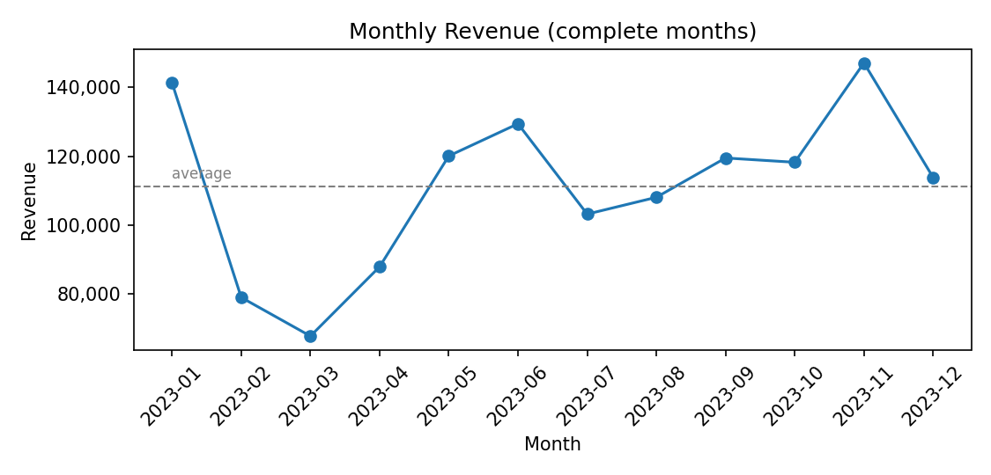
Figure 14: Monthly revenue (complete months)
The best complete month is 2023-11 (147,150) and the lowest is 2023-03 (67,660). Revenue starts high in January 2023, falls sharply in February and March, recovers from April onward, and reaches its highest level in November. Monthly average revenue is 111,268.
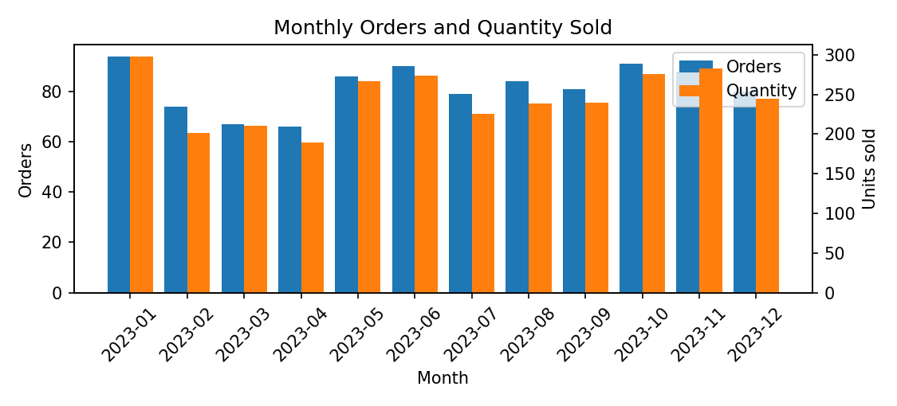
Figure 15: Monthly orders and units sold
Orders and quantity follow similar patterns, with fewer fluctuations than revenue; revenue moves more because the mix of high-priced Electronics orders changes from month to month.
Table 16: Monthly summary
Month | Revenue | Orders | Units | AOV | MoM change | Note
2023-01 | 141,360 | 94 | 298 | 1,504 | -
2023-02 | 78,910 | 74 | 201 | 1,066 | -44.2%
2023-03 | 67,660 | 67 | 210 | 1,010 | -14.3%
2023-04 | 87,840 | 66 | 189 | 1,331 | 29.8%
2023-05 | 120,080 | 86 | 267 | 1,396 | 36.7%
2023-06 | 129,450 | 90 | 274 | 1,438 | 7.8%
2023-07 | 103,160 | 79 | 226 | 1,306 | -20.3%
2023-08 | 108,050 | 84 | 239 | 1,286 | 4.7%
2023-09 | 119,490 | 81 | 240 | 1,475 | 10.6%
2023-10 | 118,240 | 91 | 276 | 1,299 | -1.0%
2023-11 | 147,150 | 88 | 283 | 1,672 | 24.5%
2023-12 | 113,830 | 80 | 245 | 1,423 | -22.6%
2024-01 | 11,380 | 20 | 60 | 569 | -90.0% | Partial

Because the data span only one full year, seasonality cannot be confirmed; the November high and the February-March low could be seasonal or random.

20. Dashboard Design
The Streamlit dashboard (app.py) uses a sidebar for navigation and filters and a main area for KPI cards and charts. Filters (Region, Gender, Category, Product, Shipping Status, Age Group and Date Range) are applied to the cleaned data before any calculation, so every KPI, chart, table and insight reflects the selection. The filtered data can be downloaded as CSV.
Table 17: Dashboard pages
Page | Content
1. Executive Overview | Three rows of KPI cards, monthly revenue trend, revenue by category and region, shipping status donut
2. Sales Analysis | Selectable monthly metric, best/lowest month, daily revenue with 7-day average, product and category charts, quantity histogram, month x category heatmap
3. Customer Analysis | Customer KPIs, age histogram, revenue by age group and gender, purchase frequency, Pareto curve, segments, top-10 customers
4. Product & Category | Top products by revenue and quantity, category donuts, AOV, box plot, price vs units scatter, product x region heatmap, performance table
5. Shipping Analysis | Status distribution, fee histogram, status by region/category/product, return rates with confidence intervals, fee box plot and scatter
6. Business Insights | Auto-generated insights, regional table, statistical tests, descriptive statistics, correlation heatmap, cleaning log, data-quality notes

Design choices: charts have titles, axis labels, thousand separators and hover tooltips; return-rate charts show 95% confidence intervals so users do not over-read small differences; partial months are marked; warnings explain the data limitations where they affect interpretation. Dashboard screenshots can be added to the screenshots folder after running the application locally.

21. Key Findings
- Revenue is 1,346,600 from 1,000 orders; average order value is 1,347.
- Laptop alone provides 51.7% of revenue; Electronics provides 89.2%.
- Revenue is evenly spread across regions (23.5% to 25.8% each).
- Best complete month: 2023-11; lowest: 2023-03.
- 32.4% of orders with known status were returned, equal to 415,640 of revenue.
- West has a significantly different (higher) return rate than other regions (39.9%).
- No significant difference in return rate between categories, products or genders.
- 86.0% of customer IDs are repeat buyers; the top 20% of IDs generate 48.7% of revenue.

22. Business Insights
Overview: The selection contains 1,000 orders from 292 customer IDs, generating revenue of 1,346,600 (average order value 1,347).
Products: Laptop generates the highest revenue (696,000, 51.7% of sales). Monitor sells the most units (503). Mouse is the lowest revenue product (0.9% of sales).
Categories: Electronics is the top category with 89.2% of revenue from 47.7% of orders; the lowest is Accessories (5.3% of revenue).
Regions: East leads on revenue (329,950, 25.8%); South is lowest (301,040). The best region is 9.6% above the lowest one.
Trend: Best complete month by revenue: 2023-11 (147,150); lowest: 2023-03 (67,660). Partial month(s) 2024-01 were excluded from this comparison.
Shipping: Return rate is 32.4% (delivered 32.9%, in transit 34.6%) among orders with known status. Returned orders account for 415,640 of revenue (30.9%).
Returns: Highest return rate by region: West (39.9%, 95% CI 33.9-46.3%); lowest: South (27.5%).
Returns: Highest return rate by category: Accessories (33.1%, 95% CI 28.6-37.9%); lowest: Electronics (31.8%).
Returns: Highest return rate by product: Headphones (34.5%, 95% CI 26.5-43.5%); lowest: Monitor (30.2%).
Statistics: Significant at the 5% level: Is shipping status related to Region?; Is customer age related to order value? (correlation 0.07: statistically detectable but very weak, so of little practical importance).
Customers: 86.0% of customer IDs purchased more than once. The top 20% of customers generate 48.7% of revenue. (Customer IDs show inconsistent gender/region, so treat customer-level results as indicative.)
Demographics: The age group with the highest revenue is 46-55 (23.0%). By gender, Male customers contribute 53.1% of revenue.
Attention areas: 32.4% of orders with a known status were returned, which removes 415,640 from revenue (net revenue 930,960). 5.0% of orders have no shipping status recorded, a data-capture gap.

23. Business Recommendations
- Investigate returns in the West region first (return rate 39.9% versus 27.5% in South): check carriers, delivery times and product handling there.
- Treat the overall return rate (32.4%) as a company-wide issue: collect return reasons, because it removes about 31% of revenue.
- Protect the Electronics line, especially Laptop, through stock availability and quality control since it drives most revenue; consider promotions that lift Accessories and Wearables order value, e.g. bundles with Electronics.
- Review what happened in February-March (lowest months) and plan campaigns before them, after confirming with a second year of data whether the pattern repeats.
- Fix data capture: make Region and Shipping Status mandatory, add an Order ID, and use one consistent Customer ID per person.
- Reconcile pricing: some Unit Price entries did not match the product price list; add a validation rule that Unit Price x Quantity equals Total Price.

24. Limitations
- No Order ID: each row is treated as one order; multi-item baskets cannot be identified.
- Customer IDs are inconsistent (same ID with different gender/region), so customer analysis is indicative.
- Region, Shipping Status and Age had missing values (100 ages were imputed); Unknown labels reduce the sample for region and status analysis.
- Only one full year of data (plus 1 day of the following year), so seasonality and year-over-year growth cannot be evaluated.
- No cost, profit, discount, payment or return-reason data, so profitability and causes of returns cannot be analysed.
- Currency is not specified.
- The dataset has no public source reference; it is treated as a provided dataset and results apply only to it.

25. Future Scope
- Forecast monthly revenue (e.g. ARIMA or Prophet) once more history is available.
- Add RFM-based customer segmentation when reliable customer IDs and order IDs exist.
- Predict return risk with a classification model if return reasons and delivery times are captured.
- Connect the dashboard to a database or live feed and deploy it (for example on Streamlit Community Cloud).
- Add profit analysis and basket analysis when cost and order-level data are available.

26. Conclusion
The project delivered a complete analytics workflow and an interactive dashboard on 1,000 e-commerce orders. The results show a revenue base that is geographically balanced but concentrated in a few high-priced Electronics products, and a high overall return rate (32.4%) that is the most important operational concern, with West standing out statistically. The report also demonstrates careful handling of data quality: no rows were deleted, every correction is logged, and limitations are stated. All figures were calculated directly from the dataset, so the analysis can be reproduced by running the code.

27. References
- McKinney, W. (2022). Python for Data Analysis, 3rd ed. O'Reilly Media.
- pandas documentation. https://pandas.pydata.org/docs/
- SciPy documentation (scipy.stats). https://docs.scipy.org/doc/scipy/
- Plotly Python documentation. https://plotly.com/python/
- Streamlit documentation. https://docs.streamlit.io/
- Matplotlib documentation. https://matplotlib.org/stable/
- Wilson, E. B. (1927). Probable inference, the law of succession, and statistical inference. Journal of the American Statistical Association, 22(158), 209-212.
- Dataset: realistic_e_commerce_sales_data.csv (provided with this project; no public URL).

