AICTE | IBM SkillsBuild
Data Analytics with AI Internship 2026
PROJECT REPORT
E-Commerce Sales and Customer Behavior Analysis
Data cleaning, exploratory analysis, KPI reporting, statistical testing and business recommendations using Python
Submitted by
Student Name: Bhagyashri Rajput
Internship / Program: AICTE | IBM SkillsBuild – Data Analytics with AI Internship 2026
Institution: RCPET's Institute Of Management Research And Development
October 2026

Table of Contents
1. Introduction
2. Problem Statement
3. Project Objectives
4. Dataset Description
5. Data Collection / Dataset Source
6. Tools and Technologies
7. Project Methodology
8. Data Cleaning
9. Exploratory Data Analysis
10. KPI Analysis
11. Product Analysis
12. Category Analysis
13. Regional Analysis
14. Monthly Sales Analysis
15. Customer Analysis
16. Age Group Analysis
17. Gender Analysis
18. Shipping Analysis
19. Return Analysis
20. Price vs Quantity Analysis
21. Customer Contribution Analysis
22. Business Questions and Answers
23. Key Findings
24. Business Recommendations
25. Conclusion
26. References

Abstract
This project analyses an e-commerce order dataset of 1,000 orders placed by 292 customers between 2023-01-01 and 2024-01-03. The raw data was first inspected and cleaned: incorrect unit prices were repaired, missing ages were recovered from customers' other orders, and missing regions and shipping statuses were labelled rather than guessed. The cleaned data was then used for exploratory analysis, KPI calculation, statistical testing (correlation and chi-square tests) and visualisation, all in Python.
Total revenue was 1,346,600. Electronics generated 89.2% of it, and two products – Laptop and Smartphone – generated 77.9%. Revenue was spread fairly evenly across regions, and customers aged 46 and above contributed 57.8%. The main weakness is fulfilment: of orders with a recorded status, only 32.9% were delivered and 32.4% were returned, with the West region significantly worse (return rate 39.9%). Product price and quantity purchased were unrelated (r = 0.004). The report closes with data-driven recommendations for sales growth, product and regional strategy, customer retention, return reduction, shipping and inventory planning.

1. Introduction
E-commerce companies collect a large amount of data every day: who bought what, where, when, at what price, and whether the order reached the customer or came back. Turning this data into decisions is the job of a data analyst. Well-prepared analysis shows which products earn the most, which regions and customers matter, when demand is high or low, and where the delivery process fails.
This report documents a complete data-analytics project carried out for the AICTE | IBM SkillsBuild Data Analytics with AI Internship 2026. It follows a professional workflow: understand the data, clean it carefully and transparently, explore it, calculate business KPIs, test patterns statistically, visualise results and finally recommend actions. Every number in the report was calculated from the supplied dataset using Python; nothing was assumed or invented.
The project answers twelve specific business questions (listed in Section 22) about sales, products, regions, customers, shipping and returns. The accompanying files are a Jupyter Notebook containing all code and outputs, an interactive Streamlit dashboard, a README and a requirements file.

2. Problem Statement
An e-commerce company wants to understand its sales performance, customer purchasing behavior, product demand, regional revenue contribution, and shipping outcomes. The company has historical order data containing information about customers, products, categories, prices, quantities, regions, order dates, shipping status, and related attributes.
The objective of this project is to clean and analyze the e-commerce dataset using Python, identify important sales and customer behavior patterns, evaluate product and regional performance, analyze shipping and return behavior, and generate actionable business recommendations.

3. Project Objectives
The analysis is designed to help the company make data-driven decisions to:
- Increase sales;
- Identify high-performing products and categories;
- Understand valuable customer segments;
- Identify strong and weak regions;
- Reduce product returns;
- Improve shipping performance; and
- Improve overall customer experience.
Technical objectives: (1) inspect and clean the raw data without silently deleting anything; (2) engineer useful derived fields; (3) perform exploratory and statistical analysis; (4) build clear, correctly labelled visualisations; (5) answer all twelve business questions with evidence; and (6) deliver a notebook, a dashboard and this report.

4. Dataset Description
The raw file contains 1,000 rows and 12 columns. Each row represents one order (the dataset has no order-ID column), so the number of rows is used as the number of orders. Orders were placed between 2023-01-01 and 2024-01-03. Table 1 describes each column.
Table 1: Columns in the raw dataset
Column | Type | Description
Customer ID | Text | Customer identifier (e.g. CUST0268); 292 unique customers
Gender | Text | Male / Female, as recorded on the order
Region | Text | North, South, East or West
Age | Number | Customer age in years (18 to 69)
Product Name | Text | Laptop, Smartphone, Monitor, Smartwatch, Headphones, Keyboard, Mouse
Category | Text | Electronics, Accessories or Wearables
Unit Price | Number | Price of one unit
Quantity | Integer | Units ordered (1 to 5)
Total Price | Number | Order value = unit price × quantity (shipping not included)
Shipping Fee | Number | Shipping charge for the order (5.00 to 19.98)
Shipping Status | Text | Delivered, In Transit or Returned
Order Date | Text | Date of order in day-month-year format (e.g. 08-12-2023)

Revenue definition. Revenue (gross sales) is the sum of Total Price. Net revenue excludes orders whose status is Returned. Shipping fees are analysed separately and are not part of revenue. The dataset does not state a currency, so values are shown as plain currency units.
Table 2: Missing values in the raw dataset
Column | Missing values | % of rows
Region | 50 | 5.0%
Age | 100 | 10.0%
Shipping Status | 50 | 5.0%

Missing values occur only in Age (100), Region (50) and Shipping Status (50); 1,000 rows were loaded and no exact duplicate rows exist.

5. Data Collection / Dataset Source
The dataset is the publicly available E-Commerce Sales dataset on Kaggle:
https://www.kaggle.com/datasets/refiaozturk/e-commerce-sales
The CSV file supplied for the project (realistic_e_commerce_sales_data.csv) was used as the primary and only dataset. It was stored unchanged in the project’s data folder as e_commerce_sales.csv. All cleaning was applied to a separate copy in memory, and a cleaned version was saved as ecommerce_sales_cleaned.csv, so the original data remains available for verification. The data contains pseudonymous customer IDs only; no names, contact details or other personal information are present.

6. Tools and Technologies
Table 3: Tools used in the project
Tool | Purpose in this project
Python 3 | Primary programming language
pandas | Loading, cleaning, transformation, grouping and aggregation of the data
NumPy | Numerical operations, conditional logic and random jitter for scatter plots
Matplotlib | Bar, line, pie/donut, histogram, box and scatter charts
Seaborn | Statistical charts and heatmaps with a consistent style
SciPy | Pearson and Spearman correlation; chi-square tests of independence
Streamlit | Interactive dashboard with filters (app.py)
Jupyter Notebook | Documented, reproducible analysis combining code, outputs and explanations
Microsoft Word | This project report

7. Project Methodology
The project followed a fixed order: all cleaning was completed and validated before any analysis or visualisation was performed.
- Data collection – load the Kaggle CSV and keep it unchanged.
- Data understanding – rows, columns, data types, missing values, duplicates, inconsistent and impossible values.
- Data cleaning – standardise names, convert dates, repair or label problems, and log every decision with the reason.
- Validation – automatic checks (assertions) that confirm the cleaned data is consistent.
- Data transformation / feature engineering – month, age group, return flags, net revenue and shipping-fee percentage.
- Exploratory data analysis and KPIs – distributions, totals, averages and rates.
- Statistical analysis – correlation (price vs quantity) and chi-square tests (are return differences real?).
- Visualisation, business insights and recommendations – charts with titles and labelled axes, then evidence-based actions.

8. Data Cleaning
Cleaning followed the rule “do not silently delete data”. For every important decision the notebook records what problem was found, how it was handled and why. Table 4 summarises the decisions; the most important ones are explained below.

8.1 Cleaning log
Table 4: Cleaning decisions (from the notebook cleaning log)
Step | Problem found | Action and reason | Rows
Column names | Spaces and capital letters in names | Converted to snake_case. Safer, consistent code. | 0
Text values | Possible spacing/case inconsistencies | Trimmed spaces, standardised case. Prevents duplicate category labels. | 0
Order date | Dates stored as text (dd-mm-yyyy) | Converted to datetime with explicit format. Needed for monthly analysis. | 1,000
Duplicates | Checked exact and near duplicates | None found - no rows removed. Nothing to remove; check kept for reproducibility. | 0
Invalid values | Negative / zero / impossible values | None found. No action required. | 0
Unit price | Unit price ~2.07x list price in some rows; unit x qty != total | unit_price recomputed as total_price / quantity; flag column added. total_price matches the list price in all rows, so it is the reliable field. | 20
Age | Missing age values | Filled from the same customer's other orders; remaining -> 'Unknown' age group. Real data from same customer, no invented ages. | 100
Region | Missing region | Labelled 'Unknown'; excluded from regional rankings only. Region cannot be inferred (customers order from several regions). | 50
Shipping status | Missing shipping status | Labelled 'Unknown'; return/status % use recorded-status orders. Status cannot be inferred; avoids understating return rate. | 50
Outliers | High order values flagged by IQR | Kept - they are genuine high-priced product orders. Not errors; removing them would hide the most valuable sales. | 0
Customer attributes | Same customer ID has multiple genders / regions across orders | Documented; gender & region analysed per order, not per customer. Cannot be corrected without inventing data. | 192

8.2 Incorrect unit prices
Every product should have one list price (Laptop 1,500, Smartphone 800, Monitor 300, Smartwatch 200, Headphones 100, Keyboard 50, Mouse 30). However, 20 rows carried a unit price about 2.07 times the list price (for example a Laptop at 3,109.56 instead of 1,500), so unit price × quantity did not equal Total Price. Total Price, divided by quantity, equalled the product's list price in every one of the 1,000 rows, which shows that Total Price was correct and Unit Price was wrong.
The unit price was therefore recalculated as Total Price ÷ Quantity, and a flag column (unit_price_corrected) was kept for traceability. Deleting the rows would have thrown away valid orders (their quantity, region, status and date were correct); leaving them would have made some Laptop orders look twice as expensive and distorted the price-vs-quantity analysis.

8.3 Missing values
Age (100 missing). The notebook first proved that a customer's age never changes between orders, then filled each missing age from the same customer's other orders. This recovered 93 values; 7 orders belong to customers with no recorded age at all and are grouped as “Unknown”. Filling with the average age would have invented data and was rejected.
Region (50 missing) and Shipping Status (50 missing). These cannot be inferred from other columns (customers order from several regions, and an order's status is independent of its other fields), so they were labelled “Unknown” and kept in the overall sales totals. Unknown-region orders are left out of regional rankings, and return rates are calculated only on orders with a recorded status, so that missing values are not wrongly treated as “not returned”.

8.4 Outliers and invalid values
No negative or zero quantities, prices or fees and no impossible ages were found. The IQR rule (values beyond 1.5 × IQR from the quartiles) was used to check numeric columns (Table 5).
Table 5: Outlier check using the IQR rule (cleaned data)
Column | Min | Max | IQR lower limit | IQR upper limit | Outliers
total_price | 30.00 | 7,500.00 | -1,750.00 | 3,450.00 | 124
shipping_fee | 5.00 | 19.98 | -2.71 | 27.35 | 0
age | 18.00 | 69.00 | -1.00 | 95.00 | 0
quantity | 1.00 | 5.00 | -1.00 | 7.00 | 0
unit_price | 30.00 | 1,500.00 | -1,075.00 | 1,925.00 | 0

Only Total Price shows outliers (124 orders), and they all come from Laptop and Smartphone orders – genuine high-priced purchases, not errors. They were kept because removing them would hide the most valuable sales.

8.5 Customer attributes that are inconsistent
192 of 292 customer IDs appear with both genders, and 217 of 289 customers with a recorded region appear in more than one region. This cannot be corrected without inventing data, so gender and region are analysed per order as recorded, and customer-level analysis uses only Customer ID, revenue, orders and quantity.

8.6 Validation result
After cleaning, automatic checks confirmed: no unparsed dates, no duplicates, positive quantities, unit price × quantity = total price in every row, one price per product, and no unlabelled missing values. The raw data (1000 × 12) became the cleaned data (1000 × 24) – no rows were removed; one flag column was added, plus the derived columns described in the next section.
Derived columns created: order month, month name, age group (18–25, 26–35, 36–45, 46–55, 56+, Unknown), return / delivered / in-transit flags, status-recorded flag, net revenue (revenue excluding returned orders), shipping fee as a percentage of order value, and a flag marking the incomplete last month. No customer is under 18, so the “Under 18” group is not needed.

9. Exploratory Data Analysis
After cleaning, the dataset holds 1,000 orders, 292 customers, 7 products, 3 categories and four recorded regions. Table 6 gives summary statistics for the numeric columns.
Table 6: Summary statistics of numeric columns (cleaned data)
Column | Mean | Std. dev. | Min | Median | Max
age | 46.68 | 15.01 | 18.00 | 49.00 | 69.00
unit_price | 446.63 | 510.90 | 30.00 | 200.00 | 1,500.00
quantity | 3.01 | 1.40 | 1.00 | 3.00 | 5.00
total_price | 1,346.60 | 1,834.04 | 30.00 | 600.00 | 7,500.00
shipping_fee | 12.42 | 4.41 | 5.00 | 12.32 | 19.98

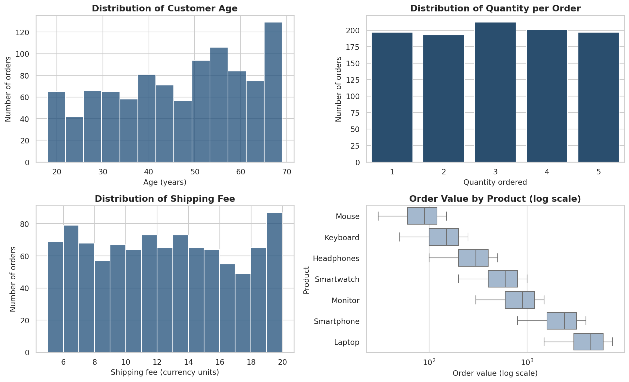
Figure 1: Distributions of age, quantity, shipping fee and order value
Customer ages are spread between 18 and 69; quantity is almost evenly spread across 1 to 5 units; shipping fee is evenly spread between about 5 and 20. Order value is strongly right-skewed (skewness 1.93): the mean order value (1,347) is more than double the median (600) because Laptop and Smartphone orders are far larger than Accessory orders. The box plot (log scale) confirms that order value is driven mostly by the product.
Customers placed between 1 and 9 orders each; 41 customers (14.0%) ordered once and 86.0% ordered more than once.

10. KPI Analysis
KPI formulas were chosen from the real columns: Total Revenue = Σ Total Price; Total Orders = number of rows; Average Order Value = Total Revenue ÷ Total Orders; Return Rate = Returned Orders ÷ orders with a recorded status × 100; Net Revenue = revenue of orders that were not returned.
Table 7: Key performance indicators
KPI | Value
Total Revenue (gross sales) | 1,346,600
Net Revenue (excluding returned orders) | 930,960
Revenue in Returned Orders | 415,640 (30.9% of revenue)
Total Orders | 1,000
Total Quantity Sold | 3,008
Average Order Value | 1,346.60
Average Unit Price (per order) | 446.63
Average Product List Price (7 products) | 425.71
Average Shipping Fee | 12.42
Number of Customers | 292
Number of Products | 7
Number of Categories | 3
Delivered Orders | 313
In Transit Orders | 329
Returned Orders | 308
Orders with Unknown Status | 50
Overall Return Rate (recorded-status orders) | 32.4%
Return Rate (all orders, for reference) | 30.8%

The business sold 3,008 units for 1,346,600 in revenue. However, 30.9% of that revenue (415,640) sits in orders that were returned, so net revenue is 930,960. The return rate is high whichever base is used (32.4% of recorded orders; 30.8% of all orders).

11. Product Analysis
The catalogue has only seven products, so a “Top 10” ranking contains all seven; the lowest-ranked products are the bottom performers. Table 8 ranks them by revenue.
Table 8: Product performance (ranked by revenue)
Product | Unit price | Revenue | Rev. share | Orders | Units | Unit share | Avg order value
Laptop | 1,500 | 696,000 | 51.7% | 154 | 464 | 15.4% | 4,519
Smartphone | 800 | 353,600 | 26.3% | 142 | 442 | 14.7% | 2,490
Monitor | 300 | 150,900 | 11.2% | 181 | 503 | 16.7% | 834
Smartwatch | 200 | 74,200 | 5.5% | 122 | 371 | 12.3% | 608
Headphones | 100 | 37,000 | 2.7% | 120 | 370 | 12.3% | 308
Keyboard | 50 | 22,900 | 1.7% | 145 | 458 | 15.2% | 158
Mouse | 30 | 12,000 | 0.9% | 136 | 400 | 13.3% | 88

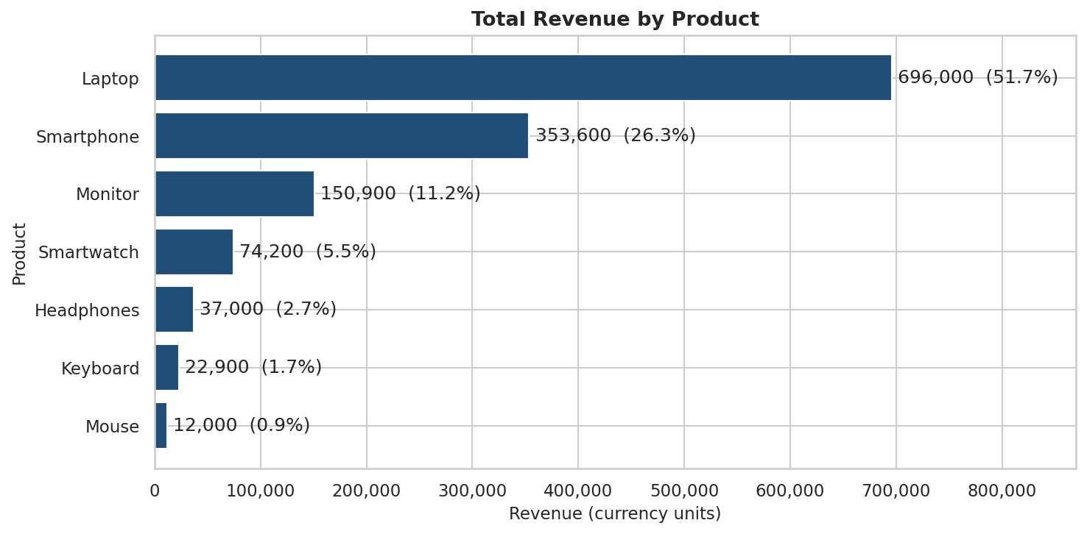
Figure 2: Total revenue by product
Laptop is the clear leader with 696,000 (51.7% of revenue) from only 154 orders. Laptop and Smartphone together produce 77.9% of revenue. The weakest product is Mouse (12,000; 0.9%).
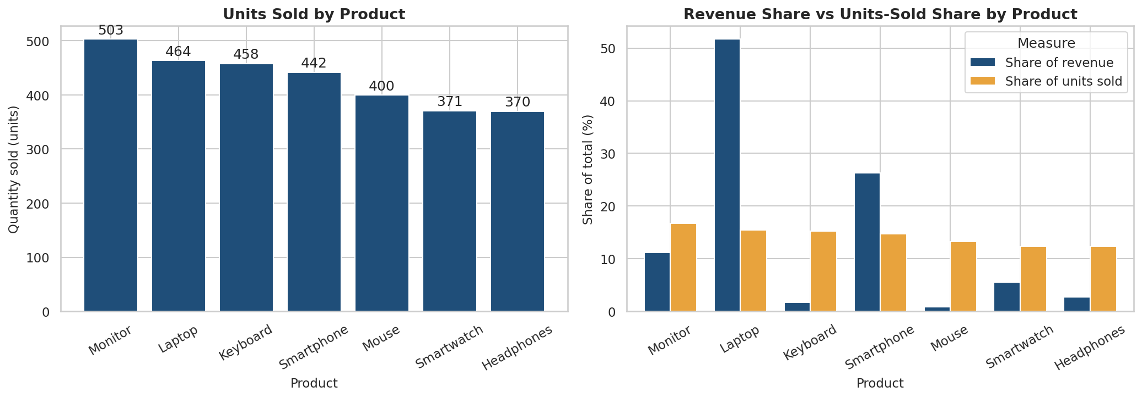
Figure 3: Units sold by product, and revenue share versus units-sold share
Monitor sold the most units (503), followed by Laptop (464) and Keyboard (458), but Monitor ranks 3 of 7 in revenue. Units sold range only from 370 to 503 per product, so price rather than volume explains the revenue differences. High volume does not mean high revenue: Mouse sold 400 units yet gives 0.9% of revenue.

12. Category Analysis
Table 9: Category performance
Category | Products | Revenue | Rev. share | Orders | Units | Avg order value | Return rate
Electronics | 3 | 1,200,500 | 89.2% | 477 | 1,409 | 2,517 | 31.8%
Wearables | 1 | 74,200 | 5.5% | 122 | 371 | 608 | 32.5%
Accessories | 3 | 71,900 | 5.3% | 401 | 1,228 | 179 | 33.1%

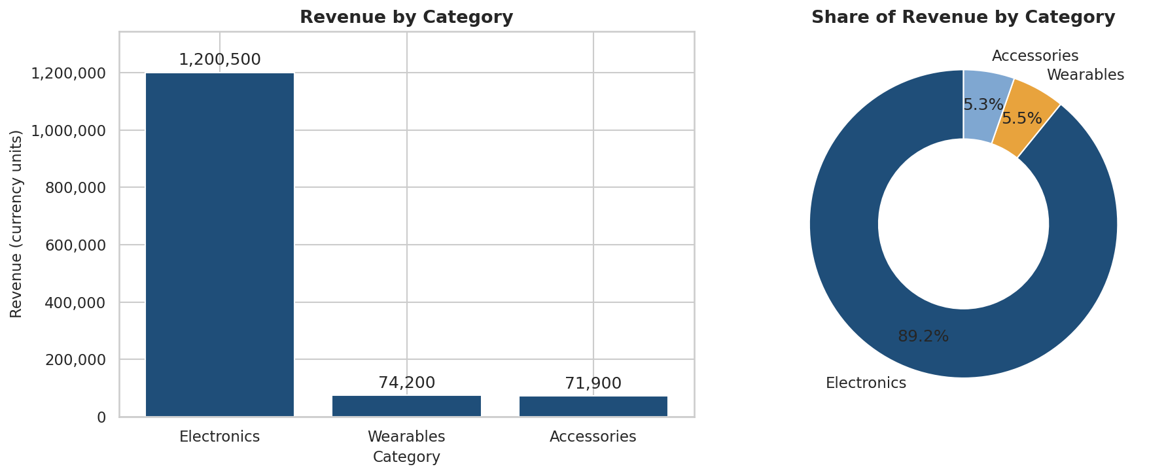
Figure 4: Revenue and revenue share by category
Electronics is the best category with 1,200,500 (89.2% of revenue). Accessories account for 40.1% of orders and 1,228 units but only 5.3% of revenue, because their average order value is only 179. Revenue is therefore highly concentrated in a single category.

13. Regional Analysis
Orders without a region (50 orders; 67,230 revenue) are shown for completeness but are excluded from the strongest/weakest ranking.
Table 10: Regional performance
Region | Revenue | Rev. share | Orders | Units | Avg order value
East | 329,950 | 24.5% | 231 | 715 | 1,428
North | 324,990 | 24.1% | 229 | 702 | 1,419
West | 323,390 | 24.0% | 246 | 733 | 1,315
South | 301,040 | 22.4% | 244 | 726 | 1,234
Unknown | 67,230 | 5.0% | 50 | 132 | 1,345

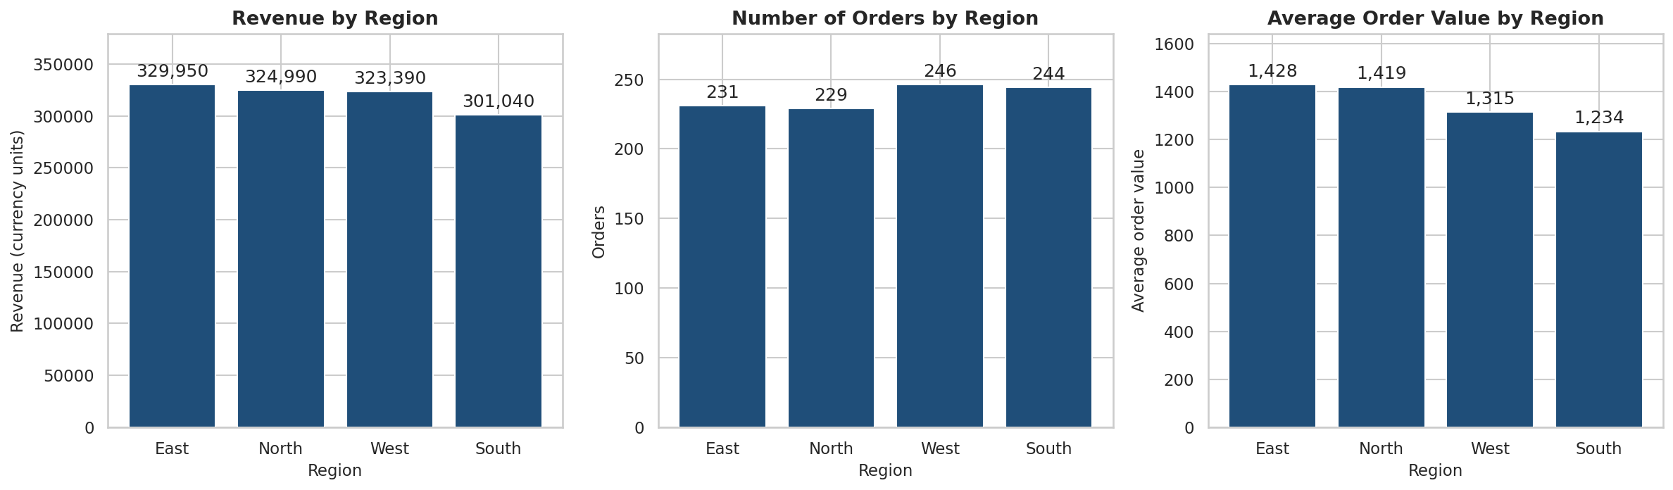
Figure 5: Revenue, number of orders and average order value by region
East is the strongest region (329,950; 24.5%) with the highest average order value (1,428); South is the weakest (301,040; 22.4%). The gap between the best and weakest region is only 9.6%, so regional revenue is fairly balanced. West receives the most orders (246) but ranks 3 in revenue.

13.1 Revenue by category and region
Table 11: Revenue by category and region
Category | East | North | South | West | Unknown | Total
Electronics | 288,900 | 294,500 | 266,600 | 289,700 | 60,800 | 1,200,500
Wearables | 23,800 | 14,000 | 17,800 | 15,200 | 3,400 | 74,200
Accessories | 17,250 | 16,490 | 16,640 | 18,490 | 3,030 | 71,900
Total | 329,950 | 324,990 | 301,040 | 323,390 | 67,230 | 1,346,600

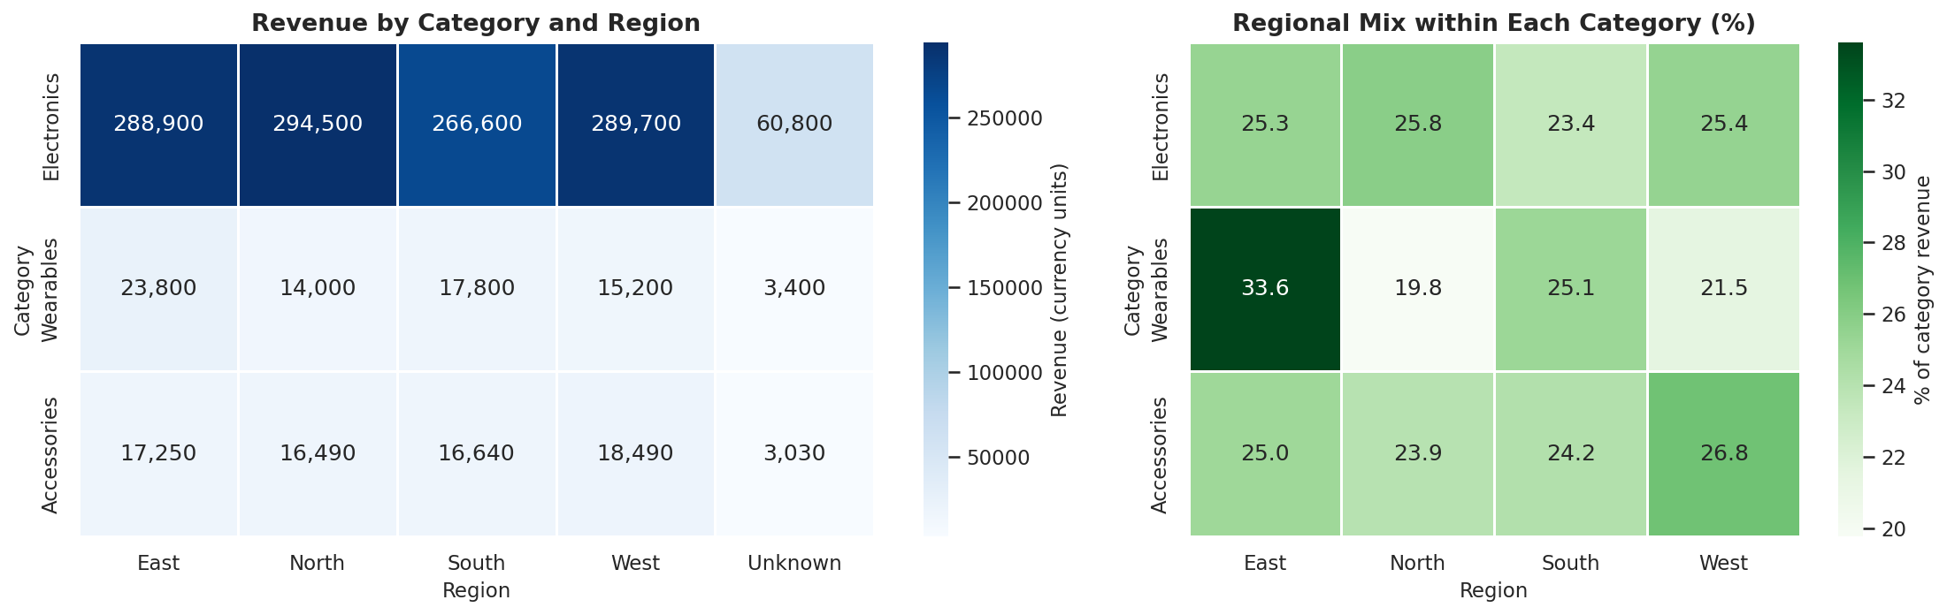
Figure 6: Heatmap of revenue by category and region
Electronics dominates every region, making up 88% to 91% of each region's revenue; the largest single combination is Electronics in North (294,500). Wearables vary most between regions, from 14,000 (North) to 23,800 (East).

14. Monthly Sales Analysis
The data covers all of 2023 and only the first three days of January 2024. The last month is incomplete, so it is displayed but not used to decide the highest or lowest month or month-over-month changes.
Table 12: Monthly revenue, orders and quantity
Month | Revenue | Orders | Units | Avg order value | Revenue MoM % | Note
Jan 2023 | 141,360 | 94 | 298 | 1,504 | –
Feb 2023 | 78,910 | 74 | 201 | 1,066 | -44.2%
Mar 2023 | 67,660 | 67 | 210 | 1,010 | -14.3%
Apr 2023 | 87,840 | 66 | 189 | 1,331 | +29.8%
May 2023 | 120,080 | 86 | 267 | 1,396 | +36.7%
Jun 2023 | 129,450 | 90 | 274 | 1,438 | +7.8%
Jul 2023 | 103,160 | 79 | 226 | 1,306 | -20.3%
Aug 2023 | 108,050 | 84 | 239 | 1,286 | +4.7%
Sep 2023 | 119,490 | 81 | 240 | 1,475 | +10.6%
Oct 2023 | 118,240 | 91 | 276 | 1,299 | -1.0%
Nov 2023 | 147,150 | 88 | 283 | 1,672 | +24.5%
Dec 2023 | 113,830 | 80 | 245 | 1,423 | -22.6%
Jan 2024 | 11,380 | 20 | 60 | 569 | – | Partial (3 days)

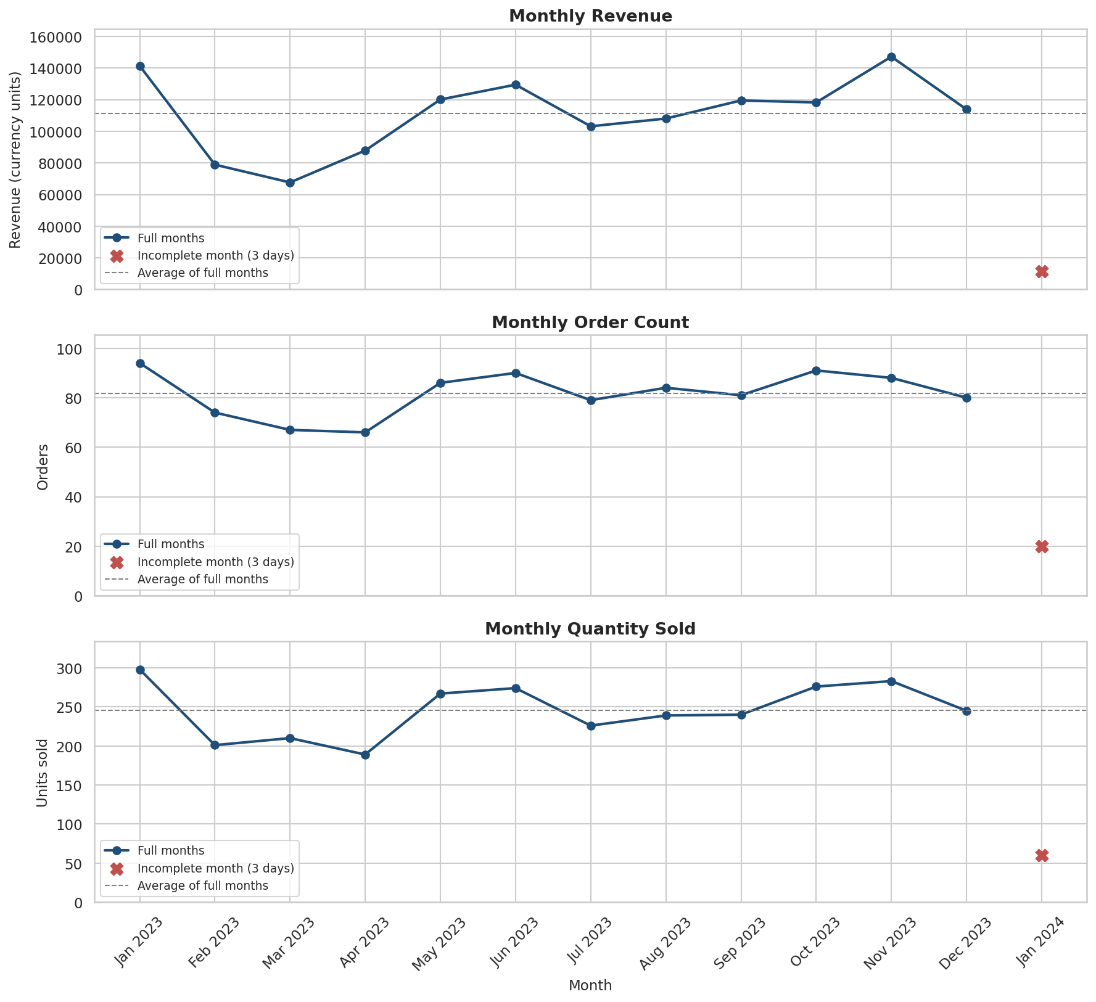
Figure 7: Monthly revenue, order count and quantity sold
Among complete months, revenue peaked in Nov 2023 (147,150) and was lowest in Mar 2023 (67,660); the peak is 2.2 times the lowest month. Orders peaked in Jan 2023 (94) and were lowest in Apr 2023 (66). The largest month-over-month rise was May 2023 (36.7%) and the largest fall Feb 2023 (-44.2%). Average monthly revenue is 111,268 from 82 orders. Revenue and orders move together (correlation 0.89), but revenue also depends on how many Laptops and Smartphones are sold. Sales are uneven rather than steadily growing.

15. Customer Analysis
There are 292 customers. They placed an average of 3.4 orders and spent an average of 4,612 each (median 3,595). 86.0% are repeat customers; 41 customers bought only once.
Table 13: Customers by number of orders placed
Orders per customer | 1 | 2 | 3 | 4 | 5 | 6 | 7 | 8 | 9
Customers | 41 | 61 | 60 | 56 | 39 | 18 | 10 | 3 | 4

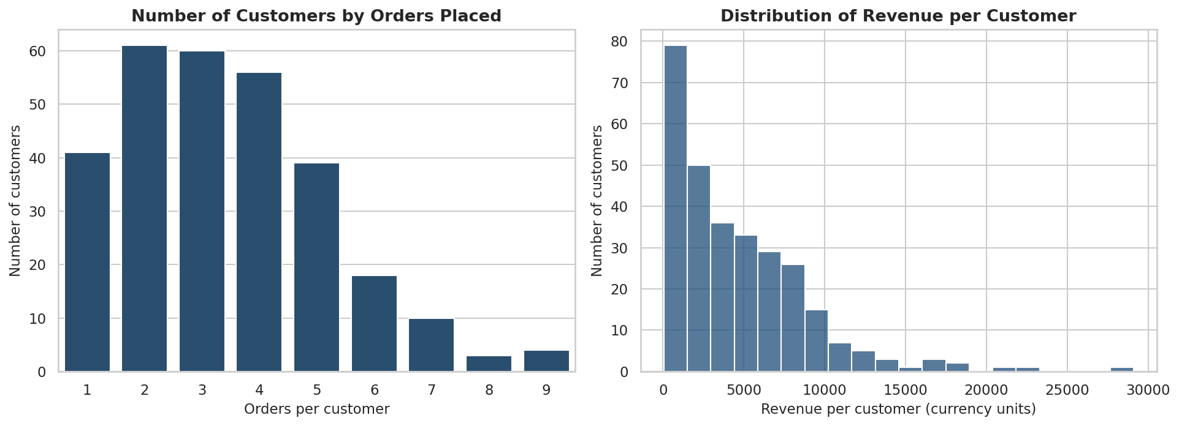
Figure 8: Customers by orders placed, and distribution of revenue per customer
Most customers order two to four times, and revenue per customer is right-skewed: many customers spend a modest amount while a smaller group spends much more. This pattern is analysed further in Section 21. Note that gender and region are not stable per customer (Section 8.5), so customer-level analysis uses only revenue, orders and quantity.

16. Age Group Analysis
Customers are 18 to 69 years old, so five groups were used. Orders from customers whose age is unknown (7 orders) are shown separately.
Table 14: Sales by age group
Age group | Customers | Revenue | Rev. share | Orders | Units | Avg order value | Revenue / customer
18-25 | 37 | 126,580 | 9.4% | 107 | 322 | 1,183 | 3,421
26-35 | 46 | 180,780 | 13.4% | 150 | 430 | 1,205 | 3,930
36-45 | 56 | 246,840 | 18.3% | 191 | 575 | 1,292 | 4,408
46-55 | 54 | 295,370 | 21.9% | 206 | 641 | 1,434 | 5,470
56+ | 94 | 482,370 | 35.8% | 339 | 1,022 | 1,423 | 5,132
Unknown | 5 | 14,660 | 1.1% | 7 | 18 | 2,094 | 2,932

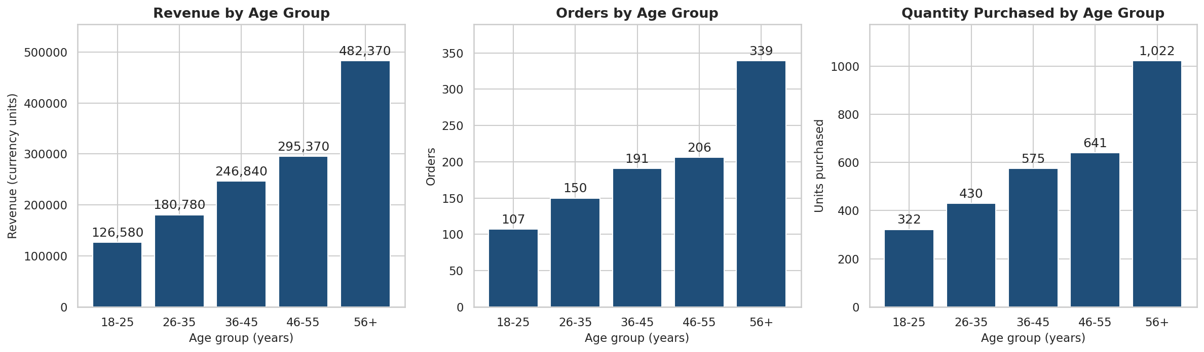
Figure 9: Revenue, orders and quantity purchased by age group
The 56+ group contributes the most: 482,370 (35.8% of revenue), 339 orders and 1,022 units. The smallest group is 18-25 (9.4%). Customers aged 46 and above generate 57.8% of revenue. Part of this is group size – 56+ covers a wider age band – but revenue per customer is also higher (5,132 for 56+ versus 3,421 for 18–25). Average order value is similar across groups (1,183 to 1,434); differences come mainly from the number of orders.

17. Gender Analysis
Gender is analysed as recorded on each order (see the limitation in Section 8.5).
Table 15: Sales by gender
Gender | Revenue | Rev. share | Orders | Units | Avg order value | Return rate
Male | 715,590 | 53.1% | 524 | 1,586 | 1,366 | 34.5%
Female | 631,010 | 46.9% | 476 | 1,422 | 1,326 | 30.1%

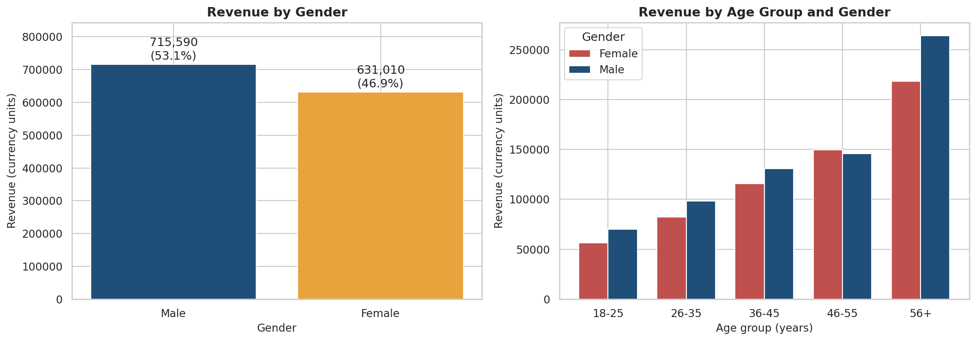
Figure 10: Revenue by gender and by age group and gender
Male orders generate 715,590 (53.1%) and Female orders 631,010 (46.9%) – a small difference, with orders of 524 versus 476 and similar average order value (1,366 vs 1,326). In the age-group chart, the 56+ group is the largest for both genders, so age matters more than gender for revenue.

18. Shipping Analysis
Percentages are shown on the 950 orders with a recorded status, so that Delivered + In Transit + Returned = 100%. The table also shows each status as a share of all 1,000 orders.
Table 16: Order status distribution
Status | Orders | % of recorded orders | % of all orders | Revenue | Avg shipping fee
Delivered | 313 | 32.9% | 31.3% | 407,380 | 12.39
In Transit | 329 | 34.6% | 32.9% | 443,560 | 12.85
Returned | 308 | 32.4% | 30.8% | 415,640 | 11.91
Unknown | 50 | – | 5.0% | 80,020 | 12.85

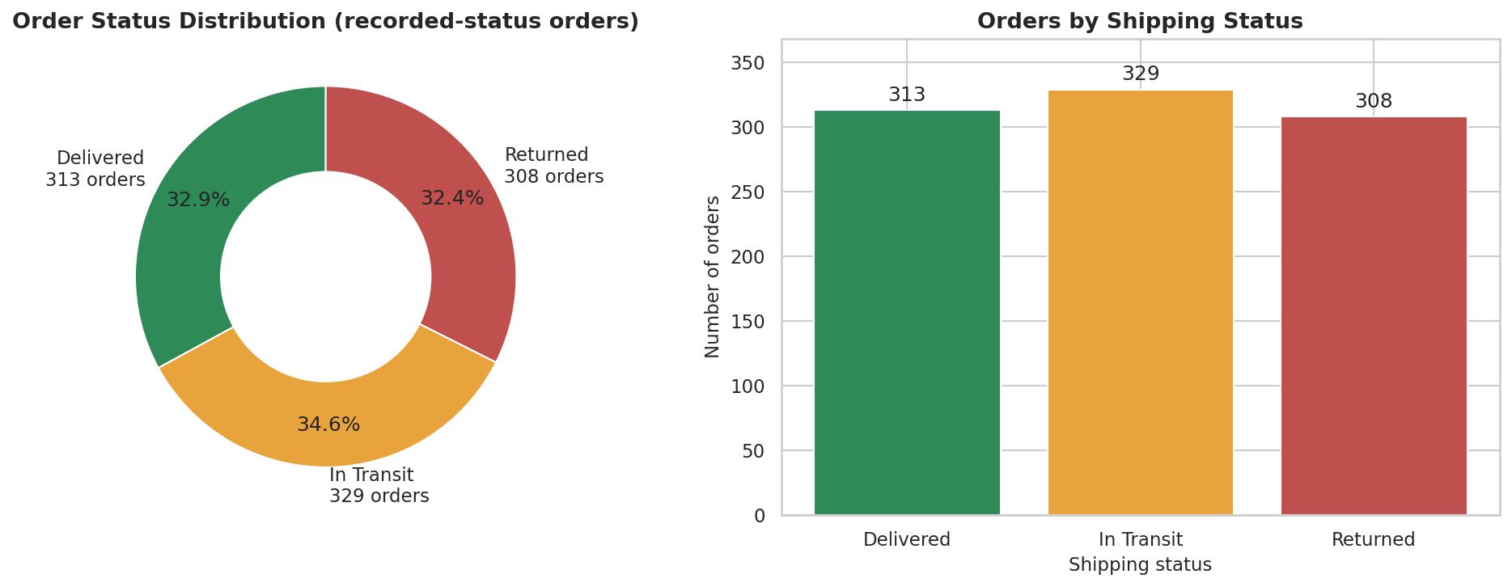
Figure 11: Distribution of order status (Delivered, In Transit, Returned)
Delivered 32.9%, In Transit 34.6%, Returned 32.4%. The three outcomes are almost equal: only about one in three recorded orders is confirmed as delivered, and about one in three has been returned. Counting the 50 unknown-status orders in the base gives Delivered 31.3%, In Transit 32.9%, Returned 30.8% and Unknown 5.0%. Average shipping fee is almost identical for the three statuses (12.39, 12.85, 11.91), so the fee level does not appear to explain returns.
Table 17: Shipping fee burden by category
Category | Avg order value | Avg shipping fee | Fee as % of order value
Electronics | 2,517 | 12.62 | 0.5%
Wearables | 608 | 12.35 | 2.0%
Accessories | 179 | 12.20 | 6.8%

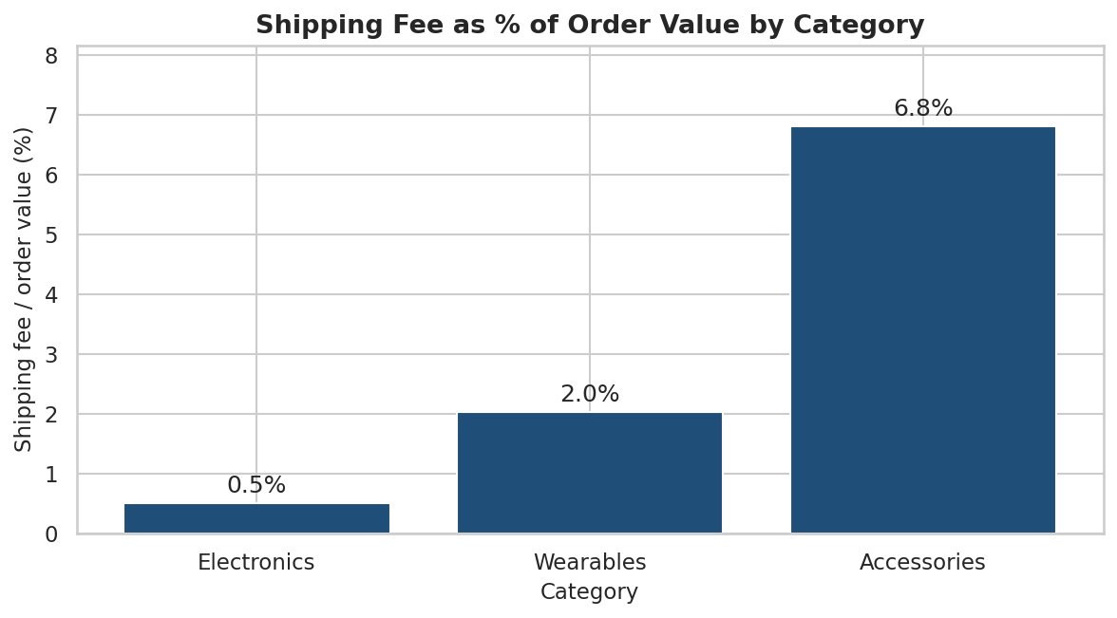
Figure 12: Shipping fee as a percentage of order value by category
Shipping costs only 0.5% of Electronics order value but 6.8% of Accessories order value, so low-priced orders carry a heavy shipping burden. The dataset has no delivery or dispatch dates, so delivery speed could not be measured; shipping performance is therefore assessed through status outcomes and cost.

19. Return Analysis
Return Rate = Returned Orders ÷ Orders with a recorded status × 100. Orders with unknown status are excluded from the denominator because they cannot be classified. To avoid misleading rankings, products and regions are ranked only when they have at least 30 recorded-status orders; all seven products (the smallest has 116 recorded orders) and all four regions pass this rule.

19.1 Returns by region
Table 18: Returned orders and return rate by region
Region | Recorded orders | Returned orders | Return rate | Returned revenue | % of all returns
West | 238 | 95 | 39.9% | 108,710 | 30.8%
North | 213 | 65 | 30.5% | 81,170 | 21.1%
East | 217 | 62 | 28.6% | 101,680 | 20.1%
South | 233 | 64 | 27.5% | 88,900 | 20.8%

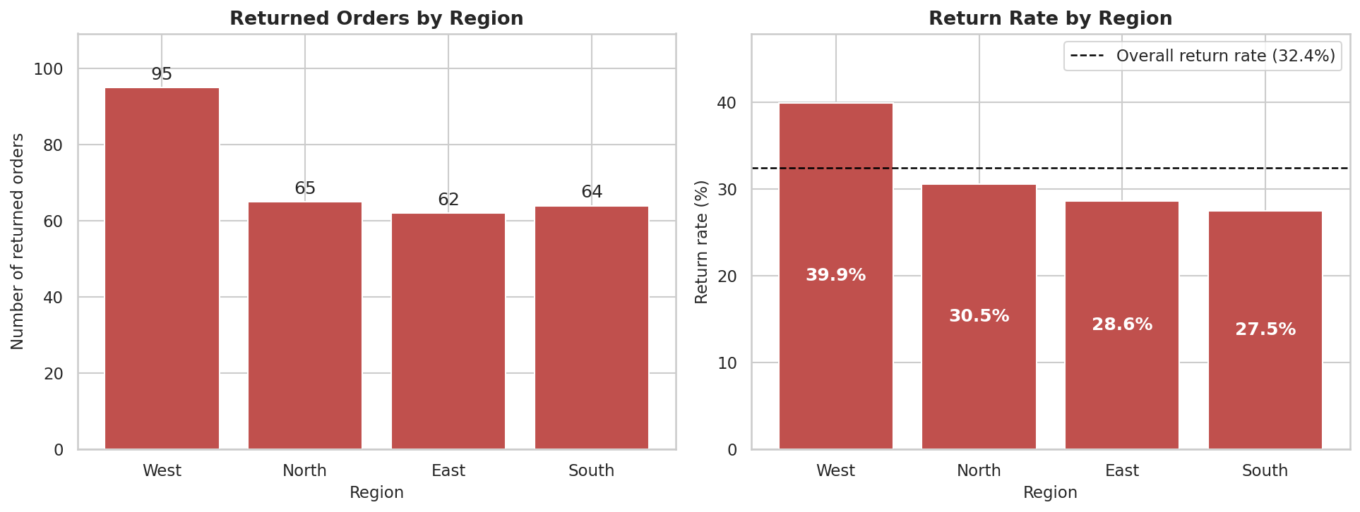
Figure 13: Returned orders and return rate by region
West needs attention: it has the most returned orders (95) and the highest return rate (39.9%) compared with 27.5% in South. A chi-square test confirms the regional difference is statistically significant (χ² = 10.46, p = 0.0150), so it is unlikely to be due to chance.
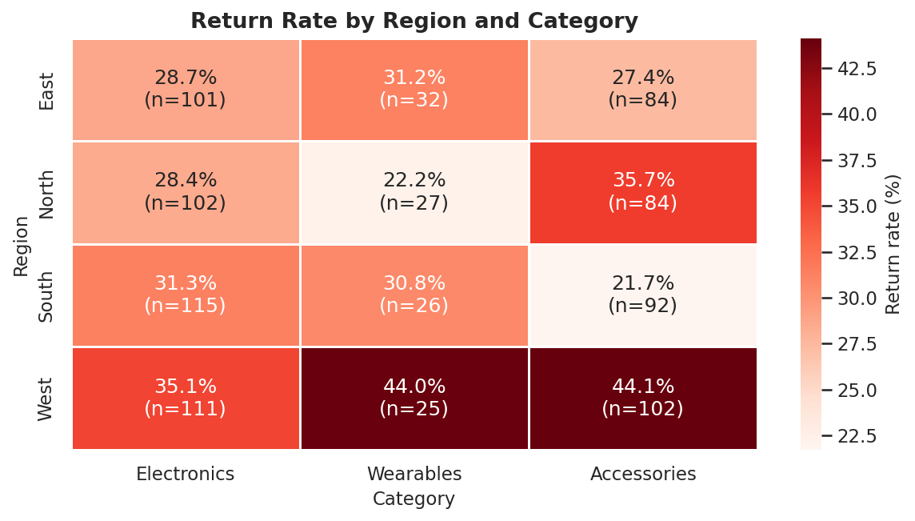
Figure 14: Return rate by region and category
The West return rate is the highest in all three categories, which suggests a regional cause (for example carrier, packaging or delivery quality) rather than a product problem. The dataset cannot confirm the cause, and some cells are small (see n in each cell).

19.2 Returns by product
Table 19: Return rate by product
Product | Recorded orders | Returned orders | Return rate | Returned revenue
Headphones | 116 | 40 | 34.5% | 12,000
Laptop | 144 | 49 | 34.0% | 223,500
Mouse | 131 | 44 | 33.6% | 4,140
Smartwatch | 117 | 38 | 32.5% | 22,800
Smartphone | 133 | 42 | 31.6% | 102,400
Keyboard | 137 | 43 | 31.4% | 7,000
Monitor | 172 | 52 | 30.2% | 43,800

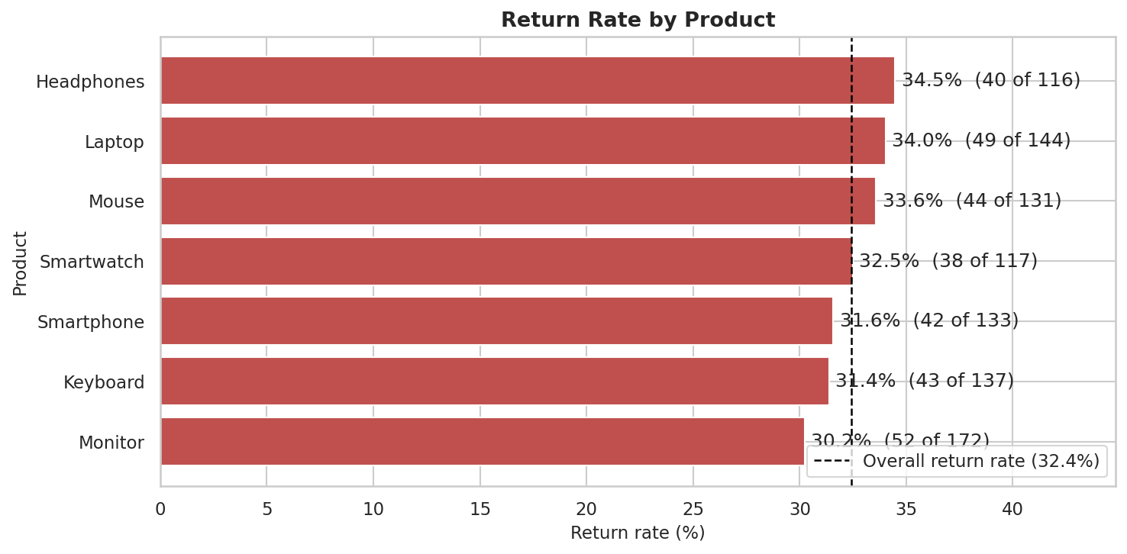
Figure 15: Return rate by product
Headphones has the highest return rate (34.5%), followed by Laptop (34.0%) and Mouse (33.6%); the lowest is Monitor (30.2%). The differences are small and not statistically significant (χ² = 0.96, p = 0.99), so returns are a company-wide problem rather than the fault of one product. In money terms, Laptop returns are the most costly (223,500 of returned revenue) because of its high price.

20. Price vs Quantity Analysis
This section tests whether customers buy fewer (or more) units when the unit price is higher. Pearson correlation measures a linear relationship and Spearman correlation a rank-based relationship; values near zero mean no relationship. Correlation does not prove causation.
Table 20: Correlation between unit price and quantity (1,000 orders)
Measure | Coefficient | p-value | Interpretation
Pearson r | +0.0044 | 0.890 | Negligible / no linear relationship
Spearman ρ | -0.0104 | 0.742 | Negligible / no monotonic relationship
Pearson r on log(price) | -0.0075 | 0.812 | Negligible / no relationship

Table 21: Average quantity per order by product (cheapest to most expensive)
Product | Unit price | Avg quantity per order | Total units
Mouse | 30 | 2.94 | 400
Keyboard | 50 | 3.16 | 458
Headphones | 100 | 3.08 | 370
Smartwatch | 200 | 3.04 | 371
Monitor | 300 | 2.78 | 503
Smartphone | 800 | 3.11 | 442
Laptop | 1,500 | 3.01 | 464

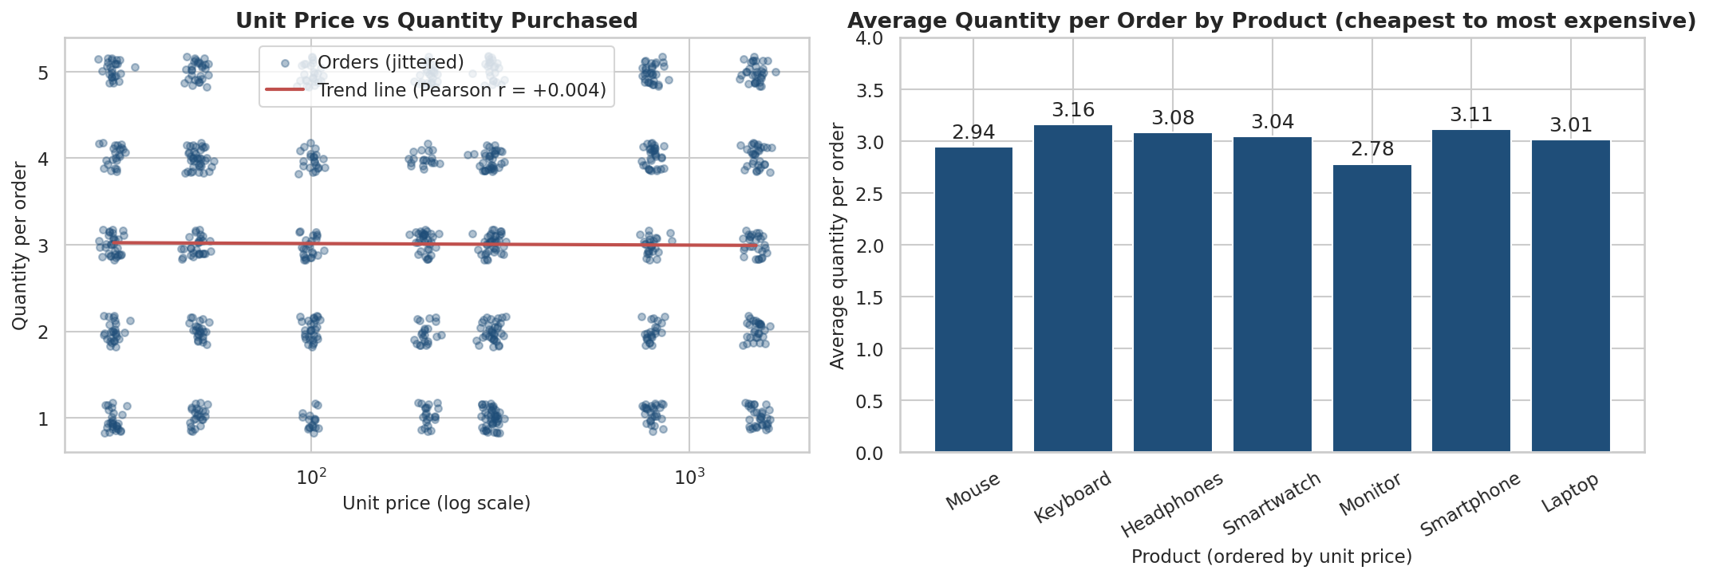
Figure 16: Unit price versus quantity purchased
The scatter plot shows no pattern. The correlation (r = 0.004, p = 0.89) is practically zero and not statistically significant. The cheapest product (Mouse, price 30) averages 2.94 units per order and the most expensive (Laptop, price 1,500) averages 3.01. In this dataset customers order about the same number of units (1–5) whatever the price; because revenue = price × quantity, price level, not quantity, drives the revenue differences between products. This is an association only and does not show that price has or has not caused buying behaviour.

21. Customer Contribution Analysis
Table 22: Top 10 customers by revenue
Rank | Customer ID | Revenue | % of total | Orders | Units | Avg order value | Returned orders
1 | CUST0204 | 29,100 | 2.2% | 9 | 33 | 3,233 | 4
2 | CUST0095 | 22,440 | 1.7% | 9 | 34 | 2,493 | 2
3 | CUST0131 | 21,180 | 1.6% | 8 | 24 | 2,648 | 0
4 | CUST0139 | 18,350 | 1.4% | 7 | 22 | 2,621 | 2
5 | CUST0281 | 17,850 | 1.3% | 8 | 25 | 2,231 | 2
6 | CUST0144 | 17,320 | 1.3% | 5 | 22 | 3,464 | 2
7 | CUST0200 | 16,700 | 1.2% | 4 | 13 | 4,175 | 3
8 | CUST0197 | 16,150 | 1.2% | 5 | 18 | 3,230 | 0
9 | CUST0064 | 14,600 | 1.1% | 7 | 17 | 2,086 | 5
10 | CUST0293 | 14,200 | 1.1% | 5 | 17 | 2,840 | 2

Table 23: Customer value tiers
Tier | Customers | Revenue | Rev. share | Avg orders | Avg revenue | Return rate
High value (top 10%) | 29 | 402,100 | 29.9% | 5.7 | 13,866 | 31.0%
Mid value (next 40%) | 117 | 733,630 | 54.5% | 4.0 | 6,270 | 33.5%
Low value (bottom 50%) | 146 | 210,870 | 15.7% | 2.5 | 1,444 | 31.7%

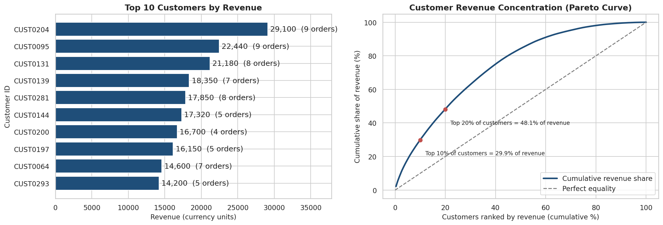
Figure 17: Top 10 customers and customer revenue concentration (Pareto curve)
The top customer is CUST0204 with 29,100 from 9 orders (2.2% of all revenue). The top 10 customers together bring 187,890 (14.0%). The top 10% of customers (29 customers) contribute 29.9% of revenue and the top 20% contribute 48.1%, so revenue is moderately concentrated but not dependent on a single customer.
High-value customers are important because they buy more often (5.7 orders on average versus 2.5 for the bottom half) and tend to buy high-priced products. Their return rate (31.0%) is close to the company average (32.4%), so returns hurt the most valuable accounts too. Losing or disappointing these customers would have an outsized effect on revenue, which is why they should receive retention programmes and priority service.

22. Business Questions and Answers
Q1. Which products and categories generate the highest sales?
Laptop (696,000; 51.7%) and Smartphone (353,600; 26.3%) are the top products; the bottom product is Mouse (12,000; 0.9%). The best category is Electronics with 1,200,500 (89.2%), followed by Wearables (5.5%) and Accessories (5.3%). (Tables 8 and 9, Figures 2 and 4.)
Q2. Which regions contribute the most revenue?
East contributes the most (329,950; 24.5%) and South the least (301,040; 22.4%). Order counts are East 231, North 229, West 246, South 244, and average order values are East 1,428, North 1,419, West 1,315, South 1,234. The gap is only 9.6%. (Table 10, Figure 5.)
Q3. Which products have the highest quantity sold?
Monitor (503 units), Laptop (464) and Keyboard (458). Compared with revenue the ranking is very different: Laptop leads in revenue with only 464 units. (Table 8, Figure 3.)
Q4. How do sales change month by month?
Among complete months, revenue peaked in Nov 2023 (147,150) and was lowest in Mar 2023 (67,660); orders peaked in Jan 2023 (94) and were lowest in Apr 2023 (66). Sales are uneven rather than steadily growing. January 2024 contains only 3 days and is not compared. (Table 12, Figure 7.)
Q5. Which age groups and genders contribute most to sales?
The 56+ age group contributes the most (35.8% of revenue, 339 orders, 1,022 units); 18-25 contributes the least (9.4%). By gender, Male orders contribute 53.1% and Female 46.9%. (Figures 9 and 10.)
Q6. Which regions have the highest returned orders?
West has the most returned orders (95) and the highest return rate (39.9%); the lowest is South (27.5%). The difference is statistically significant (p = 0.0150), so West requires attention. (Figure 13.)
Q7. What percentage of orders are Delivered, In Transit, or Returned?
On the 950 orders with a recorded status: Delivered 32.9%, In Transit 34.6%, Returned 32.4%. On all 1,000 orders: Delivered 31.3%, In Transit 32.9%, Returned 30.8%, Unknown 5.0%. (Figure 11.)
Q8. Which products have the highest return rate?
Headphones (34.5%), Laptop (34.0%) and Mouse (33.6%); the lowest is Monitor (30.2%). All products have at least 116 recorded orders (rule: minimum 30). The differences are not statistically significant (p = 0.99). (Figure 15.)
Q9. How much revenue is generated from each category and region?
Total revenue is 1,346,600. By category: Electronics 1,200,500, Wearables 74,200, Accessories 71,900. By region: East 329,950, North 324,990, South 301,040, West 323,390, Unknown 67,230. The largest combination is Electronics in North (294,500). (Table 11, Figure 6.)
Q10. Is there a relationship between product price and quantity purchased?
No meaningful relationship. Pearson r = 0.004 (p = 0.89), Spearman ρ = -0.010 (p = 0.74). Quantity does not rise or fall with price. This is a correlation only, not proof of causation. (Figure 16.)
Q11. Which customers contribute the most to total sales?
The top customers are CUST0204 (29,100), CUST0095 (22,440), CUST0131 (21,180), CUST0139 (18,350), CUST0281 (17,850). The top 10 customers bring 14.0% of revenue and the top 10% of all customers bring 29.9%. They buy more often and buy higher-priced products, so they are critical to the business. (Tables 22–23, Figure 17.)
Q12. What recommendations can improve sales and shipping performance?
See Section 24. The recommendations cover sales growth, product strategy, regional strategy, customer retention, marketing and segmentation, return reduction, shipping improvement and inventory planning, each linked to evidence from the analysis.

23. Key Findings
- Revenue totals 1,346,600 from 1,000 orders and 3,008 units; average order value is 1,347.
- Revenue is concentrated in a few high-priced products: Laptop (51.7%) and Smartphone (26.3%); Electronics gives 89.2% of revenue.
- Volume is not value: Monitor sells the most units (503) but ranks 3 in revenue; Accessories are 40% of orders but only 5.3% of revenue.
- Regions are balanced: East is highest and South lowest, a gap of 9.6%.
- Sales are uneven by month: peak Nov 2023 (147,150), low Mar 2023 (67,660); the weakest months are Mar 2023, Feb 2023, Apr 2023.
- Older customers drive sales: age 46+ gives 57.8% of revenue; 56+ alone gives 35.8%. The gender split is 53.1% male and 46.9% female.
- Only 32.9% of recorded orders are Delivered; 34.6% are In Transit and 32.4% are Returned.
- Returned orders hold 415,640 of revenue (30.9%); net revenue after returns is 930,960.
- West has the highest return rate (39.9%) and most returns (95) – statistically significant (p = 0.015). Product-level differences are not significant (p = 0.99).
- Price and quantity are unrelated (r = 0.004); products differ in revenue because of price, not quantity.
- The top 10% of customers bring 29.9% of revenue; the top customer is CUST0204 (29,100); 86.0% of customers are repeat buyers.
- Shipping fees weigh 6.8% of Accessories order value versus 0.5% for Electronics.
- Data-quality issues were found and fixed or documented: 20 wrong unit prices, 100 missing ages (only 7 unrecoverable), 50 missing regions, 50 missing shipping statuses, and customer IDs with inconsistent gender/region.

24. Business Recommendations
Every recommendation below is tied to evidence found in this dataset.
Table 24: Evidence-based recommendations
Area | Evidence from the analysis | Recommended action
Sales growth | Laptop and Smartphone give 77.9% of revenue; Mar 2023 revenue was 67,660 versus an average of 111,268; Accessories have an average order value of only 179. | Keep the two top products always in stock and featured; run promotions for the weakest months (Mar 2023, Feb 2023, Apr 2023); bundle Accessories with every Laptop, Smartphone and Monitor order to raise basket size.
Product strategy | Price and quantity are unrelated (r = 0.004); Mouse and Keyboard give 2.6% of revenue; Wearables give 5.5%. | Do not rely on price cuts alone to raise units – test discounts on a small scale first; use Mouse and Keyboard as add-ons/bundle items; trial additional wearables or Smartphone + Smartwatch bundles.
Regional strategy | East is strongest (24.5%, highest order value); South has the lowest revenue and order value (1,234) but the lowest return rate (27.5%); West has high volume but the highest return rate. | Use East as a best-practice benchmark; push higher-value Electronics in South; fix West fulfilment first.
Customer retention | Top 10% of customers = 29.9% of revenue; 41 customers (14%) ordered only once; high-value customers’ return rate is 31.0%. | Launch a VIP/loyalty programme (priority shipping, early access, support); send follow-up offers after a first purchase; follow up personally when a VIP order is returned.
Marketing and segmentation | Ages 46+ give 57.8% of revenue; 18–25 gives only 9.4%; the gender split is 53.1% / 46.9%. | Prioritise the 46+ segment with Electronics campaigns and trust messages (warranty, easy returns); build entry-level offers (Accessories, Smartwatch) for 18–25; use gender-neutral campaigns.
Return reduction | Return rate 32.4%; returned orders hold 30.9% of revenue; West return rate 39.9% vs 27.5%; no significant product difference. | Audit carriers, packaging and delivery time in West; fix process issues (order accuracy, packaging, product descriptions) instead of removing one product; add extra quality checks for Laptops (largest returned value); record a return reason for every return.
Shipping improvement | Only 32.9% of recorded orders delivered, 34.6% In Transit; shipping = 6.8% of Accessories value; 50 unknown statuses and 50 unknown regions; no delivery dates. | Track In-Transit order age with delivery-time targets and alerts; use bundles or a free-shipping threshold for low-value orders; make status and region mandatory at order entry; add delivery-date fields.
Inventory and product planning | Peak revenue month Nov 2023; most orders Jan 2023; most units: Monitor (503), Laptop (464), Keyboard (458); only 12 complete months of data. | Build stock ahead of peak periods; plan Monitor, Laptop, Keyboard for volume and Laptop/Smartphone for value; collect more than one year of data before firm seasonal forecasts.

25. Conclusion
The cleaned e-commerce dataset shows a business whose revenue comes mainly from a small number of high-priced Electronics products (Laptop and Smartphone), spread fairly evenly across four regions and led by customers aged 46 and above. Revenue per customer is moderately concentrated in a group of high-value, repeat buyers.
The most important weakness is fulfilment. Roughly one in three recorded orders is returned and only about one in three is confirmed as delivered. The return problem is regional (West) and company-wide rather than caused by a single product. Because price and quantity are unrelated, growth should come from higher order value, retention, cross-selling and fixing returns rather than from price cuts alone.
Limitations. The data covers one year (the last month has only three days); there is no order ID, delivery date or return reason; 5–10% of values are missing in three columns; and customer IDs carry inconsistent gender and region. Findings about causes (for example why West has more returns) therefore need further investigation.
Future scope. With more data, the analysis can be extended with delivery-time analysis, return-reason analysis, customer segmentation (RFM), seasonality and demand forecasting, and a predictive model of returns. The Streamlit dashboard delivered with this project lets managers explore the same analysis interactively with filters.
Skills demonstrated: data inspection and cleaning, feature engineering, aggregation, KPI design, statistical testing, data visualisation, and translating results into business recommendations.

26. References
- Öztürk, R. E-Commerce Sales (dataset). Kaggle. https://www.kaggle.com/datasets/refiaozturk/e-commerce-sales
- The pandas development team. pandas documentation. https://pandas.pydata.org/docs/
- Harris, C. R. et al. NumPy documentation. https://numpy.org/doc/
- Hunter, J. D. Matplotlib: A 2D graphics environment. https://matplotlib.org/stable/
- Waskom, M. seaborn: statistical data visualization. https://seaborn.pydata.org/
- Virtanen, P. et al. SciPy documentation (scipy.stats). https://docs.scipy.org/doc/scipy/
- Streamlit Inc. Streamlit documentation. https://docs.streamlit.io/
- Project Jupyter. Jupyter documentation. https://jupyter.org/documentation
- AICTE – All India Council for Technical Education. https://www.aicte-india.org/
- IBM SkillsBuild. https://skillsbuild.org/

