**TUTORIAL NO :5**

**AIM :**

1. list activities at VJTI TPO for placement
2. draw an architecture for vjti TPO placement
3. think of services that should be offered by the software
4. study RESTFUL api
5. develop tpo services using micro service architecture

**THEORY :**

**Context**

You are developing a server-side enterprise application. It must support a variety of different clients including desktop browsers, mobile browsers and native mobile applications. The application might also expose an API for 3rd parties to consume. It might also integrate with other applications via either web services or a message broker. The application handles requests (HTTP requests and messages) by executing business logic; accessing a database; exchanging messages with other systems; and returning a HTML/JSON/XML response. There are logical components corresponding to different functional areas of the application.

**use case diagram:**

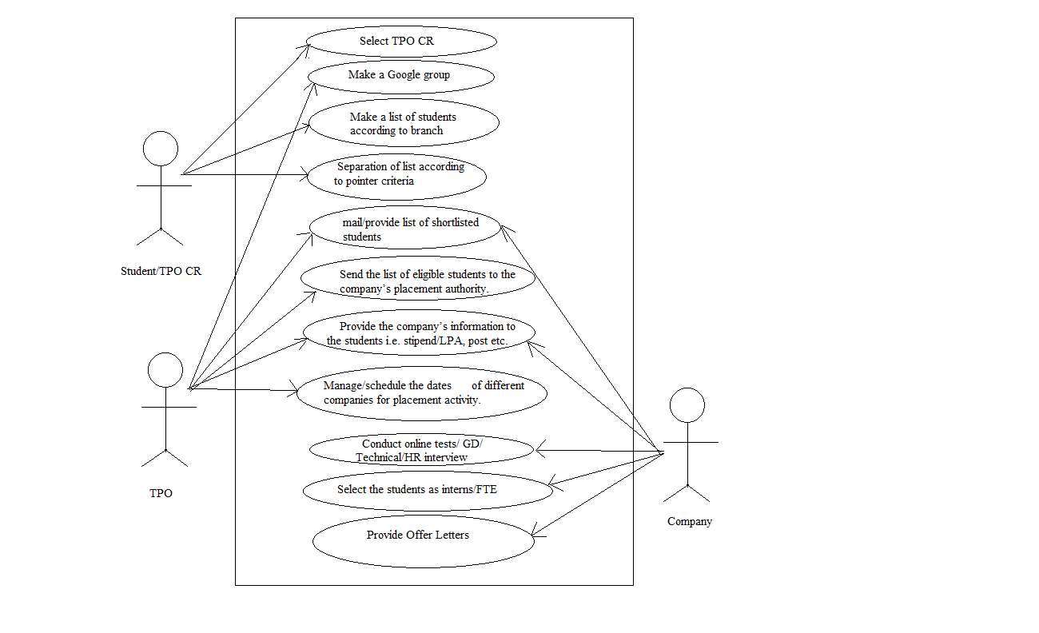

**class diagram :**

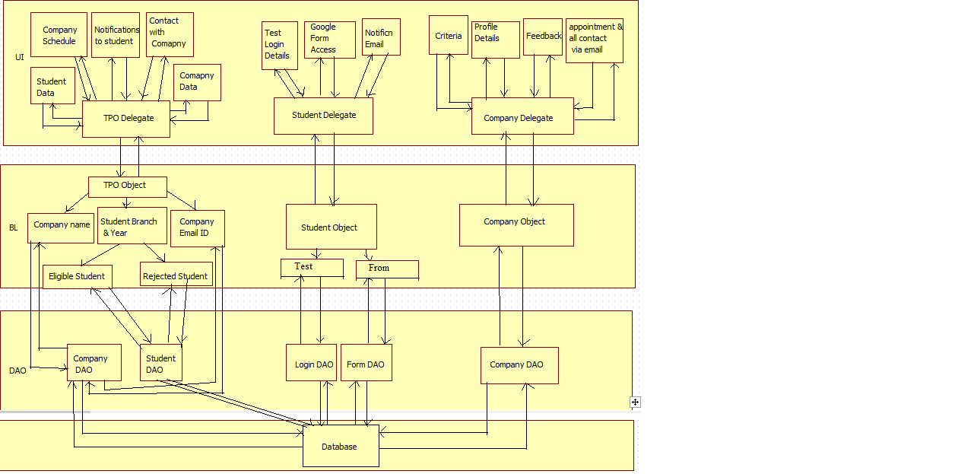

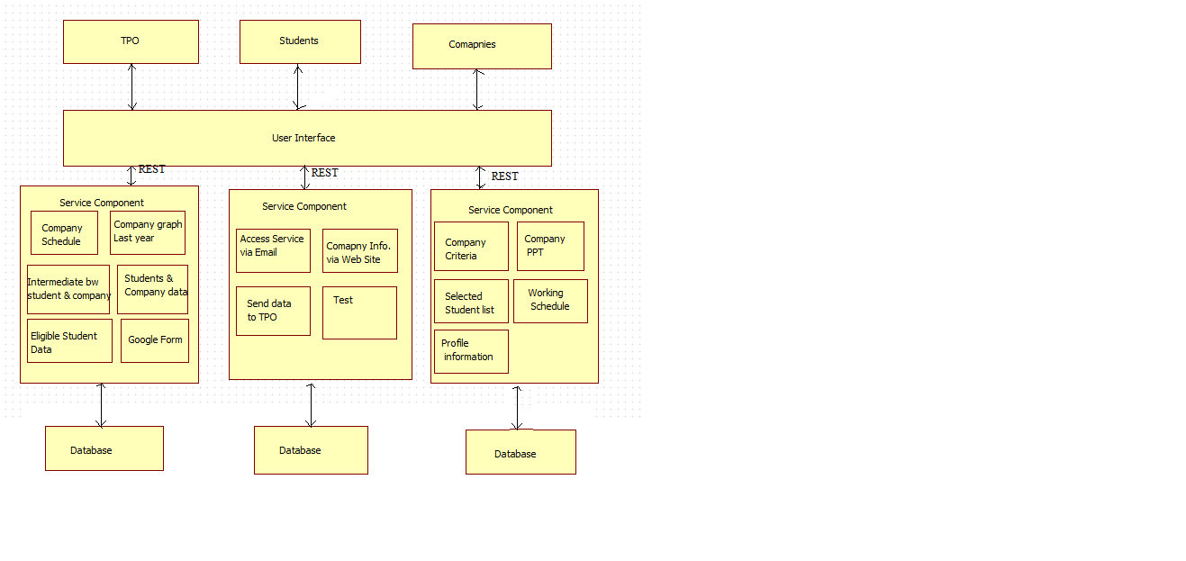

**code :**

**student.py**

|  |
| --- |
| from flask import Flask, render_template, request |
|  | app = Flask(__name__) |
|  |  |
|  | @app.route('/') |
|  | def student(): |
|  | return render_template('student.html') |
|  |  |
|  | @app.route('/result',methods = ['POST', 'GET']) |
|  | def result(): |
|  | if request.method == 'POST': |
|  | result = request.form |
|  | return render_template("stdata.html",result = result) |
|  |  |
|  | if __name__ == '__main__': |
|  | app.run(debug = True) |

**student.html**

|  |
| --- |
| <html> |
|  | <body> |
|  |  |
|  | <form action = "http://localhost:5000/result" method = "POST"> |
|  | <p>Name <input type = "text" name = "name" /></p> |
|  | <p>Branch <input type = "text" name = "branch" /></p> |
|  | <p>Year <input type = "text" name = "year" /></p> |
|  | <p>Pointer <input type ="text" name = "pointer" /></p> |
|  | <p><input type = "submit" value = "submit" /></p> |
|  | </form> |
|  |  |
|  | </body> |
|  | </html> |

**stdata.html**

|  |
| --- |
| <!doctype html> |
|  | <html> |
|  | <body> |
|  |  |
|  | <table border = 1> |
|  | {% for key, value in result.iteritems() %} |
|  |  |
|  | <tr> |
|  | <th> {{ key }} </th> |
|  | <td> {{ value }} </td> |
|  | </tr> |
|  |  |
|  | {% endfor %} |
|  | </table> |
|  |  |
|  | </body> |
|  | </html> |
|  |  |

**company.py**

|  |
| --- |
|  |
| from flask import Flask, render_template, request |
|  | app = Flask(__name__) |
|  |  |
|  | @app.route('/') |
|  | def company(): |
|  | return render_template('company.html') |
|  |  |
|  | @app.route('/result',methods = ['POST', 'GET']) |
|  | def result(): |
|  | if request.method == 'POST': |
|  | result = request.form |
|  | return render_template("codata.html",result = result) |
|  |  |
|  | if __name__ == '__main__': |
|  | app.run(debug = True) |
|  |  |

**company.html**

|  |
| --- |
| <html> |
|  | <body> |
|  |  |
|  | <form action = "http://localhost:5000/result" method = "POST"> |
|  | <p>Company Name <input type = "text" name = "company-name" /></p> |
|  | <p>Package <input type = "text" name = "package" /></p> |
|  | <p><input type = "submit" value = "submit" /></p> |
|  | </form> |
|  |  |
|  | </body> |
|  | </html> |

**codata.html**

|  |
| --- |
| <!doctype html> |
|  | <html> |
|  | <body> |
|  |  |
|  | <table border = 1> |
|  | {% for key, value in result.iteritems() %} |
|  |  |
|  | <tr> |
|  | <th> {{ key }} </th> |
|  | <td> {{ value }} </td> |
|  | </tr> |
|  |  |
|  | {% endfor %} |
|  | </table> |
|  |  |
|  | </body> |
|  | </html> |

