**Basics of JAVA**

1. File Name Same as a Class name ,what will be the output?

Ans:

* Print Expected Output : “Hello World”.
* Create .class file same name as class name ( FirstProgram.class )

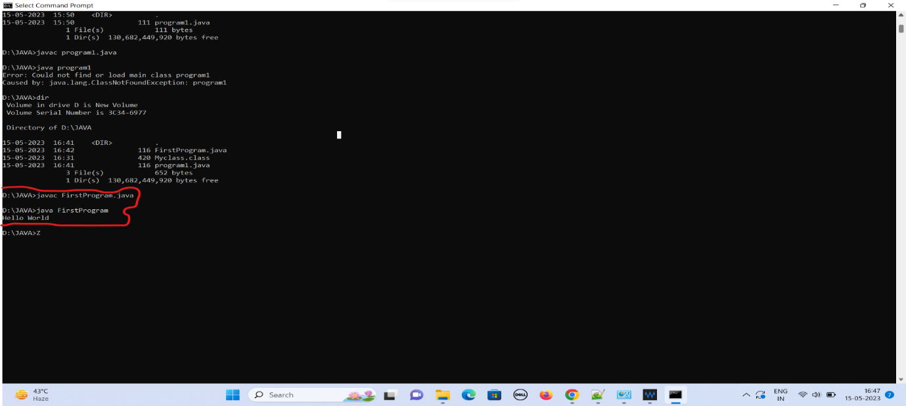

1. File Name can be different as a Class name, what will be the output?

Ans :

* Output – Throw’s a runtime Error “Could not find or load main class Program1 ”
* The program can be saved with different file name as class name.
* Also Compilation can be done but .class file could be created as same name as class name not a file name. (FirstProgram1.class not Program.class)

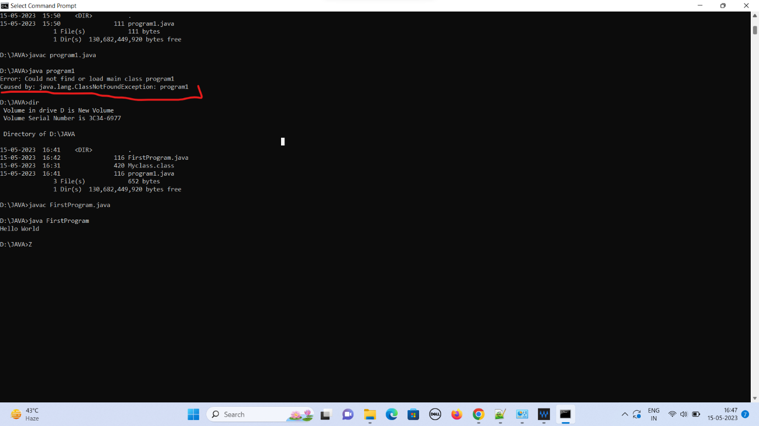

1. In Main method if we can remove Static keyword, what will be the output?

Ans:

* Remove static keyword throw’s an Error “Main method is not static in class Jumble1 please define the main method as Public static void main”.

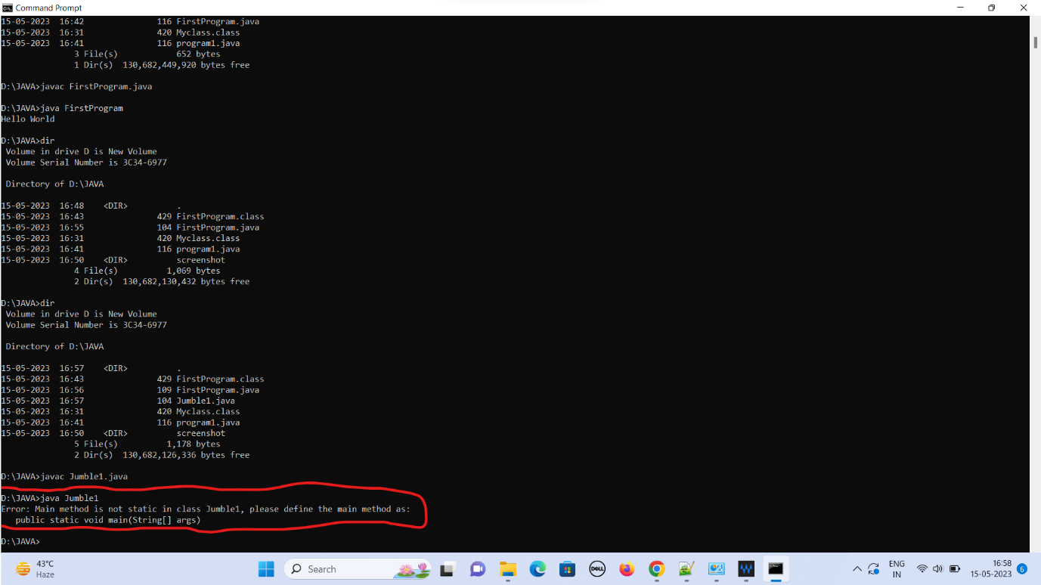

1. In Main method if we can remove Public keyword, what will be the output?

Ans:

* Remove static keyword throw’s an Error “Main method is not static in class Jumble2 please define the main method as Public static void main”.

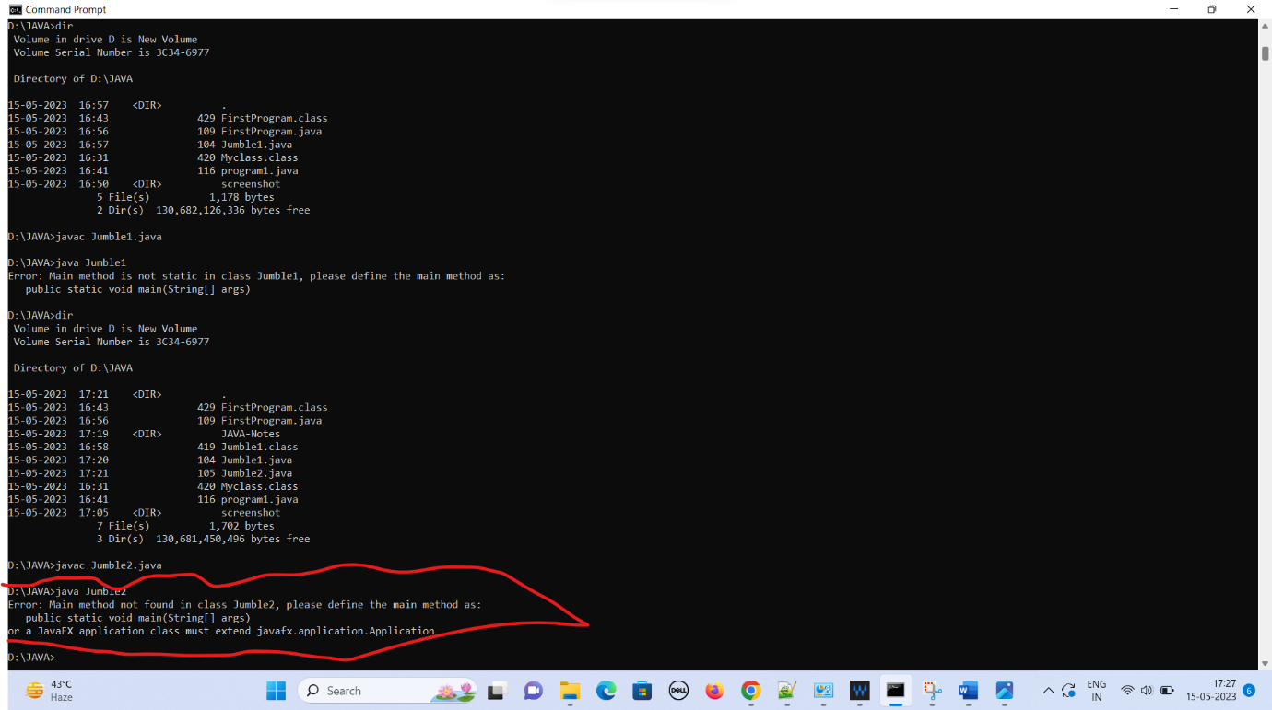

1. In Main method if we can remove main keyword, what will be the output?

Ans:

* Remove static keyword throw’s an Error “Main method is not static in class Jumble2 please define the main method as Public static void main”.

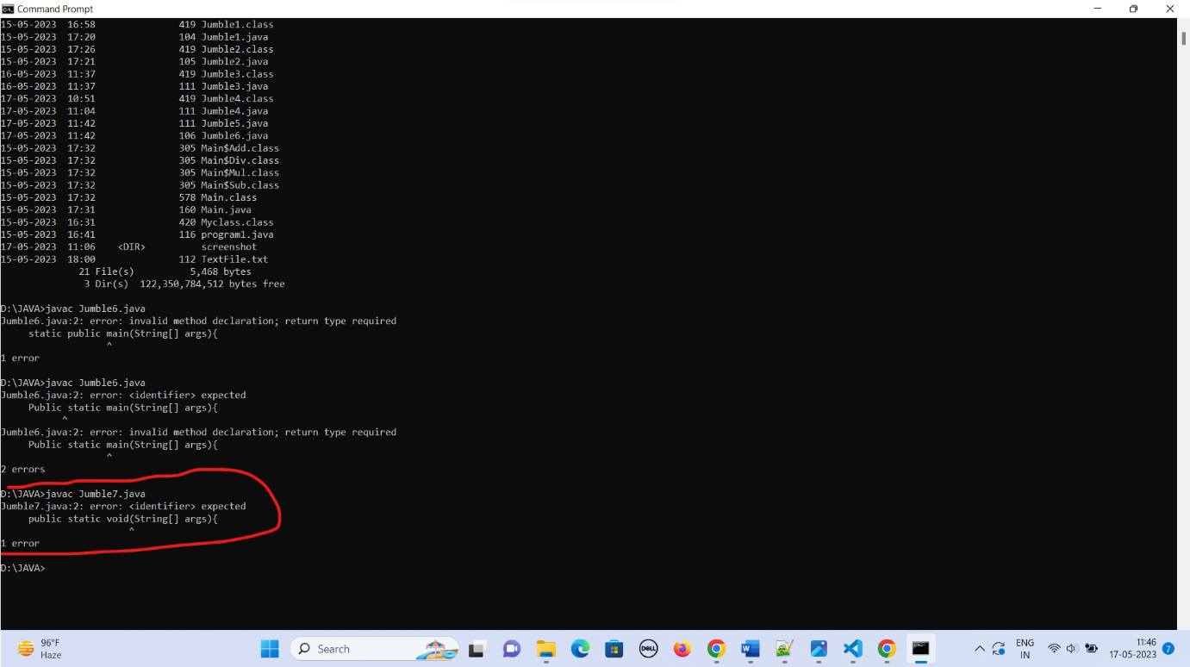

1. In Main method if we can remove void keyword, what will be the output?

Ans:

* Remove static keyword throw’s an Error “Main method is not static in class Jumble2 please define the main method as Public static void ^main(String[] args)”.

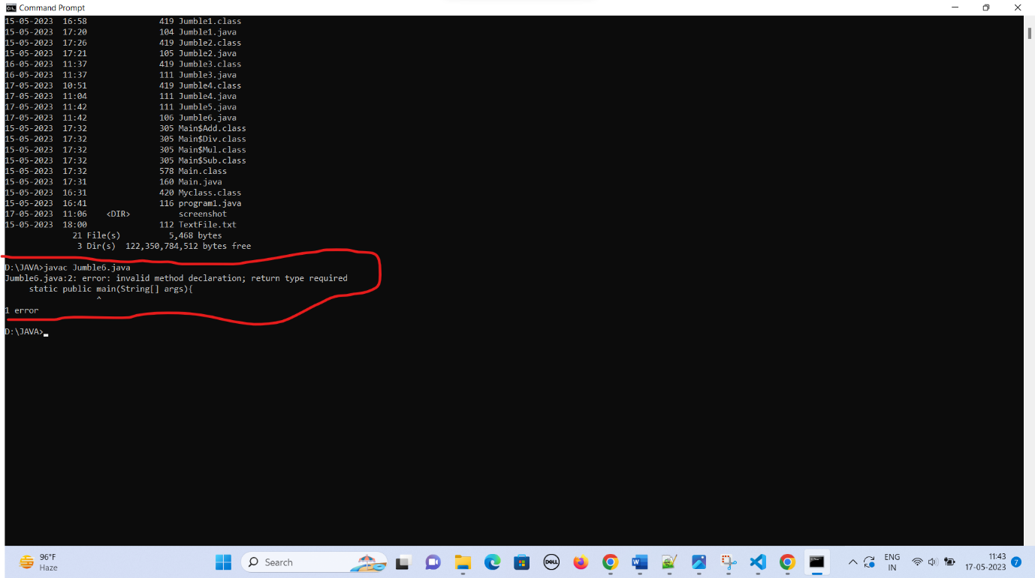

1. Swapping the keywords (void to main) in the main method/ what will be the output?

Ans:

* Save the file same name as class name.(Jumble3.java)
* After compilation throws an error “Expected public static main^ void(String[] args)”

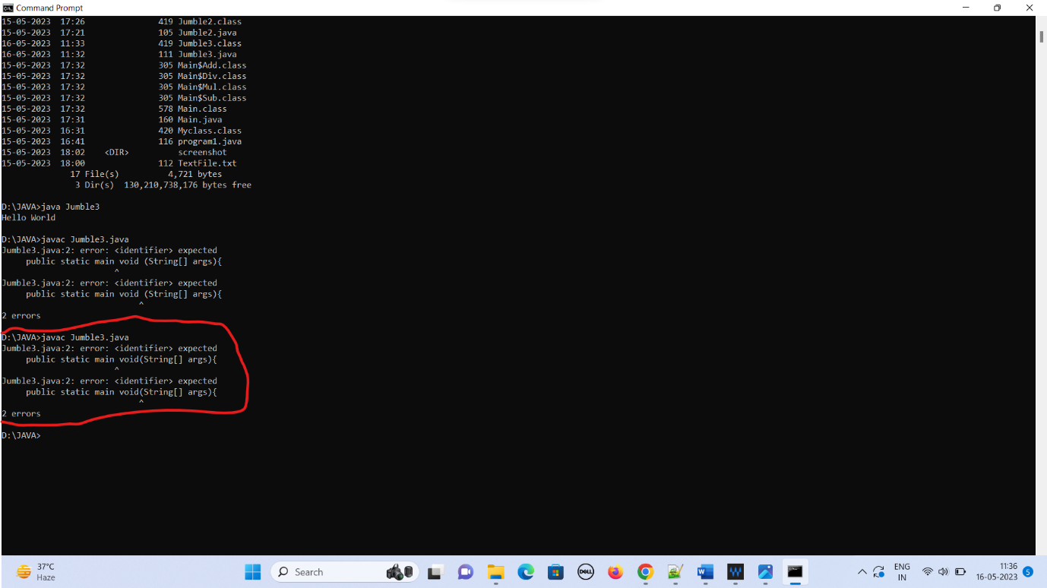

1. Swapping the keywords (static to public) in the main method/ what will be the output?

Ans:

* Save the file same name as class name.(Jumble4.java)
* After compilation .class file can be created (Jumble4.class)
* Output can be: “Hello World”

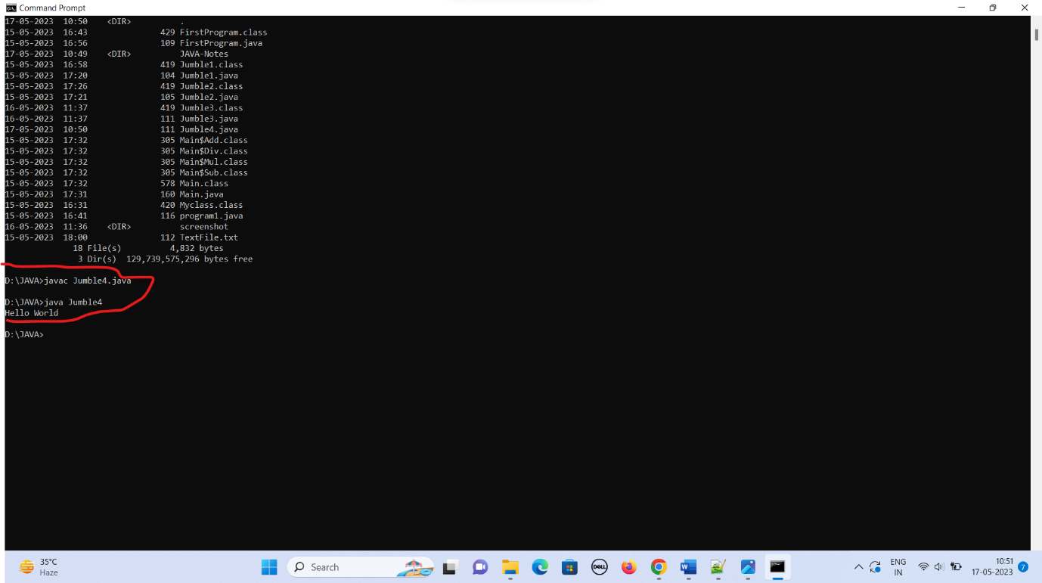

1. Swapping the keywords (void to public) in the main method/ what will be the output?

Ans:

* Save the file same name as class name.(Jumble5.java)
* After compilation throws an 3-error :

1. “”

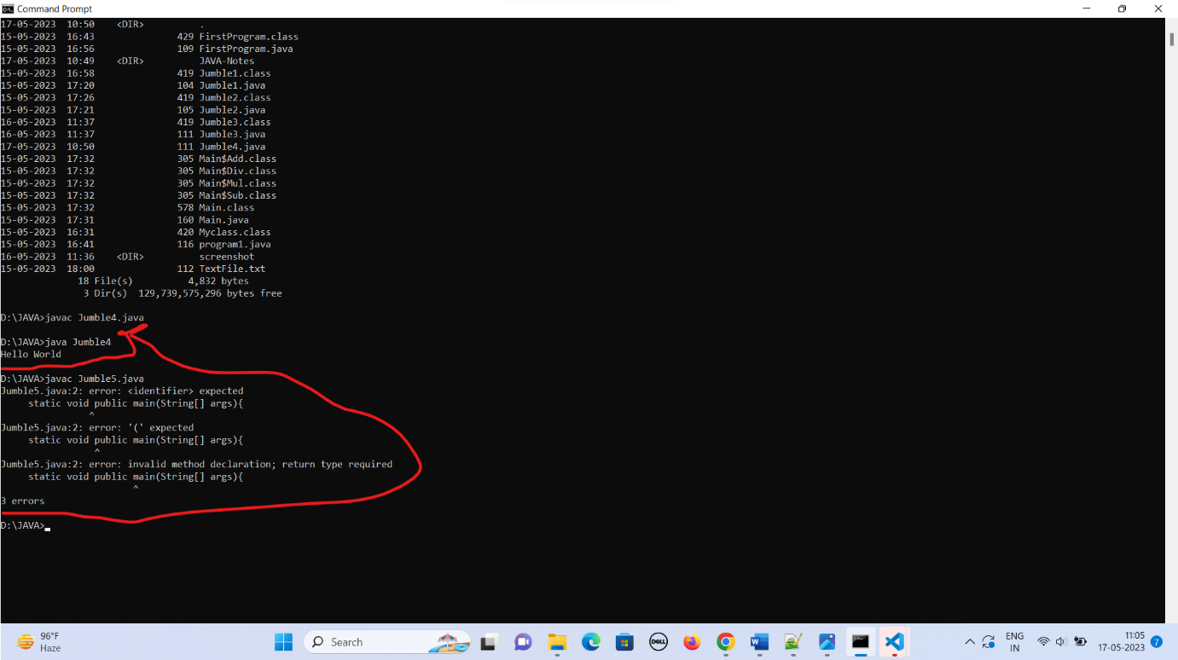

1. Create a single java file in which create 5-classes (main/add/sub/mul/div), After compilation how many file should be created?

Ans:

* Save the file with same name as a class name (Main.java)
* After compilation there are five .class file can be created (Main.class, Add.class, Sub.class, Div.class, Mul.class)

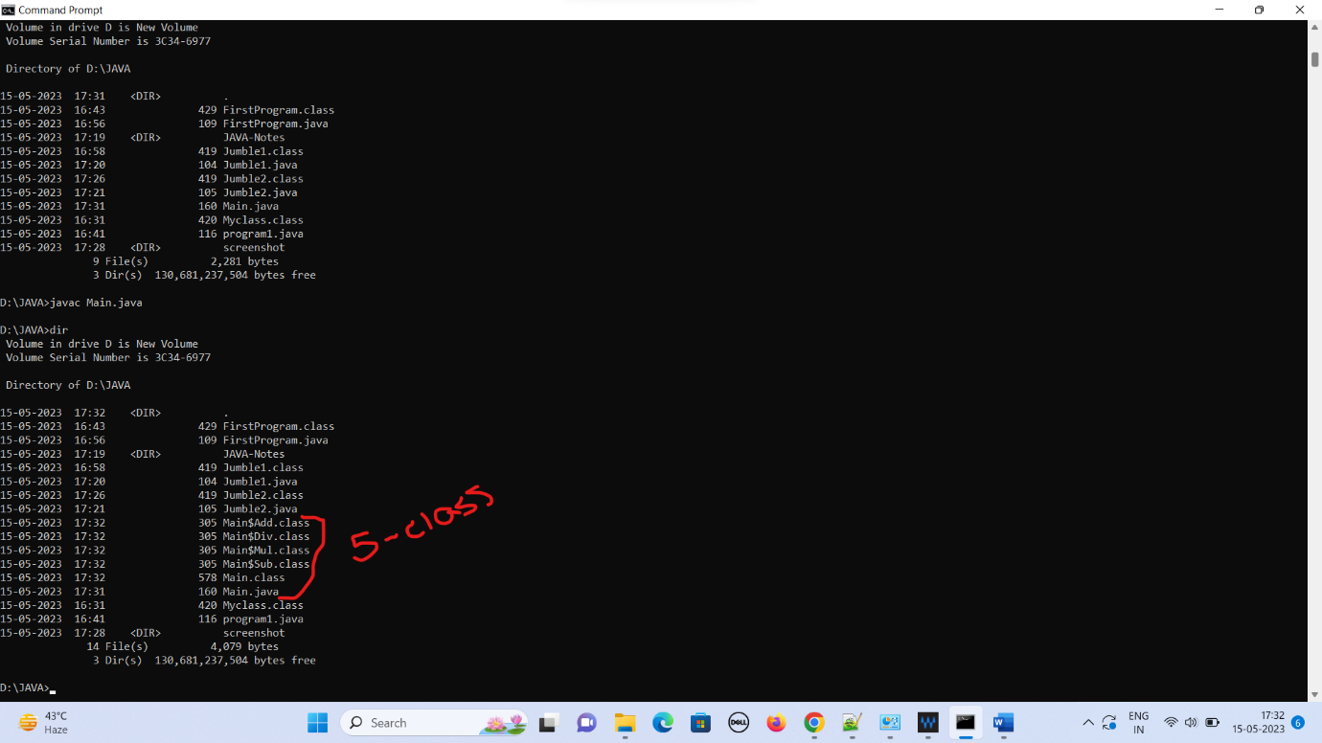

1. Create a text file of java class, What is the output?

Ans:

* The program can be saved same as class name but the txt extension. (TextFile.txt instead of TextFile.java)
* It throws a compilation error “File not found TextFile.java”
* JDK knows only .java source file. It can not contain any other document file.

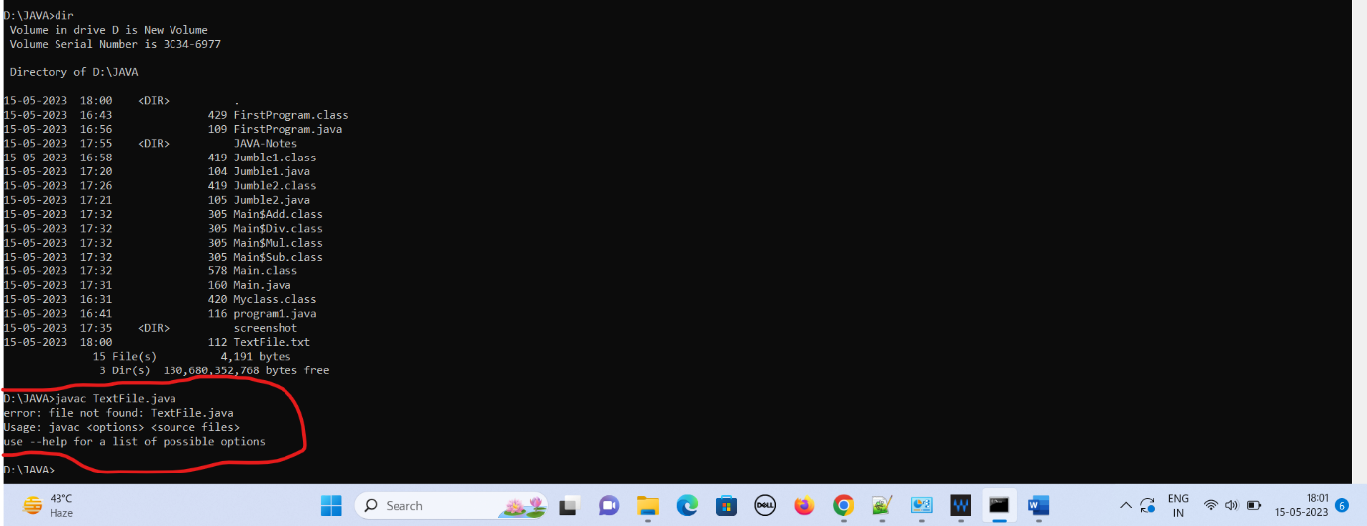

1. Difference between JDK, JRE and JVM?

Ans:

|  |  |  |
| --- | --- | --- |
| JDK | JRE | JVM |
|  |  | Platform dependent. |
|  |  | Convert source code into byte code. |
|  |  | It checked |
|  |  |  |