**Problem Set**

**Problem Set 1**

In this task, let us work on the Triggers concepts. Please see below for the questions and Instructions:

**Instructions:**

1. So far, you have worked on MySQL for simple and complex queries. I assume that you are familiar with the MySQL syntax and in the last week.
2. Assuming that students designed FlySafeAirways project

**Questions:**

1. Create an insert trigger which will not allow reservation of tickets for a date less than the current system date.

Answer:-

CREATE OR REPLACE TRIGGER t_reserve BEFORE

INSERT ON reservation FOR EACH row DECLARE

BEGIN

IF sysdate > :new.journey_date THEN

raise_application_error(-20001, 'journey date is less than system date');

END IF;

END;

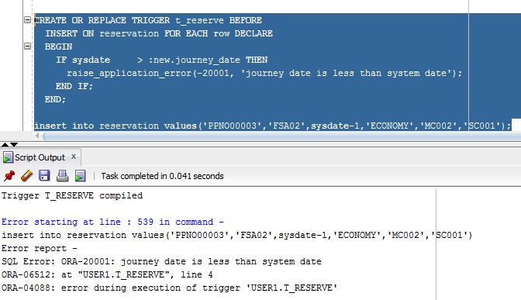

1. Create a delete trigger, which will not allow more than records where Journey date is greater than current system date to be deleted from the Ticket table.

Answer:-

create or replace trigger ticket_before_delete before delete

on ticket

for each row declare begin

IF (:old.journey_date > sysdate) then

raise_application_error(-20001, 'cannot delete ticket where journey date is more than system date');

END IF;

END;

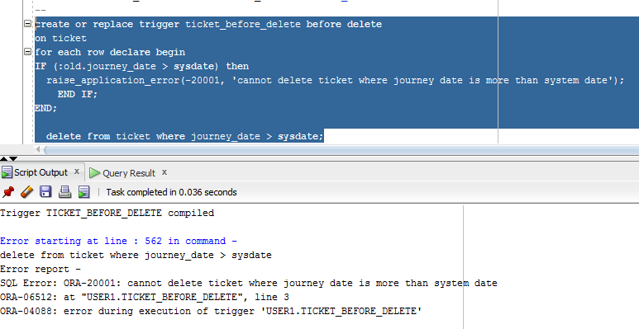

1. Create an insert trigger which will not allow Price to be less than 3000 in the flight-class table

Answer:-

CREATE OR REPLACE TRIGGER flightclass BEFORE

INSERT ON flight_class FOR EACH row DECLARE

BEGIN

IF :new.amount < 3000 THEN

raise_application_error(-20001, 'amount not allowed to be less than 3000');

END IF;

END;

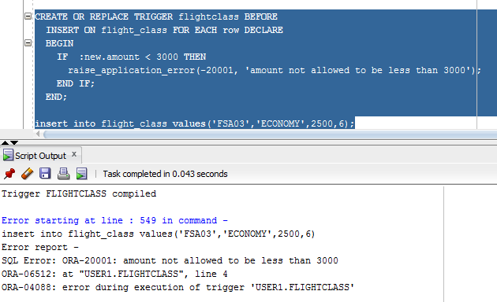

1. List the triggers for the flight-class table.

Answer:-

SELECT * FROM ALL_TRIGGERS WHERE TABLE_NAME = 'FLIGHT_CLASS';

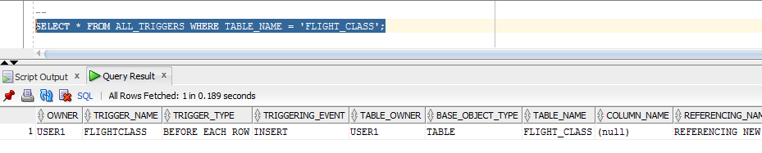

1. Create an update trigger which will not allow any changes in the value of fare column of the flight-class table.

Answer:-

CREATE OR REPLACE TRIGGER FLIGHTCLASS_BEFORE_UPDATE

BEFORE UPDATE OF AMOUNT ON flight_class

BEGIN

RAISE_APPLICATION_ERROR (

num=> -20107,

msg=> 'Update on AMOUNT not allowed!!!');

end;

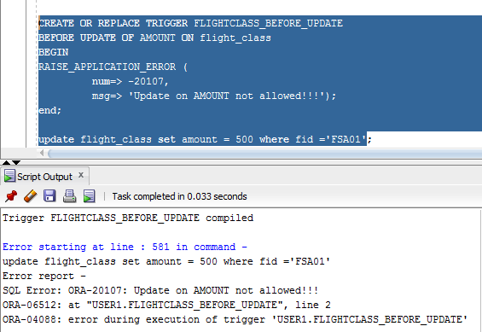

**Problem Set 2**

In this task, let us work on the Triggers concepts. Please see below for the questions and Instructions:

Assuming that you know how to create table and insert values into it.

 1. Create a table with the following fields.

1. Student_Id  - Integer
2. Student_name – varchar(20)
3. Marks_in_Quiz – Integer.

2. Create a Insert Trigger which will  allow you to enter Marks_in_Quiz  with the following criteria.

Marks_in_Quiz --- Range is 0 to 10

 If you Enter Marks as negative number or greater than 10, Your Trigger should display message “Allowable Range of Marks_in_Quiz is 0 to 10 “

Answer:-

CREATE OR REPLACE TRIGGER STUDENT_INSERT_BEFORE

BEFORE INSERT ON STUDENT

FOR EACH row

BEGIN

IF :new.MKS_IN_QUIZ < 0 AND :new.MKS_IN_QUIZ > 10 THEN

raise_application_error(-20001, 'MARKS SHOULD BE IN THE RANGE OF 0 - 10');

END IF;

END;