Problem Set

1. Explain index in oracle ? Give examples of two common index techniques?

Answer:-

* An index is associated with a table or table cluster, that can sometimes speed data access.
* By creating an index on one or more columns of a table, you gain the ability in some cases to retrieve a small set of randomly distributed rows from the table.
* Indexes are one of many means of reducing disk I/O.

The common index techniques are:-

1. Non-clustered:-

* The data is present in arbitrary order, but the logical ordering is specified by the index. The data rows may be spread throughout the table regardless of the value of the indexed column or expression.
* It contains the index keys in sorted order, with the leaf level of the index containing the pointer to the record.
* The physical order of the rows is not the same as the index order.
* The indexed columns are typically non-primary key columns used in JOIN, WHERE, and ORDER BY clauses.
* There can be more than one non-clustered index on a database table.

1. Clustered:-

* Clustering alters the data block into a certain distinct order to match the index, resulting in the row data being stored in order.
* Only one clustered index can be created on a given database table.
* Clustered indices can greatly increase overall speed of retrieval, but usually only where the data is accessed sequentially in the same or reverse order of the clustered index, or when a range of items is selected.
* Since the physical records are in this sort order on disk, the next row item in the sequence is immediately before or after the last one, and so fewer data block reads are required.
* The primary feature of a clustered index is therefore the ordering of the physical data rows in accordance with the index blocks that point to them.

2. When is the bitmap index created.

Answer:-

* A bitmap index is a special kind of index that stores the bulk of its data as bit arrays (bitmaps) and answers most queries by performing bitwise logical operations on these bitmaps.
* The most commonly used indexes, such as B+trees, are most efficient if the values they index do not repeat or repeat a small number of times.
* In contrast, the bitmap index is designed for cases where the values of a variable repeat very frequently.
* For example, the gender field in a customer database usually contains at most three distinct values: male, female or unknown (not recorded). For such variables, the bitmap index can have a significant performance advantage over the commonly used trees.

3. Create a simple index on a column of a table?

Answer:-

Query:-

create index i on employees (emp_name);

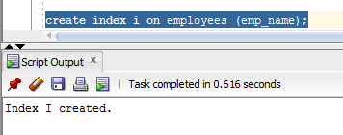

4. Can we have more than a single index on a table? What is the overhead of creating many indexes for a table

Answer:-

Yes we can have more than one index on a single table. To create an index on a combination of columns, you can list the column names within the parentheses, separated by commas.

The indexes need to be updated every time a row is added, deleted, or modified. This may take too much of processing time if there are more add, update or delete operations on the table and may slow down the as all these operations should be performed for all the indexes in a table.

5. What are the restriction on index columns.

Answer:-

Restrictions on columns as index keys

* All the columns must exist in the table on which the index is defined.
* The table must exist in the current database, and cannot be an object that the CREATE EXTERNAL TABLE statement defined.
* The data type of the column cannot be a collection data type.
* The maximum number of columns and the total width of all column index keys are dependent on the page size of the database server. See Creating Composite Indexes.
* We cannot add an ascending index to a column list on which a unique constraint is defined. See Using the ASC and DESC Sort-Order Options.
* We cannot add a unique index to a column list that has a primary-key constraint. The reason is that defining the column or column list as the primary key causes the database server to implement the constraint by creating a unique internal index on the column or column list. The CREATE INDEX statement cannot define another unique index whose key is the same column or column list.
* The number of indexes that you can define on the same list of columns is restricted.

6. Give an example of the function based index

Answer:-

Rather than indexing a column, you index the function on that column, storing the product of the function, not the original column data. When a query is passed to the server that could benefit from that index, the query is rewritten to allow the index to be used.

Query:-

create or replace FUNCTION res_flcode (p_ppno IN VARCHAR2)

RETURN VARCHAR2

DETERMINISTIC

IS

flcode varchar2(10);

cursor c is

SELECT distinct flight_code

FROM reservation

WHERE p_ppno = ppno;

BEGIN

open c;

loop

fetch c into flcode;

exit when c%NOTFOUND;

end loop;

close c;

RETURN flcode;

END;

CREATE INDEX func_res ON

reservation(res_flcode(ppno));

SELECT res_flcode('PPNO00001') FROM reservation;

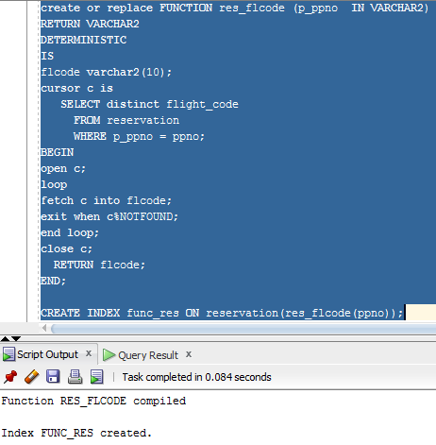

SELECT res_flcode('PPNO00005') FROM reservation where ppno = 'PPNO00005';

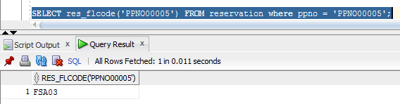

7. Create an index on expression

Answer:-

Query:-

CREATE INDEX emp_lower_name_idx ON employees (lower(emp_name));

SELECT * FROM employees WHERE lower(emp_name) = 'ram';

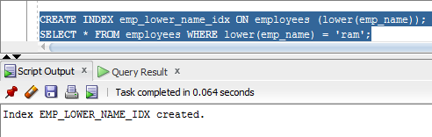

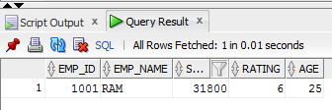

8. What is a cluster. Create a cluster and add tables to it.

Answer:-

A cluster is a schema object that contains data from one or more tables, all of which have one or more columns in common. Oracle Database stores together all the rows from all the tables that share the same cluster key.

Query:-

CREATE CLUSTER ticket_details

(status varchar(10))

SIZE 512

STORAGE (initial 100K next 50K);

CREATE INDEX idx_ticket ON CLUSTER ticket_details;

CREATE TABLE ticket_wtg

CLUSTER ticket_details (status)

AS SELECT * FROM ticket WHERE status = 'WTG';

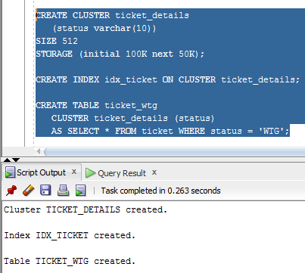

select * from ticket_wtg;

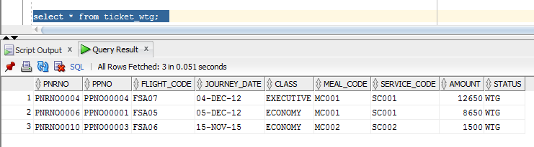

9. What is a sequence?

Answer:-

A sequence is an object in Oracle that is used to generate a number sequence. This can be useful when you need to create a unique number to act as a primary key.

10. How do we access the sequence once they are created?

Answer:-

Query:-

select sequence_name from user_sequences;

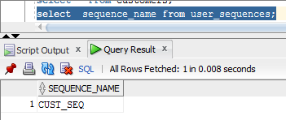

11. Create a sequence and use it in the insert statement?

Answer:-

Query:-

select * from ticket_wtg;

CREATE TABLE customers

( customer_id number(10) NOT NULL,

customer_name varchar2(50) NOT NULL,

city varchar2(50)

);

CREATE SEQUENCE cust_seq

START WITH 1000

INCREMENT BY 1

NOCACHE;

NOCYCLE;

INSERT INTO customers

(customer_id, customer_name,city)

VALUES

(cust_seq.NEXTVAL, 'Adam','New York');

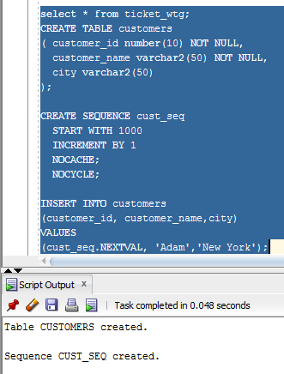

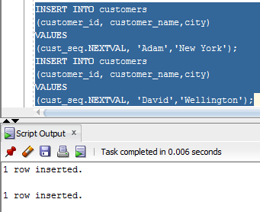

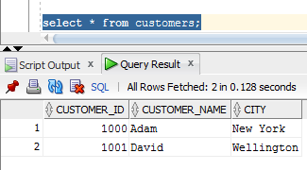

12. How many types of index are there in the video?

Answer:-

1. BitMap index
2. Function based index
3. Simple index
4. Index on expression
5. B Tree index
6. B+ Tree index

13. What object is used for automatic number generation

Answer:-

A sequence is an object in Oracle that is used to generate a number sequence. This can be useful when you need to create a unique number to act as a primary key.

14. What pseudo columns are used in sequence

Answer:-

ROWNUM,CURRVAL,NEXTVAL,USER,SYSDATE

15. What is the overhead of creating many indexes for a table.

Answer:-

The indexes need to be updated every time a row is added, deleted, or modified. This may take too much of processing time if there are more add, update or delete operations on the table and may slow down the as all these operations should be performed for all the indexes in a table.