Problem Set 2

create three users of your choice

Answer:-Created 3 users with username = user1,user2,user3

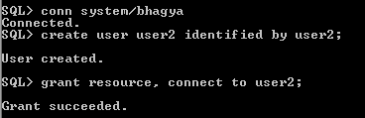

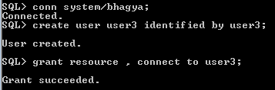

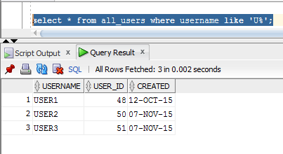

create table, view from default user

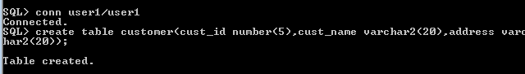

open multi-session to perform the following operations.

Multi-sessions are just to speed the operations, otherwise with a single session also you can perform the task.

grant select on the table to one user



grant insert on table to second user

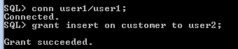

grant delete on table to third user



Execute the SQL Plus statement

SHOW USER

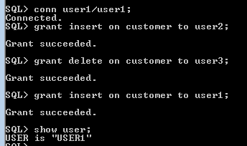

Perform the operations from the respective users.

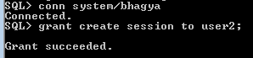

Insert values into customer from user2

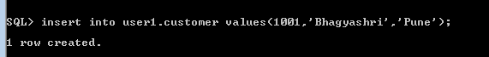

Select values from customer table by user1

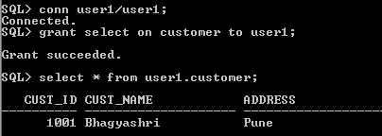

delete values from customer table by user3

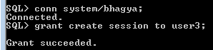

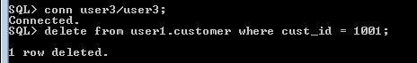

Perform the operation which are not allowed and see the error message.

insert record in customer using user3

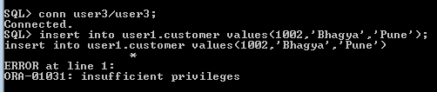

update record in customer using user2

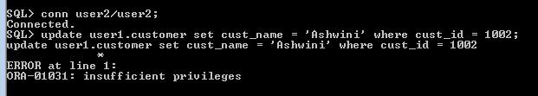

grant update for a particular field for different users.

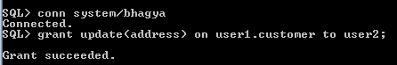

Grant update on all fields to a user.



revoke the rights given to all the user.

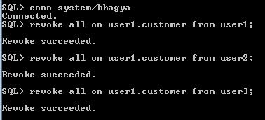

Grant select on table to first user with grant option.

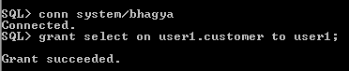

From first user

Grant select on table to second user with grant option

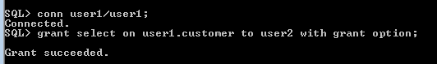

From second user

Grant select on table to third user with grant option

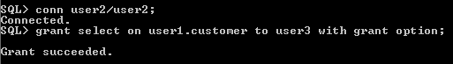

from your default

revoke rights on first user

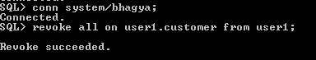



See what happens to the rights of second and thrid user

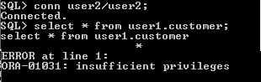

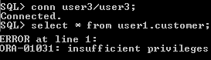

revoke all the rights.

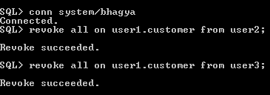

create a simple view

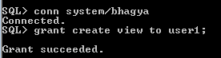

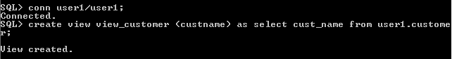

grant rights on view to first second users , not on the table

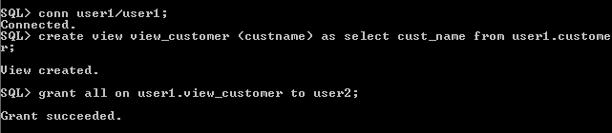

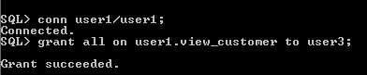

from first, second users

perform select on view

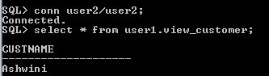

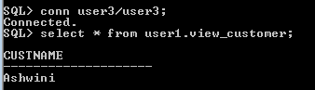

also perform DML operations.

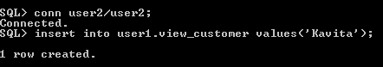

create a complex view

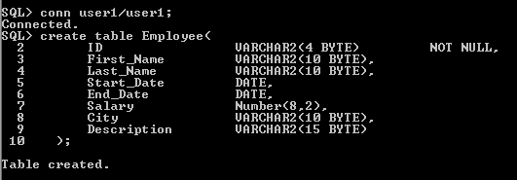

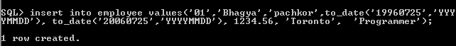

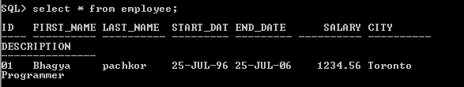

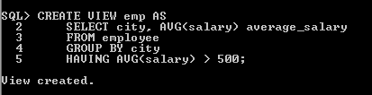

grant rights on view to first second users , not on the table

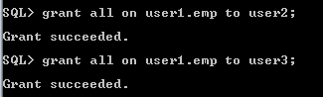

from first, second users

perform select on view

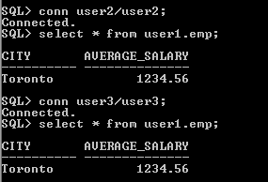

**Problem Set 3**

What is locking a table? In how many modes we can lock a table give examples.

How do you make a transaction read only?

Answer:-

* Locking a table means to deny the access or grant access to a table or view by other users for the duration of an operation.
* The LOCK TABLE statement is used to lock one or more tables, table partitions, or table sub partitions in a specified mode. This lock manually overrides automatic locking and permits or denies access to a table or view by other users for the duration of your operation.
* Some forms of locks can be placed on the same table at the same time. Other locks allow only one lock for a table.
* A locked table remains locked until either commit or rollback is done on the transaction, either entirely or to a save point before you locked the table.
* A lock never prevents other users from querying the table. A query never places a lock on a table. Readers never block writers and writers never block readers.

The different types of lock modes are:-

1. ROW SHARE :-It permits concurrent access to the locked table but prohibits users from locking the entire table for exclusive access.
2. ROW EXCLUSIVE :-It is the same as ROW SHARE, but it also prohibits locking in SHARE mode. This locks are automatically obtained when updating, inserting, or deleting.
3. SHARE UPDATE:-It is similar to ROW SHARE.
4. SHARE:-SHARE permits concurrent queries but prohibits updates to the locked table.
5. SHARE ROW EXCLUSIVE :-It is used to look at a whole table and to allow others to look at rows in the table but to prohibit others from locking the table in SHARE mode or from updating rows.
6. EXCLUSIVE:-It permits queries on the locked table but prohibits any other activity on it.
7. NOWAIT :-If you want the database to return control to you immediately if the specified table, partition, or table subpartition is already locked by another user. In this case, the database returns a message indicating that the table, partition, or subpartition is already locked by another user.

To make a transaction read only use the SET TRANSACTION statement to establish the current transaction as read-only or read/write, establish its isolation level, assign it to a specified rollback segment, or assign a name to the transaction.

The operations performed by a SET TRANSACTION statement affect only current transaction, not other users or other transactions. The transaction ends whenever we issue a COMMIT or ROLLBACK statement.