**PROBLEM SET**

**Step by Step Guide for SQL queries**  
**For the queries given, write the SQL statements**

1)      Display first 5 record of the executive class type in Flight-class table?

Answer:-

query:- SQL> select * from flight_class where rownum <= 5 and class = 'EXECUTIVE';

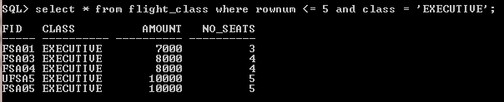

2)      Display passenger details who traveled between 1st dec 2012 to 15th dec 2012

Answer:-

query:-

SQL> select p.ppno,p.name,p.dob,p.sex,p.address,p.contact_no from passenger p,

reservation r where p.ppno = r.ppno and r.journey_date between '01-DEC-12' and

'15-DEC-12';

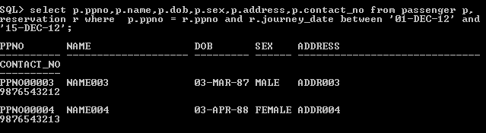

3)      Display the flight details of all the flights whose first letter of its flight name is ‘C’ or ‘L’

Answer:-

query:- SQL> select * from flight where fname like 'C%' or fname like'L%';

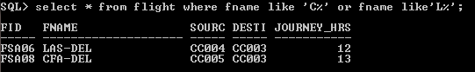

4)      Display all the distinct prices in Flight table?

Answer:-

query:- SQL> select distinct amount from flight_class;

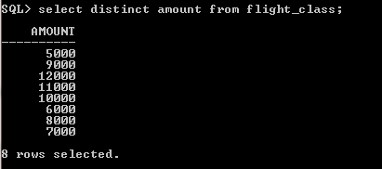

5)      Display all the distinct Countries in City-Master?

Answer:-

query:- SQL> select distinct country from city_master;

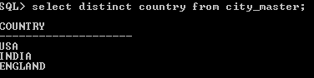

6)      Display all the cities of India for which Flysafe airways provide service?

Answer:-

query:- SQL> select distinct cm.city_name from city_master cm,flight f where cm.city_cod

e=f.source_code and cm.country = 'INDIA';

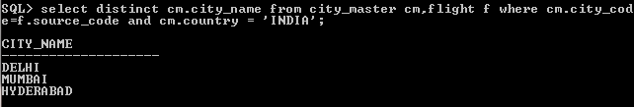

7)      Find the common services provided by the Flights FSA02 and FSA04?

SQL> select distinct sm.service_name from service_master sm ,flight_services fs

where fs.service_code = sm.service_code and fs.fid = 'FSA02' and fs.fid = 'FSA04';

Answer:-

query:- SQL> select distinct sm.service_name from service_master sm,flight_services fs w

here fs.fid = 'FSA02' or fs.fid = 'FSA04';

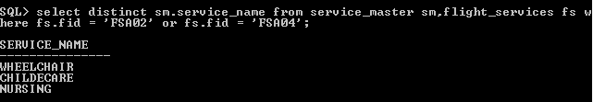

8)      Display all the Flight Id’s whose departure time is between 9 to 15 hours?

Answer:-

query:-

SQL> select distinct fid from flight_days where dept_time between 9 and 15;

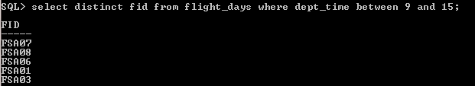

9)      Display all the Flight Id’s whose business class price is between 6000 to 9000?

Answer:-

query:- SQL> select distinct fid from flight_class where class = 'BUSINESS'and amount be

tween 6000 and 9000;

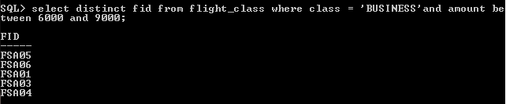

10)  Find all the Flight Id’s that provide ‘Child Care’ or ‘Nursing’ Services.

Answer:-

query:- SQL> select distinct fs.fid from flight_services fs,service_master sm where sm.s

ervice_code = fs.service_code and sm.service_name = 'CHILDECARE' or sm.service_n

ame='NURSING';

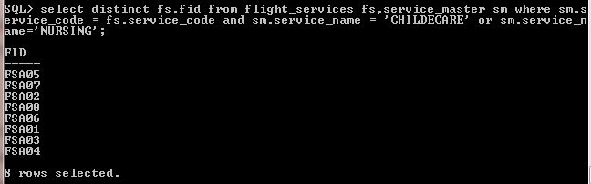

11)  Find all the Flight Id’s that provide ‘Child Care’ and ‘Chinese Food’ Services.

select fid from flight_meal where meal_code IN (select meal_code from meal_master where MEAL_NAME = 'CHINESE')

INTERSECT

select fid from flight_services where service_code IN (select service_code from service_master where SERVICE_NAME = 'CHILDECARE');

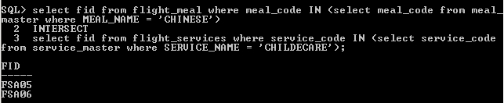

12)  Display the flight details of all the flights which start from ‘Delhi’ on weekends?

Answer:-

query:- select * from flight where fid IN (select distinct fd.fid from flight_days fd,CITY_MASTER cm where fd.DAY = 'SUNDAY' or fd.DAY = 'SATURDAY' and cm.city_name = 'DELHI');

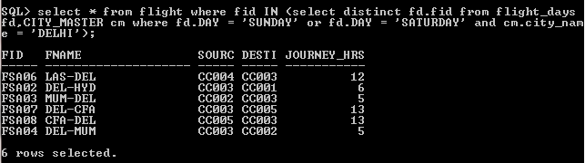

13)  Find the source and destination of the flights for which the passengers selected CHINIESE for meals.

Answer:-

query:- select source_code,destination_code from flight where fid IN (select fm.fid from flight_meal fm,meal_master mm where fm.MEAL_CODE = mm.MEAL_CODE and meal_name = 'CHINESE ');

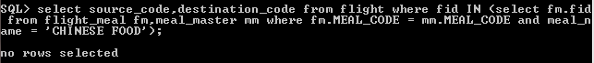

14)  Display flight details of all the flights which start on weekdays?

Answer:-

select * from flight where fid IN (select fid from flight_days where DAY not like 'SUNDAY' and not DAY like 'SATURDAY');

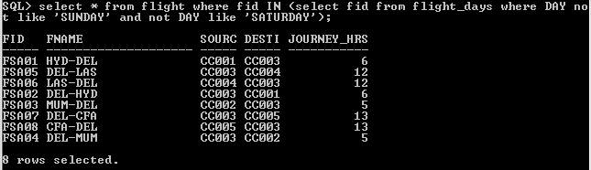

15)  Display flight details of all the flights which offer meals whose Meal-Name is either ‘SOUTH’ or ‘NORTH’?

Answer:-

query:- select * from flight where fid IN (select fid from flight_meal fm,meal_master mm where fm.MEAL_CODE = mm.MEAL_CODE and mm.MEAL_NAME = 'SOUTH' or mm.meal_name = 'NORTH');

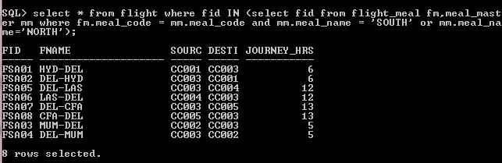

16)  Find the passport number of the passengers whose name is “Name003” and travelled on 12th December 2012

Answer:-

query:- select p.ppno from ticket t,passenger p where t.journey_date = '12-DEC-2012' and p.NAME = 'NAME003' ;

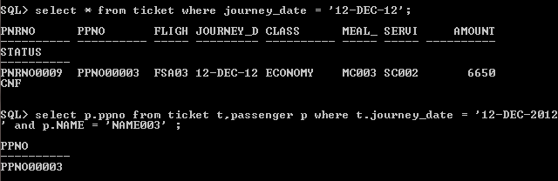

17)  Display the details of all the passengers whose journey date is greater than today’s date and status is ‘waiting’?

Answer:-

query:- SQL> select p.ppno,p.name,p.dob,p.sex,p.address,p.contact_no from ticket t,passe

nger p where p.ppno=t.ppno and t.status = 'WTG' and t.journey_date > sysdate;

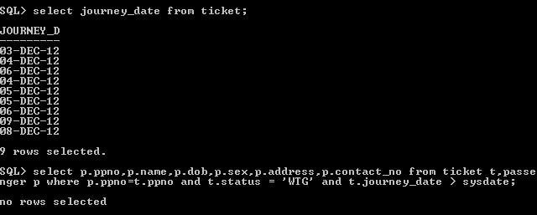

18:-display flight class details where source is delhi and destination is hyderabad

Answer:-

select * from flight_class where fid IN(select fid from flight where source_code IN (select city_code from city_master where city_name = 'DELHI') and destination_code IN (select city_code from city_master where city_name = 'HYDERABAD'));

