**PROBLEM SET**

1)      Display the minimum of Journey hours

Answer:-

query :- select min(journey_hrs) from FLIGHT;

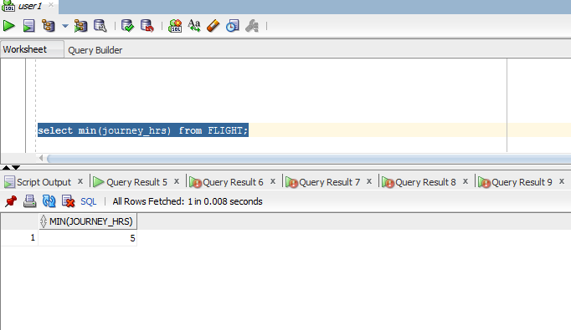

2)      Count the number of passengers who reserved a ticket.

Answer:-

query:- select count(*) from RESERVATION;

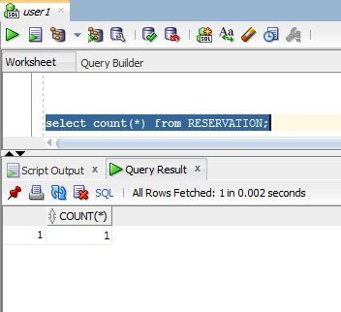

3)      Find the number of passengers for each flight.

Answer:-

query:- select FLIGHT_CODE ,count(*) from TICKET group by FLIGHT_CODE;

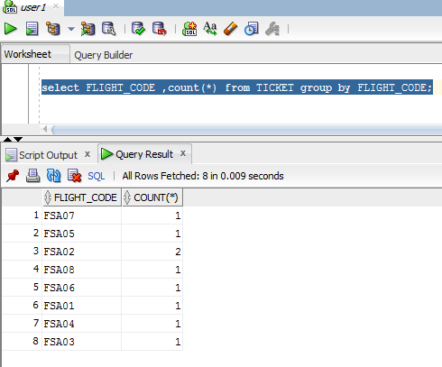

4)       Display the details of all the flight’s having maximum number of seats

Answer:-

query:- select * from flight where fid IN (select fid from flight_class where NO_SEATS IN (select max(NO_SEATS) from FLIGHT_CLASS));

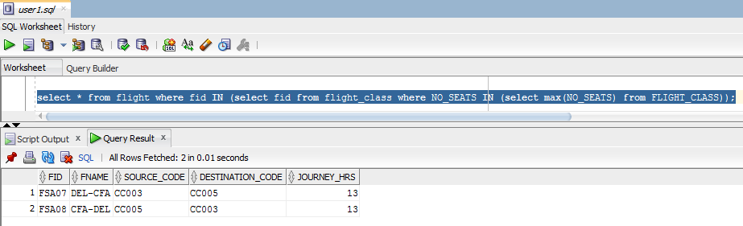

5)      Display all the type of meals provided by Fly Safe Airways

Answer:-

query:- select meal_name from meal_master where MEAL_CODE IN (select meal_code from FLIGHT_MEAL );

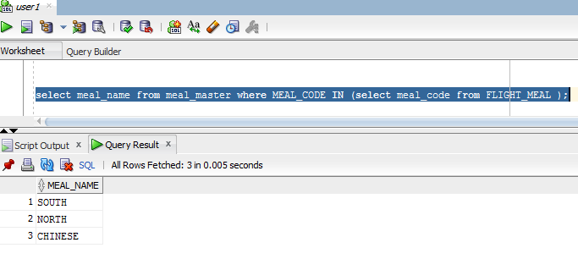

6)      Display the service names available in Flight Id ‘FSA003’

Answer:-

query:- select service_name from service_master where SERVICE_CODE IN (select service_code from flight_services where FID = 'FSA03');

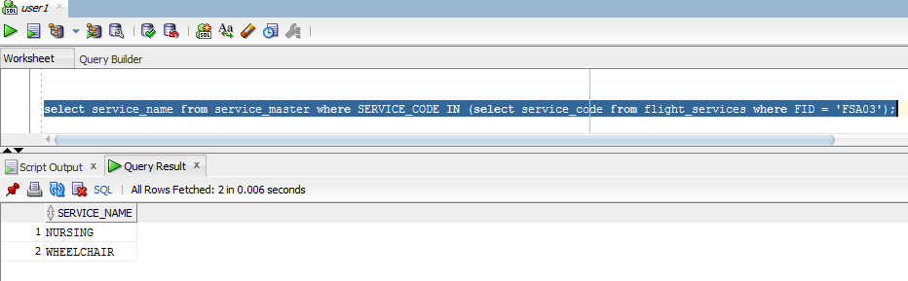

7)      Find the total number of passengers travelled in "FSA003" on 4 December 2012?

Answer:-

query:- select count(*) from reservation where JOURNEY_DATE = '4-DEC-12' and flight_code = 'FSA03';

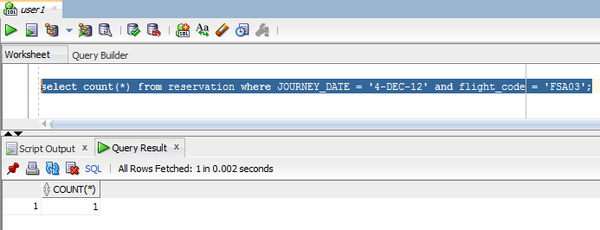

8)      Select all rows in Flight table whose Source Name is “DELHI” and Journey_Date on 24-dec-2012.

Answer:-

query:- select * from flight where fid IN (select flight_code from ticket where journey_date = ' 24-DEC-2012' and flight_code IN (select fid from flight where SOURCE_CODE IN (select SOURCE_CODE from city_master where city_name = 'DELHI')));

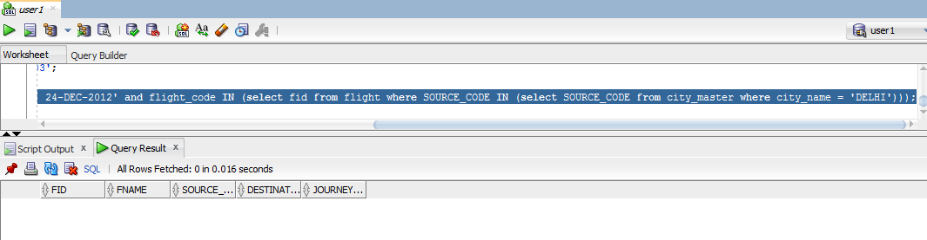

9)      Find the passenger names who travelled on 5th December,2012

Answer:-

query:- select name from passenger where ppno IN (select ppno from reservation where journey_date = '5-DEC-12');

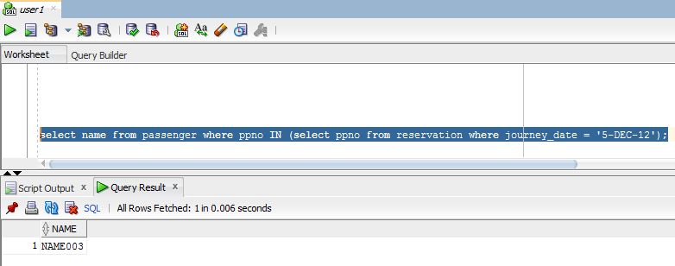

10)  Display total number of seats reserved for the class “ECONOMY” of all flights on date 5th December,2012

Answer:-

query:- select count(no_seats) from flight_class where class = 'ECONOMY' and fid IN (select flight_code from reservation where journey_date = '5-DEC-2012');

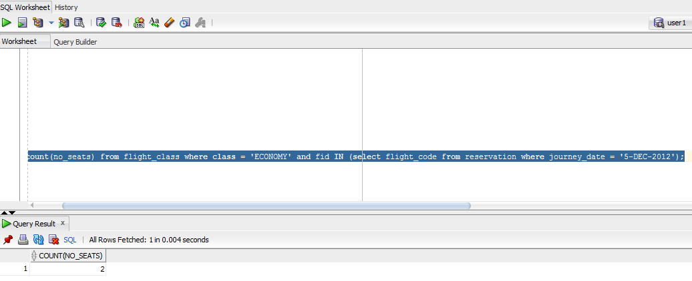

11)  Find the flight details of all the flights which travelled on 04-dec-2012

Answer:-

query:- select f.fid,f.fname,f.source_code,f.destination_code,f.journey_hrs from flight f,reservation r where journey_date = '4-DEC-2012' and f.fid = r.flight_code;

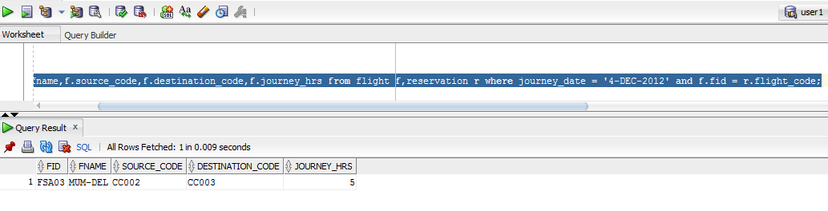

12)  Display the net income obtained from each class type

Answer:-

query:- select sum(amount) as net_income from flight_class;

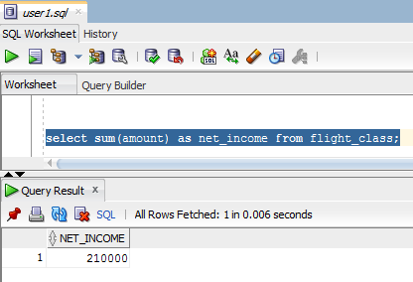

13)  Display the amount charged for luggage of 78Kg for an executive class passenger

Answer:-

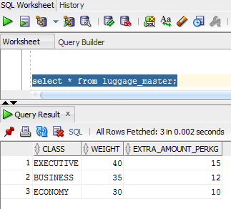

query:- select extra_amount_perkg from luggage_master where weight = 78 and class = 'EXECUTIVE';

14)  Find the total amount charged for ‘north meals’ and ‘nursing service’?

Answer:-

query:- select sum(amount) as TOTAL_AMOUNT from meal_master where meal_name = 'NORTH' or meal_name= 'SOUTH';

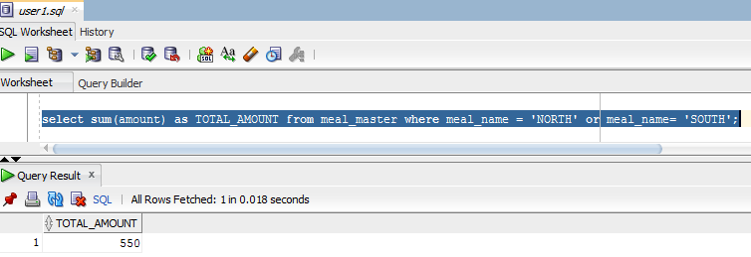

15)  Display the passenger details of all the passengers who have cancelled their ticket with journey date 04-dec-2012?

Answer:-

query:- select * from passenger where ppno IN (select ppno from ticket t,cancellation c where t.pnrno = c.pnrno and c.pnrno IN (select pnrno from ticket where journey_date = '4-DEC-12'));

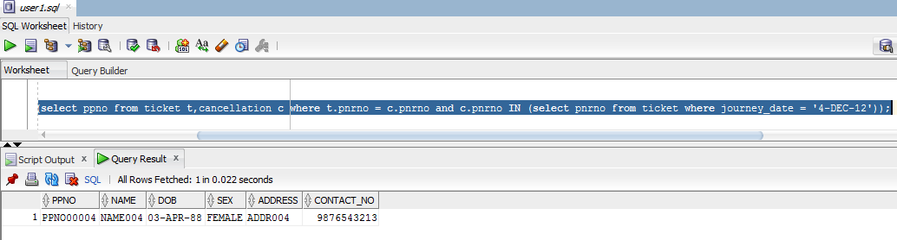

16)  Find the availability of the seats of all the flights whose Journey Date is 15-dec-2012, Source city Name is ‘Hyderabad’ and destination city name is ‘delhi’?

Answer:-

query:- select count(remaining_seats) from availability where fid IN (select fid from flight_class where fid IN(select fid from flight where source_code IN (select city_code from city_master where city_name = 'HYDERABAD') and destination_code IN (select city_code from city_master where city_name = 'DELHI')));

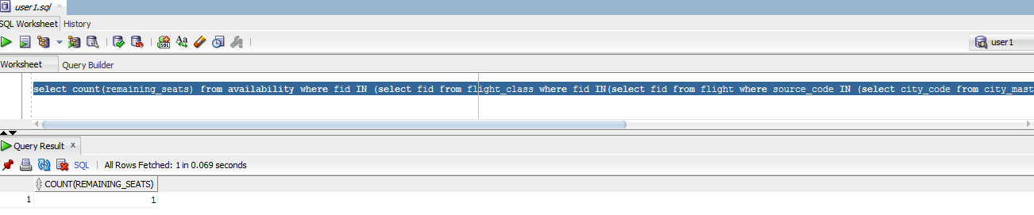

17)  Find the Destinations of all the flights which start from ‘Delhi’?

Answer:-

query:- select city_name from city_master where city_code IN (select destination_code from flight where source_code IN (select city_code from city_master where city_name = 'DELHI'));

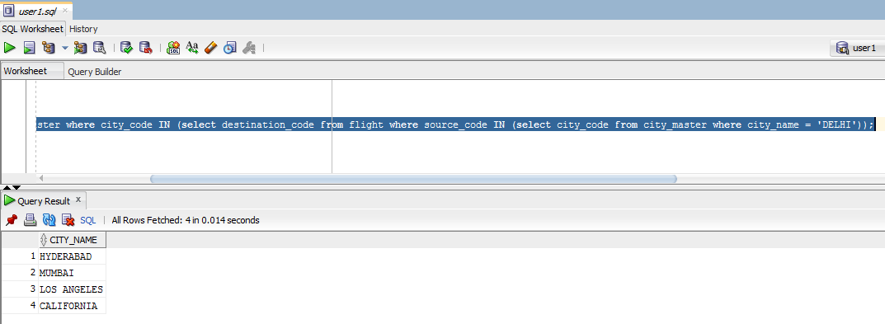

18)  Find the Net income obtained from passengers through Luggage charges

Answer:-

query:- select SUM(amount) as net_income from passenger_luggage_charges ;

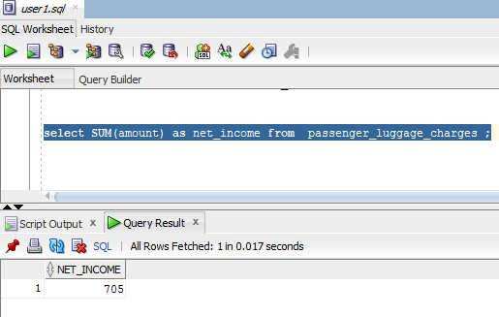

19)  Find the Net income obtained from passengers through Services

Answer:-

query:- select SUM(amount) as net_income from service_master ;

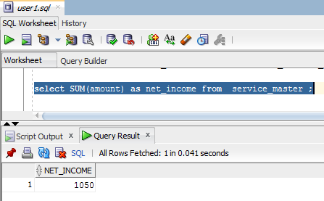

20)  Display number of seats available in each flight

Answer:-

query:- select count(remaining_seats) as seats,fid from availability group by fid;

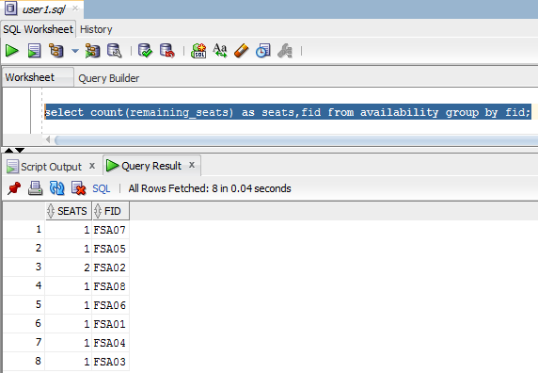

21)  Display number of seats available in each flight, where the price of each seat is greater than 6000

Answer:-

query:- select count(a.remaining_seats) as seats,a.fid from availability a,flight_class fc where fc.amount > 6000 and fc.fid = a.fid group by a.fid;

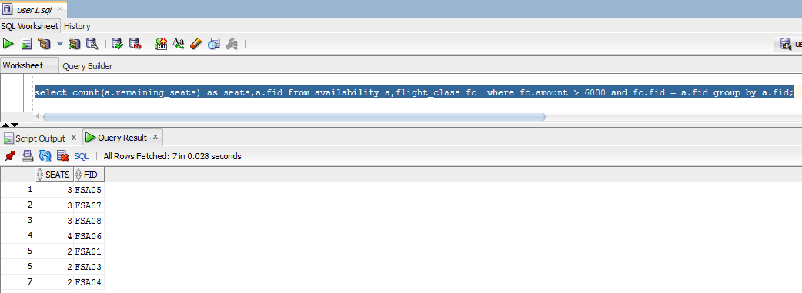

22)  Display the flight id’s which provide all the services?

Answer:-

query:- select distinct fid from flight_services where service_code IN (select service_code from service_master);

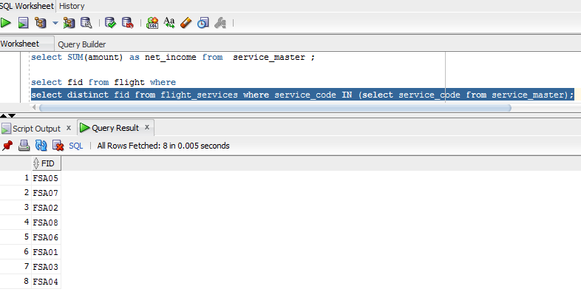

23)  Display the passenger details who travelled more than once?

Answer:-

query:- select * from passenger where ppno IN (select ppno from ticket group by ppno having count(ppno) > 1);

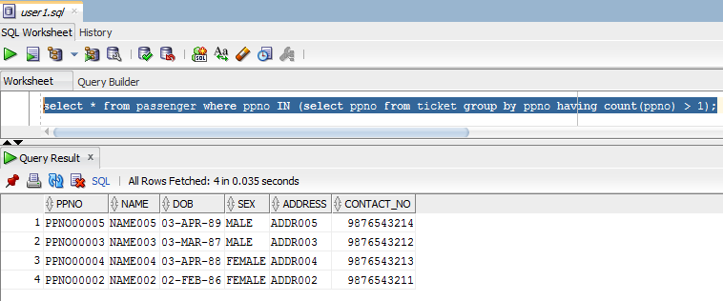

24)  Find the Passenger who travelled in every flight

Answer:-

query:- select * from passenger where ppno IN ( select ppno from flight where fid = ALL(select distinct fid from flight));

