**PROBLEM SET**

**Complex SQL Queries**

**Bus_Service( service_no : *integer***, Bus_no :*integer*, Source: *string*, Destination: *string*, Distance:*integer*, Departs :*time*, Arrives : *time*, Fare : *integer***)**

**Bus(Bus_no : *integer***, Bus_name : *string*, Rating:*integer*, Max_operating_distance : *integer***)**

**Drives( Emp_id : *integer*, Bus_no : *integer*)**

**Employees( Emp_id : *integer***, Emp_name : *string*, Salary : *integer ,*Rating*: integer,*Age: *integer***)**

**Assume that every bus operates daily

** The set of bold attributes is the primary key

Following are the values in the table:-

BUS table

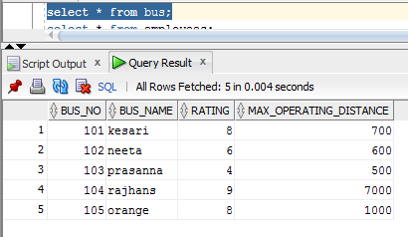

BUS_SERVICE

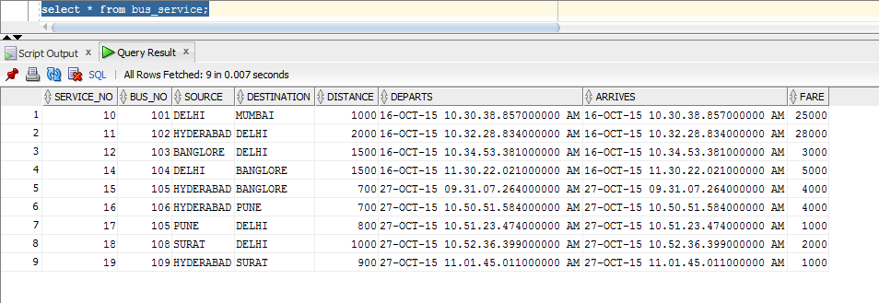

EMPLOYEES

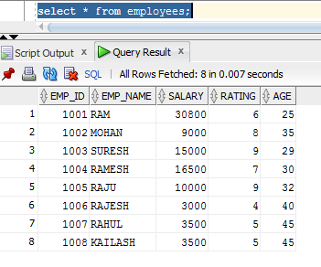

DRIVES

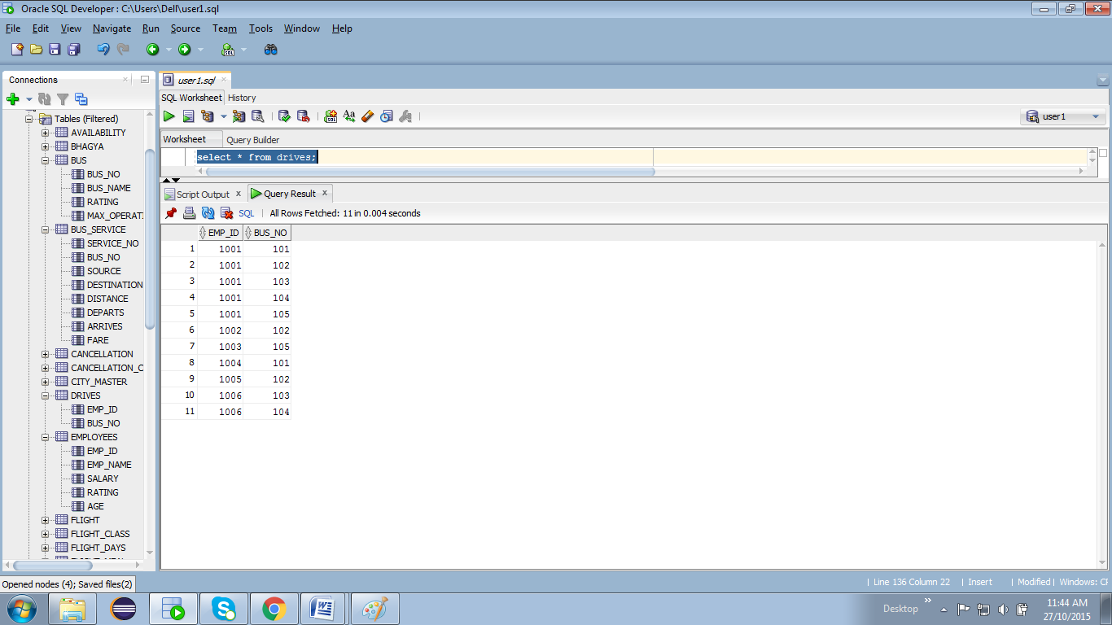

**Write the following SQL Queries by considering the Schema Given above**

1.      Find all those bus names such that all the drivers who operate on them earn more than 20k.

Answer:- select bus_name from bus where bus_no IN (select bus_no from drives where emp_id IN (select emp_id from employees where salary > 2000));

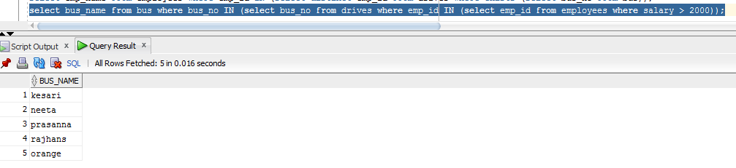

2.      Find the routes that can be driven by every driver who salary is more than 25k. (Hint: The driver must operate at least one bus with a sufficiently large operating distance.)

Answer:- SELECT SOURCE,DESTINATION FROM BUS_SERVICE WHERE BUS_NO IN ( select bus_no from drives where emp_id IN (

(SELECT e.emp_id FROM employees e,bus b WHERE e.SALARY > 25000 AND b.MAX_OPERATING_DISTANCE IN

(SELECT MAX(MAX_OPERATING_DISTANCE) FROM BUS))));

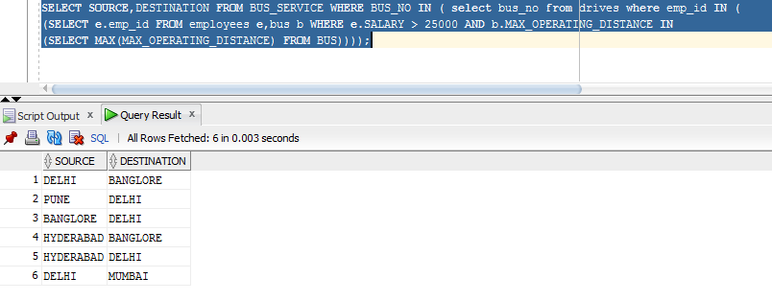

3.      Find the names of drivers who can operate buses with operating distance greater than 1000 Km but are not drivers of any bus whose rating is less than 5.

Answer:-select emp_name from employees where emp_id IN ( select emp_id from drives where bus_no IN (select bus_no from bus where max_operating_distance > 1000 and bus_no NOT IN ( select bus_no from bus where rating <

5)));

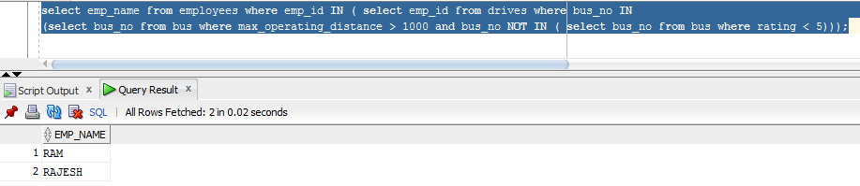

4.       A person wants to travel from ‘Hyderabad’ to ‘Delhi’ with no more than two changes of buses. List all possible departure times from ‘Hyderabad’ if the person wants to arrive in ‘Delhi’ by 6 A.M.

Answer:- select departs from bus_service where source = 'HYDERABAD' and destination IN (select source from bus_service where destination = 'DELHI' and arrives = '28-OCT-15 06.00.00.00 AM');

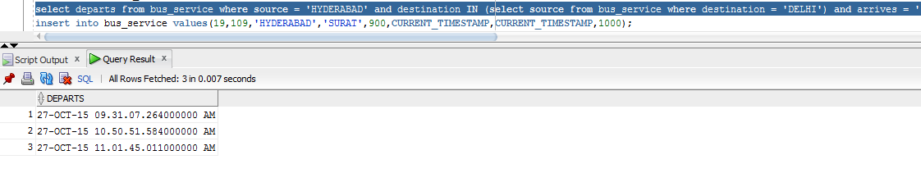

5.      Find the names of the drivers who do not drive a bus with rating 7.

Answer:- select emp_name from employees where emp_id IN (select emp_id from drives where bus_no IN (select bus_no from bus where rating not in ( 7)));

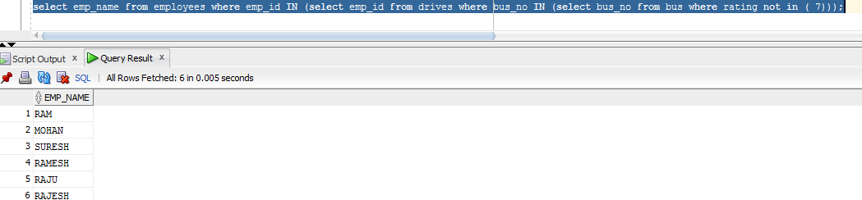

6.      Find the names of the drivers who do not drive any bus with rating 7.

Answer:- select emp_name from employees where emp_id IN (select emp_id from drives where bus_no IN (select bus_no from bus where rating not in ( 7)));



7.      Find the rating of all drivers whose rating is better than some driver named ‘Ram’.

Answer:- select rating from employees where rating > all (select rating from employees where emp_name = 'RAM');

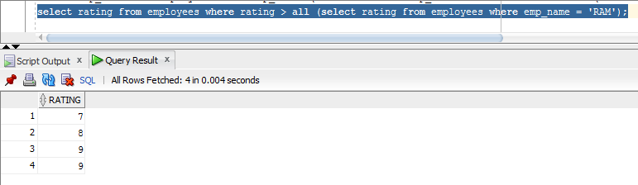

8.      Find the driver names whose rating is at least 7 or drives a bus with rating at least 7

Answer:-

select emp_name from employees where rating >= 7 and emp_id IN (select emp_id from drives where BUS_NO IN (select bus_no from bus where rating >= 7));

