**PROBLEM SET**

**Bus_Service( service_no : *integer***, Bus_no :*integer*, Source: *string*, Destination: *string*, Distance:*integer*, Departs :*time*, Arrives : *time*, Fare : *integer***)**

**Bus(Bus_no : *integer***, Bus_name : *string*, Rating:*integer*, Max_operating_distance : *integer***)**

**Drives( Emp_id : *integer*, Bus_no : *integer*)**

**Employees( Emp_id : *integer***, Emp_name : *string*, Salary : *integer ,*Rating*: integer,*Age: *integer***)**

**Below are the table details and their values:-**

**EMPLOYEES**

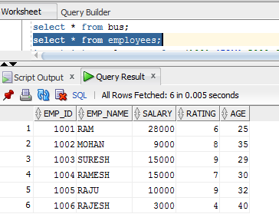

**BUS**

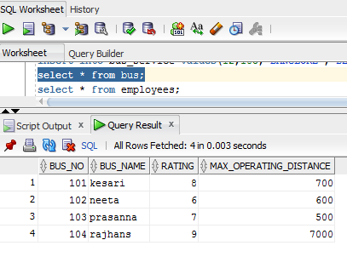

**DRIVES**

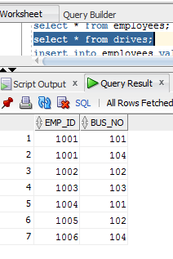

**BUS_SERVICE**

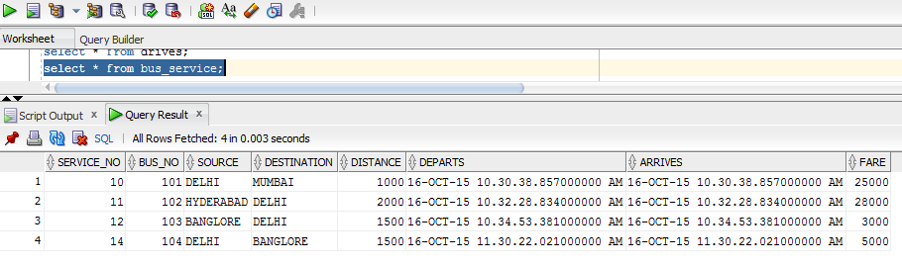

1. Increment the salary of all those drivers by 10% who drives a bus with rating at least ‘8’.

Answer:-

query:- update employees set salary = salary + (10/100 * salary) where emp_id IN (select emp_id from drives where bus_no IN (select bus_no from bus where rating >= 8));

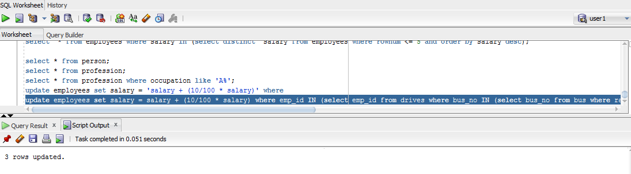

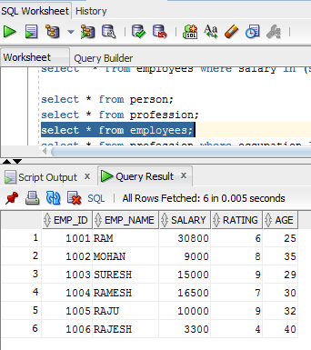

1. Retire all those employees whose age is greater than 60 and who drives only buses with rating at most 4. *(hint : Retirement here asks for deletion)*

Answer:-

query:-

delete from employees where age > 60 and emp_id IN (select emp_id from drives where bus_no IN (select bus_no from bus where rating <=4));



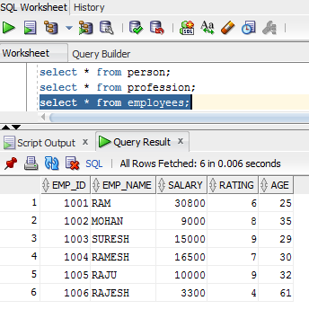

1. For all the employees who are not drivers and whose rating is at least 8, make each of them a driver by assigning each one to all buses with rating at most 4.

Answer:-

query:- insert into drives(emp_id,bus_no) select e.emp_id,b.bus_no from employees e,bus b where e.emp_id not in (select d.emp_id from drives d) and e.rating >= 8 and b.rating <= 4;

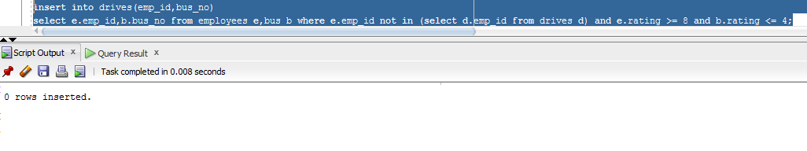

1. Find the difference between the average salary of all drivers and the average salary of all employees (including drivers).

Answer:-

query:- select (avg(e2.salary) - avg(e1.salary)) as salary_difference from employees e1,employees e2 where e1.emp_id in (select emp_id from employees) and e2.emp_id in (select distinct emp_id from drives);

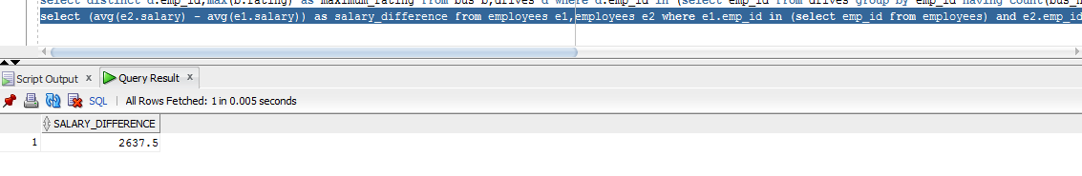

1. For each driver who drives more than three buses, find the emp_id and the maximum rating of the bus that he (or she) drives.

Answer:-

query:- select distinct d.emp_id,max(b.rating) as maximum_rating from bus b,drives d where d.emp_id in (select emp_id from drives group by emp_id having count(bus_no) > 3) group by d.emp_id;

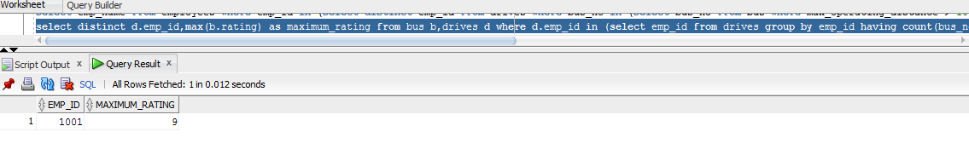

1. Find the names of drivers whose salary is less than the minimum fare from ‘Hyderabad’ to ‘Bangalore’.

Answer:-

query:- select emp_name from employees where emp_id IN (select emp_id from drives) and salary < (select min(fare) from bus_service where source = 'HYDERABAD' and destination = 'BANGLORE');

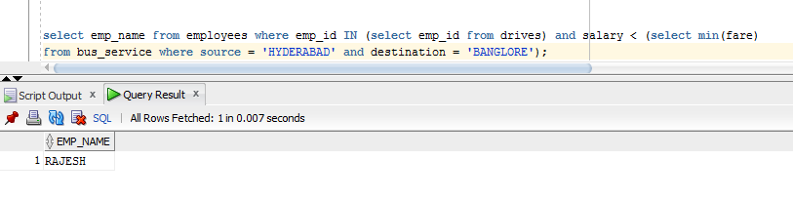

1. For all buses with rating over 8, find the name of the bus and the average salary of all drivers for this bus.

Answer:-

query:- select b.bus_name,avg(e.salary) as average_salary from bus b,employees e,drives d where e.emp_id = d.emp_id and d.bus_no = b.bus_no and b.rating > 8 group by b.bus_name;

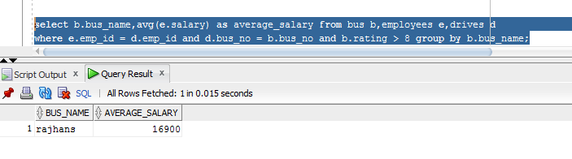

1. Find the name and salary of every employee who does not drive and whose salary is more than the average salary for drivers.

Answer:-

query:- select emp_name,salary from employees where emp_id not in (select emp_id from drives) and salary > (select avg(salary) from employees where emp_id in (select emp_id from drives));

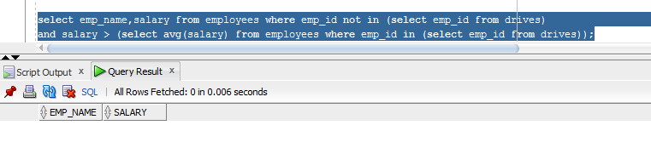

1. Find the names of drivers who drive only the buses with operating speed longer than 1000 Km.

Answer:-

query:- select emp_name from employees where emp_id IN (select emp_id from drives where bus_no IN ( select bus_no from bus where max_operating_distance > 1000));

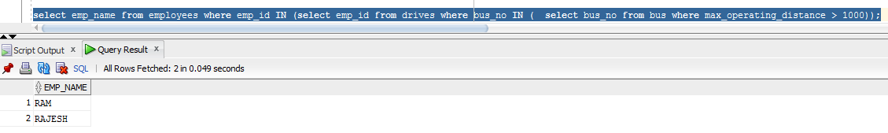

1. Find the names of drivers who drive only the buses with operating speed longer than 1000 Km, but on at least two buses.

Answer:-

query:- select emp_name from employees where emp_id in (select distinct emp_id from drives where bus_no in (select bus_no from bus where max_operating_distance > 1000 group by bus_no having count(emp_id) > 2));

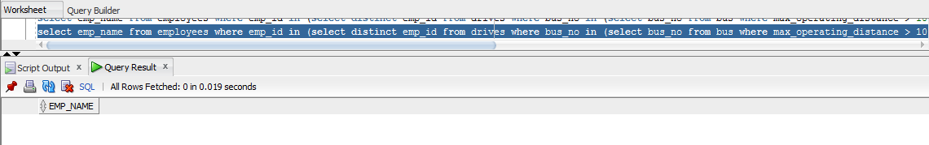

1. Find the names of drivers who drive only the buses with operating speed longer than 1000 Km and who drives some bus with rating at least 7.

Answer:-

query:- select emp_name from employees where emp_id in (select distinct emp_id from drives where bus_no in (select bus_no from bus where max_operating_distance > 1000 or rating >= 7));

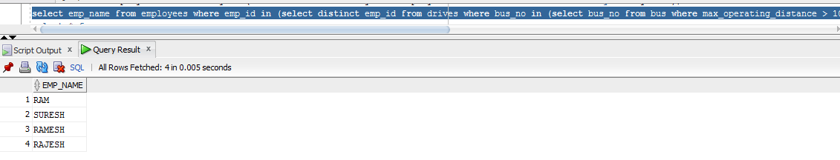

1. For each bus driven by more than 5 drivers, find the bus name and the count of its drivers who earn more than 25k.

Answer:-

query:- select b.bus_name,count(d.emp_id) from drives d,bus b,employees e where e.emp_id = d.emp_id and e.salary > 25000 group by b.bus_name,d.emp_id having count(d.emp_id) > 5 ;

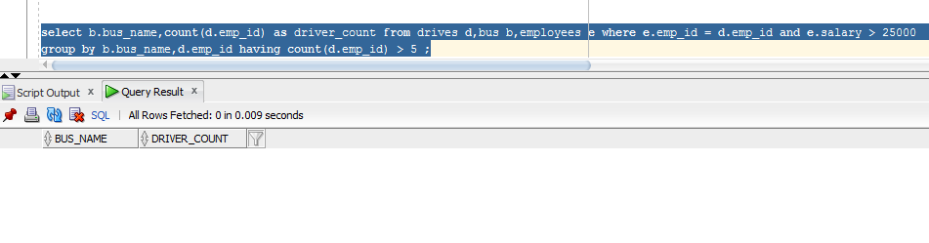

1. Find the driver names who drives all the buses

Answer:-

query:- select distinct e.emp_name from employees e,bus b

where emp_id IN (select emp_id from drives group by emp_id having count(bus_no) = (select count(*) from bus)) group by emp_name;

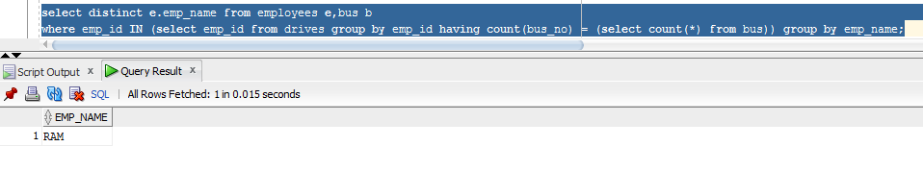

1. Find the top 5 employee names in terms of their salary.

Answer:-

query:- SELECT emp_name FROM (SELECT emp_name FROM employees ORDER BY salary desc) WHERE rownum <= 5;;

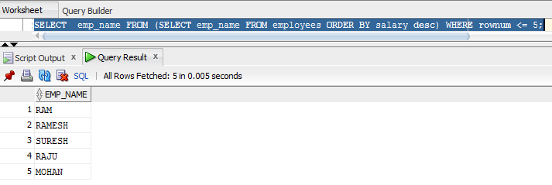

1. Find the names of drivers who operates most number of buses

Answer:-

query:- select distinct e.emp_name

from employees e , bus b

where e.emp_id in (select emp_id from drives

group by emp_id having count(bus_no) = (select max(count(bus_no)) from drives group by emp_id)) group by e.emp_name;

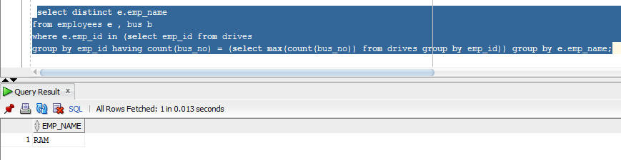

1. Find the names of drivers who operate most number of buses and along with the name find out the average rating of buses they drive.

Answer:-

query:- select distinct e.emp_name,avg(b.rating) as average_rating

from employees e , bus b

where e.emp_id in (select emp_id from drives

group by emp_id having count(bus_no) = (select max(count(bus_no)) from drives group by emp_id)) group by e.emp_name;

