**Problem 1**

**Explain how rowtype can be used in pl/sql?**

Answer:-

* The rowtype attribute provides a record type that represents a row in a database table.
* It is denoted by %ROWTYPE.
* A PL/SQL record is a data structure that can hold data items of different kinds.
* Records consist of different fields, similar to a row of a database table.
* Variables declared using %ROWTYPE are treated like those declared using a datatype name. It can be used in variable declarations as a datatype specifier.
* %ROWTYPE is used to declare a record with the same types as found in the specified database table, view or cursor.
* To reference a field in the record, use recordname.fieldname

**Problem 2**

**What is the difference between the columntype and rowtype in pl/sql**

Answer:-

|  |  |  |
| --- | --- | --- |
| Sr.no | ROWTYPE | COLUMNTYPE |
|  | Denoted by %ROWTYPE | Denoted by%TYPE |
|  | Used to declare a record with the same types as found in the specified database table, view or cursor: | Used to declare a field with the same type as that of a specified table’s column: |
|  | Reference the cursor name whenever we use the variable | Declare a separate variable for each column. |
|  | %ROWTYPE is used to declare record | %TYPE is used to declare scalar variables |
|  | Example:-  DECLARE  dept_rec departments%ROWTYPE;  BEGIN  SELECT * INTO dept_rec  FROM departments  WHERE department_id = 10  AND ROWNUM < 2;  END; | Example:-  [DECLARE](http://www.oracle.com/pls/db10g/search?remark=quick_search&word=DECLARE)  v_EmpName emp.ename%[TYPE](http://www.oracle.com/pls/db10g/search?remark=quick_search&word=TYPE);  [BEGIN](http://www.oracle.com/pls/db10g/search?remark=quick_search&word=BEGIN)  [SELECT](http://www.oracle.com/pls/db10g/search?remark=quick_search&word=SELECT) ename [INTO](http://www.oracle.com/pls/db10g/search?remark=quick_search&word=INTO) v_EmpName [FROM](http://www.oracle.com/pls/db10g/search?remark=quick_search&word=FROM) emp [WHERE](http://www.oracle.com/pls/db10g/search?remark=quick_search&word=WHERE) [ROWNUM](http://www.oracle.com/pls/db10g/search?remark=quick_search&word=ROWNUM) = 1;  [DBMS_OUTPUT](http://www.oracle.com/pls/db10g/search?remark=quick_search&word=DBMS_OUTPUT).PUT_LINE('Name = ' || v_EmpName);  [END](http://www.oracle.com/pls/db10g/search?remark=quick_search&word=END); |

**Problem 3**

**Write a code to demonstrate the column type?**

Answer:-

set serveroutput on

DECLARE

v_EmpName employees.emp_name%TYPE;

BEGIN

SELECT emp_name INTO v_EmpName FROM employees WHERE ROWNUM = 1;

DBMS_OUTPUT.PUT_LINE('Name = ' || v_EmpName);

END;

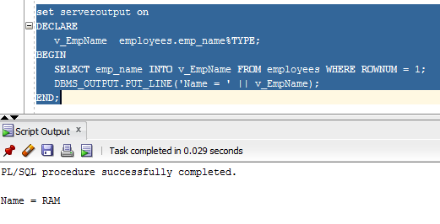

**Problem 4**

**Write the pl/sql code to give the usage of rowtype?**

Answer:-

set serveroutput on

DECLARE

v_emp employees%ROWTYPE;

BEGIN

SELECT * into v_emp from employees where rownum = 1;

DBMS_OUTPUT.PUT_LINE('emp no = ' || v_emp.emp_id);

DBMS_OUTPUT.PUT_LINE('Name = ' || v_emp.emp_name);

DBMS_OUTPUT.PUT_LINE('Salary = ' || v_emp.salary);

DBMS_OUTPUT.PUT_LINE('Rating = ' || v_emp.rating);

DBMS_OUTPUT.PUT_LINE('Age = ' || v_emp.age);

END;

