**PROBLEM SET**

So far, you have worked on MySQL for simple and complex queries. Now that you are familiar with the MySQL syntax attempt the following questions using MYSQL.

**Task:**

1. Create a cursor to display PNR number, names of the passengers from passenger table.

Answer:-

query:-

DECLARE

t_pnrno ticket.pnrno%type;

p_name passenger.name%type;

CURSOR p_passenger is

select ticket.pnrno,passenger.name from passenger,ticket

where ticket.ppno = passenger.ppno;

BEGIN

OPEN p_passenger;

LOOP

FETCH p_passenger into t_pnrno, p_name;

EXIT WHEN p_passenger%notfound;

dbms_output.put_line(t_pnrno || ' ' || p_name || ' ');

END LOOP;

CLOSE p_passenger;

END;

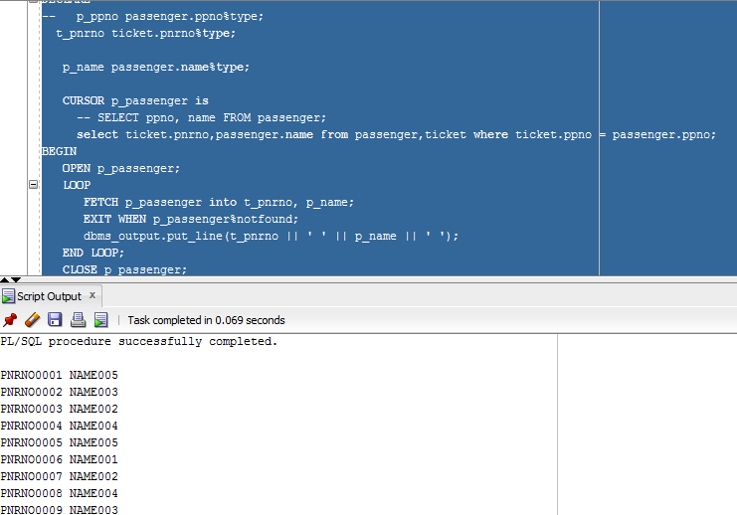

1. Create a forward_only cursor in order to allow changes and that should fetch each row from the reservation table having class 'Business Clase' and the journey date at the current cursor position is changed to may 15,2001.

Answer:-

query:-

set serveroutput on

declare

var_rows number(5);

cursor res is

select * from reservation where class = 'BUSINESS' for update of JOURNEY_DATE;

r res%ROWTYPE;

begin

open res;

loop

fetch res into r ;

exit when res%NOTFOUND;

update reservation set JOURNEY_DATE = '15-MAY-01' where current of res;

IF SQL%NOTFOUND THEN

dbms_output.put_line('No records where updated');

ELSIF SQL%FOUND THEN

var_rows := SQL%ROWCOUNT;

dbms_output.put_line(var_rows || 'record are updated');

END IF;

end loop;

close res;

end;

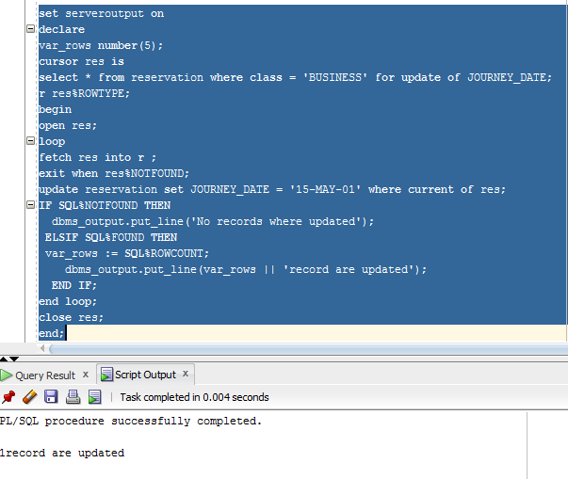

1. Create a cursor to display all rows in flight table having source as ‘mumbai’.

Answer:-

query:-

set serveroutput on

declare

fid FLIGHT.FID%TYPE;

fname FLIGHT.FNAME%TYPE;

src_code FLIGHT.SOURCE_CODE%TYPE;

dest_code FLIGHT.DESTINATION_CODE%TYPE;

jhrs FLIGHT.JOURNEY_HRS%TYPE;

cursor flight_curr is

select f.fid,f.fname,f.source_code,f.destination_code,f.journey_hrs

from flight f , city_master cm

where f.SOURCE_CODE = cm.CITY_CODE and cm.CITY_NAME = 'MUMBAI';

begin

open flight_curr;

loop

fetch flight_curr into fid,fname,src_code,dest_code,jhrs;

EXIT WHEN flight_curr%NOTFOUND;

DBMS_OUTPUT.PUT_LINE (fid || ' ' || fname || ' ' || src_code || ' ' || dest_code || ' ' || jhrs);

end loop;

close flight_curr;

end;

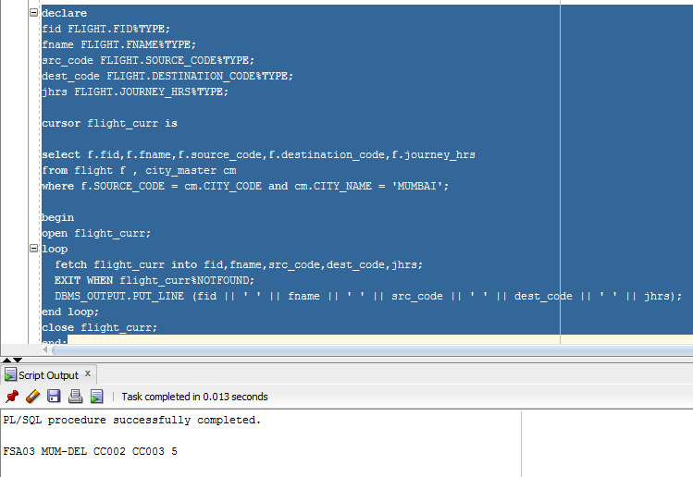

1. Create a keyset cursor to display passenger details from the reservation table and the meal_code is ‘V’ or ‘NV’.

Answer:-

query:-

declare

ppno passenger.ppno%TYPE;

name passenger.name%TYPE;

dob passenger.dob%TYPE;

sex passenger.sex%TYPE;

addr passenger.address%TYPE;

con passenger.contact_no%TYPE;

cursor pass is

select p.ppno,p.name,p.dob,p.sex,p.address,p.contact_no

from passenger p ,reservation r

where p.ppno= r.ppno and r.meal_code = 'V' or r.meal_code = 'NV';

begin

open pass;

loop

fetch pass into ppno,name,dob,sex,addr,con;

EXIT WHEN pass%NOTFOUND;

DBMS_OUTPUT.PUT_LINE (ppno || ' ' || name || ' ' || dob || ' ' || sex || ' ' || addr || ' ' || con);

end loop;

close pass;

end;

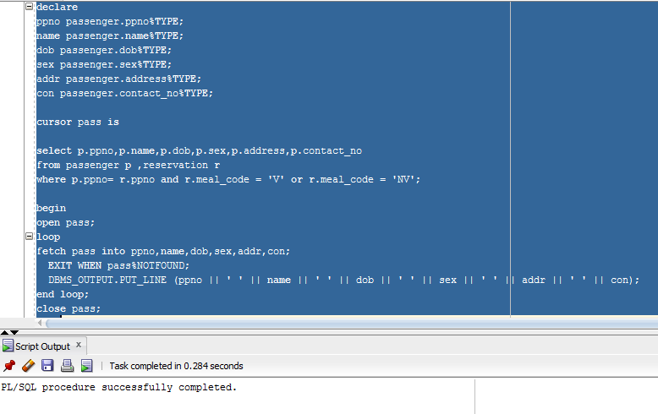

1. Create a read_only cursor to display all the rows from flight table and the aircraft code is ‘FSA08’ or ‘FSA09’.

Answer:-

quey:-

set serveroutput on

declare

fid flight.fid%TYPE;

fname flight.fname%TYPE;

src_code flight.source_code%TYPE;

dest_code flight.destination_code%TYPE;

jhrs flight.journey_hrs%TYPE;

cursor flite is

select * from flight where FID = 'FSA08' or fid = 'FSA09';

begin

open flite;

loop

fetch flite into fid,fname,src_code,dest_code,jhrs;

EXIT WHEN flite%NOTFOUND;

DBMS_OUTPUT.PUT_LINE (fid || ' ' || fname || ' ' || src_code || ' ' || dest_code || ' ' || jhrs);

end loop;

close flite;

end;

