**Problem Set**

**Task:**

Please see below for the questions on Stored Procedures and Instructions:

Assuming that students designed FlySafeAirways project

**Instructions:**

1. Our Customer FlySafeAirways asked to create some procedures for the following Questions.

**Questions:**

1. Create a stored procedure to display the flight information that takes off from Mumbai.

Answer:-

query:-

create or replace procedure flight_info (fid out varchar ,fname out varchar ,src_code out varchar ,dest_code out varchar,jhrs out number )

is

begin

select f.fid,f.fname,f.source_code,f.destination_code,f.journey_hrs into fid,fname,src_code,dest_code,jhrs

from flight f , city_master cm

where f.SOURCE_CODE = cm.CITY_CODE and cm.CITY_NAME = 'MUMBAI';

end flight_info;

--

declare

fid varchar2(5);

fname varchar2(20);

src_code varchar2(5);

dest_code varchar2(5);

jhrs number(2,0);

begin

flight_info(fid,fname,src_code,dest_code,jhrs);

dbms_output.put_line(fid || ' ' ||fname || ' ' || src_code || ' ' || dest_code || ' ' || jhrs);

end;

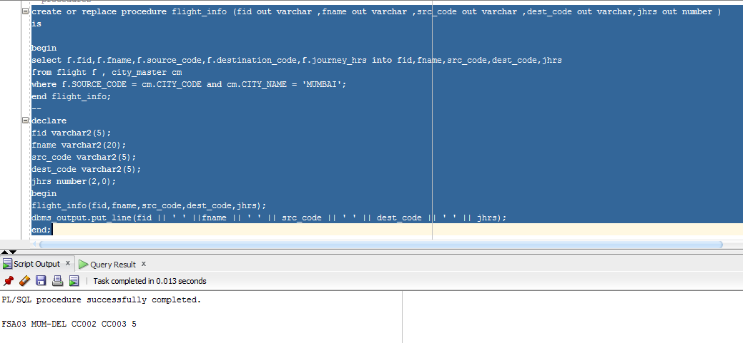

1. Create and execute a procedure to display all the meal options available in the British airways.

Answer:-

query:-

create or replace procedure meal_options2

is

mopt meal_master%rowtype;

begin

for mopt in (select mm.meal_code,mm.meal_name,mm.amount

from meal_master mm,flight_meal fm

where f.meal_code = mm.meal_code)

loop

DBMS_OUTPUT.PUT_LINE (mopt.meal_code || ' ' || mopt.meal_name || ' ' || mopt.amount);

end loop;

end meal_options2;

select serveroutput on size 500000;

exec meal_options2();

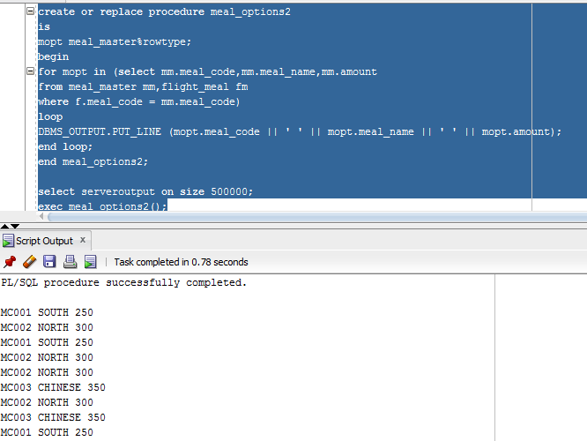

1. Display all the stored procedures present in the fly safe airways database.

Answer:-

query:-

SELECT * FROM ALL_OBJECTS WHERE OBJECT_TYPE IN ('PROCEDURE') and owner = 'USER1';

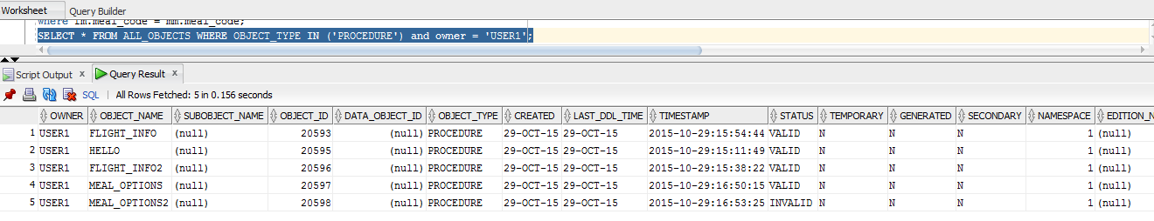

1. Create and execute a stored procedure to display the airlines that offer ‘child care’ as a service. Modify this procedure to display the airlines that offer the service ‘nurse’.

Answer:-

query:-

create procedure service

is

s flight%rowtype;

begin

for s in (

select f.fid,f.fname

from flight f,flight_services fs,service_master sm

where f.fid = fs.fid and fs.service_code = sm.service_code and sm.service_name = 'CHILDECARE')

loop

DBMS_OUTPUT.PUT_LINE (s.fid || ' ' || s.fname);

end loop;

end service;

select serveroutput on size 500000;

exec service();

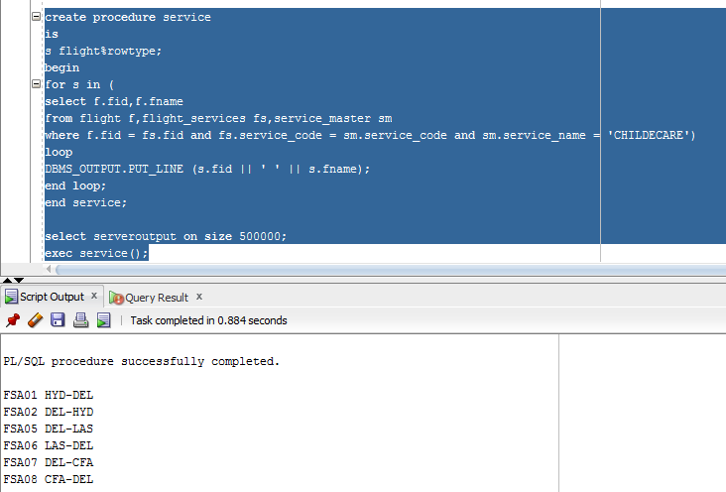

create or replace procedure service

is

s flight%rowtype;

begin

for s in (

select f.fid,f.fname

from flight f,flight_services fs,service_master sm

where f.fid = fs.fid and fs.service_code = sm.service_code and sm.service_name = 'NURSE')

loop

DBMS_OUTPUT.PUT_LINE (s.fid || ' ' || s.fname);

end loop;

end service;

select serveroutput on size 500000;

exec service();

