How to create table? Can you create two tables with same name?

Answer :-We can create table using the below SQL query :-

CREATE TABLE table_name  
(  
column_name1 data_type(size),  
column_name2 data_type(size),  
column_name3 data_type(size),  
....  
);

For example:-

CREATE TABLE Persons  
(  
PersonID int,  
LastName varchar(255),  
FirstName varchar(255),  
Address varchar(255),  
City varchar(255)  
);

We cannot have same names for table therefore we cannot create two tables with same name.

**Problem set-1**

1. Create the DDL Statements for the [***schema***](http://wiki2014.msitprogram.net/DD09/Flight_Tables.docx)***provided to you***.
2. **Flight**

FID                               Varchar2(5)     PK

 FName                        Varchar2(20)

Source_Code               Varchar2(5)     FK

Destination_Code       Varchar2(5)     FK

Journey_Hours            Number(2)

Answer:-

SQL>

**City_Master**

City_Code                    Varchar2(5)     PK

City_Name                  Varchar2(20)

Country                       Varchar2(20)

Answer:-

SQL> create table city_master(city_code varchar2(5) not null, city_name varchar2

(20),country varchar2(20),primary key (city_code));

**Flight-Class**

FID                               Varchar2(5)     FK

Class                            Varchar2(10)

Amount                       Number(7,2)

No_Seats                     Number(2)

Answer:-

 SQL> create table flight_class (fid varchar2(5), class varchar2(10), amount numb

er(7,2),no_seats number(2),foreign key(fid) references flight(fid));

**Service-Master**

Service_Code              Varchar2(5)     PK

Service_Name             Varchar2(15)

Amount                       Number(7,2)

Answer:-

 SQL> create table service_master(service_code varchar2(5) not null, service_name

varchar2(15), amount number(7,2) ,primary key (service_code));

**Flight-Services**

FID                               Varchar2(5)     FK

Service_Code              Varchar2(5)     FK

Answer:-

 SQL> create table flight_services (fid varchar2(5), service_code varchar2(5) ,fo

reign key (fid) references flight(fid),foreign key (service_code) references ser

vice_master(service_code));

**Meal-Master**

Meal _Code                Varchar2(5)     PK

Meal _Name               Varchar2(15)   PK

Amount                       Number(7,2)

Answer:-

 SQL> create table meal_master(meal_code varchar2(5) not null, meal_name varchar2

(15), amount number(7,2) ,primary key (meal_code));

**Flight-** **Meal**

FID                               Varchar2(5)     FK

Meal _Code                Varchar2(5)     FK

Answer:-

SQL> create table flight_meal (fid varchar2(5), meal_code varchar2(5),foreign ke

y(fid) references flight(fid),foreign key(meal_code) references meal_master(meal

_code));

**Flight_Days**

FID                               Varchar2(5)     FK

Dept_time                   Number(2)

Day                              Varchar2(10)

Answer:-

SQL> create table flight_days (fid varchar2(5) , dept_time number(2),day varchar

2(10),foreign key(fid) references flight(fid));

**Luggage-Master**

Class                            Varchar2(10)

Weight                        Number(3)

Extra_Amount_PERKG Number(7,2)

Answer:-

SQL> create table luggage_master(class varchar2(10), weight number(3),extra_amou

nt_perkg number(7,2));

**Passenger-Luggage-Charges**

PNRNO                        Varchar2(10)   FK

WEIGHT                       Number(32)

AMOUNT                     Number(7,2)

Answer:-

 SQL> create table passenger_luggage_charges(pnrno varchar2(10), weight number(32

), amount number(7,2),foreign key(pnrno) references ticket(pnrno));

**Passenger**

PPNO                           Varchar2(10)   PK

Name                          Varchar2(20)

DOB                             Date

Sex:                              Varchar2(6)

Address                       Varchar2(30)

Contact_No                 Number(10)

Answer:-

 SQL> create table passenger(ppno varchar2(10), name varchar2(20),dob date,sex va

rchar2(6),address varchar2(30),contact_no number(10) ,primary key(ppno));

**Reservation**

PPNO                           Varchar2(10)   FK

Flight_Code                 Varchar2(5)     FK

Journey_Date              Date

Class                            Varchar2(10)

Meal_Code                 Varchar2(5)     FK

Service_Code              Varchar2(5)     FK

Answer:-

SQL> create table reservation(ppno varchar2(10),flight_code varchar2(5),journey_

date date,class varchar2(10),meal_code varchar2(5),service_code varchar2(5),fore

ign key(meal_code) references meal_master(meal_code),foreign key(service_code) r

eferences service_master(service_code));

**Ticket**

PNRNO                        Varchar2(10) PK

PPNO                           Varchar2(10) FK

Flight_Code                 Varchar2(5)     FK

Journey_Date              Date

Class                            Varchar2(10)

Meal_Code                 Varchar2(5)     FK

Service_Code              Varchar2(5)     FK

Amount                       Number(7,2)

Status

Answer:-

 SQL> create table ticket(pnrno varchar2(10),ppno varchar2(10),flight_code varcha

r2(5), journey_date date, class varchar2(10),meal_code varchar2(5),service_code

varchar2(5),amount number(7,2),status varchar2(10), primary key(pnrno),foreign k

ey(ppno) references passenger(ppno),foreign key(flight_code) references flight(f

id),foreign key(meal_code) references meal_master(meal_code), foreign key(servic

e_code) references service_master(service_code));

**Cancellation Charges**

Before-Hours                Number(2)

Charges                       Number(7,2)

Answer:-

 SQL> create table cancellation_charges(before_hrs number(2), charges number(7,2)

);

**Cancellation**

CID                              Varchar2(5)     FK

PNRNO                        Varchar2(10)   FK

Before-Hours                Number(2)

Answer:-

 SQL> create table cancellation(cid varchar2(5), before_hrs number(2), pnrno varchar2(10),primary key(c

id),foreign key(pnrno) references ticket(pnrno));

**Availability**

FID                               Varchar2(5)     FK

Class                            Varchar2(10)

Journey-date               Date

Remaining-seats         Number(2)

Answer:-

SQL> create table availability(fid varchar2(5), class varchar2(10),journey_date

date,remaining_seats number(2), foreign key(fid) references flight(fid));

Problem set-2:-

1. Insert data  given below  [***Download***](http://wiki2014.msitprogram.net/DD09/FSA_Table_Data.docx)***in tables created in previous problem set.***.
2. Apply different kinds of constraints you have studied. *(Foreign key constraint, on delete, on cascade etc)*

**City_Master**

|  |  |  |
| --- | --- | --- |
| **City-Code** | **City-Name** | **Country** |
| CC001 | HYDERABAD | INDIA |
| CC002 | MUMBAI | INDIA |
| CC003 | DELHI | INDIA |
| CC004 | LOS ANGELES | USA |
| CC005 | CALIFORNIA | ENGLAND |

**Answer:-**

**insert into city_master values ('CC001','HYDERABAD','INDIA')**

**insert into city_master values ('CC002','MUMBAI','INDIA')**

**insert into city_master values ('CC003','DELHI','INDIA')**

**insert into city_master values ('CC004','LOS ANGELES','USA')**

**insert into city_master values ('CC005','CALIFORNIA','ENGLAND')**

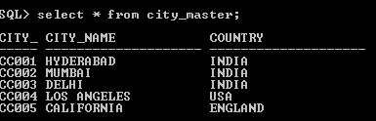

**Flight**

|  |  |  |  |  |
| --- | --- | --- | --- | --- |
| **FID** | **FName** | **Source-Code** | **Destination-Code** | **Journey-Hours** |
| FSA01 | HYD-DEL | CC001 | CC003 | 6 |
| FSA02 | DEL-HYD | CC003 | CC001 | 6 |
| FSA03 | MUM-DEL | CC002 | CC003 | 5 |
| FSA04 | DEL-MUM | CC003 | CC002 | 5 |
| FSA05 | DEL-LAS | CC003 | CC004 | 12 |
| FSA06 | LAS-DEL | CC004 | CC003 | 12 |
| FSA07 | DEL-CFA | CC003 | CC005 | 13 |
| FSA08 | CFA-DEL | CC005 | CC003 | 13 |

**SQL> insert into flight values('FSA01','HYD-DEL','CC001','CC003',6);**

**SQL> insert into flight values('FSA02','DEL-HYD','CC003','CC001',6);**

**SQL> insert into flight values('FSA03','MUM-DEL','CC002','CC003',5);**

**SQL> insert into flight values('FSA04','DEL-MUM','CC003','CC002',5);**

**SQL> insert into flight values('FSA05','DEL-LAS','CC003','CC004',12);**

**SQL> insert into flight values('FSA06','LAS-DEL','CC004','CC003',12);**

**SQL> insert into flight values('FSA07','DEL-CFA','CC003','CC005',13);**

**SQL> insert into flight values('FSA08','CFA-DEL','CC005','CC003',13);**

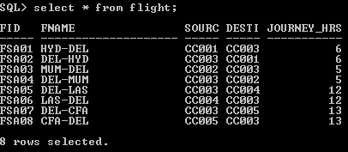

**Flight_Days**

|  |  |  |
| --- | --- | --- |
| **FID** | **Day** | **Dept-time** |
| FSA01 | MONDAY | 11 |
| FSA05 | MONDAY | 18 |
| FSA06 | TUESDAY | 9 |
| FSA02 | TUESDAY | 23 |
| FSA01 | WEDNESDAY | 11 |
| FSA05 | WEDNESDAY | 18 |
| FSA06 | THURSDAY | 9 |
| FSA02 | THURSDAY | 23 |
| FSA01 | FRIDAY | 11 |
| FSA05 | FRIDAY | 18 |
| FSA06 | SATURDAY | 9 |
| FSA02 | SATURDAY | 23 |
| FSA03 | TUESDAY | 8 |
| FSA07 | TUESDAY | 15 |
| FSA08 | WEDNESDAY | 7 |
| FSA04 | WEDNESDAY | 23 |
| FSA03 | THURSDAY | 11 |
| FSA07 | THURSDAY | 18 |
| FSA08 | FRIDAY | 9 |
| FSA04 | FRIDAY | 23 |
| FSA03 | SATURDAY | 11 |
| FSA07 | SATURDAY | 18 |
| FSA08 | SUNDAY | 9 |
| FSA04 | SUNDAY | 23 |

SQL> insert into flight_days values('FSA01',11,'MONDAY');

SQL> insert into flight_days values('FSA05',18,'MONDAY');

SQL> insert into flight_days values('FSA06',9,'TUEDAY');

SQL> insert into flight_days values('FSA02',23,'TUESDAY');

SQL> insert into flight_days values('FSA01',11,'WEDNESDAY');

SQL> insert into flight_days values('FSA05',18,'WEDNESDAY');

SQL> insert into flight_days values('FSA06',9,'THURSDAY');

SQL> insert into flight_days values('FSA02',23,'THURSDAY');

SQL> insert into flight_days values('FSA01',11,'FFRIDAY');

SQL> insert into flight_days values('FSA05',18,'FFRIDAY');

SQL> insert into flight_days values('FSA06',9,'SATURDAY');

SQL> insert into flight_days values('FSA02',23,'SATURDAY');

SQL> insert into flight_days values('FSA03',8,'TUESDAY');

SQL> insert into flight_days values('FSA07',15,'TUESDAY');

SQL> insert into flight_days values('FSA08',7,'WEDNESDAY');

SQL> insert into flight_days values('FSA04',23,'WEDNESDAY');

SQL> insert into flight_days values('FSA03',11,'THURSDAY');

SQL> insert into flight_days values('FSA07',18,'THURSDAY');

SQL> insert into flight_days values('FSA08',9,'FRIDAY');

SQL> insert into flight_days values('FSA04',23,'FRIDAY');

SQL> insert into flight_days values('FSA03',11,'SATURDAY');

SQL> insert into flight_days values('FSA07',18,'SATURDAY');

SQL> insert into flight_days values('FSA08',9,'SUNDAY');

SQL> insert into flight_days values('FSA04',23,'SUNDAY');

SQL> select * from flight_days

FID DEPT_TIME DAY

----- ---------- ----------

FSA01 11 MONDAY

FSA05 18 MONDAY

FSA06 9 TUEDAY

FSA02 23 TUESDAY

FSA01 11 WEDNESDAY

FSA05 18 WEDNESDAY

FSA06 9 THURSDAY

FSA02 23 THURSDAY

FSA01 11 FFRIDAY

FSA05 18 FFRIDAY

FSA06 9 SATURDAY

FID DEPT_TIME DAY

----- ---------- ----------

FSA02 23 SATURDAY

FSA03 8 TUESDAY

FSA07 15 TUESDAY

FSA08 7 WEDNESDAY

FSA04 23 WEDNESDAY

FSA03 11 THURSDAY

FSA07 18 THURSDAY

FSA08 9 FRIDAY

FSA04 23 FRIDAY

FSA03 11 SATURDAY

FSA07 18 SATURDAY

FID DEPT_TIME DAY

----- ---------- ----------

FSA08 9 SUNDAY

FSA04 23 SUNDAY

24 rows selected.

**Flight-Class**

|  |  |  |  |
| --- | --- | --- | --- |
| FID | CLASS | AMOUNT | NO-SEATS |
| FSA001 | EXECUTIVE | 7000 | 3 |
| FSA001 | BUSINESS | 6000 | 4 |
| FSA001 | ECONOMY | 5000 | 5 |
| FSA002 | EXECUTIVE | 7000 | 3 |
| FSA002 | BUSINESS | 6000 | 4 |
| FSA002 | ECONOMY | 5000 | 5 |
| FSA003 | EXECUTIVE | 8000 | 4 |
| FSA003 | BUSINESS | 7000 | 5 |
| FSA003 | ECONOMY | 6000 | 6 |
| FSA004 | EXECUTIVE | 8000 | 4 |
| FSA004 | BUSINESS | 7000 | 5 |
| FSA004 | ECONOMY | 6000 | 6 |
| UFSA005 | EXECUTIVE | 10000 | 5 |
| FSA005 | BUSINESS | 9000 | 6 |
| FSA005 | ECONOMY | 8000 | 7 |
| FSA006 | EXECUTIVE | 10000 | 5 |
| FSA006 | BUSINESS | 9000 | 6 |
| FSA006 | ECONOMY | 8000 | 7 |
| FSA007 | EXECUTIVE | 12000 | 6 |
| FSA007 | BUSINESS | 11000 | 7 |
| FSA007 | ECONOMY | 10000 | 8 |
| FSA008 | EXECUTIVE | 12000 | 6 |
| FSA008 | BUSINESS | 11000 | 7 |
| FSA008 | ECONOMY | 10000 | 8 |

SQL> insert into flight_class values('FSA01','EXECUTIVE',7000,3);

SQL> insert into flight_class values('FSA01','BUSINESS',6000,4);

SQL> insert into flight_class values('FSA01','ECONOMY',7000,3);

SQL> insert into flight_class values('FSA02','BUSINESS',5000,5);

SQL> insert into flight_class values('FSA02','ECONOMY',5000,5);

SQL> insert into flight_class values('FSA03','EXECUTIVE',8000,4);

SQL> insert into flight_class values('FSA03','BUSINESS',7000,5);

SQL> insert into flight_class values('FSA02','ECONOMY',6000,6);

SQL> insert into flight_class values('FSA04','EXECUTIVE',8000,4);

SQL> insert into flight_class values('FSA04','BUSINESS',7000,5);

SQL> insert into flight_class values('FSA04','ECONOMY',6000,6);

SQL> insert into flight_class values('UFSA05','EXECUTIVE',10000,5);

SQL> insert into flight_class values('UFSA5','EXECUTIVE',10000,5);

SQL> insert into flight_class values('FSA05','BUSINESS',9000,6);

SQL> insert into flight_class values('FSA05','ECONOMY',8000,7);

SQL> insert into flight_class values('FSA05','EXECUTIVE',10000,5);

SQL> insert into flight_class values('FSA06','EXECUTIVE',10000,5);

SQL> insert into flight_class values('FSA06','BUSINESS',9000,6);

SQL> insert into flight_class values('FSA06','ECONOMY',8000,7);

SQL> insert into flight_class values('FSA07','EXECUTIVE',12000,6);

SQL> insert into flight_class values('FSA06','ECONOMY',8000,7);

SQL> insert into flight_class values('FSA07','BUSINESS',11000,7);

SQL> insert into flight_class values('FSA07','ECONOMY',10000,8);

SQL> insert into flight_class values('FSA08','EXECUTIVE',12000,6);

SQL> insert into flight_class values('FSA08','BUSINESS',11000,7);

SQL> insert into flight_class values('FSA08','ECONOMY',10000,8);

SQL> select * from flight_class;

FID CLASS AMOUNT NO_SEATS

----- ---------- ---------- ----------

FSA01 EXECUTIVE 7000 3

FSA01 BUSINESS 6000 4

FSA01 ECONOMY 7000 3

FSA02 BUSINESS 5000 5

FSA02 ECONOMY 5000 5

FSA03 EXECUTIVE 8000 4

FSA03 BUSINESS 7000 5

FSA02 ECONOMY 6000 6

FSA04 EXECUTIVE 8000 4

FSA04 BUSINESS 7000 5

FSA04 ECONOMY 6000 6

FID CLASS AMOUNT NO_SEATS

----- ---------- ---------- ----------

UFSA5 EXECUTIVE 10000 5

FSA05 BUSINESS 9000 6

FSA05 ECONOMY 8000 7

FSA05 EXECUTIVE 10000 5

FSA06 EXECUTIVE 10000 5

FSA06 BUSINESS 9000 6

FSA06 ECONOMY 8000 7

FSA07 EXECUTIVE 12000 6

FSA06 ECONOMY 8000 7

FSA07 BUSINESS 11000 7

FSA07 ECONOMY 10000 8

FID CLASS AMOUNT NO_SEATS

----- ---------- ---------- ----------

FSA08 EXECUTIVE 12000 6

FSA08 BUSINESS 11000 7

FSA08 ECONOMY 10000 8

25 rows selected.

**Service-Master**

|  |  |  |
| --- | --- | --- |
| **Service-Code** | **Service-Name** | **Amount** |
| SC001 | CHILDECARE | 400 |
| SC002 | NURSING | 300 |
| SC003 | WHEELCHAIR | 350 |

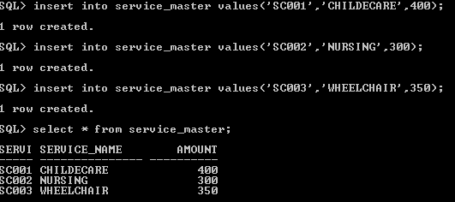

**Meal-Master**

|  |  |  |
| --- | --- | --- |
| **Meal -Code** | **Meal-Name** | **Amount** |
| MC001 | SOUTH | 250 |
| MC002 | NORTH | 300 |
| MC003 | CHINESE | 350 |

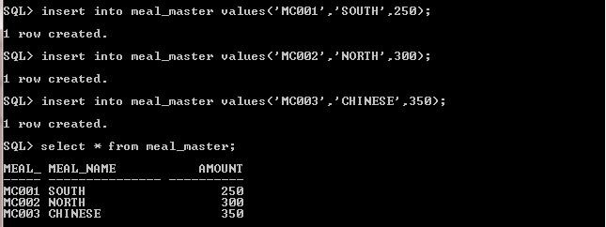

**Luggage-Master**

|  |  |  |
| --- | --- | --- |
| **CLASS** | **WEIGHT** | **EXT-AMT-PKG** |
| EXECUTIVE | 40 | 15 |
| BUSINESS | 35 | 12 |
| ECONOMY | 30 | 10 |

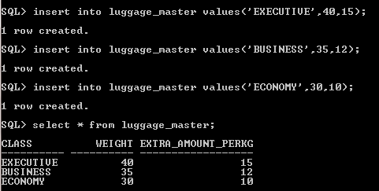

**Flight-Services**

|  |  |
| --- | --- |
| **FID** | **Service-Code** |
| FSA001 | SC001 |
| FSA001 | SC002 |
| FSA002 | SC001 |
| FSA002 | SC002 |
| FSA003 | SC002 |
| FSA003 | SC003 |
| FSA004 | SC002 |
| FSA004 | SC003 |
| FSA005 | SC001 |
| FSA005 | SC003 |
| FSA006 | SC001 |
| FSA006 | SC003 |
| FSA007 | SC001 |
| FSA007 | SC002 |
| FSA008 | SC001 |
| FSA008 | SC002 |

SQL> insert into flight_services values('FSA01','SC001');

SQL> insert into flight_services values('FSA01','SC002');

SQL> insert into flight_services values('FSA02','SC001');

SQL> insert into flight_services values('FSA02','SC002');

SQL> insert into flight_services values('FSA03','SC002');

SQL> insert into flight_services values('FSA03','SC003');

SQL> insert into flight_services values('FSA04','SC002');

SQL> insert into flight_services values('FSA04','SC003');

SQL> insert into flight_services values('FSA05','SC003');

SQL> insert into flight_services values('FSA05','SC001');

SQL> insert into flight_services values('FSA06','SC001');

SQL> insert into flight_services values('FSA06','SC003');

SQL> insert into flight_services values('FSA07','SC001');

SQL> insert into flight_services values('FSA07','SC002');

SQL> insert into flight_services values('FSA08','SC001');

SQL> insert into flight_services values('FSA08','SC002');

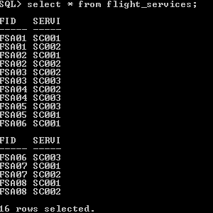

**Flight-** **Meal**

|  |  |
| --- | --- |
| **FID** | **Meal-Code** |
| FSA001 | MC001 |
| FSA001 | MC002 |
| FSA002 | MC001 |
| FSA002 | MC002 |
| FSA003 | MC002 |
| FSA003 | MC003 |
| FSA004 | MC002 |
| FSA004 | MC003 |
| FSA005 | MC001 |
| FSA005 | MC003 |
| FSA006 | MC001 |
| FSA006 | MC003 |
| FSA007 | MC001 |
| FSA007 | MC002 |
| FSA008 | MC001 |
| FSA008 | MC002 |

SQL> insert into flight_meal values('FSA01','MC001');

SQL> insert into flight_meal values('FSA01','MC002');

SQL> insert into flight_meal values('FSA02','MC001');

SQL> insert into flight_meal values('FSA02','MC002');

SQL> insert into flight_meal values('FSA03','MC002');

SQL> insert into flight_meal values('FSA03','MC003');

SQL> insert into flight_meal values('FSA04','MC002');

SQL> insert into flight_meal values('FSA04','MC003');

SQL> insert into flight_meal values('FSA05','MC001');

SQL> insert into flight_meal values('FSA05','MC003');

SQL> insert into flight_meal values('FSA06','MC001');

SQL> insert into flight_meal values('FSA06','MC003');

SQL> insert into flight_meal values('FSA07','MC001');

SQL> insert into flight_meal values('FSA07','MC002');

SQL> insert into flight_meal values('FSA08','MC001');

SQL> insert into flight_meal values('FSA08','MC002');

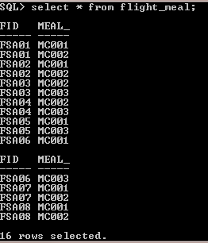

**Passenger**

|  |  |  |  |  |  |
| --- | --- | --- | --- | --- | --- |
| **PPNO** | **Name** | **DOB** | **Sex** | **Address** | **Contact-No** |
| PPNO00001 | NAME001 | 01-JAN-1985 | MALE | ADDR001 | 9876543210 |
| PPNO00002 | NAME002 | 02-FEB-1986 | FE MALE | ADDR002 | 9876543211 |
| PPNO00003 | NAME003 | 03-MAR-1987 | MALE | ADDR003 | 9876543212 |
| PPNO00004 | NAME004 | 04-APR-1988 | FEMALE | ADDR004 | 9876543213 |
| PPNO00005 | NAME005 | 05-MAY-1989 | MALE | ADDR005 | 9876543214 |

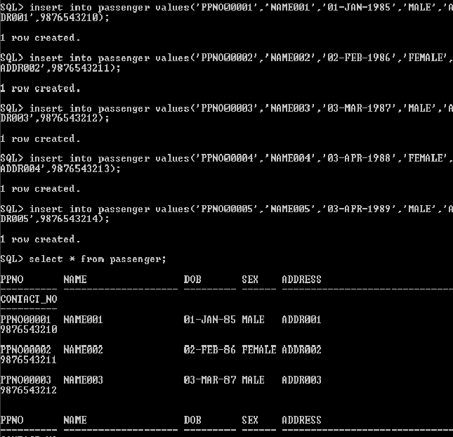

**Cancellation Charges**

|  |  |
| --- | --- |
| **Before-Hours** | **Charges** |
| 48 | Nil |
| 24 | 10 |
| 12 | 15 |
| 6 | 25 |
| 3 | 50 |

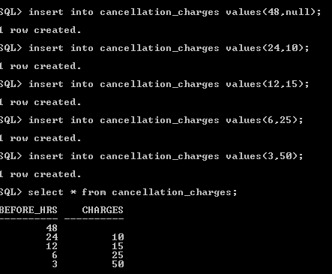

**Ticket**

|  |  |  |  |  |  |  |  |  |
| --- | --- | --- | --- | --- | --- | --- | --- | --- |
| **PNRNO** | **PPNO** | **Flight_Code** | **Journey_Date** | **Class** | **Meal_Code** | **Service_Code** | **Amount** | **Status** |
| PNRNO0001 | PPNO00005 | FSA001 | 03-DEC-12 | EXECUTIVE | MC002 | SC002 | 7600 | CNF |
| PNRNO0002 | PPNO00003 | FSA002 | 04-DEC-12 | BUSINESS | MC001 | SC001 | 6650 | CNF |
| PNRNO0003 | PPNO00002 | FSA006 | 06-DEC-12 | ECONOMY | MC003 | SC003 | 8700 | CNF |
| PNRNO0004 | PPNO00004 | FSA007 | 04-DEC-12 | EXECUTIVE | MC001 | SC001 | 12650 | WTG |
| PNRNO0005 | PPNO00005 | FSA004 | 05-DEC-12 | BUSINESS | MC003 | SC003 | 7700 | CNF |
| PNRNO0006 | PPNO00001 | FSA005 | 05-DEC-12 | ECONOMY | MC001 | SC001 | 8650 | WTG |
| PNRNO0007 | PPNO00002 | FSA002 | 06-DEC-12 | EXECUTIVE | MC001 | SC002 | 7650 | CNF |
| PNRNO0008 | PPNO00004 | FSA008 | 09-DEC-12 | BUSINESS | MC002 | SC002 | 11600 | CNF |
| PNRNO0009 | PPNO00003 | FSA003 | 08-DEC-12 | ECONOMY | MC003 | SC002 | 6650 | CNF |

SQL> insert into ticket values('PNRNO0001','PPNO00005','FSA01','03-DEC-12','EXEC

UTIVE','MC002','SC002',7600,'CNF');

SQL> insert into ticket values('PNRNO0002','PPNO00003','FSA02','04-DEC-12','BUSI

NESS','MC001','SC001',6650,'CNF');

SQL> insert into ticket values('PNRNO0003','PPNO00002','FSA06','06-DEC-12','ECON

OMY','MC003','SC003',8700,'CNF');

SQL> insert into ticket values('PNRNO0004','PPNO00004','FSA07','04-DEC-12','EXEC

UTIVE','MC001','SC001',12650,'WTG');

SQL> insert into ticket values('PNRNO0005','PPNO00005','FSA04','05-DEC-12','BUSI

NESS','MC003','SC003',7700,'CNF');

SQL> insert into ticket values('PNRNO0006','PPNO00001','FSA05','05-DEC-12','ECON

OMY','MC001','SC001',8650,'WTG');

SQL> insert into ticket values('PNRNO0007','PPNO00002','FSA02','06-DEC-12','EXEC

UTIVE','MC001','SC002',7650,'CNF');

SQL> insert into ticket values('PNRNO0008','PPNO00004','FSA08','09-DEC-12','BUSI

NESS','MC003','SC002',6650,'CNF');

SQL> insert into ticket values('PNRNO0009','PPNO00003','FSA03','08-DEC-12','ECON

OMY','MC003','SC002',6650,'CNF');

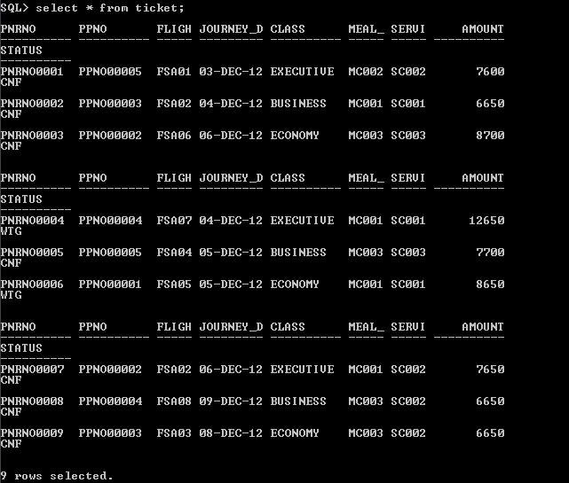

**Availability**

|  |  |  |  |
| --- | --- | --- | --- |
| **FID** | **Journey-date** | **Class** | **Remaining-seats** |
| FSA001 | 03-DEC-12 | EXECUTIVE | 3 |
| FSA002 | 04-DEC-12 | BUSINESS | 2 |
| FSA006 | 06-DEC-12 | ECONOMY | 3 |
| FSA007 | 04-DEC-12 | EXECUTIVE | 0 |
| FSA004 | 05-DEC-12 | BUSINESS | 3 |
| FSA005 | 05-DEC-12 | ECONOMY | 0 |
| FSA002 | 06-DEC-12 | EXECUTIVE | 2 |
| FSA008 | 09-DEC-12 | BUSINESS | 3 |
| FSA003 | 08-DEC-12 | ECONOMY | 2 |

SQL> insert into availability values('FSA01','EXECUTIVE','04-DEC-12',0);

SQL> insert into availability values('FSA01','EXECUTIVE','04-DEC-12',3);

SQL> delete from availability where remaining_seats = 3;

SQL> insert into availability values('FSA02','BUSINESS','04-DEC-12',2);

SQL> insert into availability values('FSA06','ECONOMY','06-DEC-12',3);

SQL> insert into availability values('FSA07','EXECUTIVE','04-DEC-12',0);

SQL> insert into availability values('FSA04','BUSINESS','05-DEC-12',3);

SQL> insert into availability values('FSA05','ECONOMY','05-DEC-12',0);

SQL> insert into availability values('FSA02','EXECUTIVE','06-DEC-12',2);

SQL> insert into availability values('FSA08','BUSINESS','09-DEC-12',3);

SQL> insert into availability values('FSA03','ECONOMY','08-DEC-12',2);

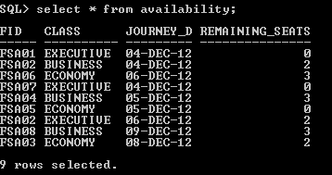

**Passenger-Luggage-Charges**

|  |  |  |
| --- | --- | --- |
| **PNRNO** | **WEIGHT** | **AMOUNT** |
| PNRNO0001 | 70 | 450 |
| PNRNO0002 | 60 | 300 |
| PNRNO0008 | 65 | 360 |

SQL> insert into passenger_luggage_charges values('PNRNO0001',70,45);

SQL> insert into passenger_luggage_charges values('PNRNO0002',60,300);

SQL> insert into passenger_luggage_charges values('PNRNO0008',65,360);

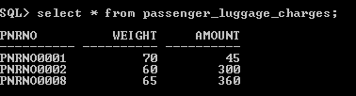

**Cancellation**

|  |  |  |
| --- | --- | --- |
| CID | PNRNO | Before-Hours |
| C0001 | PNRNO0004 | 12 |
| C0002 | PNRNO0005 | 24 |

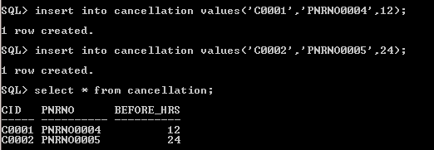

**Reservation**

PPNO                           Varchar2(10)   FK

Flight_Code                 Varchar2(5)     FK

Journey_Date              Date

Class                            Varchar2(10)

Meal_Code                 Varchar2(5)     FK

Service_Code              Varchar2(5)     FK

SQL> insert into reservation values('PPNO00005','FSA01','02-DEC-15','ECONOMY','M

C001','SC001');

