**PROBLEM SET**

**Step by Step Guide for SQL queries**  
**For the queries given, write the SQL statements**

Look at the queries asked by Client.

Try to solve them one after the other.

If you are stuck anywhere, look at the resources provided to you. If it is not helpful kindly contact respective mentor.

Finally create a sql dump of all the queries and submit it on or before deadline.

1)      Find the details of the passport number ‘PPNO000005’?

Answer:-

query:- select * from passenger where ppno = 'PPNO00005';

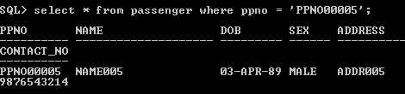

2)      Find all the flight ids of FlySafe Airways.

Answer:-

query:- select fid from flight;

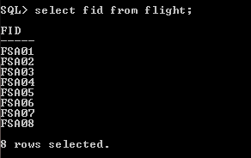

3)      Find Flight names for the flights which start from DELHI

Answer:-

query:- SQL> select fid,fname from flight where source_code IN (select city_code from ci

ty_master where city_name='DELHI');

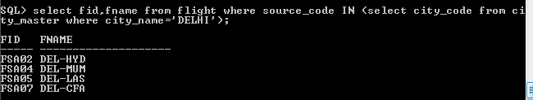

4)      Find all the Flights which are between cities in INDIA only

Answer:-

query:- SQL> select fname,fid from flight where source_code IN (select city_code from ci

ty_master where country = 'INDIA');

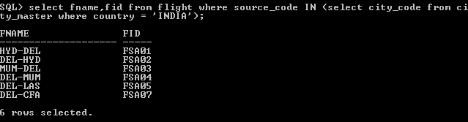

5)      Find  all the services which are above 300

Answer:-

query:- SQL> select service_name from service_master where amount > 300;

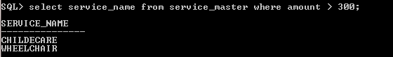

6)      Find the flights which offer Wheel Chair services

Answer:-

query:- SQL> select fname,fid from flight where fid IN(select fid from flight_services w

here service_code IN (select service_code from service_master where service_name

= 'WHEELCHAIR'));

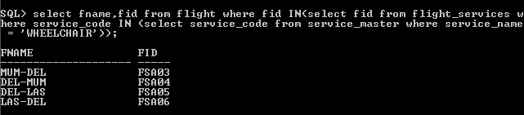

7)      Find all the Passengers who cancelled their tickets before 12 hours.

Answer:-

query:- select BEFORE_HRS from cancellation where BEFORE_HRS < 12;

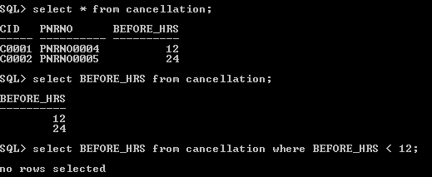

8)      Find all the Passengers who opted for Child Care services.

Answer:-

query:- SQL> select name from passenger where ppno IN (select ppno from reservation wher

e service_code IN (select service_code from service_master where service_name =

'CHILDECARE'));

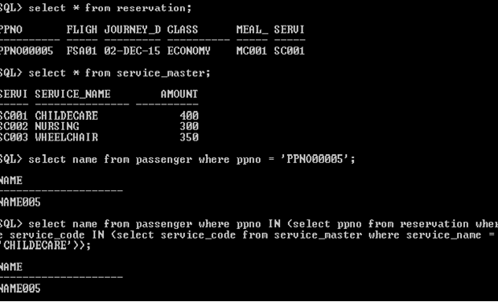

9)      Insert a row in a passenger table with following details PPNO00006 NAME006 05-MAY-1989 MALE ADDR006 9876543214

SQL> select * from passenger;

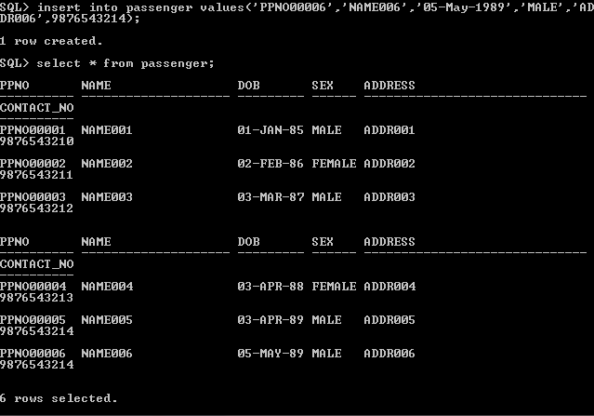

10)  Update the passenger table with following details whose passport no is PPNO00006 DOB = 06-JUN-1990, SEX = FEMALE, PHONE NO = 9876543215

SQL> update passenger set dob = '06-JUN-1990',sex='FEMALE',contact_no=9876543215

where ppno = 'PPNO00006';

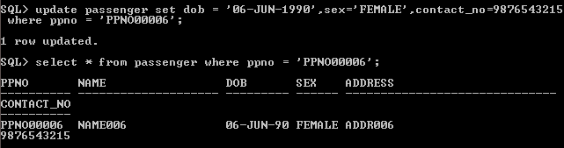

11)  Delete a row from the passenger table whose passport no is PPNO00006

SQL> delete from passenger where ppno = 'PPNO00006';

