实验13 二维数组

- 一个班有5名学生，每名学生选修了3门课程，编写程序输入每名学生每门课程的成绩，输出每个学生3门课程的平均成绩。
输入输出示例：
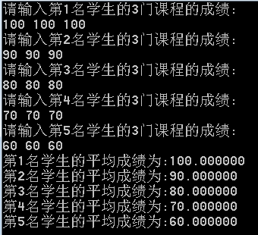
C语言源程序(ex13-1.c)：
#include <stdio.h>

#define S 5
#define C 3

int main()
{
int i,j;
float grades[S][C],avg;

// Input grades for each student and each course
for (i = 0; i < S; i++) {
printf("Enter grades for student %d:\n", i + 1);
for (j = 0; j < C; j++) {
printf(" Course %d: ", j + 1);
scanf("%f", &grades[i][j]);
}
}

// Calculate and display average grades for each student
for (i = 0; i < S; i++) {
float sum = 0;
for (j = 0; j < C; j++) {
sum += grades[i][j];
}
avg = sum / C;
printf("Student %d average grade: %.2f\n", i + 1, avg);
}

return 0;
}

- 编写程序输入一个3*3的二维数组，将其行和列的元素互换，存到另一个二维数组中并输出。
输入输出示例：
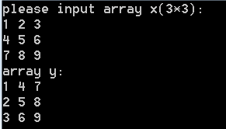
C语言源程序(ex13-2.c)：
#include <stdio.h>

#define N 3

int main() {
int i,j, x[N][N], y[N][N];

// Input elements for the 3x3 array x
printf("Please input array x (3x3):\n");
for (i = 0; i < N; i++) {
for (j = 0; j < N; j++) {
scanf("%d", &x[i][j]);
}
}

// Swap rows and columns and store in array y
for (i = 0; i < N; i++) {
for (j = 0; j < N; j++) {
y[j][i] = x[i][j];
}
}

// Output the transposed array y
printf("Array y:\n");
for (i = 0; i < N; i++) {
for (j = 0; j < N; j++) {
printf("%d ", y[i][j]);
}
printf("\n");
}

return 0;
}

- 输入一个n行m列（n<=5,m<=5）的数组，然后找出该数组中值最小的元素，输出该元素及其行下标和列下标。
输入输出示例：
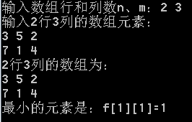
C语言源程序(ex13-3.c)：
#include <stdio.h>

#define MAX 5

int main() {
int i,j, n, m;
int a[MAX][MAX];
int minValue, minRow, minCol;

// Input dimensions of the array
printf("enter the number of array rows and columns:, m: ");
scanf("%d %d", &n, &m);

if (n > MAX || m > MAX) {
printf("Error: Maximum size is %d x %d\n", MAX, MAX);
return 1;
}

// Input elements of the array
printf("enter the array elements of 2 rows and 3 columns:\n");
for (i = 0; i < n; i++) {
for ( j = 0; j < m; j++) {
scanf("%d", &a[i][j]);
}
}

// Find the smallest element and its position
minValue = a[0][0];
minRow = 0;
minCol = 0;
for (i = 0; i < n; i++) {
for (j = 0; j < m; j++) {
if (a[i][j] < minValue) {
minValue = a[i][j];
minRow = i;
minCol = j;
}
}
}

// Output the array
printf("the array of 2 rows and 3 columns:\n", n, m);
for (i = 0; i < n; i++) {
for (j = 0; j < m; j++) {
printf("%d ", a[i][j]);
}
printf("\n");
}

// Output the smallest element and its position
printf("The smallest element is=%d\n", minRow + 1, minCol + 1, minValue);

return 0;
}
- 编写程序输入杨辉三角形的行数（不超过10行），输出杨辉三角形。
输入输出示例：
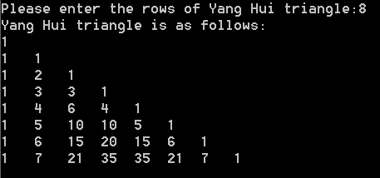
C语言源程序(ex13-4.c)：
#include <stdio.h>

#define MAX_R 10

int main() {
int i,j, pascal[MAX_R][MAX_R] = {0};
int rows;

// Input the number of rows for Pascal's triangle
printf("Enter the number of rows for Pascal's Triangle (1-10): ");
scanf("%d", &rows);

if (rows > MAX_R || rows <= 0) {
printf("Invalid input! Please enter a number between 1 and 10.\n");
return 1;
}

// Generate Pascal's triangle
for ( i = 0; i < rows; i++) {
pascal[i][0] = 1; // First element of each row is 1
for (j = 1; j <= i; j++) {
pascal[i][j] = pascal[i - 1][j - 1] + pascal[i - 1][j];
}
}

// Output Pascal's triangle
printf("Pascal's Triangle:\n");
for (i = 0; i < rows; i++) {
for (j = 0; j <= i; j++) {
printf("%d ", pascal[i][j]);
}
printf("\n");
}

return 0;
}

