Exercise:

1. Set the border to "2px solid green" for table, th and td elements.
2. Collapse the table borders into a single border.
3. Use inline styles to set the width of the table to "100%".
4. Set the text alignment in <td> elements to "right".
5. Set the padding in <th> elements to "15px".
6. Set the background color of <th> elements to "lightblue".

**HTML Code**

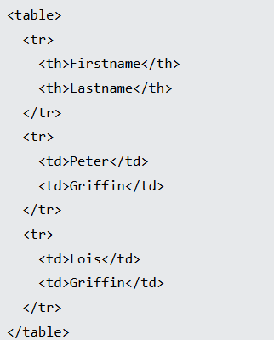

**Result：**

