TASK OF THE DAY

INPUT-

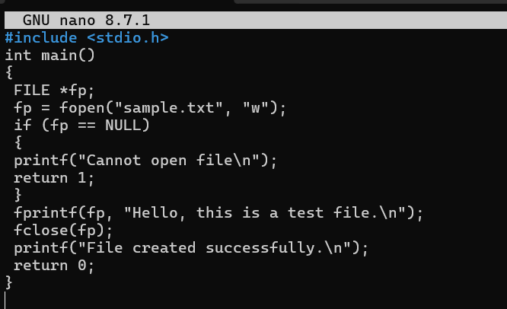
1) Give Read and Write only to the owner
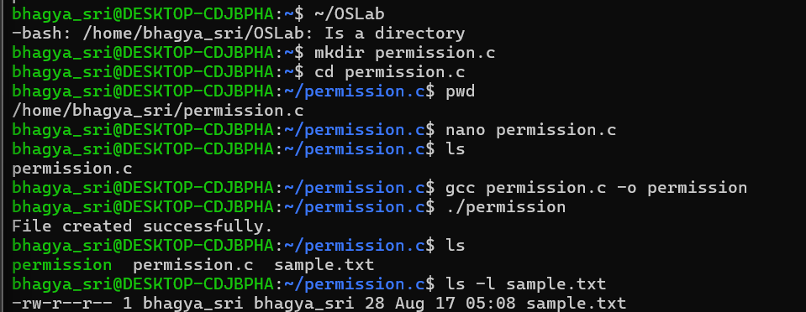
2)Give Read and Write only to the owner
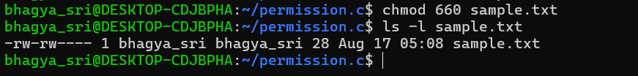
3) Only owner can read and write
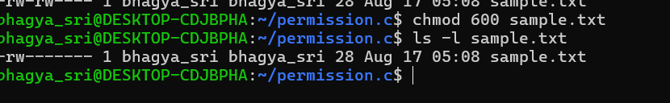
4) Owner read/write, everyone else read-only
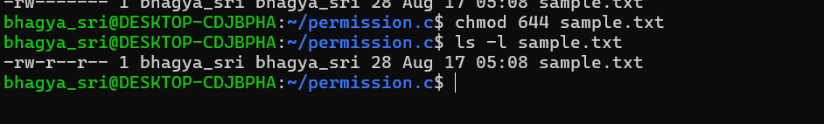
5) Owner can do everything, others can only read and execute
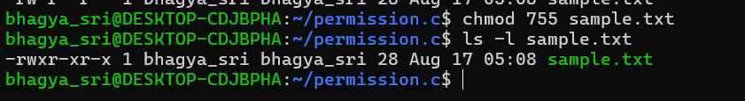
6) Owner and group can read/write
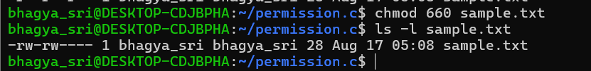
7) Only owner can execute
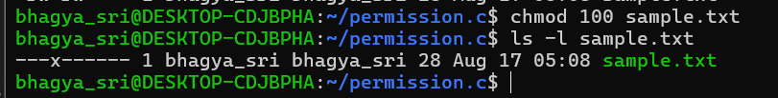
08-
8) Owner: read + write; Group: nothing; Others: nothing
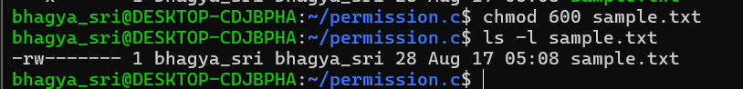
9) Owner: read + write; Group: read; Others: read →
10) Owner: read + write + execute; Group: read + execute; Others: read + execute →
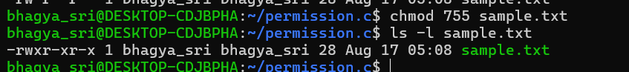
11) Owner: read + write; Group: read + write; Others: nothing →
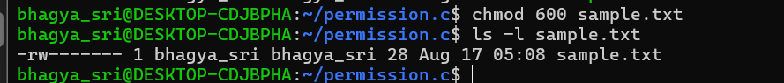
12) Everyone: read only →

