Wireshark-Based Network Traffic Investigation

PCAP Analysis Report: SBT-PCAP1 By Bhagyasree

A user reported unusual network activity. Two lab captures were provided. The communication was reconstructed from packet evidence only, using Wireshark statistics views, display filters and Follow TCP Stream. Every finding below cites a frame number (the No. column in Wireshark).

Identify the Source IP and Destination IP
Objective
The PCAP files was analyzed using Wireshark.The traffic was filtered using the client IP address.
The IPv4 Conversations table was used to identify the Source/Address A, Destination/Address B, packet count, and data transferred.
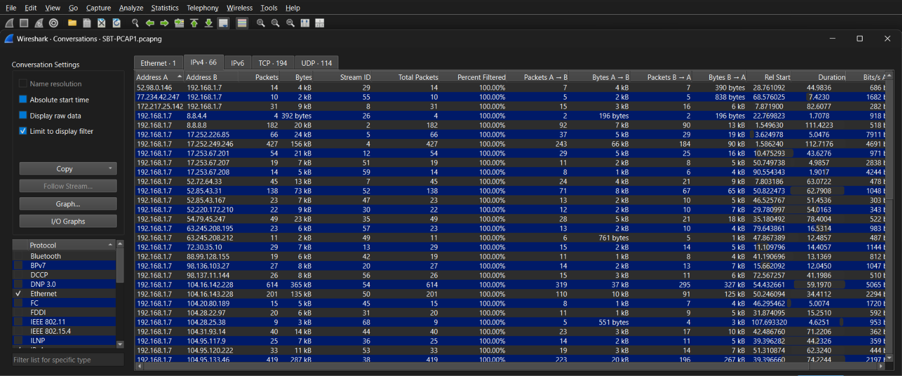
The Ipv4 conversation analysis identified communication between the client 198.168.1.7 and remote IP 17.252.226.85

Identify The Protocols and Ports

The Protocol Hierarchy Statistics in the Wireshark was analyzed to identify the protocol present in the PCAP file.The capture contians 9225 TCP packets and 3220 TLS packets,indicating that most of the observed traffic TCP and encrypted based using TLS.and also contains 224 UDP,DNS packets and 7 HTTP packets and 6 ICMP packets.

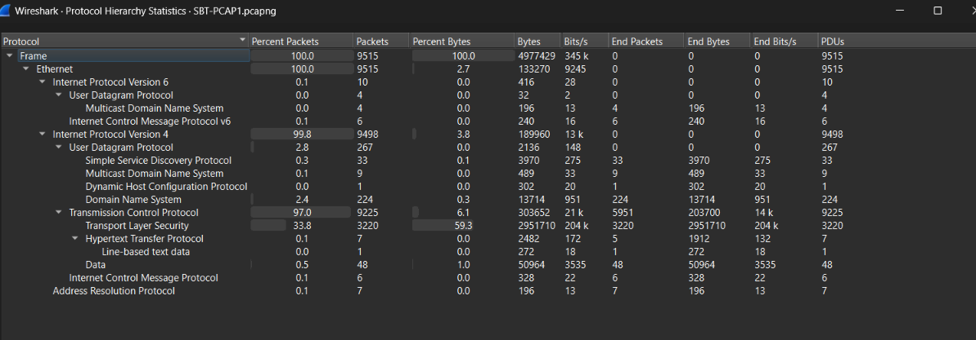

Port 80: The client used the source port 53828,communicated to the server on destination IP 80.standard port used HTTP.
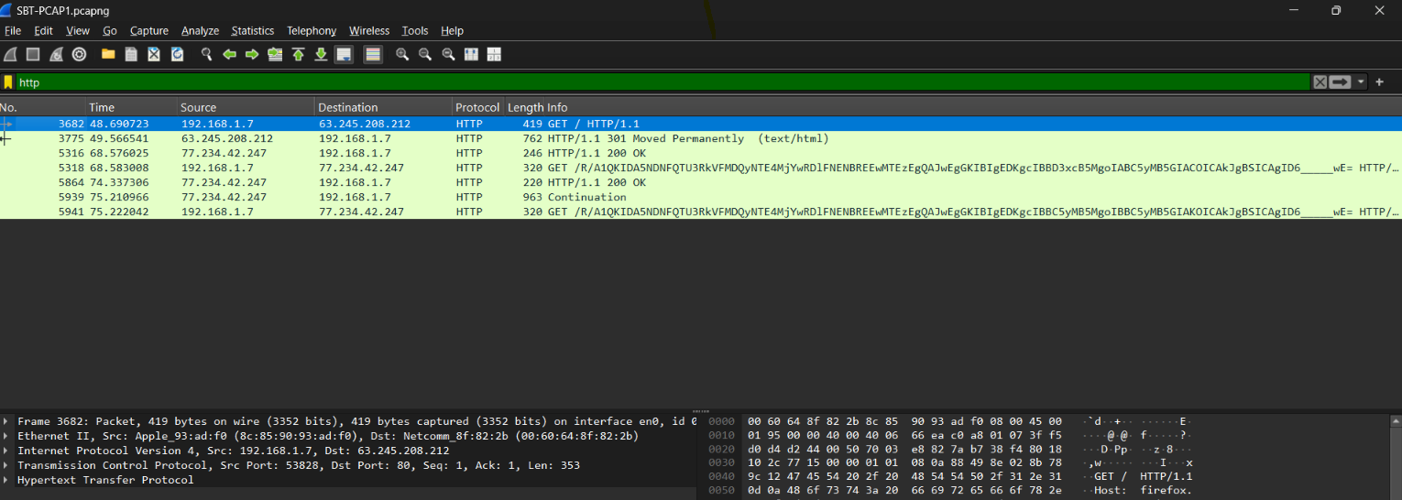

SSDP 1900
Wireshark analysis identified the SSDP traffic using UDP. The source port is 3942 and destination port is 1900.the port standard port used by SSDP.
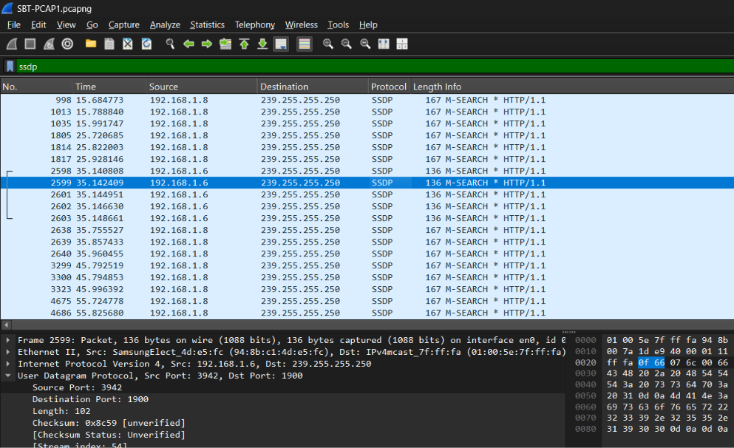

Mdns5353
mDNS uses UDP port 5353 for both the source and destination to support its peer-to-peer design, allow all devices to hear responses, and distinguish full mDNS clients from basic resolvers.
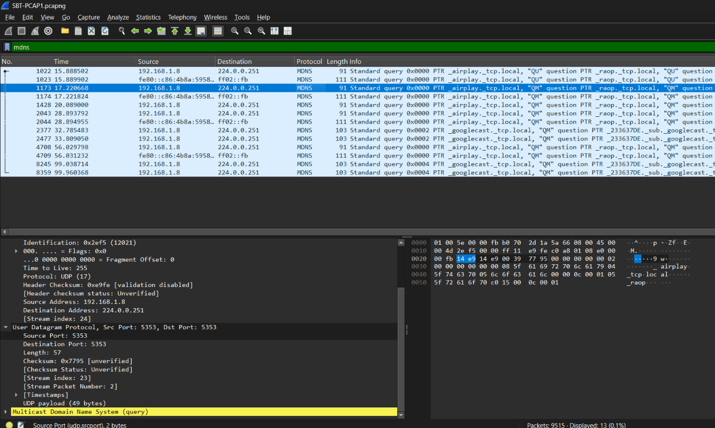

ICMP
Its doesnot use TCP/UDP Port numbers ICMP
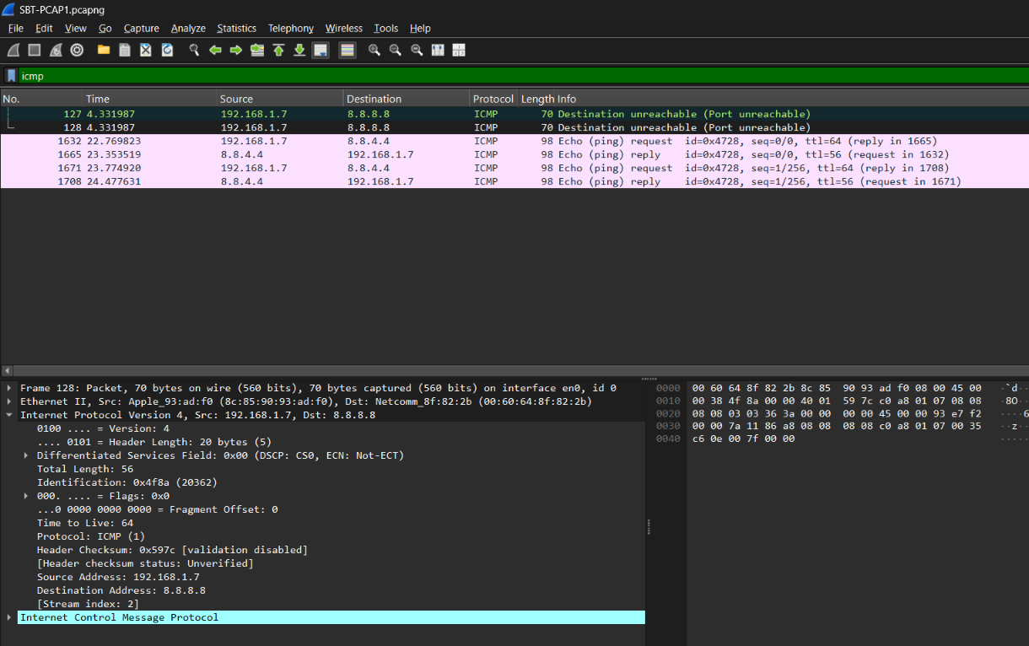
Analyze ARP and DNS traffic
ARP The gateway ask Who has 192.168.1.7 . in frames 580,3618,and 7143. The clinet responds each time with its MAC address 8c:85:90:93:ad:f0 indicating normal ARP cache refresh activity. The gateway also ask Who has 198.168.1.6 in frame in 2600 indicating an attempt to reslove another device on the local network.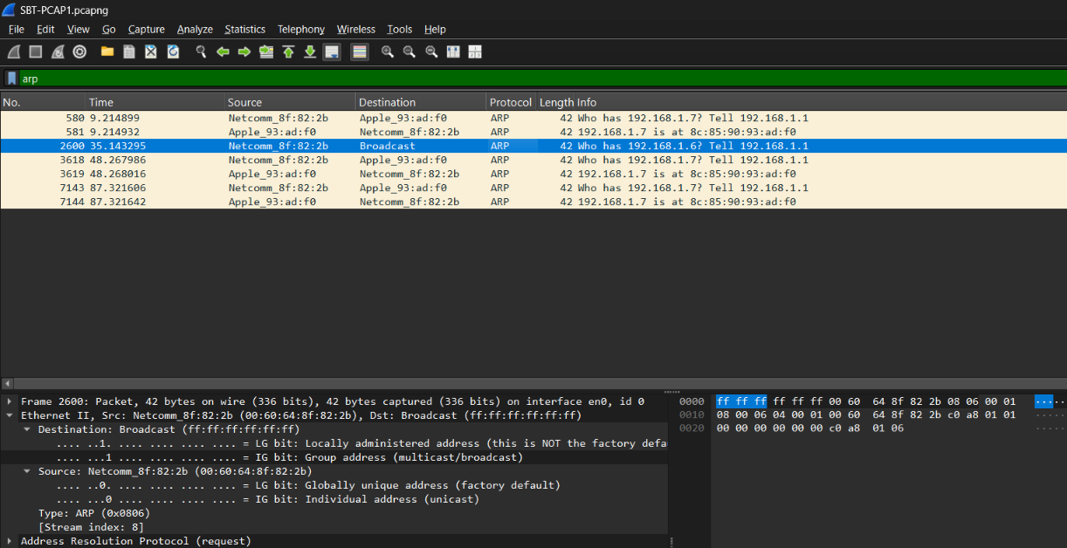
DNS
The capture shows DNS queriesf from the client 192.168.1.7 to 8.8.8.8 and DNS response from 8.8.8.8 back to the client. The UDP port 53.

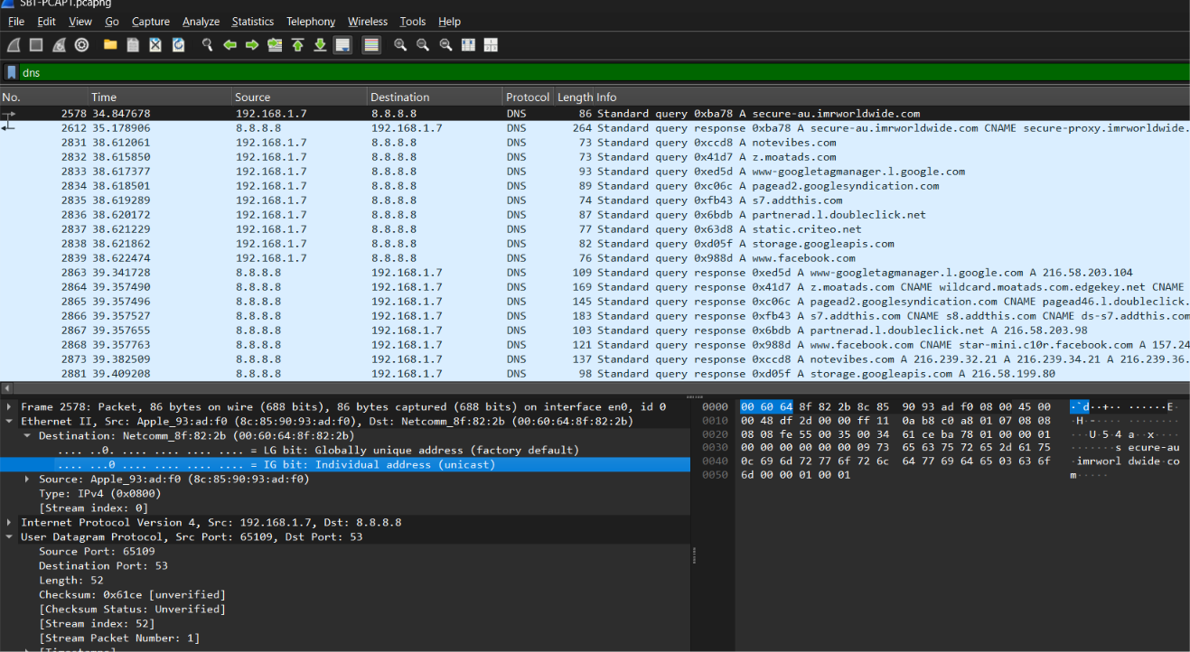
TCP Three Way Hand Shake
Frames 52 / 54 / 55: 192.168.1.7:53686 → 216.58.199.78:443. SYN at t=1.586 (Seq=3989314022), SYN-ACK (Seq=3826294920, Ack=3989314023), then ACK. A plain-HTTP example is the stream of frame 3682 (client port 53828): SYN frame 3574 (t=47.87), SYN-ACK frame 3679 (t=48.69), ACK frame 3680. The 0.8 s wait for the SYN-ACK is a slow handshake.

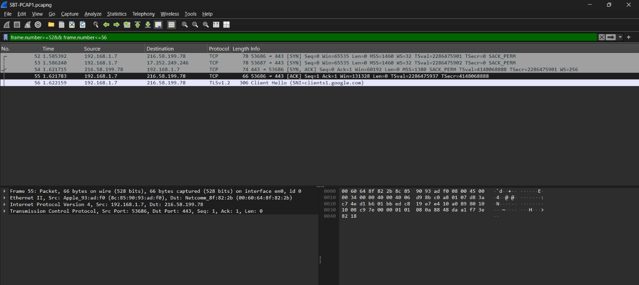
Follow TCP Stream
A TCP stream analysis shows an HTTP GET request to firefox.com. The server responded with HTTP 301 Moved Permanently, redirecting the client to https://www.mozilla.org/firefox/new/. The response was served by an Apache/2.4.6 server running on CentOS.

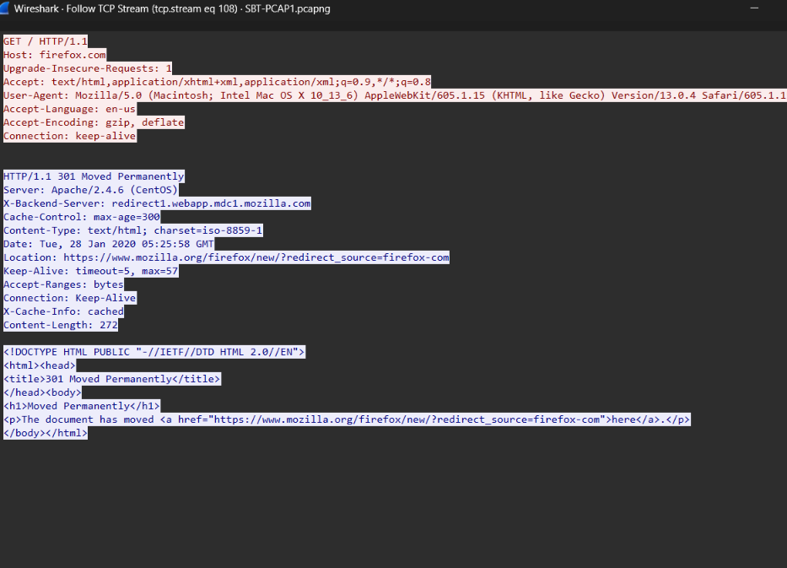

Unusual items
ICMP
frame.number ==127 || frame.number ==128
The client 192.168.1.7 sent traffic toward 8.8.8.8, but the destination port was not available/listening. The client then generated an ICMP Destination Unreachable – Port Unreachable message.

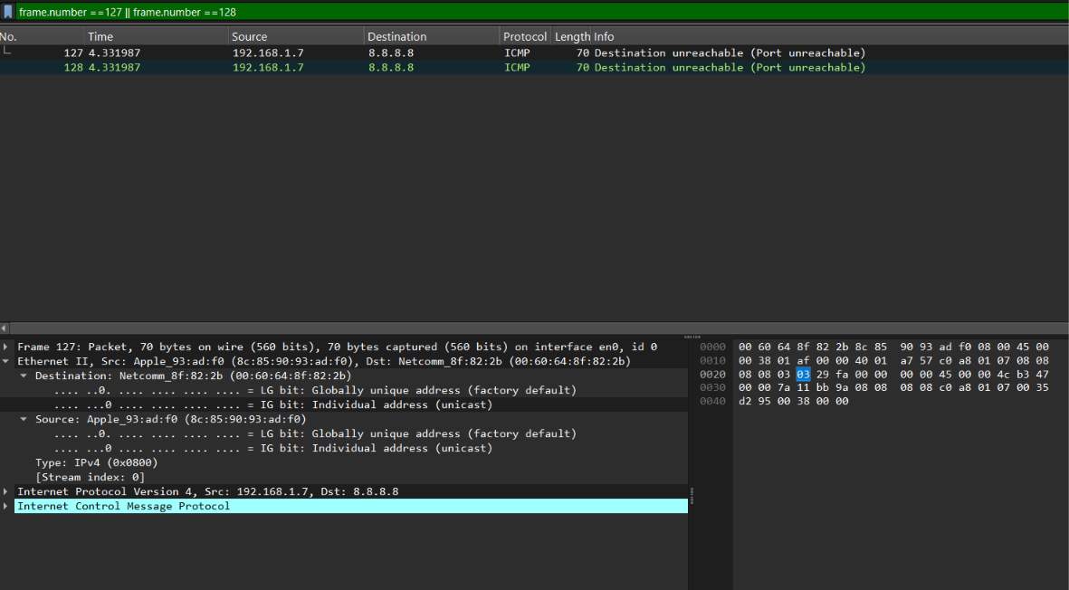

TCP
tcp.flags.reset==1
TCP RST means that a connection was suddenly terminated. Although the number of RST packets is high, the traffic mainly involves HTTPS connections on port 443 and does not show a clear port-scanning or flooding pattern. Therefore, the activity is considered benign connection termination.

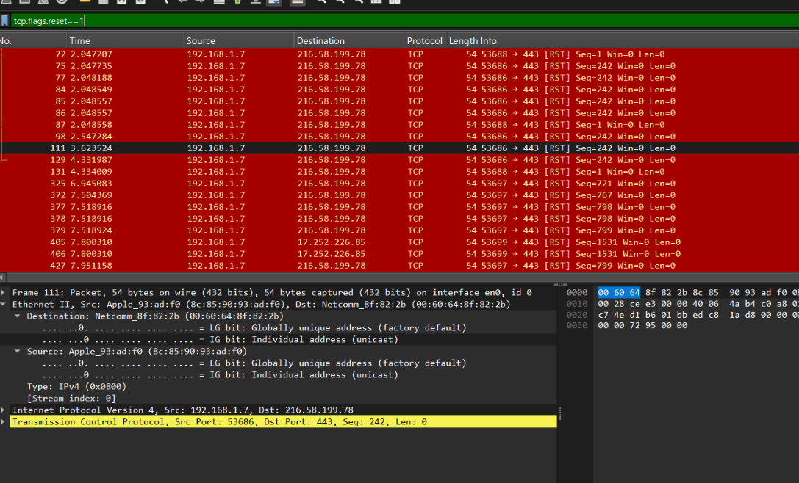
DHCP frame 2585 (t=34.94); SSDP frame 2598
Hostname Galaxy-S8 requested 192.168.1.6. IPv6 router solicitation (frame 2566) happens at the same moment, which suggests the same device.

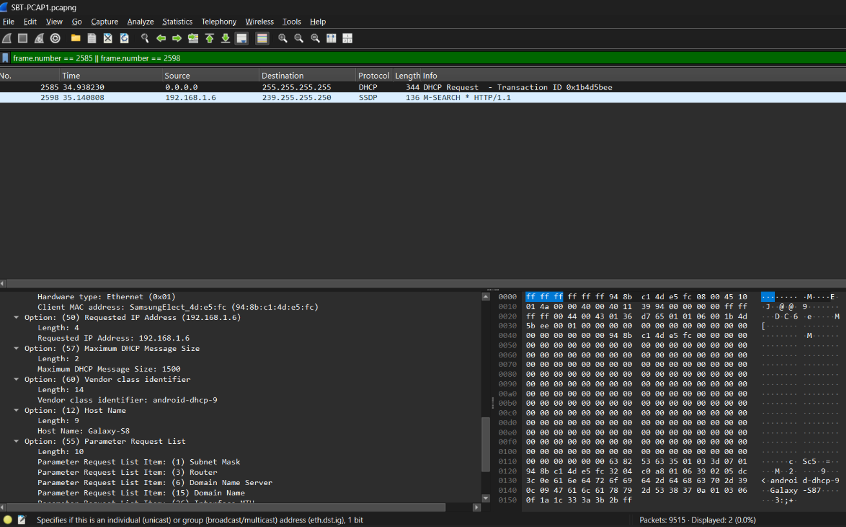
Slow ICMP echo
Frames 1632 to 1708
Replies from 8.8.4.4 in about 0.58 s and 0.70 s: high latency but working.

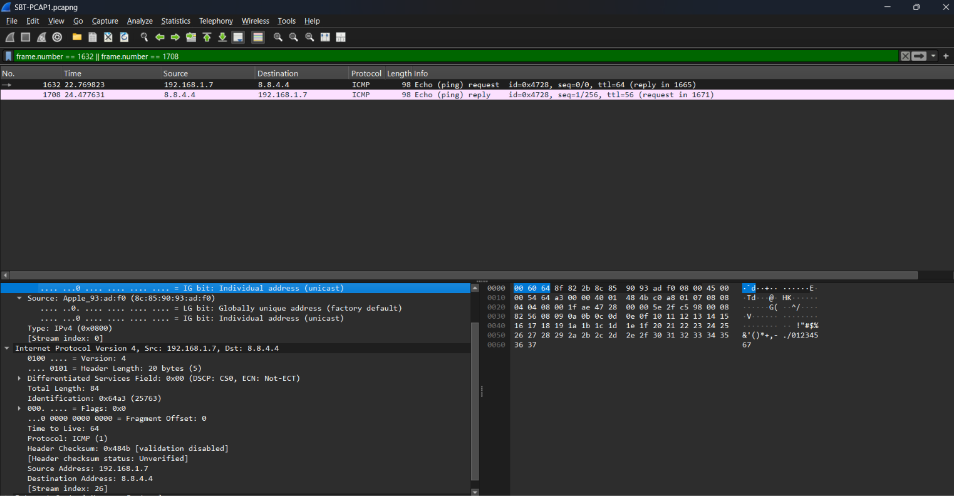

Timeline (05:24:17 UTC start

Time (s) | Frames | Event
0 | 1 to 6 | Capture starts mid-connection (client sending to 172.217.167.78:443)
1.585 | 52 to 55 | New TLS connection to Google
2 to 4 | 94 to 128 | DNS retry; late duplicate reply causes ICMP unreachable
9.2 | 580 | ARP refresh by the gateway
15.7 | 998 | SSDP and mDNS discovery begins from 192.168.1.8
22.8 | 1632 | Ping to 8.8.4.4
23.4 | n/a | Client starts querying the two silent DNS servers
34.6 to 35.1 | 2555 to 2603 | Galaxy-S8 joins (IPv6 RS/MLD, DHCP, SSDP)
47.9 to 48.7 | 3574 to 3775 | HTTP to Mozilla, 301 redirect to HTTPS
68.6 to 75.2 | 5316 to 5941 | Avast update HTTP requests
about 100 to 115 | n/a | Continued browsing (Yahoo images, Google, Apple); capture ends at 115.3 s

Conclusion
The PCAP analysis shows mostly normal and legitimate network activity.
Some unusual events like ICMP unreachable, TCP RSTs, and high latency were observed.
No clear evidence of malware, port scanning, or data exfiltration was identified.
Overall, the traffic appears benign, with some activity requiring monitoring.

